**Capstone Project Document**

**Online Storytelling Generator System**

**Table of Contents**

**…**

**List of Figures**

**…**

**List of Tables**

**…**

**A. Introduction**

**1. Project Information**

* Project Name: **Online storytelling generator system**
* Project code: **StoryArt**
* Product Type: **Website Application, Web Service**
* Start Date: **January 14th, 2020**
* End Date: **April 30th, 2020**

**2. Introduction**

The world has evolved from sign language to the written language with the pupose to store, pass-on knowledge and inspire the next generation. The traditional way of telling story was one-way from the author to the reader, what if we can enable author to generate altenative ending, a story-line that can be spread to multiple direction instead of one direction?

We introduce a platform that enable author to generate interactive story, with audio, visual effect, and multiple storyline. Imagine, as an author, you can build a thrilling adventure, where your characters can have alternative actions of their owns and different storyline can evolve; and as a reader, you’re in an adventure where the character’s next destination is your choice. Your story will never be left untold.

**3. Current Situation**

There are many tools in the market that enable author to generate their stories but those tools can’t meet up their expectation and can’t express all the authors’ idea. With traditional stories telling, it seems not to be able to attract readers anymore, our platform support the tool for generating a story with interaction, audio, video effect, multi storyline and the power to publish it. The written stories can be used for many kind of aspects such as marketing, education, game, entertainment.

**4. Problem Definition**

Below are the disadvantages of the current situation:

* Lack of meaningful contents: Internet is filled with boring contents and many of these wasted our time.
* No interaction between visitor and story: Visitor usually read stories written by an author from start to end without interactions or deflect the story line. It makes the story became normally and boring.
* Low-educational contents: Children isn’t touch much by these online stories.
* Need of high-quality marketing content: People are bothered and even uncomfortable by dozens of advertisements per day in a website.

**5. Proposed Solution**

Our solution is web application named “Story Art”. It assists authors to post their story, advertisement or even game in a convenient and reliable place to make visitor relaxed and advertise their products.

**5.1. Feature functions**

* Provide tools to generate/create story.
* Search/suggest stories.
* View/interact stories.
* Manage stories.
* Rate stories.

**5.2. Advantages and disadvantages**

The advantages and disadvantages of the proposed solution:

* **Advantages:**
* Easy to search stories by category
* Provide the the creative ways for authors to generate the story. The authors can create their stories by their own way combining the screen, options, information, animation.
* Stories recommendation based on user’s hobby can bring to user many suitable, interesting stories.
* Brings out a whole new experience of reading stories to end users. Users will be interested in the storyline that lead them to surprise.
* A game can be created for the end users to play while reading the story.
* The authors can bring their business brands to the stories for marketing purpose so that their business can spread out to customers easily and naturally.
* Provide a channel for education: the website contains the stories that bring out the useful meaning to readers. They will learn a lot and enhance the knowledge by reading the high-educational stories.
* **Disadvantages:**
* Do not manage the content for support, advertising or other activities out our website in users’ stories such as: calling for support, donations, links, ...
* Do not check the content of users’ stories before publishing. The content will be checked after system received users’ reports.
* The format of creating the story may be complicated to authors because they have to generate the screen, information, animation along with the content they input.
* New users visit the website may not understand the idea of interactive storytelling, so the website need to serve the demo when users first come to website.

**6. Functional Requirements**

Function requirements of the system are listed as below:

* **Authentication and Authorization:**
* Authenticate and authorize users to use configuration and management functions**.**
* **Admin:**
* Manage users.
* Manage users’ stories.
* **Data Collector:**
* Collect data from users by giving them the questionnaires.
* Clean and transform data after collecting from the questionnaires.
* **Data Analytic:**
* Automatically analyze collected data by applying recommendation algorithms.
* **Users:**
* Search stories to read.
* Get story suggestions based on their questionnaires.
* Get story trends.
* Interact with the story while reading (select options, input information).
* Manage their own stories (create, publish, delete, deactivate, update).

**7. Role and Responsibility**

|  |  |  |  |  |
| --- | --- | --- | --- | --- |
| **No** | **Full name** | **Role** | **Position** | **Contact** |
| 1 | Nguyễn Duy Thanh | Project Owner | Advisor | hello@nguyenduythanh.com |
| 2 | Bùi Đức Tài | Scrum Master | Leader | taibdse62836@fpt.edu.vn |
| 3 | Trần Hà Trâm Anh | Developer | Member | anhthtse141171@fpt.edu.vn |
| 4 | Nguyễn Tấn Đạt | Developer | Member | datntse61735@fpt.edu.vn |
| 5 | Nguyễn Viết Hải | Developer | Member | hainvse62107@fpt.edu.vn |

**B. Software Project Management Plan**

## **1.Problem definition**

### **. Name of this Captone Project**

* Official name: Online storytelling generator system
* Vietnamese name: Hệ thống tạo nội dung kể chuyện trực tuyến
* Abbreviation: StoryArt

### **Problem Abstract**

We provide Online storytelling generator system (StoryArt). StoryArt is a website containing stories and games. StoryArt will let authors create their own stories and games then show them up to visitors to read and play. StoryArt’s main characteristics focus in which stories that contains highly educated, marketing and entertaining contents. StoryArt lets author to create games that has ranks based on visitor’s scores. StoryArt provides suggestions based on users’ favorite topics, the current trend of stories.

Authors can create a story having multiple storylines. StoryArt let author to divide their story into many chapters as they want. In the end of each chapter except these final chapters will have a few options that allow readers to choose what they expect to read next. A storyline is created by connected chapters from start of the story to the end.

StoryArt helps author manipulate their stories and games by providing mechanism of creating multistep story, animation, store and suggest them to proper visitors. StoryArt collects data about user’s interest and age to recommend useful and suitable contents.

#### **1.3 Project Overview**

#### **1.3.1. Current Situation**

Below are the problems encountered in this project:

* **Absence of team member:** team member absence in meeting schedule because of class or work schedule, etc.
* **New technique:** Some team members are new to the techniques used in project. We need a lot of time to training.
* **Reliability:** It is hard to confirm information of user or product. We should build something to reduce risk can happen.
* **Lack of experience in writing story:** no one in team members have ability to write a story, so we have some problem in how the story is created. We need a lot of time to research and read more stories.
* **Lack of knowledge of AI:** no one in the team have deep understanding about Machine Learning

#### **1.3.2. The Proposed System**

Our proposed solution is to build an online storytelling generator system named StoryArt to resolve the current situations by allowing user to create their own stories in creative way that can interact with readers, searching stories by category, receiving recommended stories, managing their own stories, rating stories. As for administrators, they can manage stories by viewing stories’ reports, deleting stories. Besides, they can manage users by viewing user’ profile, receiving and processing all problems about users, banning users.

Our system consists of three main subsystems: Website for users to create, read, interact and manage their stories, web application for administrators and web services to process requests.

#### **1.3.3. Boundaries of the System**

The system can:

* Provide tools for users can create their stories in creative way.
* Allow users to read and interact with the story.
* Allow users to search for stories by name and multiple categories and filters.
* Allow users to sort stories by amount of views, ratings in day, month, year, all time.
* Allow users to rate, report the story.
* Allow admin to manage users, stories.
* Recommend suitable stories users based on the similarities among users and stories

The system cannot:

* Check the content in story before it is published.

#### **1.3.4. Future Plans**

* Current system only runs on website. We will support mobile application in the future.
* We will provide tools and staffs to check the content in story before publishing.
* Some charity activities in our website need to create donation method, they need to use some third-party website. We will design a system to help user can donate online:
  + Donate by user ‘s wallet: each user has personal wallet to store money in system.
  + Donate by third partner: user can pay online by third partner (Nganluong.vn, baokim.vn, payoo.vn, momo, …).

#### **1.3.5. Development environment**

**1.3.5.1. Hardware requirements**

* **For server**

|  |  |  |
| --- | --- | --- |
| **Hardware** | **Minimum Requirement** | **Recommended** |
| Internet Connection | Cable, Wi-Fi (8 Mbps) | Cable, Wi-Fi (32 Mbps or more) |
| Operation System | XP, Vista, 7, 10, Window Server 2008 | 10, Window server 2008 |
| Computer Processor | Intel® Xeon ® 1.4GHz | Intel® Xeon ® Quad Core (12M Cache, 2.50 GHz) or above |
| Computer memory | 4GB RAM | 8 GB RAM or more |
| Storage space | 1GB | 5GB or more |

Table 2 - Hardware Requirements for Server

* **For PC**

|  |  |  |
| --- | --- | --- |
| **PC** | **Minimum Requirements** | **Recommended** |
| Internet Connection | Cable, Wi-Fi (4 Mbps) | Cable, Wi-Fi (8 Mbps or more) |
| Operating System | Window 7, IOS 9 | Windows 10, IOS 10. |
| Computer Processor | Intel® Core i3 1.4GHz | Intel® Core i5 2.50GHz or above |
| Computer Memory | 4GB RAM | 8GB RAM or more |
| Web Browser | Chromes (v42 or higher) | Chrome latest stable version |

Table 3 - Hardware requirement for PC

**1.3.5.2. Software requirement**

|  |  |  |
| --- | --- | --- |
| **Software** | **Name / Version** | **Description** |
| Operation System | Windows 10 | Operating system and platform for development |
| Environment | Java EE 8.0, NodeJS v10, npm v6 | Specification for developing web application and mobile application |
| Modeling tool | StarUML, draw.io, Lucid Chart | Used to design diagram |
| IDE | IntelliJ IDEA 2019.1.4, Visual Studio Code | Programming tools |
| DBMS | MySQL WorkBench | Used to create & manage the database for system |
| Source control | GitHub/Git cmd/Git SCM | Used for source control |
| Web browser | Chrome 69 or above | Testing browser |

Table 4 - Software Requirement

## **2. Project Organization**

### **Software Process Model**

This project is developed using Scrum model for Software development project. Our team choose Scrum model because of the following reasons:

* Our team only has 4 members and with this model we can communicate and working together more frequently
* Team can change project’s priorities after every sprint
* Scrum model is easy to learn and also reduce the risk of building the product by increments
* With nature of our project problem in data transferring and interface, The intermediate product can be shown to the Project Owner after each sprint so he can estimate it.

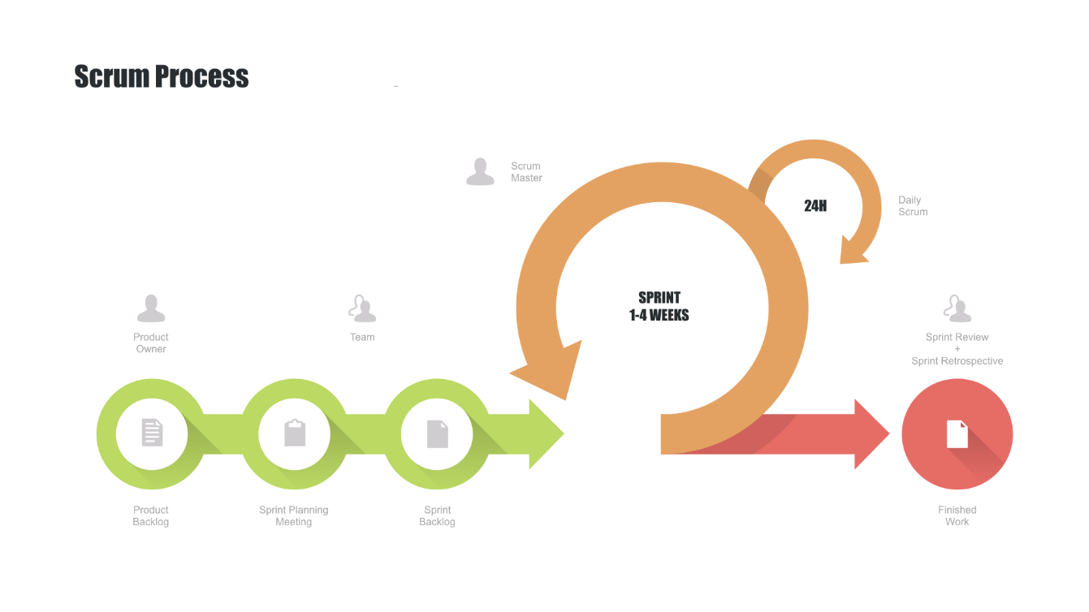

Figure 1 - Scrum Process - [1]

### Roles and Responsibilities

|  |  |  |  |
| --- | --- | --- | --- |
| **No** | **Full name** | **Role in Group** | **Responsibilities** |
| **1** | Nguyễn Duy Thanh | Project Owner | * Specifying user requirements * Controlling the development process * Giving out technique and business analysis support |
| **2** | Bùi Đức Tài | Scrum Master | * Managing process * Designing database * Clarifying requirements * Preparing documents * Designing GUI * Creating test plan * Coding * Testing * Arranging Meeting * Managing Risks |
| **3** | Nguyễn Tấn Đạt | Developer | * Designing database * Clarifying requirements * Preparing documents * Designing GUI * Creating test plan * Coding * Testing |
| **4** | Nguyễn Viết Hải | Developer | * Designing database * Clarifying requirements * Preparing documents * Designing GUI * Creating test plan * Coding * Testing |
| **5** | Trần Hà Trâm Anh | Developer | * Designing database * Clarifying requirements * Preparing documents * Designing GUI * Creating test plan * Coding * Testing |

Table - Role and Responsibilities

### Tools and Techniques

|  |  |
| --- | --- |
| **Tool/Technique** | **Name** |
| Front-end | HTML, CSS, JavaScript, React Js |
| Back-end | Java 8, Spring Framework |
| IDE | IntelliJ 2019.1.3 |
| DBMS | MySQL Workbench |
| Source Control | Github, Sourcetree, GitSCM |
| Modeling tool | StarUML, Lucid Chart |

Table - Tools and Techniques

**3. Project Management Plan**

**3.1. Product Backlog**

|  |  |  |  |
| --- | --- | --- | --- |
| **ID** | **Feature** | **User Story** | **Sprint** |
| 1 | Manage users’ account | As an admin, I can manage user account in the system in order to control the content that they published to the website, report the account that provide bad content on website | 1 |
| 2 | Manage users’ stories | As a user, I can manage my stories, which help to create, publish, update the meaningful stories with interaction to the readers | 1 |
| 3 | Search stories | As a user I can search stories to read so that I can enhance knowledge, find relaxation, play games. | 2 |
| 4 | Collect data from questionnaires | As a Timer, it can collect data from users’ interests for later purpose | 3 |
| 5 | Clean collected data | As a Timer, it can clean collected data into predefined data structure which is suitable for analysis | 3 |
| 6 | Create stories’ suggestions | As a Timer, It can create suggestions based on users’ interested topics and the similarities among users’ historical read stories | 4 |

**3.2. All Meeting Minutes**

**4. Project Management Plan**

**Summary:**

* Naming Convention:
  + Variable names should be short yet meaningful. The choice of a variable name should be designed to indicate to the casual observer the intent of its use.
  + Methods should be verbs, in mixed case with the first letter lowercase, with the first letter of each internal word capitalized.
* Indentation:
  + One declaration per line is recommended since it encourages commenting.
  + In absolutely no case should variables and functions be declared on the same line.
  + Do not put different types on the same line.
* Declarations Convention:
  + One declaration per line is recommended since it encourages commenting.
  + Using Java Code Convention from:

[*http://www.oracle.com/technetwork/java/codeconvtoc-136057.html*](http://www.oracle.com/technetwork/java/codeconvtoc-136057.html)

**C. Software Requirement Specification**

**1. User Requirement Specification**

**1.1 Guest Requirement**

Guest is a person who can get access to the system through web applications or mobile devices which consume the web application. Guest can use many functions in the system as follow:

* Search stories by keyword, filters, sortation on the system
* Get story’s suggestions
* Read stories’ details
* Generate the stories
* Manage their own’ stories

**1.2 Administrator Requirement**

Administrator can manage user’s accounts, user’s stories

**1.3 Timer Requirement**

System is also an actor, which is named Timer, runs in background to keep the system working. Timer should have the following functions:

* Collect user’s data from questionnaire given to user and the historical activities
* Analyze data and bring out suitable suggestions to users