HTML and CSS – Exercises
Exercises and homework assignments for “Software Technologies with AI” course at SoftUni AI.

Welcome to HTML
In this exercise you will create your first HTML page. Your task is to create a simple HTML file, holding a heading + paragraph and open it with a Web browser to visualize the HTML content.

Create a New Project
Start VS Code. Create and open a folder, which will hold your exercises about HTML and CSS. Give it a meaningful name, e.g. HTML-CSS-Exercises.
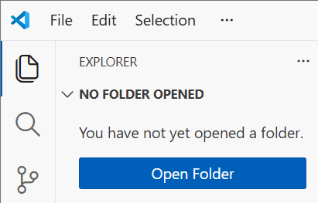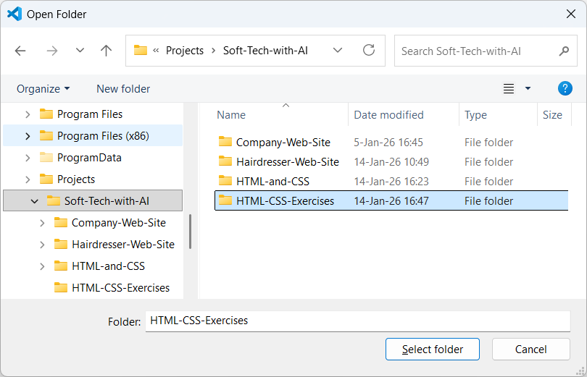
Now you have an empty VS Code project.
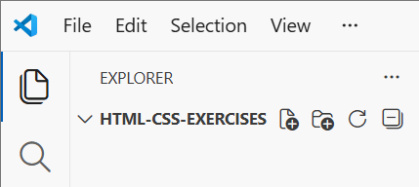

Create a New HTML File
Now create your first HTML file: index.html.
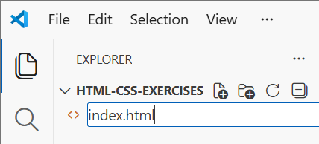

Write the HTML Code
Now it's time to write your HTML code. Open <html> tag, then close it </html>, then insert <body></body>, then insert <h1>Heading</h1> and <p>Paragraph</p> inside the HTML body.
This is an example of how your code may look like:
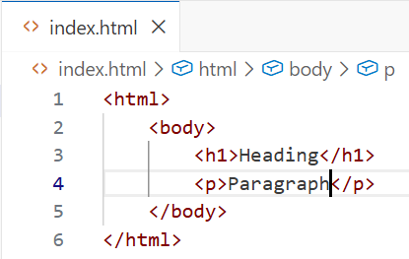

Browse the HTML File
Now your HTML page is ready. It's time to view it inside the Web browser. Run the currently open file using the "Code Runner" extension in VS Code, which adds the [Run Code] button on the top right side of your file editor.
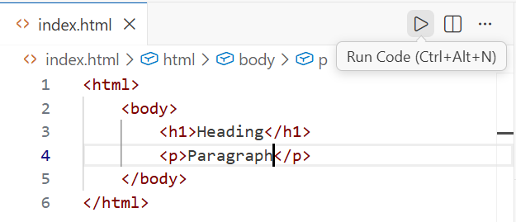
This will open the HTML file inside your Web browser. This is how the HTML page may look like in Chrome:
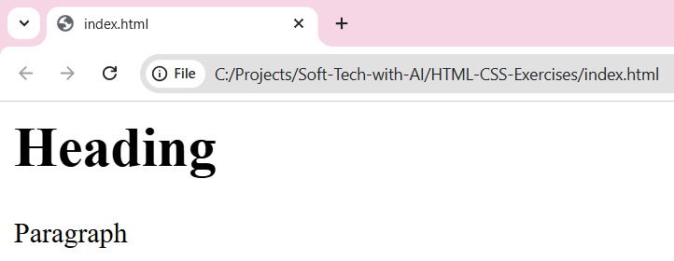
Alternatively, if you want to open manually the HTML page, you can open the project folder in the File Explorer and double-click the HTML file:
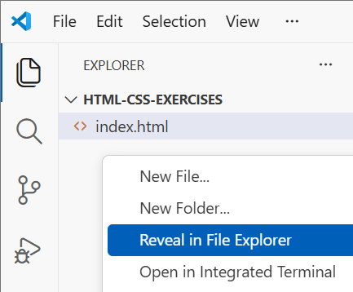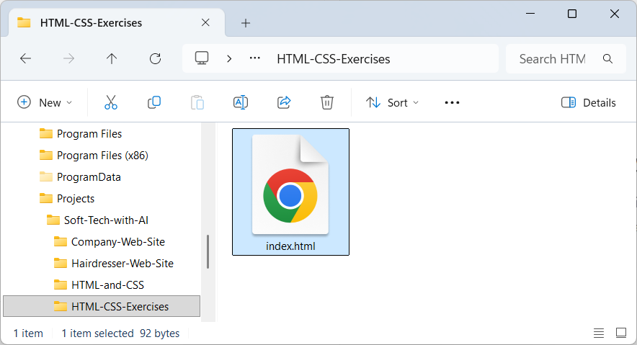
Congratulations! You completed the first exercise.

Very Simple Lesson
Your task is to create an HTML page, that presents a very simple lesson, on a topic of your choice, e.g. Solar Energy, or Linear Equations, or The French Revolution. Generate it with your AI dev agent (e.g. GitHub Copilot).

The AI Prompt
You can use a prompt like this:
Create a very simple HTML page `solar.html`, holding a lesson about "Solar Energy".
- Only use headings, paragraphs, links, lists
- No CSS styles, just HTML
Run the prompt in GitHub Copilot chat:
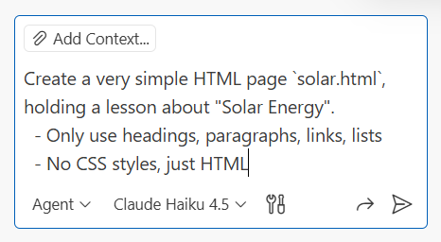

The AI-Generated HTML Page
This is how the AI-generated HTML page may look like:
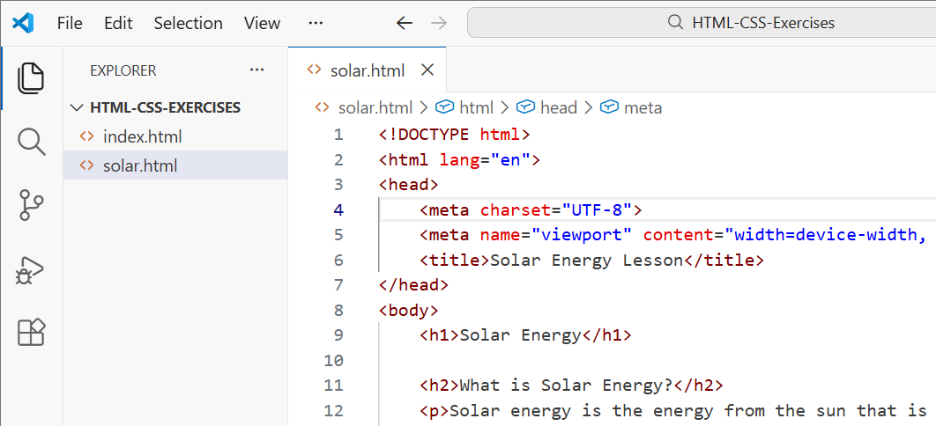

Explain Unclear Code
Look at the HTML code. See its structure and HTML tags used. Do you see any unknown tags? You can ask Copilot to explain any unclear code in the HTML. Select your code fragment in the code editor, open the context menu, and choose [Explain]:
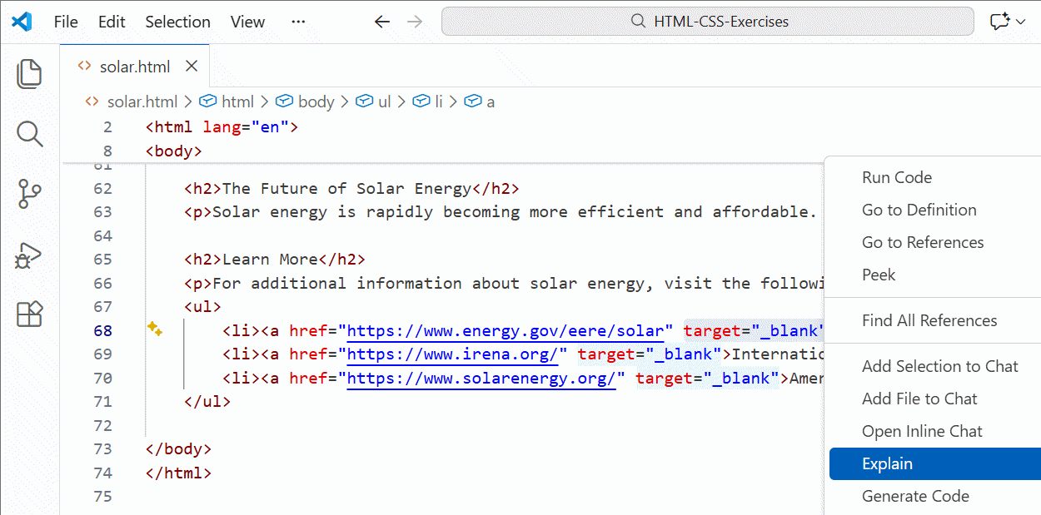
This will open GitHub Copilot and will explain the selected code fragment. In this example I selected this fragment:
target="_blank"
This is the code explanation in the Copilot chat window:
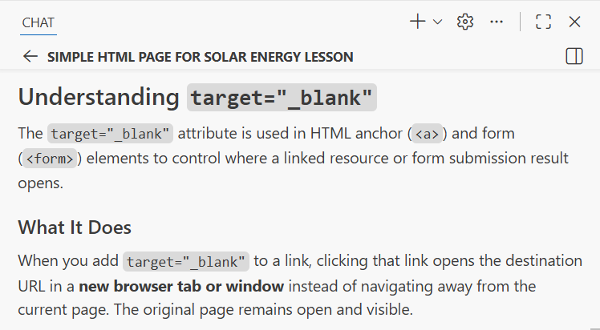

The HTML Page in the Browser
Let's open the HTML page in the Web browser to see the result:
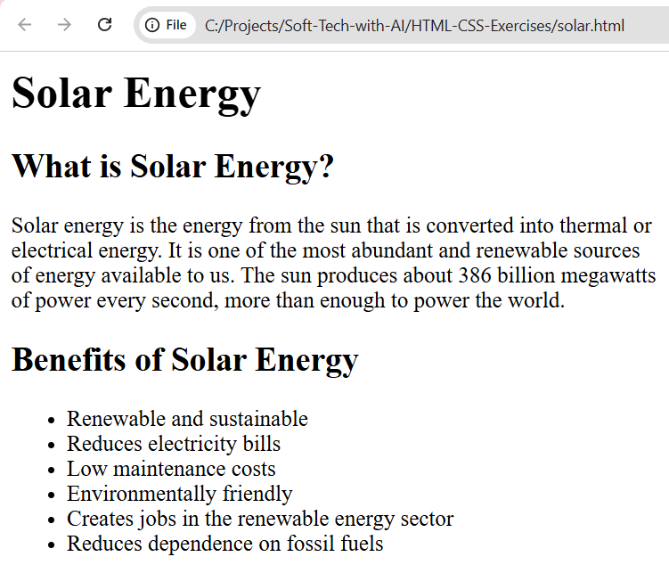

Contact List
Your task is to generate an HTML page holding a list of contacts. Contacts should hold name + email + phone. Use only HTML, without CSS. We shall work with CSS later in this exercise. We are now learning HTML.
You can use an AI prompt like this:
Create a minimalistic HTML page `contacts.html`, holding contacts (name + email + phone)
- Display a heading + list of contacts
- No CSS, single HTML file
This is a sample result from the above prompt:
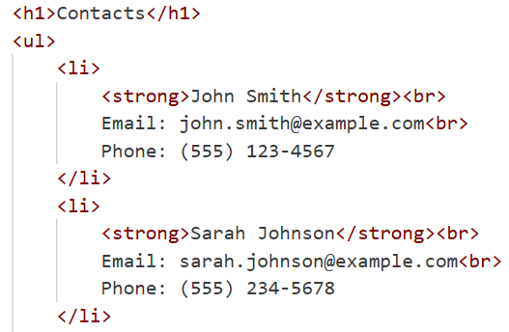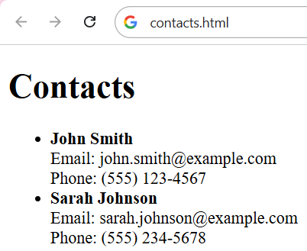

Hometown Website
Create a minimalistic website about your hometown:
- A multi-page site: index.html, history.html, places.html
- Top navigation menu: Home | History | Places to Visit
- Hyperlinks between the pages
- Images about the places
- No CSS, only HTML files
- Put all the code inside the folder `Hometown`

Creating a Sub-Folder
First, create a subfolder for your site, e.g. "Hometown". Otherwise, your working folder may contain files from different exercises mixed together, and this is confusing.

The AI Prompt
This is a sample AI prompt to generate a minimalistic multi-page website about the town of "Veliko Tarnovo":
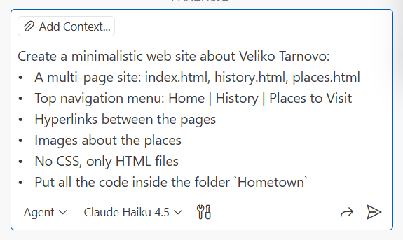

Inserting Images
Create a sub-folder "images" in your project folder.
Download images from Internet, save them to the `images` sub-folder of your website, then ask Copilot to insert these images in the HTML code.

The Website in the Browser
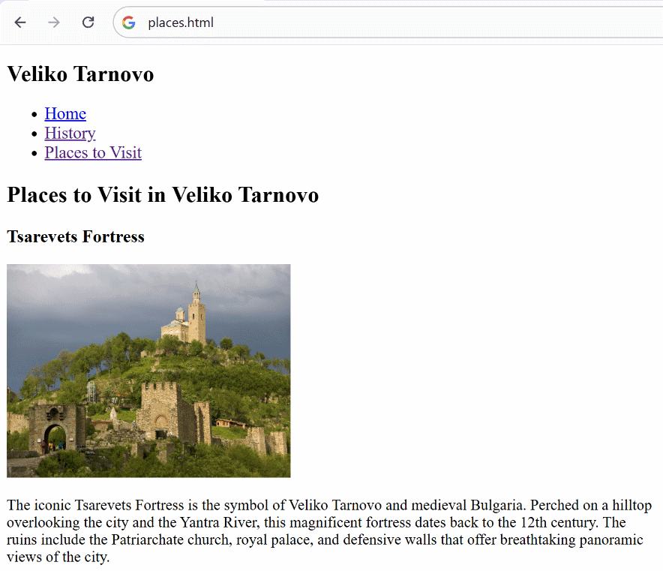
You may need to ask Copilot to format the pictures to use the same size, so they look consistent.
Until now we used only HTML. From this point on, we introduce basic CSS.

Deploy to Netlify
Publish your website on the Internet. Use a free account on the Netlify platform. Make a simple deployment by uploading the site files to Netlify, without using GitHub.
Open https://app.netlify.com, log in to your profile, go to [Projects] and select the "deploy manually" option:
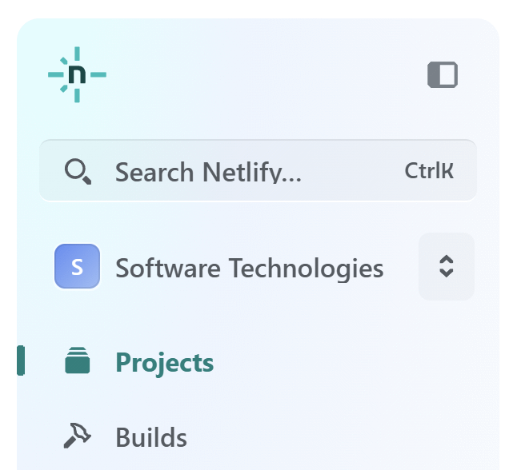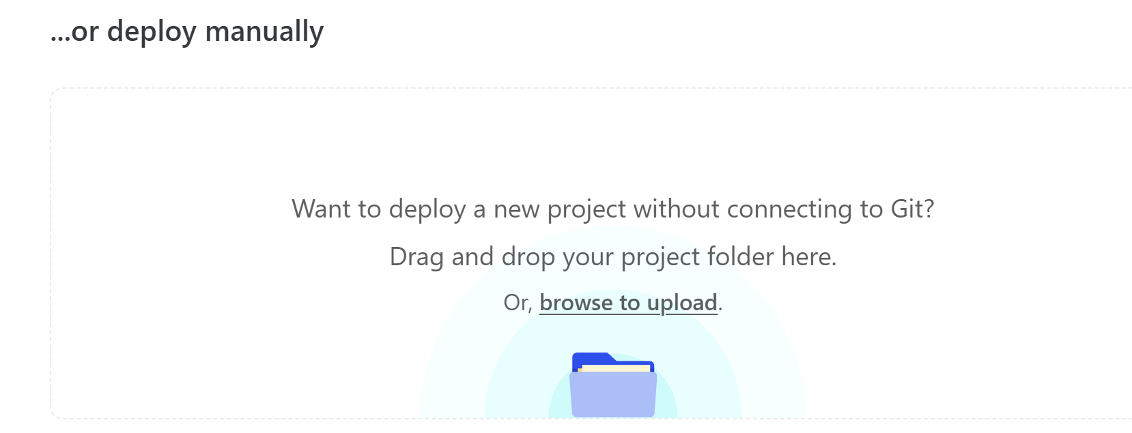
Select the folder, holding all your "Hometown Website" exercise files on your laptop, and click [Upload]:
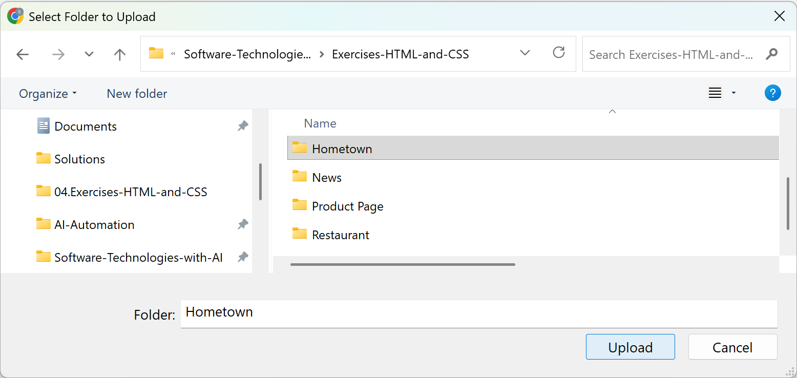
When the upload is ready, click on the [Quick Setup] button to change the project link and project name. By default they are randomly generated.
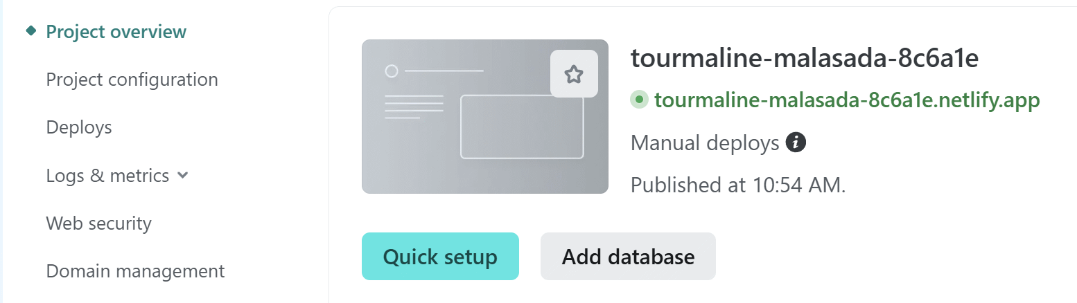
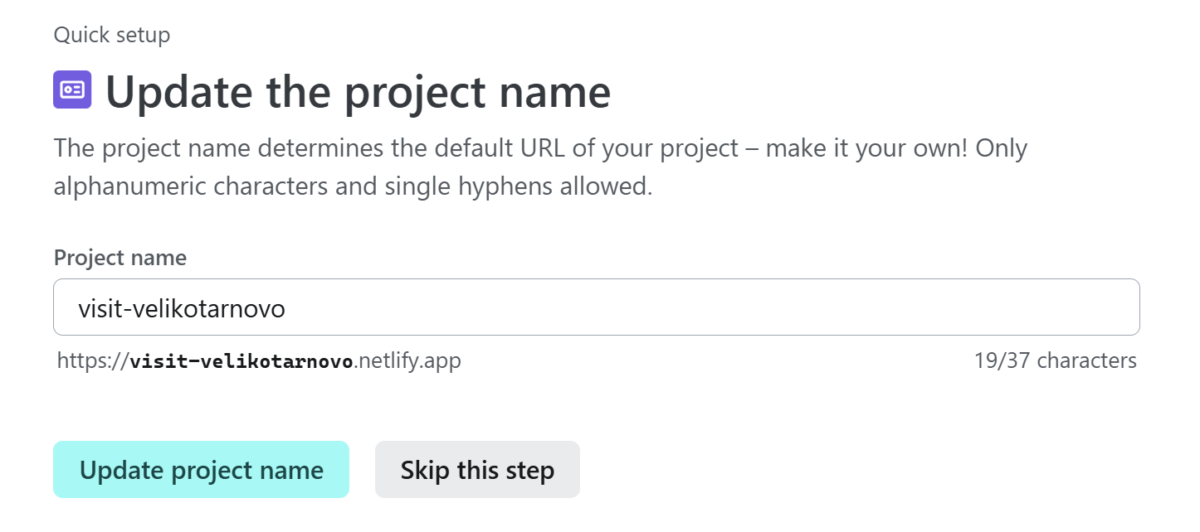
Click the right mouse button and copy the link in green:
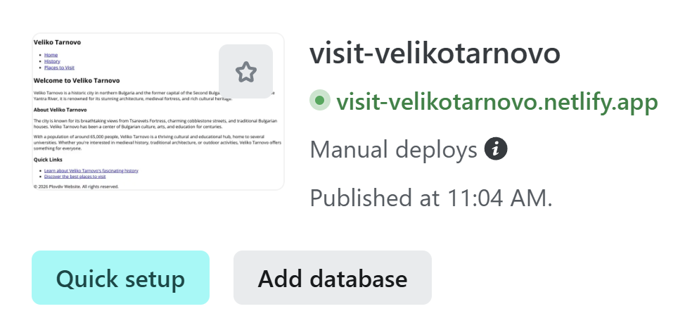
Share this link with your colleagues and curse instructors.

Styled News Website
Create a simple new website about the latest news in a certain area, e.g. soccer, movies, etc:
- Site structure: news.html, news1.html, news2.html, news3.html
- Use simple elements: headings, paragraphs, lists and links
- Use very simple CSS styling

Creating a Sub-Folder
Like you did in the last exercise, create a new sub-folder, for example "News", for better organization.

The AI Prompt
Use the following prompt for Copilot or create your own:
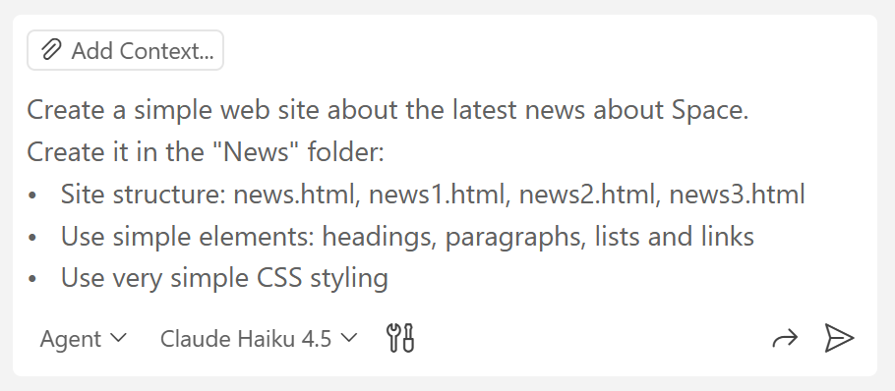

The Website in the Browser
This is a sample AI-generated new website:
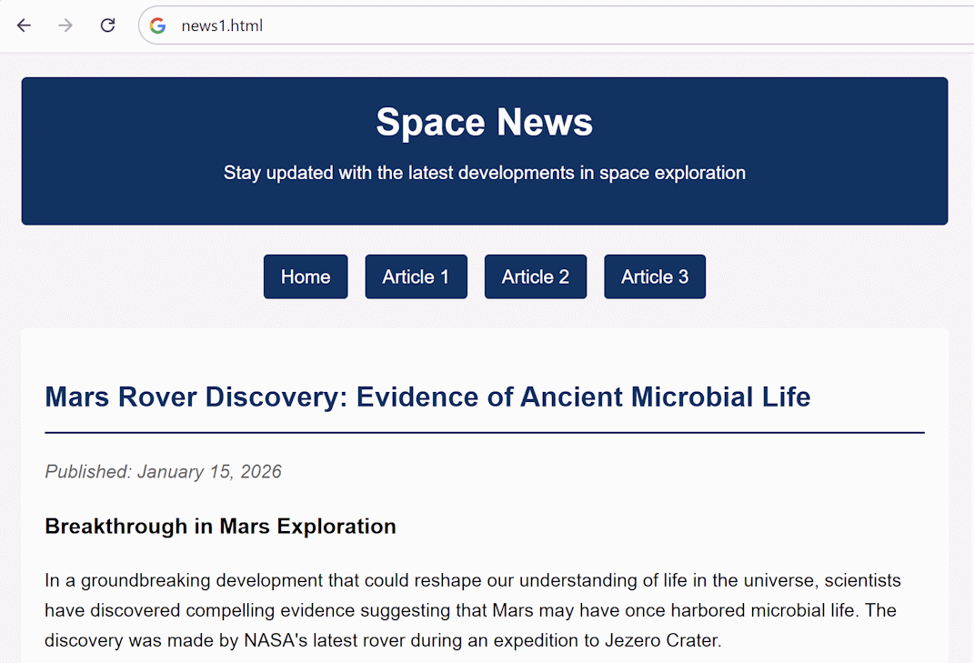
Congratulations! You used your first HTML with CSS style.
Look at the code in Visual Studio Code. Ask Copilot if there is something unknown or unclear for you in the code.

Browser Dev Tools
Use browser dev tools to inspect web pages and sites.
Open Browser Dev Tools, e.g. press [F12] in Chrome or [CTRL] + [Shift] + [I] in other cases or click the three dots in the upper right corner when you open your browser menus and find the functionality from there:
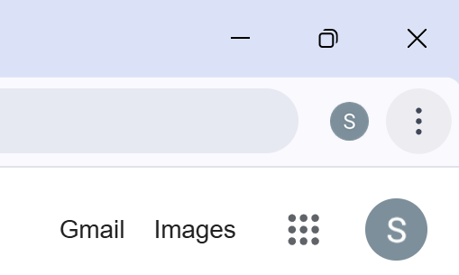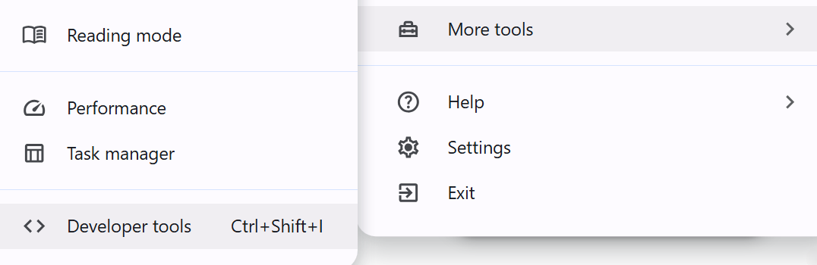
Inspect the elements and styles. Try to find examples of different tags:
- HTML elements <article>, <footer>, <header>, <section>, <link>, etc.
Research the purpose of some of the ones you don’t know.

Inspect the HTML Code
This is how the code in [Dev Tools] looks like. When you click the small arrows next to each element, you will be able to see more code:
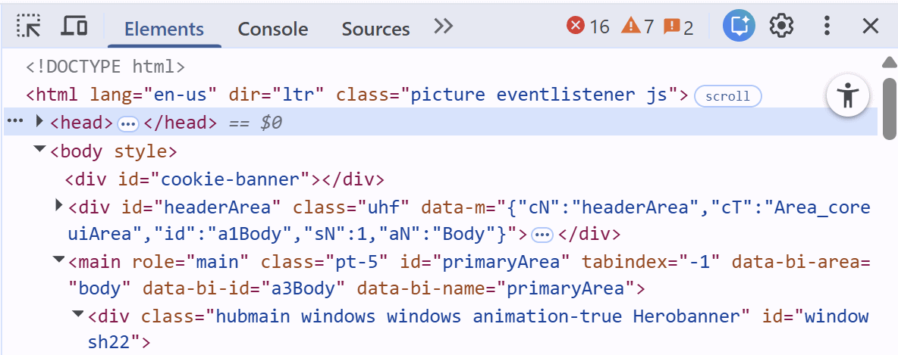

Inspect the CSS Code
This is how the CSS styles used on your Web page are visualized on [Dev Tools].
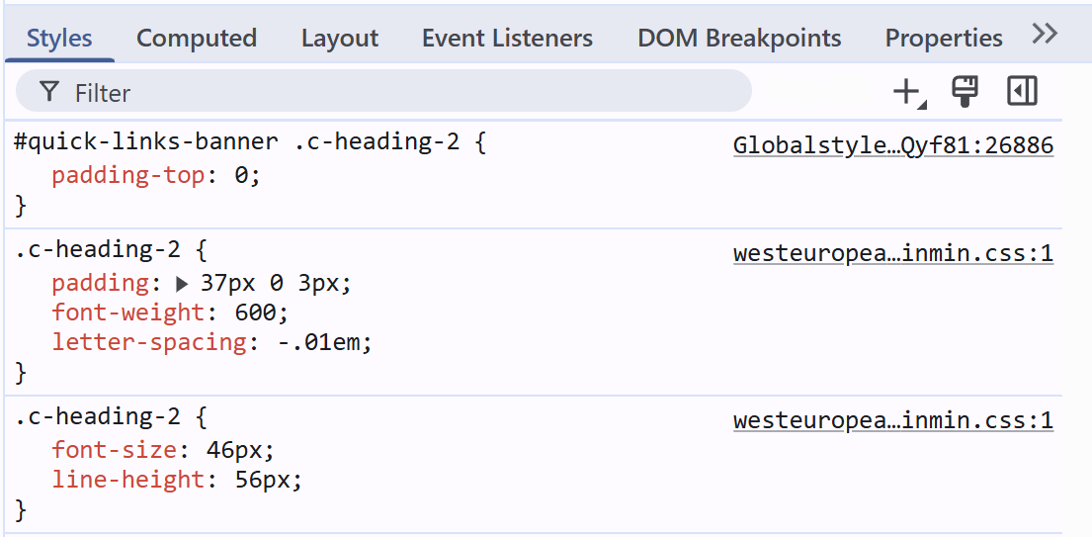
Experiment with CSS elements. Change / add / delete CSS properties: color, font-size, font-weight, height, width, image-rendering, etc.
This is how elements of the website look when you click on the in the code to inspect them:
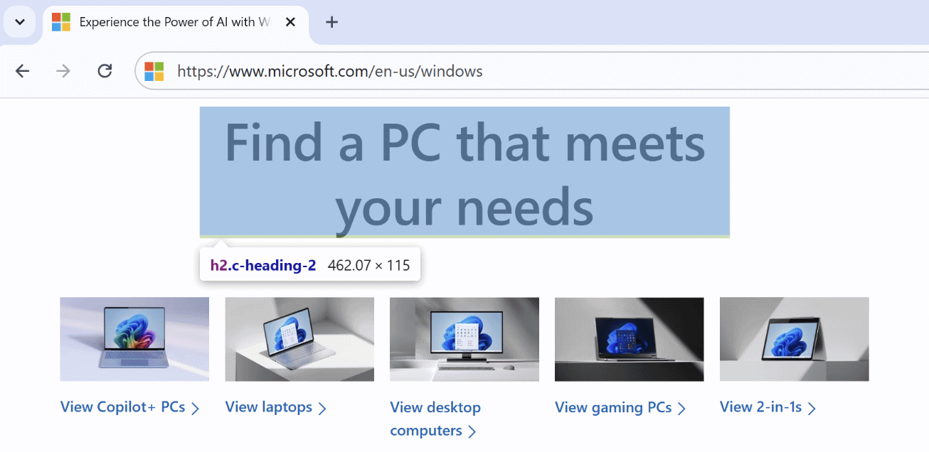
Alternatively, you can inspect elements on websites by right clicking on the mouse and selecting [Inspect].

Simple Company Site
In a separate folder, create a multi-page site about a company, e.g. hairdresser studio or local restaurant.
- Site structure: index.html, about.html, contacts.html
- Top navigation menu: Home | About | Contacts
- Footer: (c) 2005 - My Company
- Add very simple CSS styling: styles.css

The AI Prompt
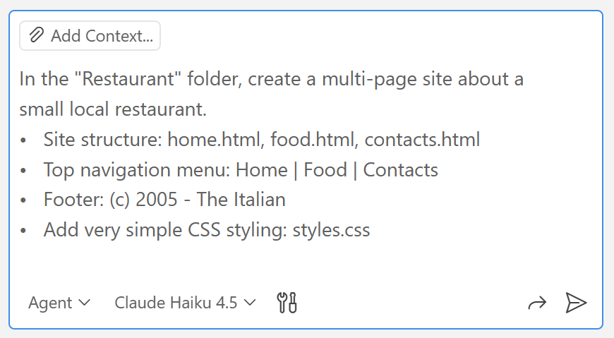

Inserting Images
Download images from Internet, save them to the `images` sub-folder of your website, then ask Copilot to insert these images in the HTML code.

The Website in the Browser
This is a sample of how your AI-generated website may look like:
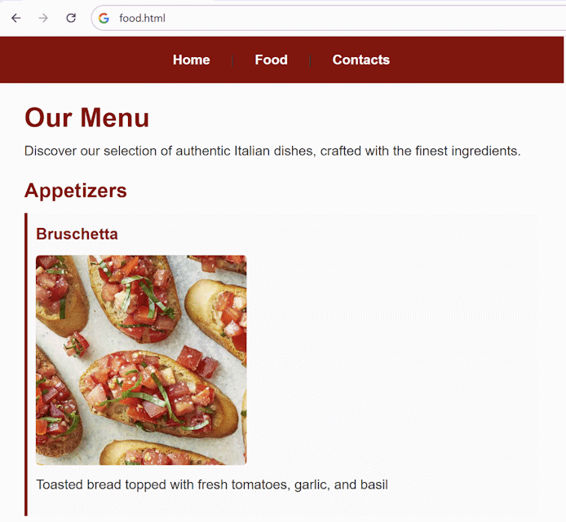

Company Home Page
In a new folder, create a simple company web page with HTML and CSS:
- Company web page, about a topic of your chоice, e.g. construction / healthcare / crafts / travel
- Page header with navigation menu: Home | Services | About | Contacts
- Main page: content, split to sections, with icons, headings and content
- Create a standard page footer

The Website in the Browser
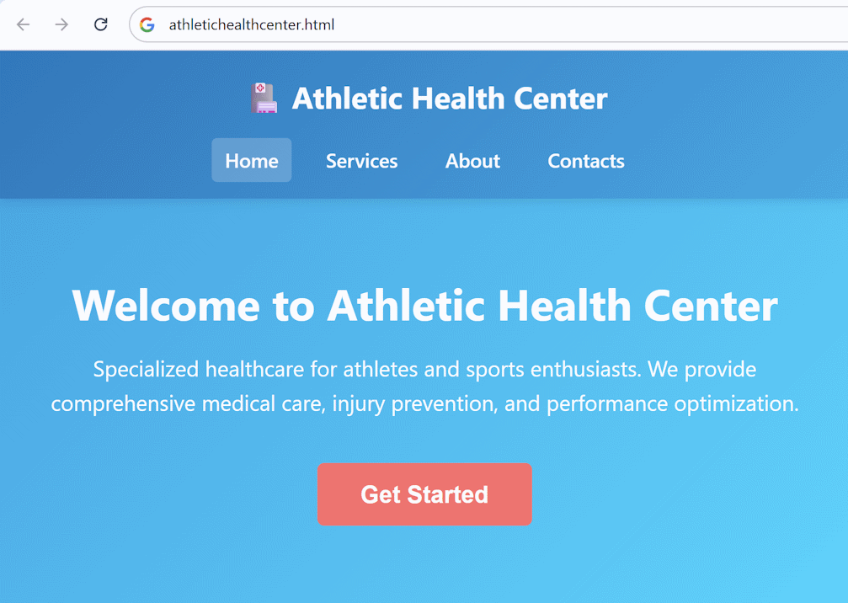

Responsive Layout
In a new folder, create a responsive CSS layout for a web page. Responsive web design is about making HTML and CSS to automatically resize, hide, shrink, or enlarge a website, to make it look good on all devices. Select a topic of your choice, e.g. a training course, a travel blog, a cooking recipe site, etc.:
- Site header (logo + title + navigation bar)
- Site main body: sections, holding articles
- Site sidebar: navigation bar with links
- Site footer: copyright text + navigation

The AI Prompt
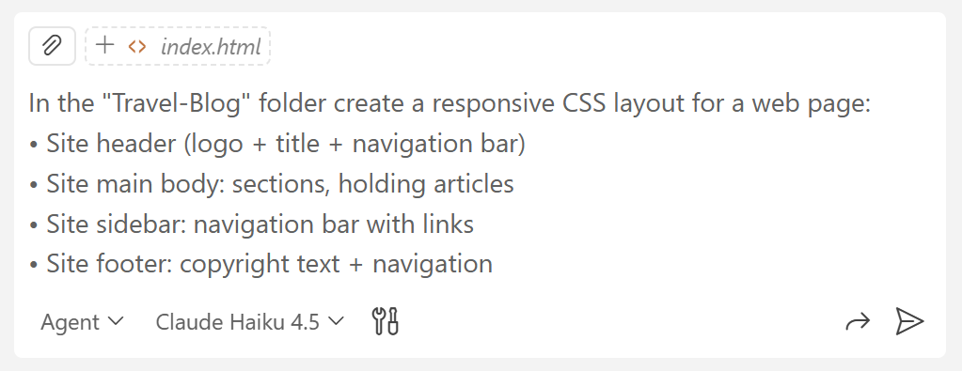

The Website in the Browser with Different Zoom Levels
You can zoom in or zoom out (make the images and text larger or smaller) by holding [Ctrl] and using the scroll wheel of the mouse.

Normal (100%) Zoom
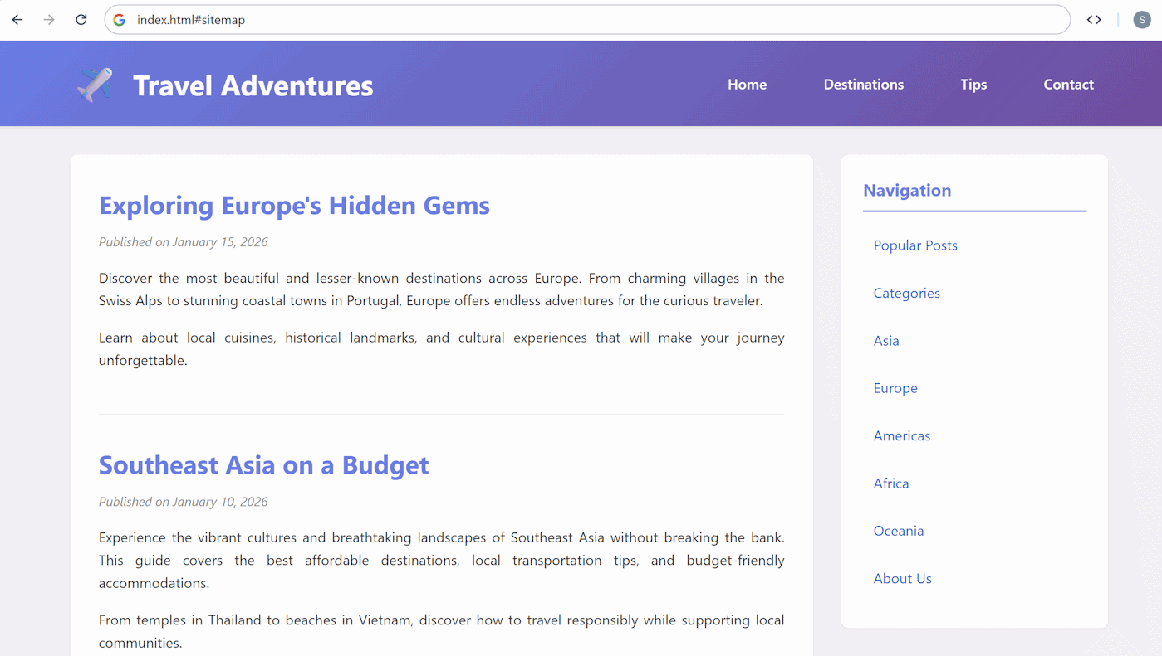

Zoomed In (150%)
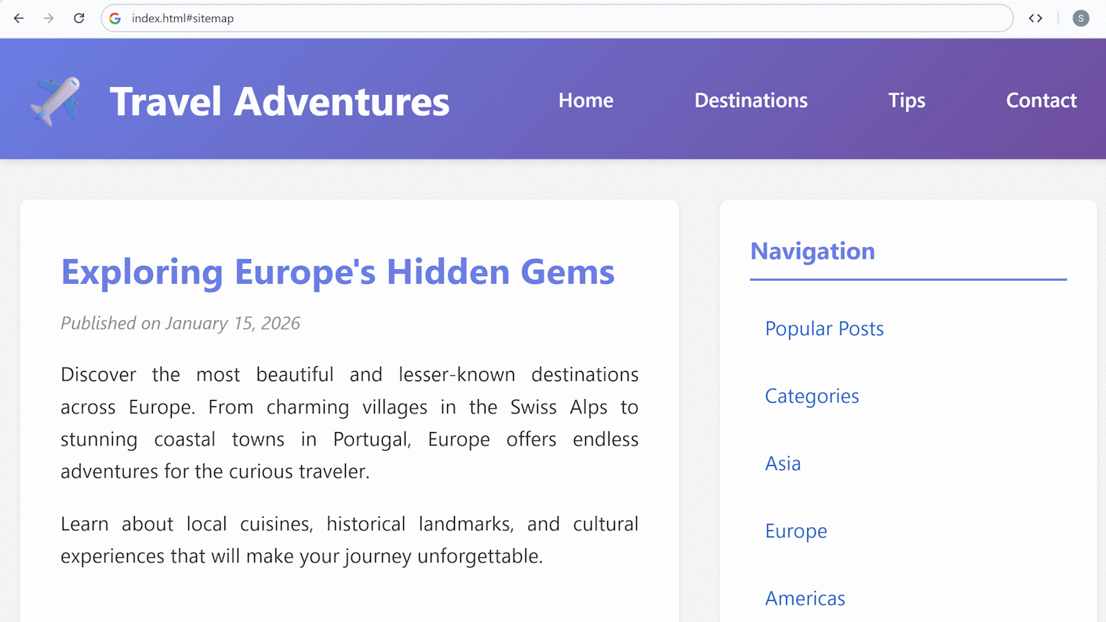

The Website on Mobile Devices
The most important test for a responsive website is whether it looks well on a phone. To test this, deploy the website on Netlify in the same way as in exercise 04. Hometown Website and open the link via a smartphone:

In case the website does not look well, write an additional prompt for Copilot to make it look well on mobile devices, redeploy and test again. Here is a sample prompt you can use:
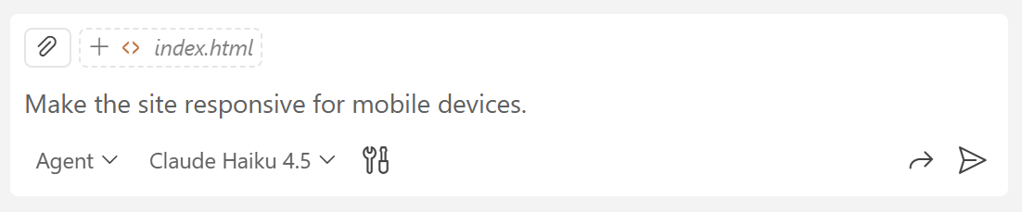

Product Comparison Table
In a new folder, create a product comparison table. Compare 2 or 3 products of your choice, e.g. two laptop models or two restaurants. Use HTML table with minimalistic CSS styling. Make the table with a responsive design.

The AI Prompt
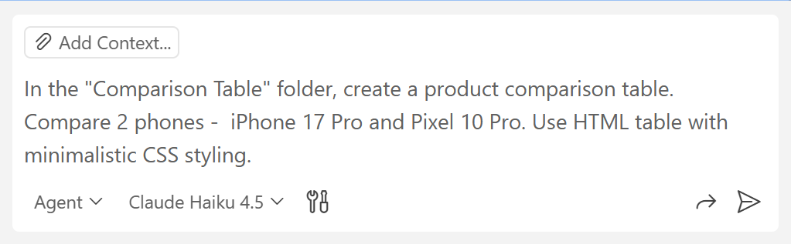

The Comparison Table in the Browser
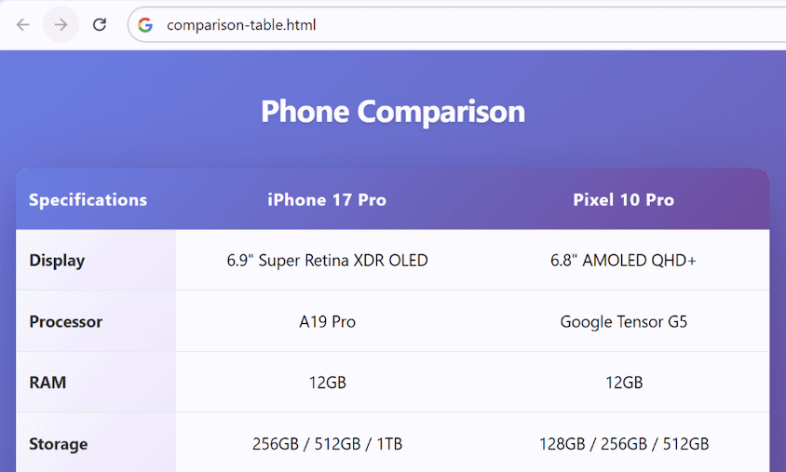

The Website on Mobile Devices
Test if the table opens in a suitable format on a mobile device like you did in the last exercise:
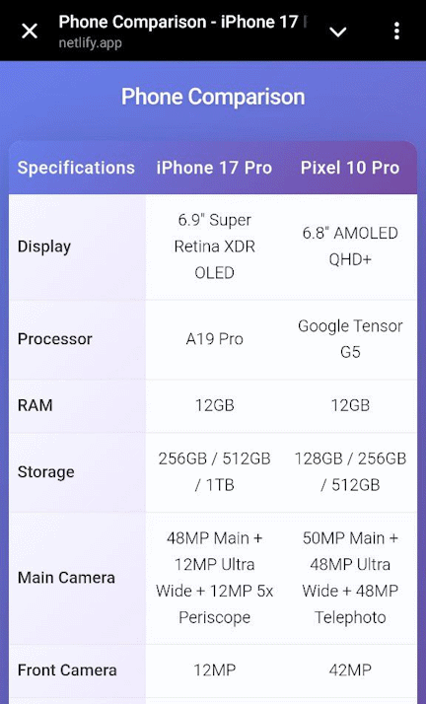

Flights Departure Board
In a new folder, create a departure table with flights for a certain airport. Use HTML table with minimalistic CSS styling. Create it with a responsive design.
Include in the tables the following columns:
- Flight No.
- Destination
- Departure
- Gate
- Status
The Website in the Browser:
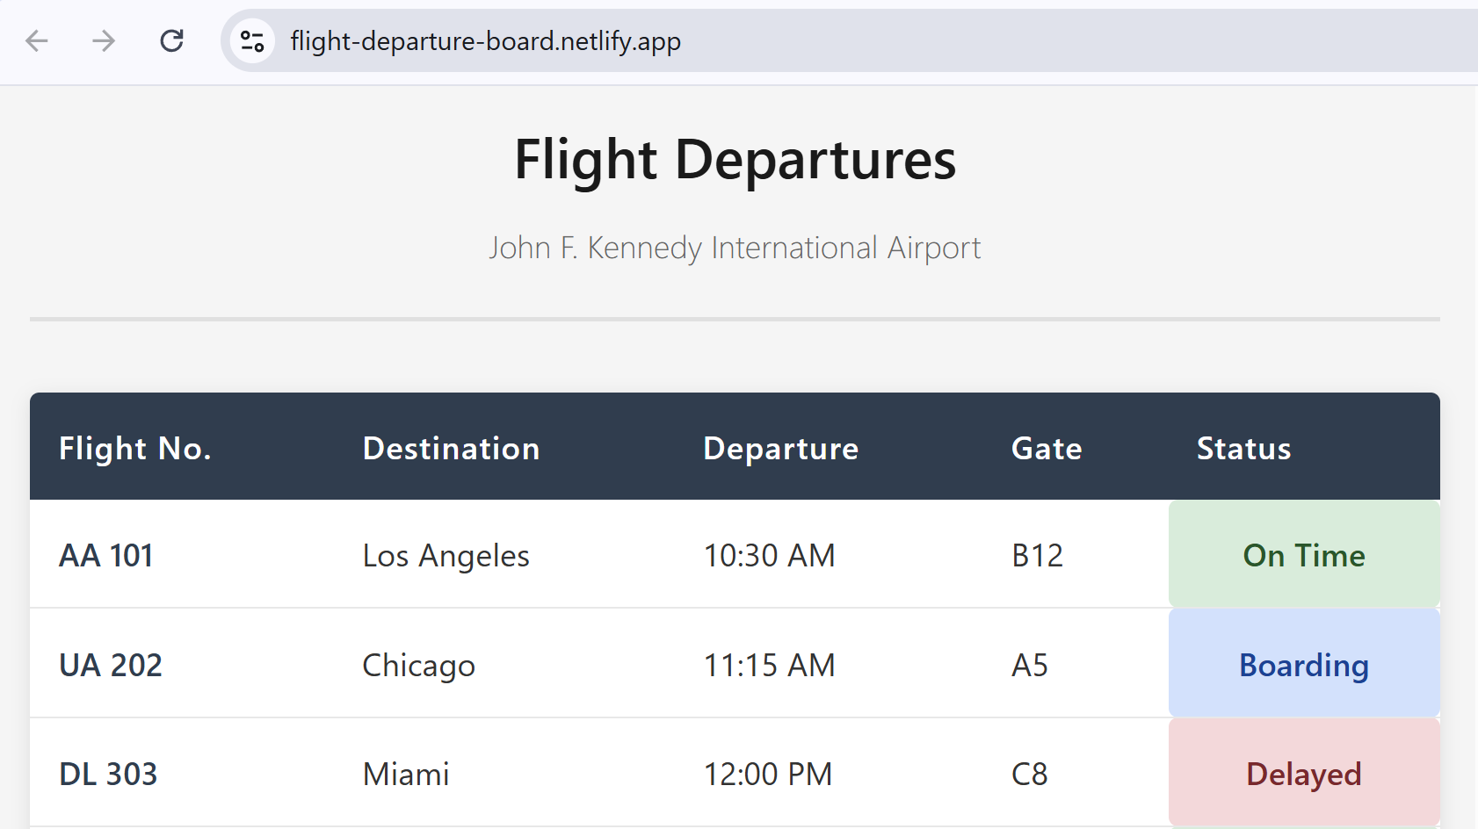

The Web Page on Mobile Devices
Make sure your Web page looks well on mobile devices with smaller screens:
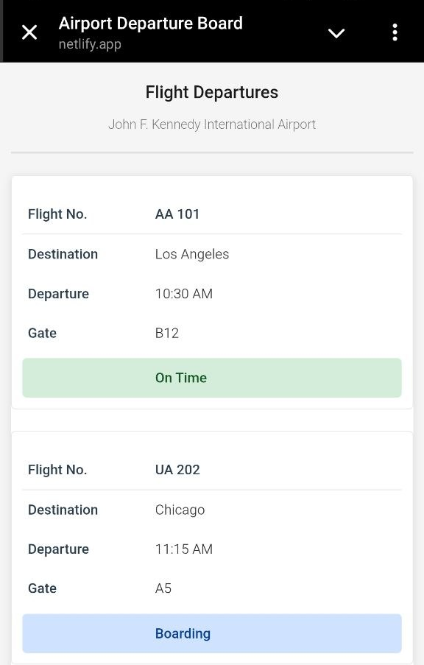

Event Registration Form
In a new folder, create a simple event registration form (example: HTML Annual Conference):
- Full Name & Email: standard text inputs
- Attendance: "In-person" or "Virtual" (radio button)
- Workshops: "HTML Basics", "CSS Layouts", "JS Intro" (checkboxes).
- Meal Preference: "Standard", "Vegetarian", "Vegan", "Gluten-Free" (drop-down).
- Submit Button: Styled with a hover effect.
- Use HTML with simple CSS styling

The AI Prompt
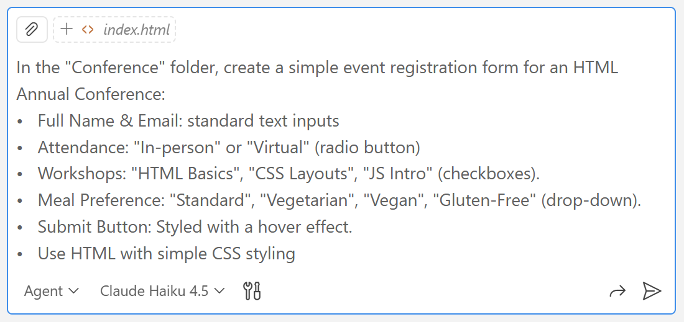

The Registration Form
These are the fields for name and registration. When you hover over the empty field there is an invitation message to fill it in:
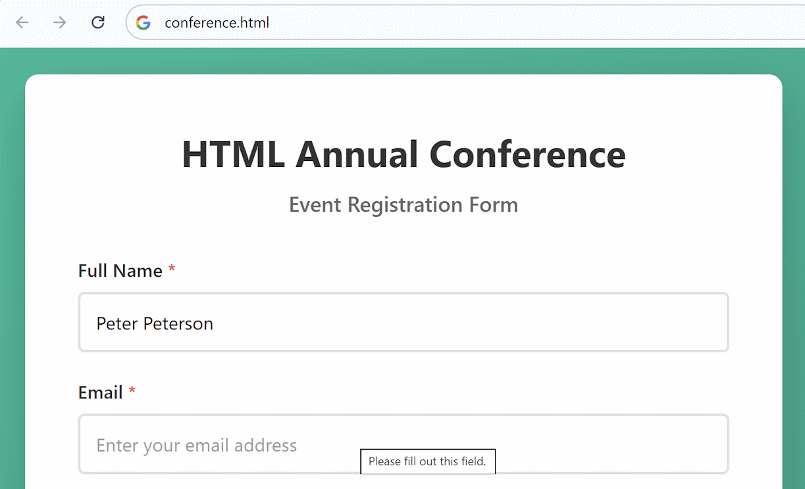
There is a drop-down menu and when you hover over the Registration button, it changes in some way, it moves slightly upwards and has a shadow. Your effects and details may vary. In this case, you cannot submit or click the button to do something, because it does not use any JavaScript.
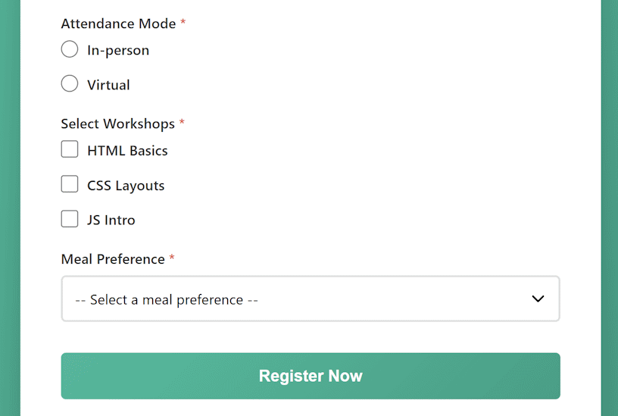

Hotel Feedback Form
In a new folder, create a simple hotel accommodation feedback form:
- Name
- Email
- Location (drop-down, optional)
- Date (optional)
- Interior (1-10)
- Cleanliness (1-10)
- Service (1-10)
- Facilities (1-10)
- Comments (free text)
- Use HTML with simple CSS styling (no JavaScript)

The Website in the Browser
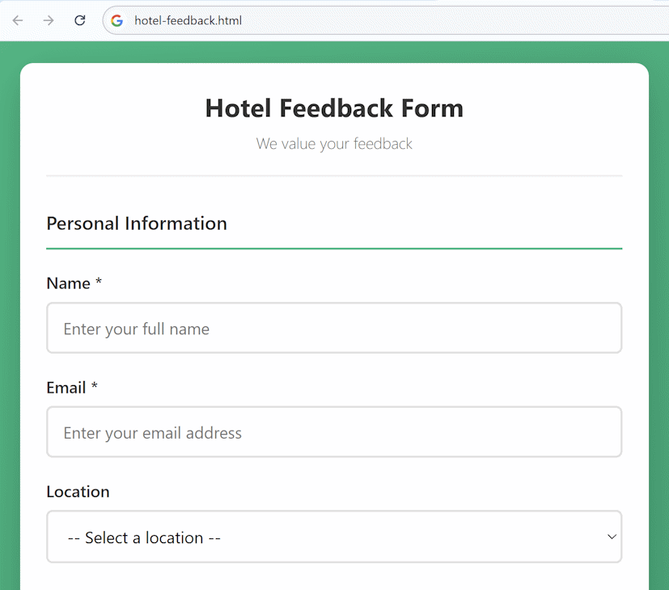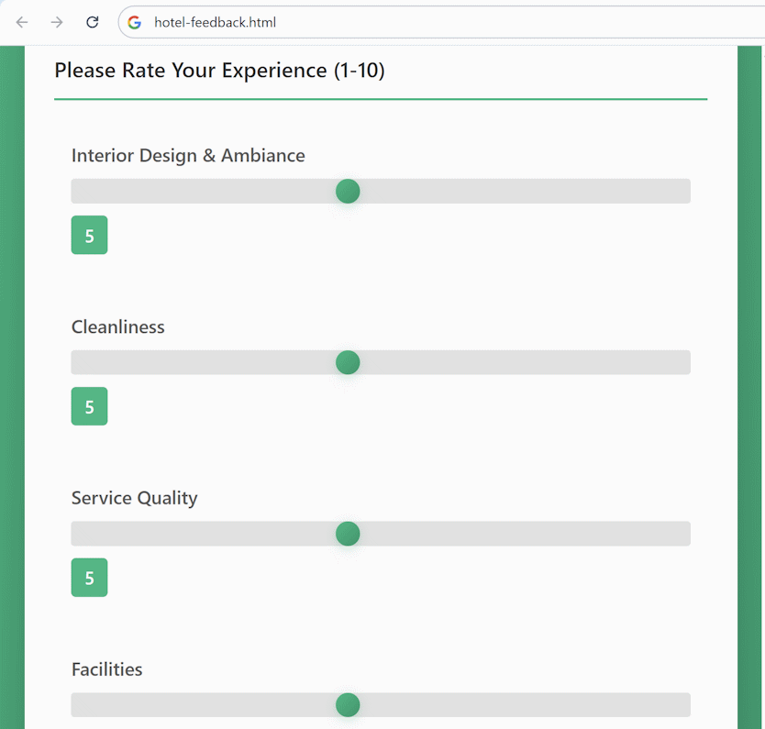

Character Counter
In a new folder, create a simple "Send Message" form with HTML and CSS. The message is text area, limited to 200 characters (excluding the spaces between the words). Implement "characters left" counter with simple JavaScript code. We add a small amount of JavaScript to make the page interactive (there is a response to a user’s input).

The Character Counter in the Browser
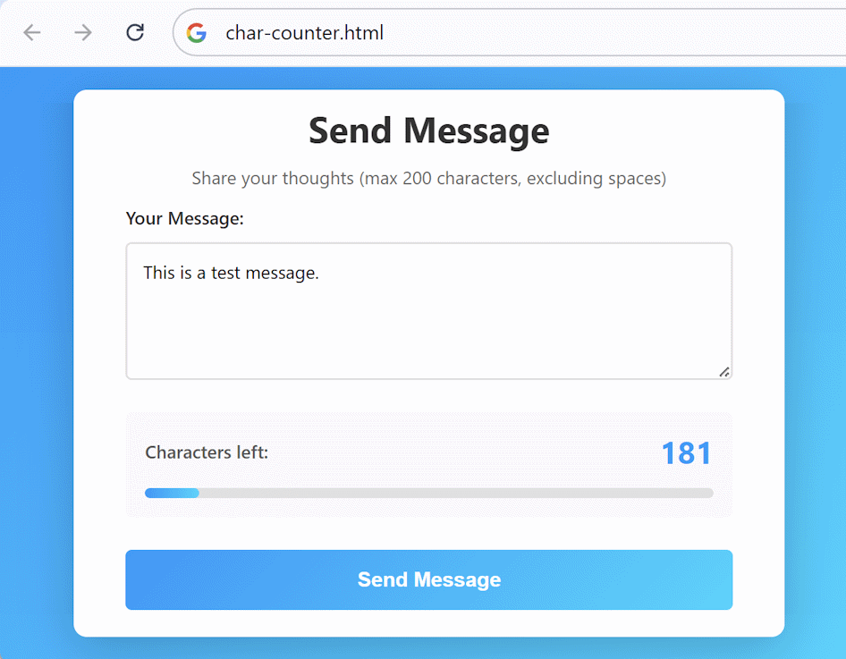

Body Mass Index Calculator
Build a body mass index calculator. Use HTML, CSS styling and JavaScript code to make it interactive. Keep it simple and minimalistic. Use a responsive design.

The Calculator in the Browser
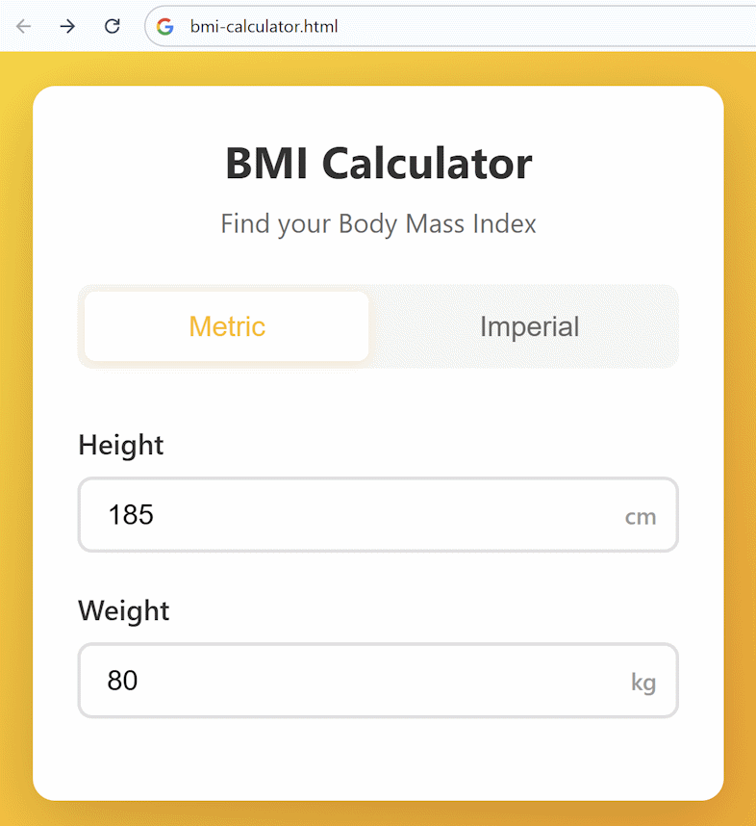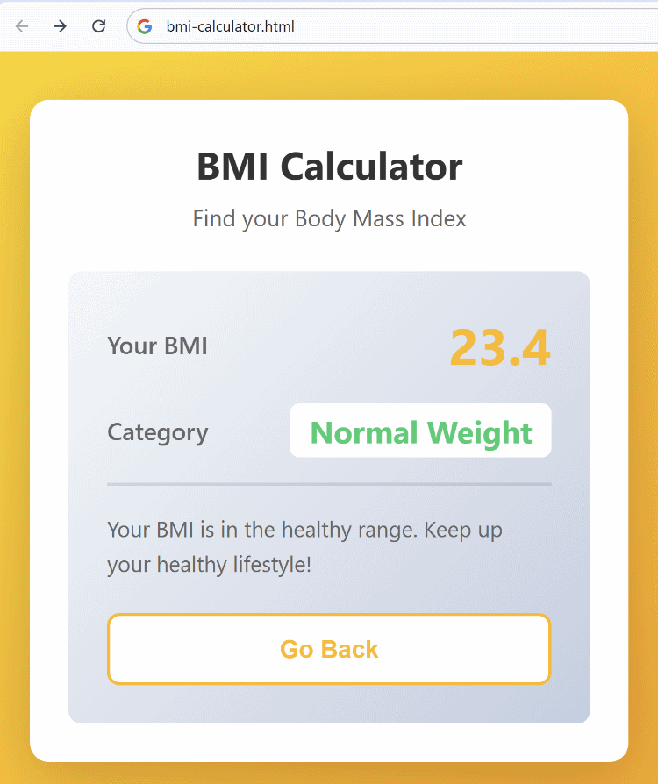

The App on Mobile Devices
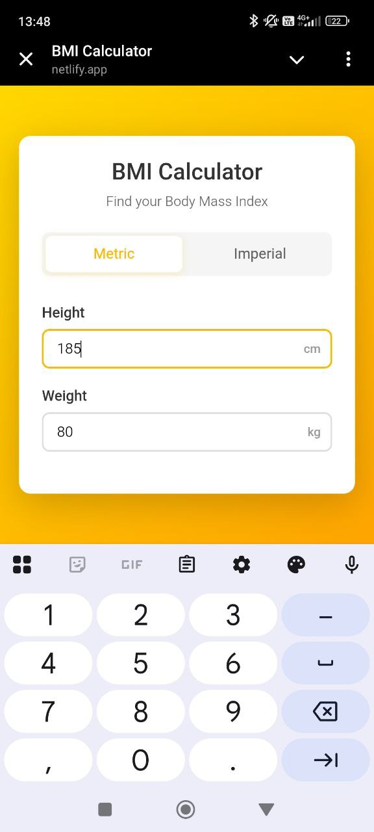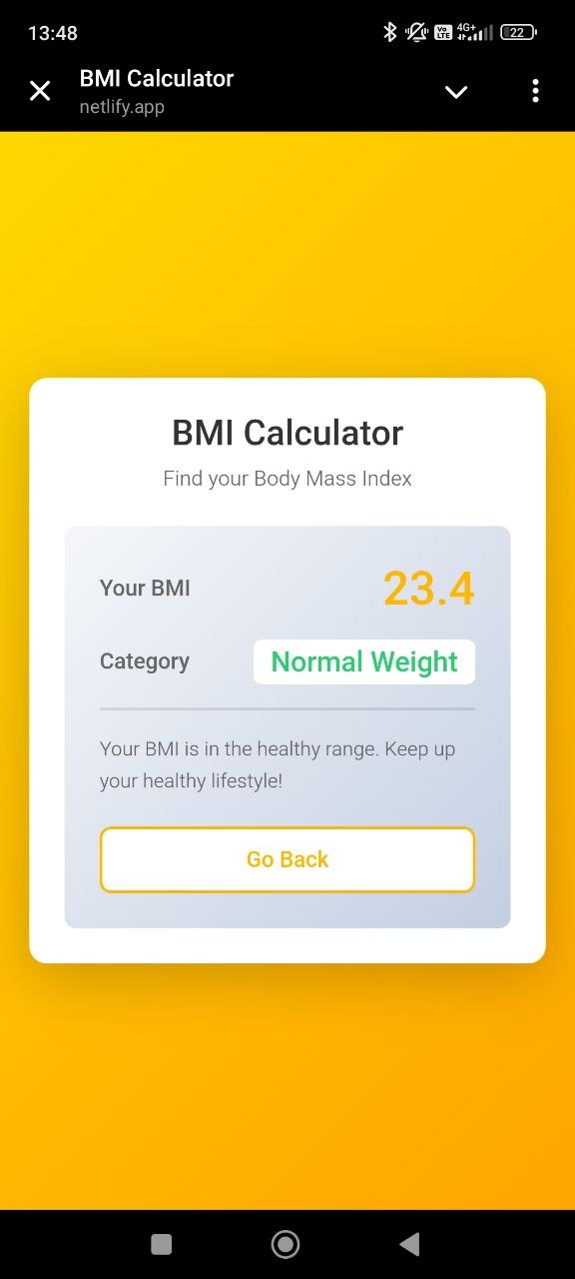

Product Page with Tabs
Implement a simple product page in HTML + CSS + JavaScript:
- Keep minimalistic
- Implement simple tabs with JavaScript
- Include a [Product Info] tab
- Include a [Specifications] tab
- Provide a [Reviews] tab

The Website in the Browser
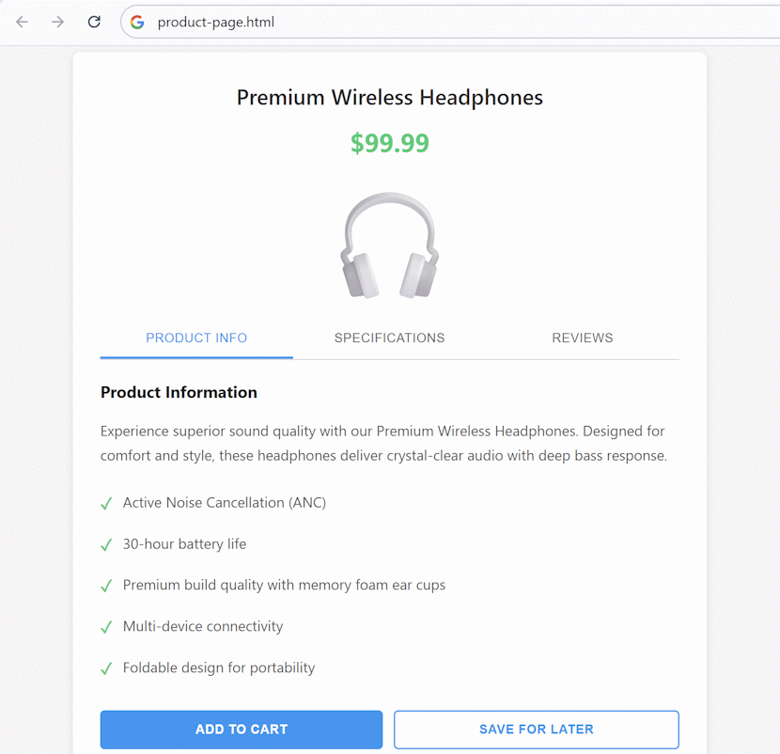

The Website on Mobile Devices
Make sure your page shows correctly on mobile devices:
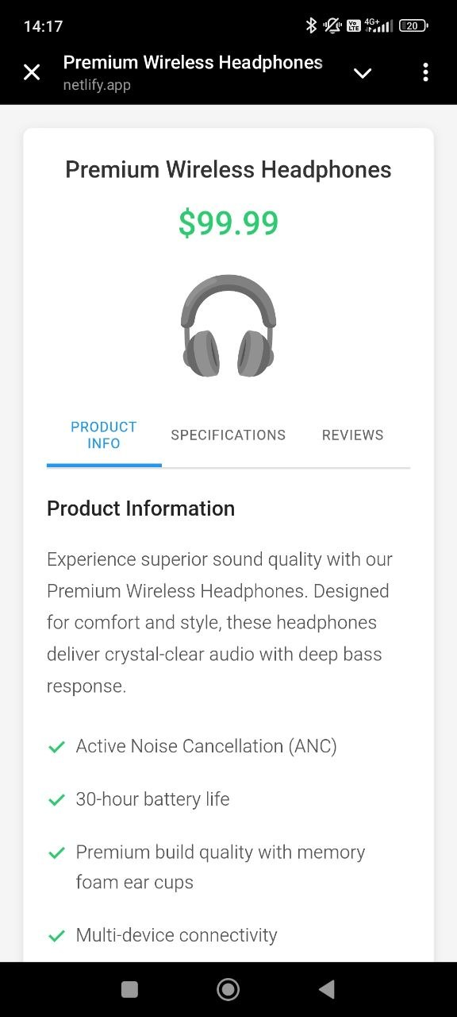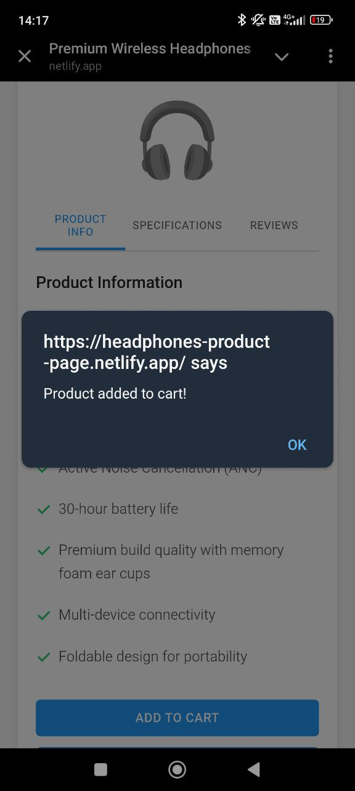

My Daily Planner *
In a new folder, create a responsive Planner web application using HTML, CSS and JavaScript.
This application does not use a database or backend.
All data is stored locally in the browser’s local storage (a built-in browser feature that allows data to persist after page refresh).
- Include a form to collect the following information:
- Task name (input)
- Priority (Low / Medium / High – select from a drop-down menu)
- Category (Work / Study / Personal – label that can be put optionally on different tasks)
- Sections "Today", "This week", "This month"
- Your planner must support the following actions:
- Add task
- Edit task
- Delete task (with confirmation)
- Mark task as done / undone
- You can use modal popups for (modal popup is a small window that appears on top of the current page and requires the user to interact with it before continuing):
- adding a task
- editing a task
- confirming task deletion
- Footer with copyright information
- Make it possible to mark done and undone tasks
- Show a statistic bar with percentage what part of today’s tasks have been completed

The Website in the Browser
This is sample implementation:
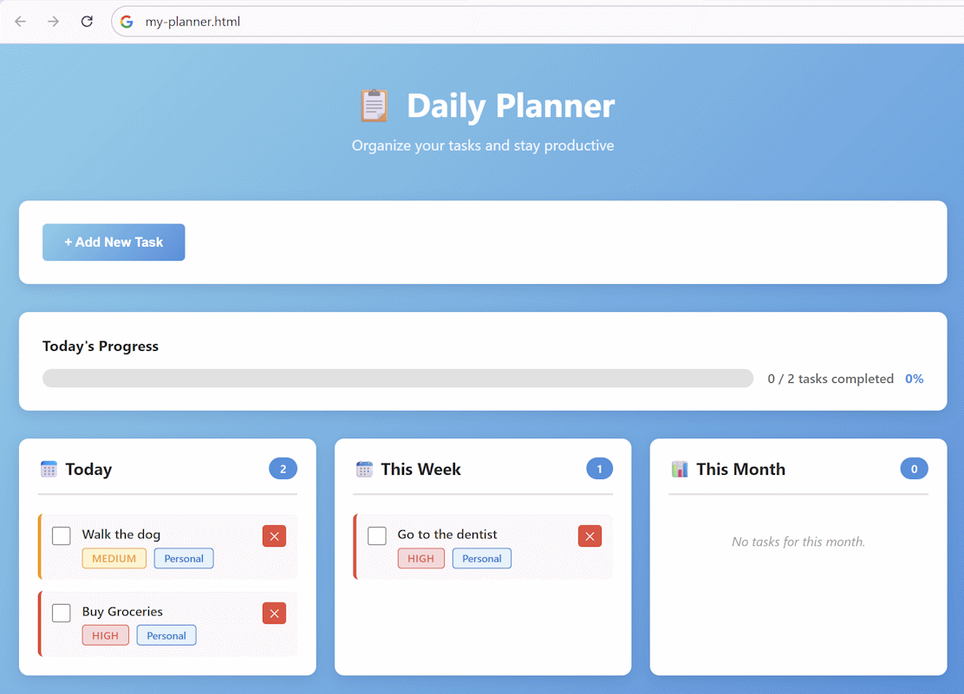

Creating New Tasks
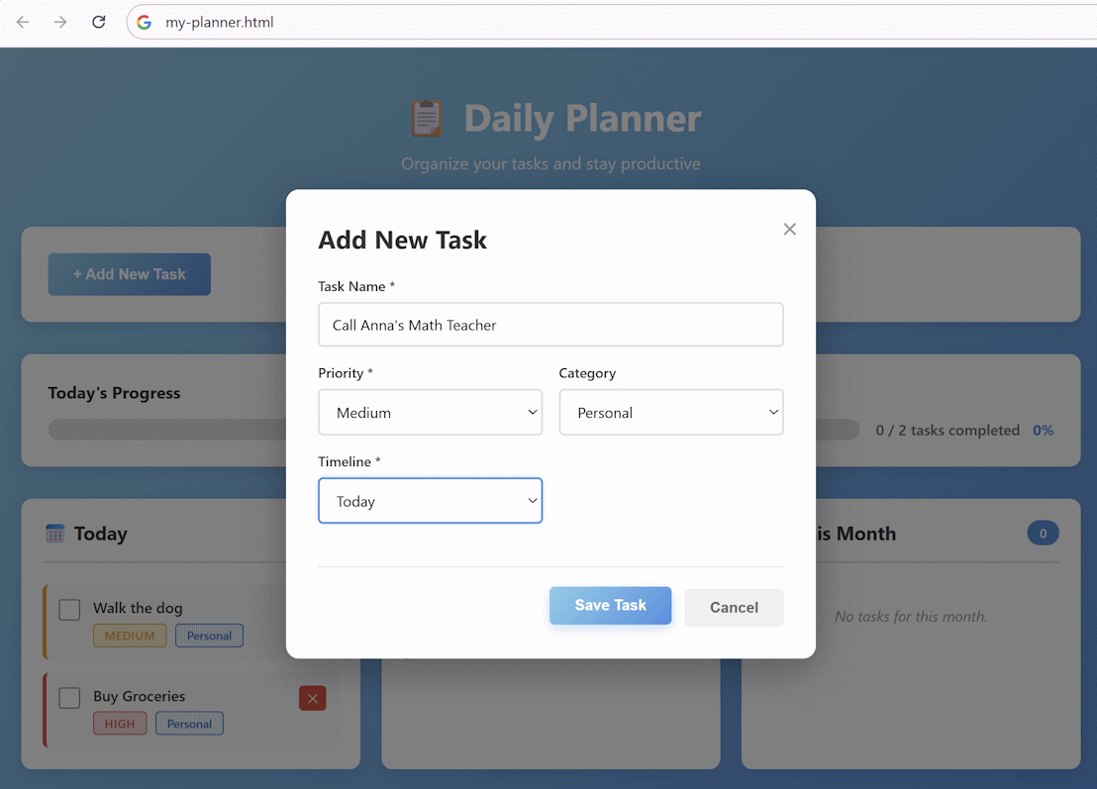

Deleting Tasks
