Files compile to exe or dll

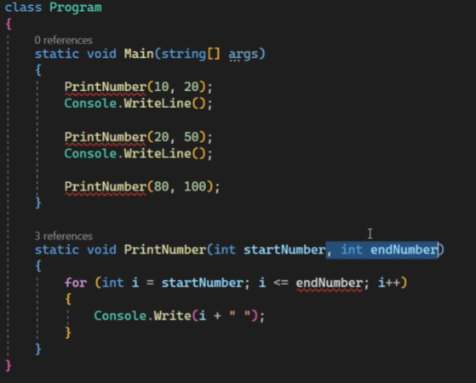

After the method name comeparameters. See the usage above

Check extract local function

1. Invoking a method – calling the method by itself but you need to set a condition under which the calling stops
2. You can set default values. If not all of the parameters have default values, place the one with default value at the end 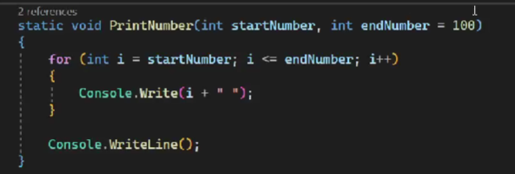
3. Value vs reference type