Assignment #6 – Device Driver

Description:
Develop a device driver that can be loaded and run in Linux. Then add some functionality to the device driver such as the user/application passing in a string to the device driver and the device driver returns an encrypted version of the string or passes in the encrypted string and returns the original string. Include a document on how to build, load and interact with the device driver (after the description in the write up template) along with screen shots of output.

Approach:
Initially I didn’t quite understand how to do the assignment, so I ran the assignment description through a google search and it helped explain the steps in layman’s terms. I then made a brief outline indicating each step and which would be best completed in what order, (i.e., start with the kernel and then the user app).

I decided to go with the concept of an encryption driver, both since it lines up conveniently with the necessary requirements, but also because I have always wanted to try creating an encryptor for myself and now I get an opportunity. Further I was looking up cipher concepts and decided to go with a simple Caesar cipher to lessen the complications and workload (being the end of the semester).

I then had to look up all the system library included functions to utilize in my function calls. This also helped to cut down on time possibly wasted on functions that already exist in Linux like global variable values and other system functions. Looking up these existing functions really helped streamline writing my part of the code because I then just had to type in those function calls with my variables and wrapper functions to get something that works.

After all of that, I then looked at expanding from the minimal hard-coded version to a version that could actually work properly with user input. I had to do a few trial and error tests but eventually I came up with creating two for-loops that each handle uppercase and lowercase letters in the message part of the user input. Ultimately that is where I decided to leave it, but I plan to revisit this in the future.

Issues and Resolutions:
My first issue was not being familiar with existing system variables and functions. This caused some redundancy issues and lack of clarity in terms of what each function can and can’t do, or what I needed to implement myself. But this was quickly remedied by researching them online.

Next issue was I kept getting buffer overflow issues due to the way I had written the code. After a quick google search I found a case where someone had had that same issue and a quick fix was in the “device_write( )” function, to simply make sure the length didn’t go out of bounds compared to the BUFFER_SIZE variable like this:
if (len > BUFFER_SIZE - 1)
{
len = BUFFER_SIZE - 1;
}
This ensures that the “len” or length variable will never go over the buffer size, and if it does, to then edit so it fits within the bounds.

The next major issue was that my code could only encrypt lower-case characters from a-z. It also means that it doesn’t take in numerical values, but I’ll save that for a later expansion. The simple fix I figured out was to just implement the same encryption loop twice, once for lower-case, and second for upper. Another important note is that this current version of the cipher simply ignores symbols and numbers. So, this will also need to be addressed at a later time for improvement.

Next, I had temporarily hard-coded the text to be encrypted for ease of use, but now I need my driver to encrypt user input and possibly even files(?). This is evident in the line that reads: “strcpy(w_buff, "hello");” in the test_app.c source file. This was quickly remedied by making the main function take in arguments from the command line and then swap those into workable variables. After that it was more straightforward.

Analysis:
This project is about creating a Caeser cipher device driver that can encrypt and decrypt strings passed from the user-space command line application. The driver supports:
- Open( )
- Read( )
- Write( )
- Release( )
- ioctl commands

The user application communicates with the device driver through the “/dev/endev” device file, while the ioctl commands are used to configure the encryption mode and cipher key values.

The device is registered as a character device and Linux assigns the major number(or unique identifying number). This is all handled by the system function call of “register_chrdev( )”. Also since the user space cannot directly access the kernel, functions like “copy_from_user( )” and “copy_to_user( )” are used to act as a middleman, handling data transfers safely.

Functions and their purposes:
- open( ): called when application opens the device
- write( ): receives user string and copies data from user space into the kernal buffer using the function “copy_from_user( )” in the Linux library.
- read( ): uses the function “copy_to_user( )” in the linux library to return encrypted/decrypted string to user space.
- ioctl( ): used to configure commands that don’t fit read/write, configures driver behavior through the encryption mode and key setting.
- release( ): used to close the device.

Caeser cipher logic:
This encryption mode shifts the characters forward by a specified amount, in this case using 26 and %26 to generate values based on the English alphabet. Decryption simply shifts those characters back the same amount.

User Application Use:
This application uses the command line format: “bash$: ./encrypt_driver <encrypt/decrypt> <key (ie, 1,2,3)> <user_message> “. The first argument is the file pathname followed by either “encrypt” or “decrypt” to specify what mode to use. Next is the cipher key which is a number between 1 and 26 to tell the program how many to shift by. And finally, the last argument is a user-defined string enclosed in quotation marks.
Example: ./test_application encrypt 3 “Hello”
Output: Khoor

Kernel:
For this project I had to do more than simply “make run”. I had to also insert the module (sudo insmod encrypt_driver.ko) into the kernel for execution, get the major number (ID) (cat /proc/devices | grep endev) and then use that information to then build the device file and test application,
(sudo mknod /dev/endev c 240 0
sudo chmod 666 /dev/endev) .

From there, I could then use the above mentioned command line format to do test runs as shown in the screenshots below. And finally, utilize the remove command (sudo rmmod encrypt_driver) to then remove said module after use.

Screen shot of compilation:
Test:
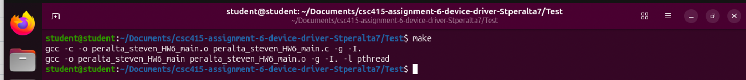
Module:
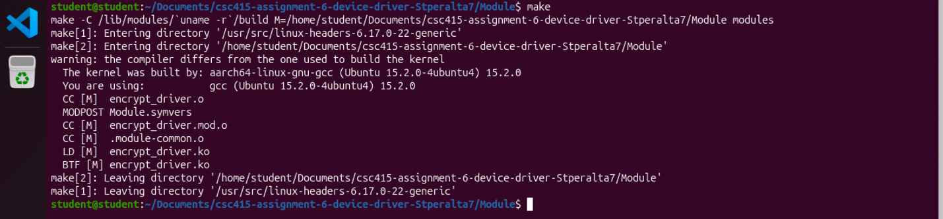
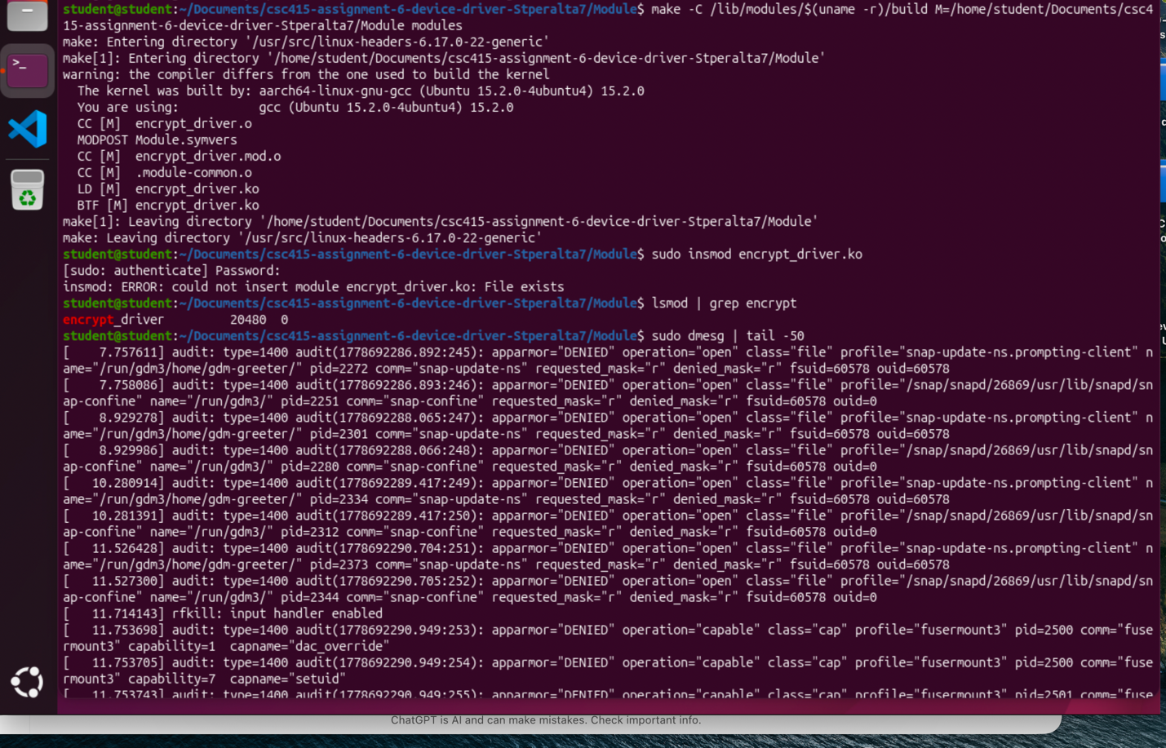
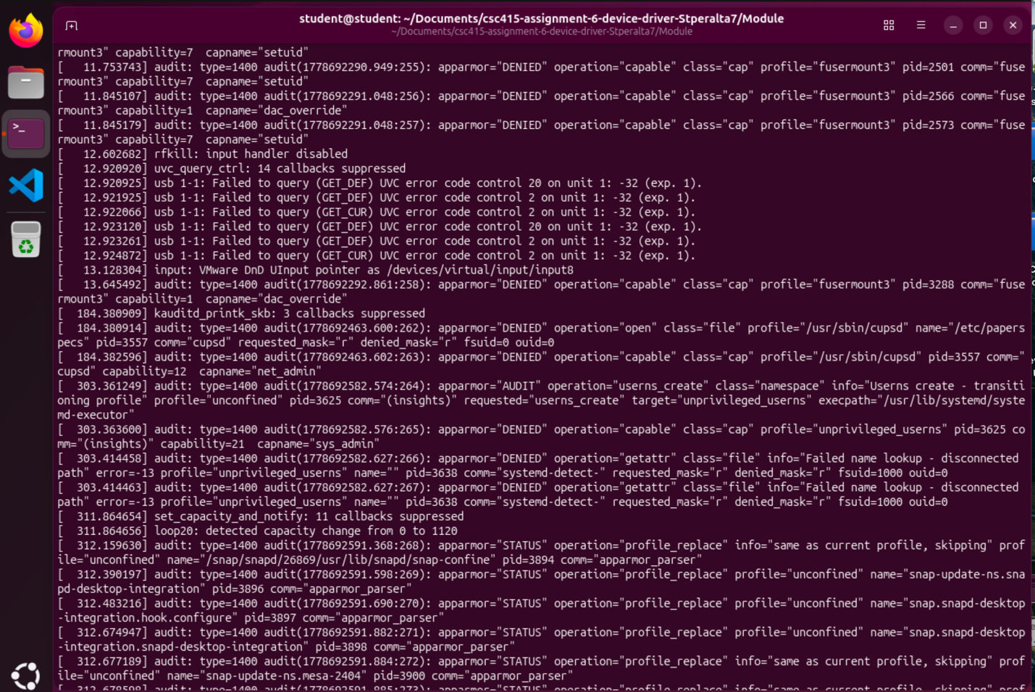
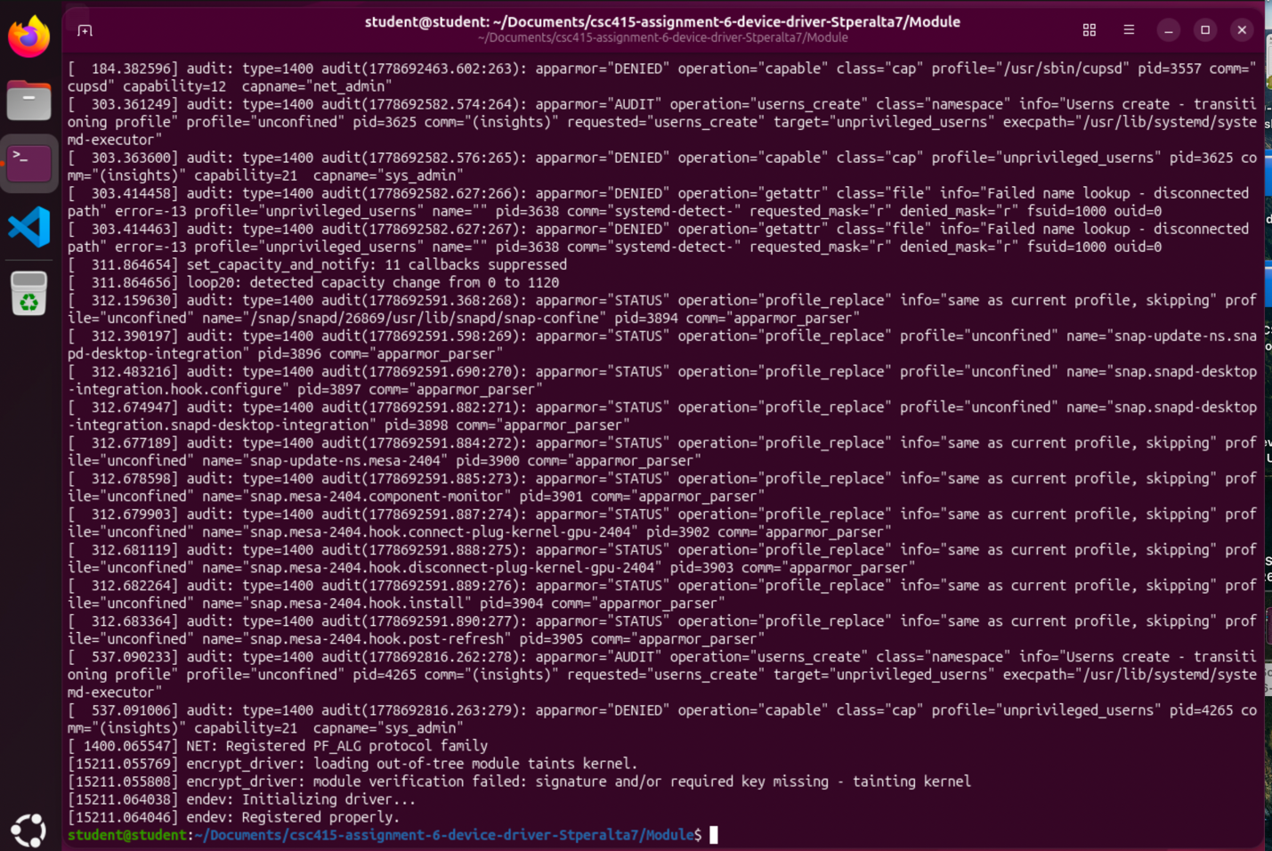

Screen shot(s) of the execution of the program:

