РИС-25-2Б Стариков Глеб

8 ферзей

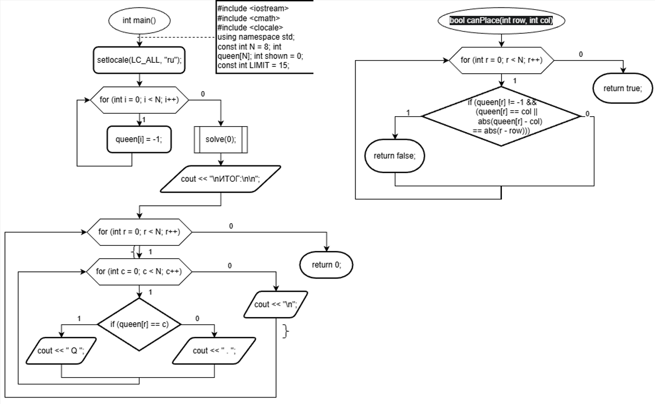

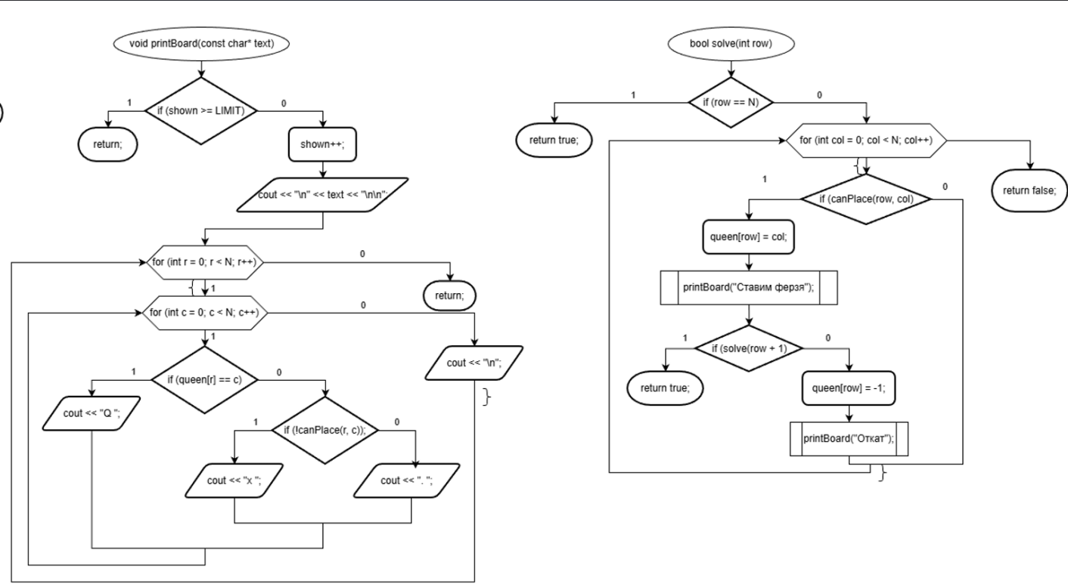

#include <iostream>
#include <cmath>
#include <clocale>
using namespace std;

const int N = 8;

int queen[N];
int shown = 0;
const int LIMIT = 15;

bool canPlace(int row, int col) {
for (int r = 0; r < N; r++) {
if (queen[r] != -1 &&
(queen[r] == col ||
abs(queen[r] - col) == abs(r - row))) {
return false;
}
}
return true;
}

void printBoard(const char* text) {
if (shown >= LIMIT) return;
shown++;

cout << "\n" << text << "\n\n";

for (int r = 0; r < N; r++) {
for (int c = 0; c < N; c++) {
if (queen[r] == c)
cout << "Q ";
else if (!canPlace(r, c))
cout << "x ";
else
cout << ". ";
}
cout << "\n";
}
}

bool solve(int row) {
if (row == N) return true;

for (int col = 0; col < N; col++) {
if (canPlace(row, col)) {
queen[row] = col;
printBoard("Ставим ферзя");

if (solve(row + 1)) return true;

queen[row] = -1;
printBoard("Откат");
}
}
return false;
}

int main() {
setlocale(LC_ALL, "ru");

for (int i = 0; i < N; i++) {
queen[i] = -1;
}

solve(0);

cout << "\nИТОГ:\n\n";

for (int r = 0; r < N; r++) {
for (int c = 0; c < N; c++) {
if (queen[r] == c)
cout << " Q ";
else
cout << " . ";
}
cout << "\n";
}
}

