Computer Science Practical File (Class XIID) By Shantam Shukla
Program 1: Factorial of a Number
n = int(input('Enter a number: '))
f = 1
for i in range(1, n + 1):
f = f * i
print('Factorial is:', f)
Output:
Enter a number: 5
Factorial is: 120
Program 2: Check Prime Number
n = int(input('Enter a number: '))
c = 0
for i in range(2, n):
if n % i == 0:
c = c + 1
if c == 0 and n > 1:
print('It is a Prime Number')
else:
print('It is not a Prime Number')
Output:
Enter a number: 7
It is a Prime Number
Program 3: Fibonacci Series
terms = int(input('Enter number of terms: '))
a = 0
b = 1
print(a, end=' ')
print(b, end=' ')
for i in range(2, terms):
c = a + b
print(c, end=' ')
a = b
b = c
Output:
Enter number of terms: 6
0 1 1 2 3 5
Program 4: Check Palindrome
s = input('Enter a string: ')
if s == s[::-1]:
print('It is a Palindrome')
else:
print('It is not a Palindrome')
Output:
Enter a string: radar
It is a Palindrome
Program 5: Bubble Sort
L = [64, 34, 25, 12, 22, 11, 90]
print('Original List:', L)
for i in range(len(L)):
for j in range(0, len(L)-i-1):
if L[j] > L[j+1]:
L[j], L[j+1] = L[j+1], L[j]
print('Sorted List:', L)
Output:
Original List: [64, 34, 25, 12, 22, 11, 90]
Sorted List: [11, 12, 22, 25, 34, 64, 90]
Program 6: Binary Search
L = [10, 20, 30, 40, 50]
item = int(input('Enter element to search: '))
found = False
for i in range(len(L)):
if L[i] == item:
print('Element found at index:', i)
found = True
break
if not found:
print('Element not found') L = [10, 20, 30, 40, 50]
item = int(input('Enter element to search: '))
low = 0
high = len(L) - 1
found = False

while low <= high:
mid = (low + high) // 2
if L[mid] == item:
print('Element found at index:', mid)
found = True
break
elif L[mid] < item:
low = mid + 1
else:
high = mid - 1

if not found:
print('Element not found')

Output:
Enter element to search: 30
Element found at index: 2
Program 7: Count Vowels in a String
s = input('Enter text: ')
v = 0
for ch in s:
if ch.lower() in 'aeiou':
v = v + 1
print('Total vowels:', v)
Output:
Enter text: Hello World
Total vowels: 3
Program 8: Matrix Addition
A = [[1, 2], [3, 4]]
B = [[5, 6], [7, 8]]
res = [[0, 0], [0, 0]]
for i in range(2):
for j in range(2):
res[i][j] = A[i][j] + B[i][j]
print('Result matrix:', res)
Output:
Result matrix: [[6, 8], [10, 12]]
Program 9: Check Armstrong Number
num = int(input('Enter a number: '))
temp = num
s = 0
while temp > 0:
d = temp % 10
s = s + (d ** 3)
temp = temp // 10
if num == s:
print('It is an Armstrong number')
else:
print('It is not an Armstrong number')
Output:
Enter a number: 153
It is an Armstrong number
Program 10: Write text to a file
f = open('story.txt', 'w')
f.write('Hello Class 12.\nThis is a text file handling program.\n')
f.close()
print('Data written successfully.')
Output:
Data written successfully.
Program 11: Read and display content of a file
f = open('story.txt', 'r')
data = f.read()
print(data)
f.close()
Output:
Hello Class 12.
This is a text file handling program.
Program 12: Append text to an existing file
f = open('story.txt', 'a')
f.write('Appending a new line.\n')
f.close()
print('Data appended.')
Output:
Data appended.
Program 13: Count total number of lines in a file
f = open('story.txt', 'r')
lines = f.readlines()
print('Total lines:', len(lines))
f.close()
Output:
Total lines: 3
Program 14 Replace Spaces with #
f = open('story.txt', 'r')
data = f.read()
newdata = data.replace(' ', '#')
f.close()
print('Modified Content:')
print(newdata)

Output:
Modified Content:
Hello#Class#12.
This#is#a#text#file#handling#program.
Appending#a#new#line.

Program 15: Count lines starting with alphabet 'A'
f = open('story.txt', 'r')
c = 0
for line in f:
if line.startswith('A') or line.startswith('a'):
c = c + 1
print('Lines starting with A:', c)
f.close()
Output:
Lines starting with A: 1
Program 16: Count occurrences of a specific word
f = open('story.txt', 'r')
data = f.read()
words = data.split()
c = 0
for w in words:
if w.lower() == 'this':
c = c + 1
print('Occurrences of "this":', c)
f.close()
Output:
Occurrences of "this": 1
Program 17: Count uppercase and lowercase letters
f = open('story.txt', 'r')
data = f.read()
u, l = 0, 0
for ch in data:
if ch.isupper(): u += 1
elif ch.islower(): l += 1
print('Uppercase:', u)
print('Lowercase:', l)
f.close()
Output:
Uppercase: 3
Lowercase: 45
Program 18: Write records using pickle module
import pickle
record = [1, 'Amit', 95.5]
f = open('student.dat', 'wb')
pickle.dump(record, f)
f.close()
print('Binary record saved.')
Output:
Binary record saved.
Program 19: Read all records from binary file
import pickle
f = open('student.dat', 'rb')
try:
while True:
rec = pickle.load(f)
print(rec)
except EOFError:
f.close()
Output:
[1, 'Amit', 95.5]
Program 20: Search record by roll number
import pickle
roll = int(input('Enter roll number to search: '))
f = open('student.dat', 'rb')
found = False
try:
while True:
rec = pickle.load(f)
if rec[0] == roll:
print('Record Found:', rec)
found = True
break
except EOFError:
f.close()
if not found:
print('Record not found.')
Output:
Enter roll number to search: 1
Record Found: [1, 'Amit', 95.5]
Program 21: Update marks in a binary file
import pickle
import os
roll = int(input('Enter roll no to update marks: '))
new_m = float(input('Enter new marks: '))
f = open('student.dat', 'rb')
t = open('temp.dat', 'wb')
found = False
try:
while True:
rec = pickle.load(f)
if rec[0] == roll:
rec[2] = new_m
found = True
pickle.dump(rec, t)
except EOFError:
f.close()
t.close()
os.remove('student.dat')
os.rename('temp.dat', 'student.dat')
print('Record updated successfully.')
Output:
Enter roll no to update marks: 1
Enter new marks: 98.0
Record updated successfully.
Program 22: Delete a record from binary file
import pickle
import os
roll = int(input('Enter roll to delete: '))
f = open('student.dat', 'rb')
t = open('temp.dat', 'wb')
try:
while True:
rec = pickle.load(f)
if rec[0] != roll:
pickle.dump(rec, t)
except EOFError:
f.close()
t.close()
os.remove('student.dat')
os.rename('temp.dat', 'student.dat')
print('Record deleted.')
Output:
Enter roll to delete: 5
Record deleted.
Program 23: Filter students scoring more than 90 marks
import pickle
f = open('student.dat', 'rb')
try:
while True:
rec = pickle.load(f)
if rec[2] > 90:
print(rec[1], 'scored > 90')
except EOFError:
f.close()
Output:
Amit scored > 90
Program 24: Append a new student record
import pickle
rec = [2, 'Rohit', 88.0]
f = open('student.dat', 'ab')
pickle.dump(rec, f)
f.close()
print('New record appended.')
Output:
New record appended.
Program 25: Write employee data to CSV file
import csv
f = open('emp.csv', 'w', newline='')
w = csv.writer(f)
w.writerow(['EmpID', 'Name', 'Salary'])
w.writerow([101, 'Anil', 50000])
w.writerow([102, 'Sunita', 60000])
f.close()
print('CSV file created.')
Output:
CSV file created.
Program 26: Read and display CSV file contents
import csv
f = open('emp.csv', 'r')
r = csv.reader(f)
for row in r:
print(row)
f.close()
Output:
['EmpID', 'Name', 'Salary']
['101', 'Anil', '50000']
['102', 'Sunita', '60000']
Program 27: Filter employees with salary > 55000
import csv
f = open('emp.csv', 'r')
r = csv.reader(f)
next(r) # skip header
for row in r:
if row and float(row[2]) > 55000:
print(row[1], 'has high salary')
f.close()
Output:
Sunita has high salary
Program 28: Append a new employee to CSV
import csv
f = open('emp.csv', 'a', newline='')
w = csv.writer(f)
w.writerow([103, 'Vijay', 55000])
f.close()
print('Row appended.')
Output:
Row appended.
Program 29: CSV search by Name
import csv
search_name = input('Enter name to search: ')
f = open('emp.csv', 'r')
r = csv.reader(f)
found = False
for row in r:
if row and row[1].lower() == search_name.lower():
print('Employee Details:', row)
found = True
break
f.close()
if not found:
print('Record not found.')
Output:
Enter name to search: Sunita
Employee Details: ['102', 'Sunita', '60000']
Program 30: Stack Push operation
def push(stack, item):
stack.append(item)
print('Pushed:', item)
s = []
push(s, 10)
push(s, 20)
print('Current Stack:', s)
Output:
Pushed: 10
Pushed: 20
Current Stack: [10, 20]
Program 31: Stack Pop operation
def pop(stack):
if len(stack) == 0:
return 'Underflow'
else:
return stack.pop()
s = [10, 20]
print('Popped element:', pop(s))
print('Stack after pop:', s)
Output:
Popped element: 20
Stack after pop: [10]
Program 32: Stack Display
def display(stack):
if len(stack) == 0:
print('Stack empty')
else:
for i in range(len(stack)-1, -1, -1):
print(stack[i])
s = [10, 20, 30]
print('Stack layout from top to bottom:')
display(s)
Output:
Stack layout from top to bottom:
30
20
10
Program 33: Stack Top Display
def peek(stack):
if len(stack) == 0:
return 'Stack Empty'
else:
return stack[-1]

s = [10, 20, 30]
print('Original Stack:', s)
print('Element at the top of the stack is:', peek(s))
Output:
Original Stack: [10, 20, 30]
Element at the top of the stack is: 30
Program 34: SQL Table Creation and Insert Queries
CREATE DATABASE School;
USE School;
CREATE TABLE Student (
RollNo INT PRIMARY KEY,
Name VARCHAR(20) NOT NULL,
Marks DECIMAL(4,1),
Gender CHAR(1)
);
INSERT INTO Student VALUES (1, 'Amit', 92.5, 'M');
INSERT INTO Student VALUES (2, 'Sumit', 85.0, 'M');
INSERT INTO Student VALUES (3, 'Priya', 95.0, 'F');
Output:
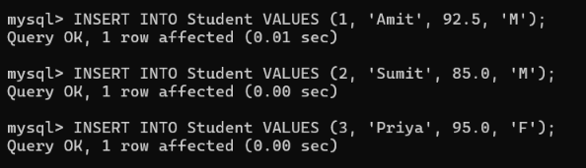
Program 35: SQL Aggregate Functions and GROUP BY
SELECT Gender, COUNT(*), AVG(Marks) FROM Student GROUP BY Gender;
Output:
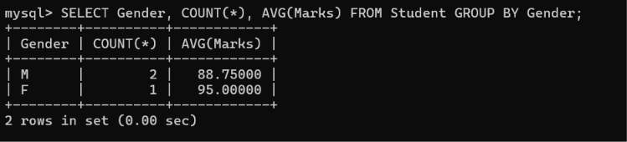
Program 36: SQL - UPDATE, DELETE, and ORDER BY Queries

UPDATE Student SET Marks = 87.0 WHERE RollNo = 2;
DELETE FROM Student WHERE RollNo = 4;
SELECT * FROM Student ORDER BY Marks DESC;

Output:
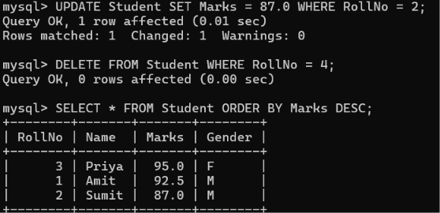
Program 37: Filtering using “Between” Operator query
SELECT * FROM Student WHERE Grade IN ('A', 'B');
Output:
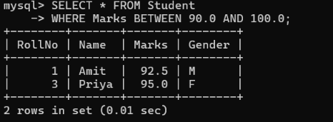

38: Cartesian Product and Equi Joins
CREATE TABLE Sports (
RollNo INT,
Game VARCHAR(15)
);

-- Populate the sports records
INSERT INTO Sports VALUES (1, 'Cricket');
INSERT INTO Sports VALUES (3, 'Badminton');

SELECT Student.Name, Sports.Game
FROM Student, Sports
WHERE Student.RollNo = Sports.RollNo;

Output:

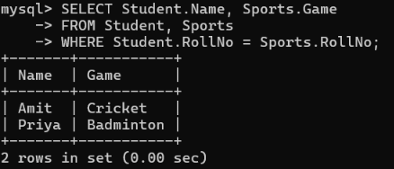
Program 39: Python-MySQL Database Connectivity Program
import mysql.connector
con = mysql.connector.connect(
host='localhost',
user='root',
password='password',
database='School'
)
cursor = con.cursor()
cursor.execute('SELECT * FROM Student')
records = cursor.fetchall()
for r in records:
print('Roll:', r[0], 'Name:', r[1], 'Marks:', r[2])
con.close()
Output:
Roll: 1 Name: Amit Marks: 92.5
Roll: 2 Name: Sumit Marks: 87.0
Roll: 3 Name: Priya Marks: 95.0

Program 40: MySql connectivity Input Output
import mysql.connector
con = mysql.connector.connecthost="localhost", user="root",password="password",database="School")
cur = con.cursor()
while True:
print("\n1. Insert Employee Record")
print("2. Display Employee Records")
print("3. Exit")
ch = int(input("Enter your choice: "))
if ch == 1:
eid = int(input("Enter Employee ID: "))
name = input("Enter Employee Name: ")
salary = float(input("Enter Salary: "))
q = "INSERT INTO Employee VALUES (%s, %s, %s)"
data = (eid, name, salary)
cur.execute(q, data)
con.commit()
print("Record inserted successfully")
elif ch == 2:
cur.execute("SELECT * FROM Employee")
rows = cur.fetchall()
for r in rows:
print(r)
elif ch == 3:
break
else:
print("Invalid choice")
con.close()

Output:
1. Insert Employee Record
2. Display Employee Records
3. Exit
Enter your choice: 1
Enter Employee ID: 101
Enter Employee Name: Amit
Enter Salary: 35000
Record inserted successfully

1. Insert Employee Record
2. Display Employee Records
3. Exit
Enter your choice: 2
(101, 'Amit', 35000.0)

