We have run the code without any modification this is output

**REPORT (1)**

TASK 1

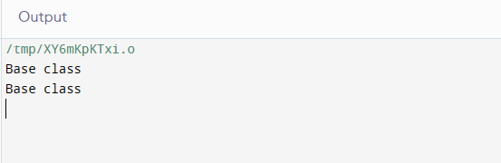

Second using virtual in code

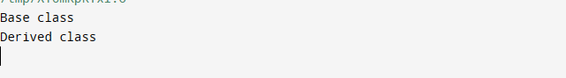

REPORT(2)

In this code we have used ploymorpism and inheritance . we have inherit mammal class with dog class.

OUTPUT

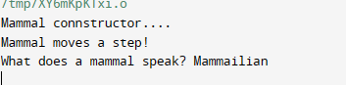

In this code is same just the int main code is change . We also inherit class cat and class horse and class gunieapig. With the mammal

REPORT (3)

