$ pip install numpy scipy h5py

$ pip install scikit-learn Pillow imutils

$ pip install beautifulsoup4

$ pip install tensorflow-gpu

$ pip install keras

cd ~

$ git clone https://github.com/fizyr/keras-retinanet

$ cd keras-retinanet

$ git checkout 42068ef9e406602d92a1afe2ee7d470f7e9860df

$ python setup.py install

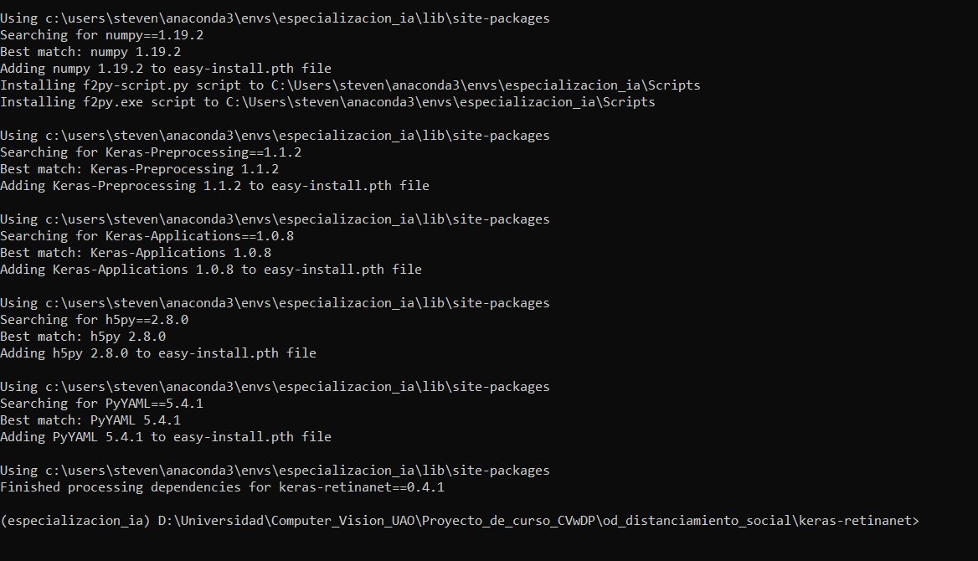

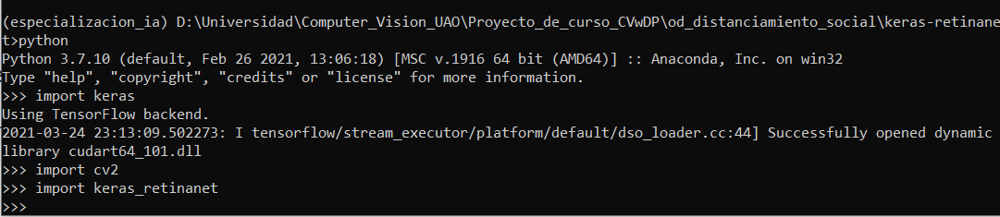

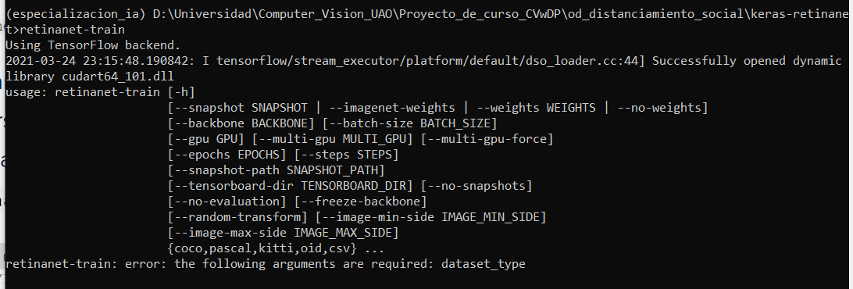

Descargar pesos del backbone

wget <https://github.com/fizyr/keras-retinanet/releases/download/0.5.1/resnet50_coco_best_v2.1.0.h5>

<https://github.com/fizyr/keras-retinanet#faq>

**GIT**

git checkout master

git fetch

git pull origin nombredeturama

git push origin master