RTS Analyzer: Sprint One

Software Engineers:

* Cody Strange – ETL Developer
* Jaden Albrecht – Database Administrator
* Hoyoung Kim – UI Developer

Institution: Utah Valley University

Course: CS4550-601 2024 Spring

# Organization

## Coding Standards

### Commenting

##### Functions

* Brief description of function
* Parameters
* Return

### Programming Paradigm

* Object oriented

### Naming Conventions

* Classes: CapWords
* Functions: snake_case
* Variables: snake_case
* Constants: ALLCAPS
* Files/Folders: snake_case

## Scheduling

### Meetings

* Whenever people feel like it

# Requirements Gathering

## Functional Requirements

* Analyze groups of replays.
  + Determine build order
  + Determine win rates based on races
  + Determine win rates of build ‘A’ vs build ‘B’
* Import and display build order to live game.

## Non-Functional Requirements

Summary: *These requirements do not pertain to specific behaviors or functionalities of the application but rather to its overall attributes and characteristics.*

##### Performance and Responsiveness

* The application should be capable of processing and displaying data with minimal latency.
* It should handle high volumes of concurrent users and data requests efficiently.

##### Scalability

* The system should be scalable to accommodate a growing number of users and an increasing amount of data.

##### Reliability and Availability

* The application should have high uptime, with minimal downtime for maintenance or updates.
* It should be reliable in delivering accurate and consistent analytics data.

##### Security

* Strong measures for data security, including encryption of sensitive data and secure handling of user information.
* Implementation of proper authentication and authorization mechanisms to protect user accounts and data.

##### Maintainability and Modularity

* The codebase should be well-organized and documented for ease of maintenance and updates.

##### Usability and Accessibility

* The user interface should be intuitive and user-friendly, catering to both novice and experienced gamers.
* The application should be accessible to users with disabilities, complying with relevant accessibility standards.

##### Compliance and Legal Requirements

* Adherence to legal and regulatory requirements, such as data protection laws (e.g., GDPR, if applicable).

## Risk Analysis

### Technical Risks

##### Risk of Inaccurate Analysis

There's a risk that the program may not accurately analyze replays due to incorrect logic, outdated algorithms, or compatibility issues with different SC2 versions.

* Mitigation: Regularly update the program to align with the latest game patches, and thoroughly test the program with a variety of replays
* Contingency: Temporarily remove feature that is inaccurate until we can guarantee accuracy

##### Risk of Incompatibility with Future SC2 Updates

Future updates to SC2 might change the replay format or introduce new features not supported by the current program.

* Mitigation: Plan for regular updates and maintenance and stay informed about upcoming SC2 updates.
* Contingency: Make it so the program doesn’t accept replays past the date of the new update until the program is compatible with the new version of sc2 replays.

### Legal and Compliance Risks

##### Risk of Data Privacy Violations

If the analytics tool collects user data, it must comply with data protection regulations like GDPR or CCPA.

* Mitigation: Implement strong data privacy policies and only collect necessary data with user consent.
* Contingency: Shut down program until it complies with data protection regulations.

### Operational Risks

##### Risk of Dependency on External Libraries

The project might rely on external libraries (like sc2reader) which could become outdated or unsupported.

* Mitigation: None
* Contingency: Drop project

##### Risk of Insufficient Testing

Inadequate testing can lead to undetected bugs and issues in production.

* Mitigation: Implement comprehensive testing strategies, including unit tests, integration tests, and user acceptance tests.
* Contingency: Fix bugs, possibly rollback to previous version of product and add more comprehensive testing

# High Level Design

## Architecture

Description: Diagram showing the relationship between all the parts of the project. Needs to be split into smaller individual diagrams, as well as being simplified to match the scope of the project.

## Wireframes

### Accounts

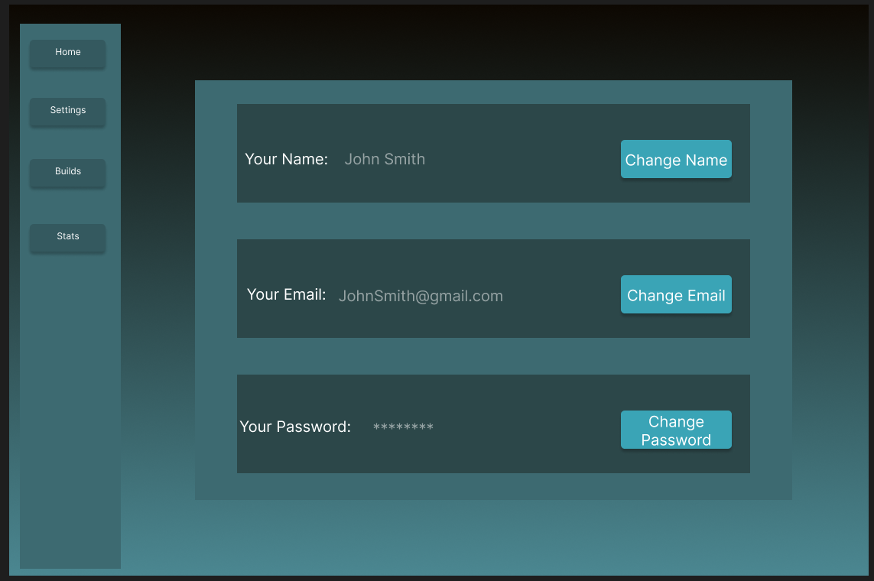

### Builds

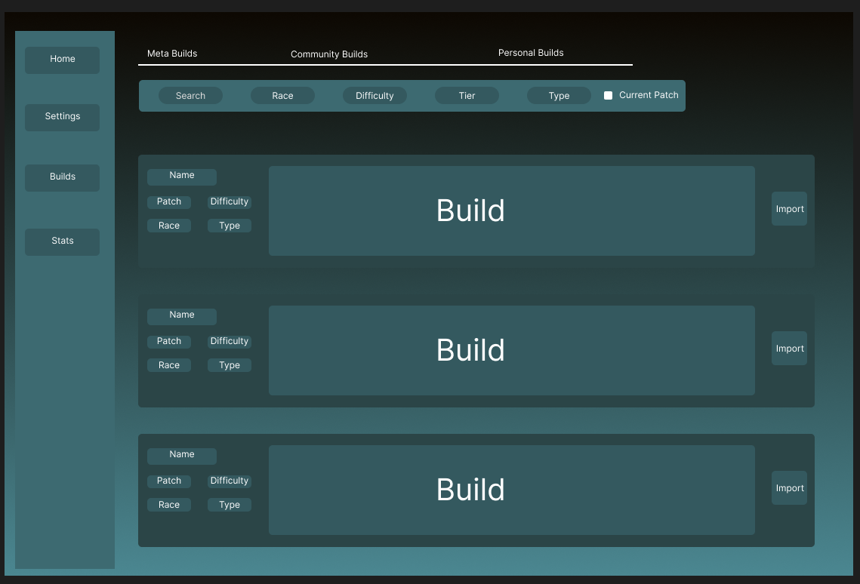

### Home

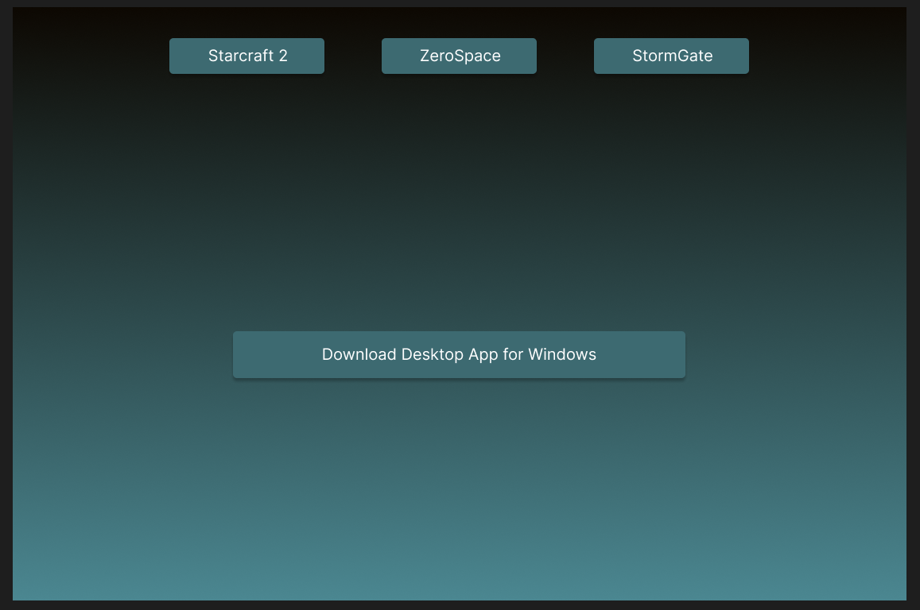

### Stats Page

### 

# Low Level Design

# Development

## Prototype

### Extractor

Description: extracts data from multiple Starcraft 2 replay files and outputs said data to a database

### Database

Description: SQL database for storing Starcraft 2 replay information, currently don’t have a way to view the data in the database

### Analyzer

### UI

# Testing