**Text №3**

**"A History of the computer"**

**In the beginning:**

The history of computers starts out about 2000 years ago, at the birth of abacus, a wooden rack holding two horizontal wires with beads strung on them. When these beads are moved around, according to programming rules memorized by the user, all regular arithmetic problems can be done. Another important invention around the same time was the Astro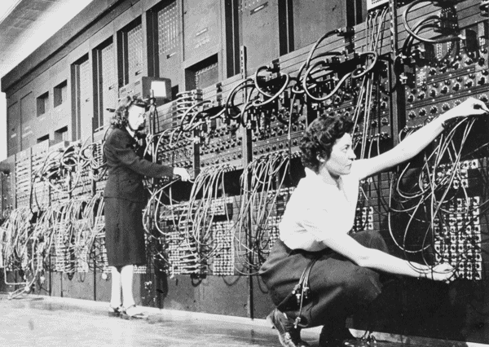labe, used for navigation.

Blaise Pascal is usually credited for building the first digital computer in 1642. It added numbers entered with dials and was made to help his father, a tax collector. In 1671, Gottfried Wilhelm von Leibniz invented a computer that was built in 1694. It could add, and, after changing some things around, multiply. Leibniz invented a special stepped gear mechanism for introducing the addend digits, and this is still being used.

The prototypes made by Pascal and Leibniz were not used in manyplaces, and considered weird until a little more than a century later, when Thomas of Colmar (Charles Xavier Thomas) created the first successful mechanical calculator that could add, subtract, multiply, and divide. A lot of improved desktop calculators by many inventors followed, so that by about 1890, the range of improvements included: accumulation of partial results, storage and automatic reentry of past results (A memory function), printing of the results, each of these required manual installation. These improvements were mainly made for commercial users, and not for the needs of science.

**Babbage.**

While Thomas of Colman was developing the desktop calculator, a series of very interesting developments in computers was started in Cambridge, England, by Charles Babbage (of whom the computer store "Babbage" is named), a mathematics professor. In 1812, Babbage realized that many long calculations, especially those needed to make mathematical tables, were really a series of predictable actions that were constantly repeated. From this he suspected that it should be possible to do these automatically.

He began to design an automatic mechanical calculating machine, which he called a difference engine. By 1822, he had a working model to demonstrate. With financial help from the British government, Babbage started fabrication of a difference engine in 1823. It was intended to be steam powered and fully automatic, it including the printing of the resulting tables, and commanded by a fixed instruction program.

The difference engine, although having limited adaptability and applicability, was really a great advance. Babbage continued to work on it for the next 10 years, but in 1833 he lost interest because he thought he had a better idea - the construction of what would now be called a general purpose, fully program-controlled, automatic mechanical digital computer. Babbage called this idea an Analytical Engine. The ideas of this design showed a lot of foresight, although this couldn't be appreciated until a full century later.

The plans for this engine required an identical decimal computer operating on numbers of 50 decimal digits (or words) and having a storage capacity (memory) of 1,000 such digits. The built-in operations were supposed to include everything that a modem general - purpose computer would need, even the all important Conditional Control Transfer Capability that would allow commands to be executed in any order, not just the order in which they were programmed.

The analytical engine was soon to use punched cards (similar to those used in a Jacquard loom), which would be read into the machine from several different Reading Stations. The machine was supposed to operate automatically, by steam power, and require only once person there.

Babbage's computers were never finished. Various reasons are used for his failure. Most used is the lack of precision machining techniques at the time. Another speculation is that Babbage was working on a solution of a problem that few people in 1840 really needed to solve. After Babbage, there was a temporary loss of interest in automatic digital computers. Between 1850 and 1900 great advances were made in mathematical physics, and it came to be known that most observable dynamic phenomena can be identified by differential equations (which meant that most events occurring in nature can be measured or described in one equation or another), so that easy means for their calculation would be helpful.

Moreover, from a practical view, the availability of steam power caused manufacturing (boilers), transportation (steam engines and boats), and commerce to prosper and led to a period of a lot of engineering achievements. The designing of railroads and the making of steamships, textile mills, and bridges required differential calculus to determine such things as: center of gravity, center of buoyancy, moment of inertia, and stress distributions.

Even the assessment of the power output of a steam engine needed mathematical integration. A strong need thus developed for a machine that could rapidly perform many repetitive calculations.