EXERCISE-13

13.Design PDA using simulator to accept the input string aabb

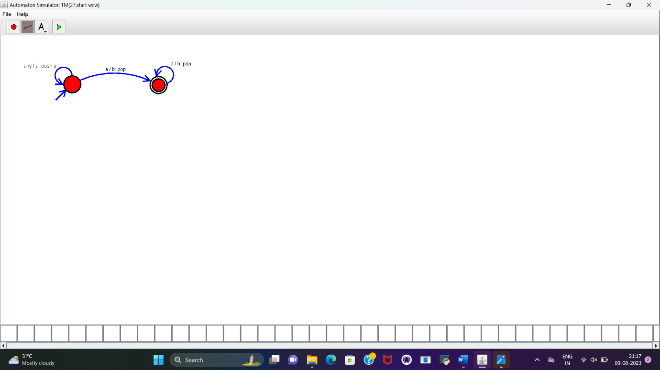

RESULT:

PDA is designed to accept the string a^nb^n and implemented successfully.