webService介绍
https://blog.csdn.net/qq_26857649/article/details/83789583

Jaxws规范下的webService开发

webService服务端的创建，与服务的发布

需要使用的jar包
ApacheCXF的jaxws实现webservice
<dependencies>

<!-- 要进行jaxwas服务开发 -->
<dependency>
<groupId>org.apache.cxf</groupId>
<artifactId>cxf-rt-frontend-jaxws</artifactId>
<version>3.0.1</version>
</dependency>

<!-- 内置jetty web服务器 -->
<dependency>
<groupId>org.apache.cxf</groupId>
<artifactId>cxf-rt-transports-http-jetty</artifactId>
<version>3.0.1</version>
</dependency>

<dependency>
<groupId>junit</groupId>
<artifactId>junit</artifactId>
<version>4.12</version>
<scope>test</scope>
</dependency>
<dependency>
<groupId>org.slf4j</groupId>
<artifactId>slf4j-log4j12</artifactId>
<version>1.6.6</version>
</dependency>
</dependencies>

<build>
<pluginManagement>
<plugins>
<plugin>
<groupId>org.apache.maven.plugins</groupId>
<artifactId>maven-compiler-plugin</artifactId>
<version>3.2</version>
<configuration>
<source>1.8</source>
<target>1.8</target>
<encoding>UTF-8</encoding>
<showWarnings>true</showWarnings>
</configuration>
</plugin>
</plugins>
</pluginManagement>
</build>

编写服务接口
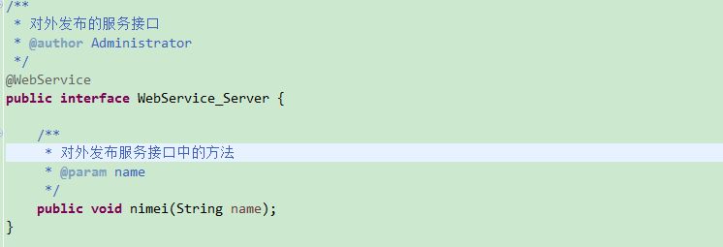
服务接口使用@WebService注解，来标记是一个可发布的Webservice服务接口，注解在接口或实现中选择一个写就okay了，这里最好写在接口上，因为我们发布的就是接口

服务接口的实现
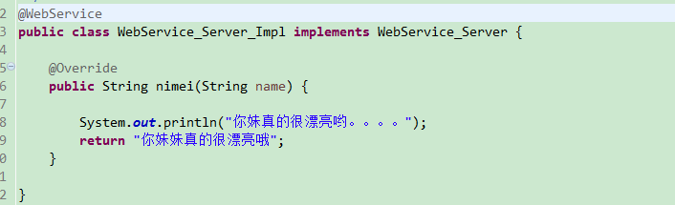

编写启动、发布服务类
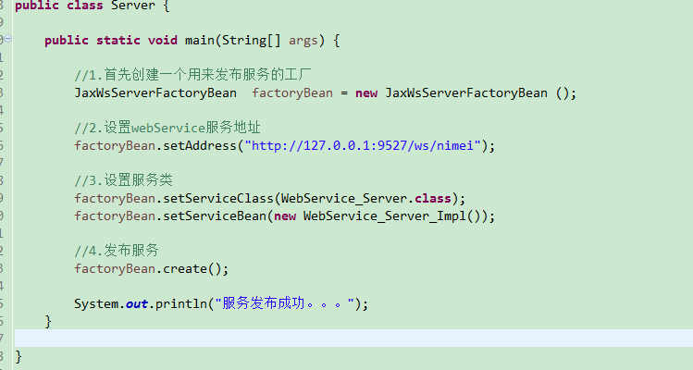

WSDL说明书（基于Shemale的XML文件）
说明书地址：服务的地址+?wsdl,阅读顺序，从下往上
因为我们是基于jax-ws协议规范下，进行webService开发，它是基于soap协议，也就是说我们的webservice请求、webservice响应，它是基于soap协议，wsdl说明书描述的就是soap请求，soap响应，还有请求与响应他们交互的数据格式的定义。
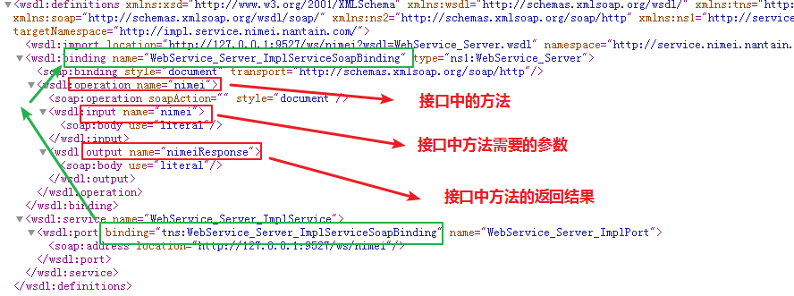

webService客户端的创建，与服务的调用

创建客户端调用服务项目
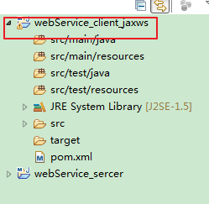

导入依赖jar包（引入的包跟服务端一样）
<dependencies>

<!-- 要进行jaxwas服务开发 -->
<dependency>
<groupId>org.apache.cxf</groupId>
<artifactId>cxf-rt-frontend-jaxws</artifactId>
<version>3.1.9</version>
</dependency>

<!-- 内置jetty web服务器 -->
<dependency>
<groupId>org.apache.cxf</groupId>
<artifactId>cxf-rt-transports-http-jetty</artifactId>
<version>3.1.9</version>
</dependency>

<dependency>
<groupId>org.apache.cxf</groupId>
<artifactId>cxf-core</artifactId>
<version>3.1.9</version>
</dependency>

<dependency>
<groupId>junit</groupId>
<artifactId>junit</artifactId>
<version>4.12</version>
<scope>test</scope>
</dependency>
<dependency>
<groupId>org.slf4j</groupId>
<artifactId>slf4j-log4j12</artifactId>
<version>1.6.6</version>
</dependency>
</dependencies>

<build>
<pluginManagement>
<plugins>
<plugin>
<groupId>org.apache.maven.plugins</groupId>
<artifactId>maven-compiler-plugin</artifactId>
<version>3.2</version>
<configuration>
<source>1.8</source>
<target>1.8</target>
<encoding>UTF-8</encoding>
<showWarnings>true</showWarnings>
</configuration>
</plugin>
</plugins>
</pluginManagement>
</build>

编写客户端服务接口
调用别人的webService服务接口，一定要知道，服务的地址是什么，服务地址中，对外发布服务的接口，接口中有哪些方法，方法的参数，方法的返回值，这些都会在接口的说明文档中进行详细的描述，所以我们作为客户端调用的时候，服务发布端一定要提供接口的说明文档
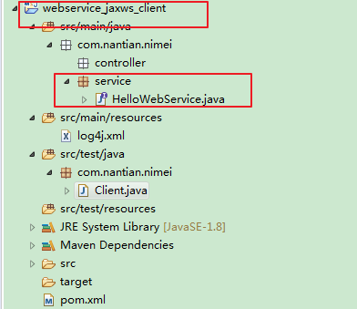

编写测试方法，调用发布的webService服务接口
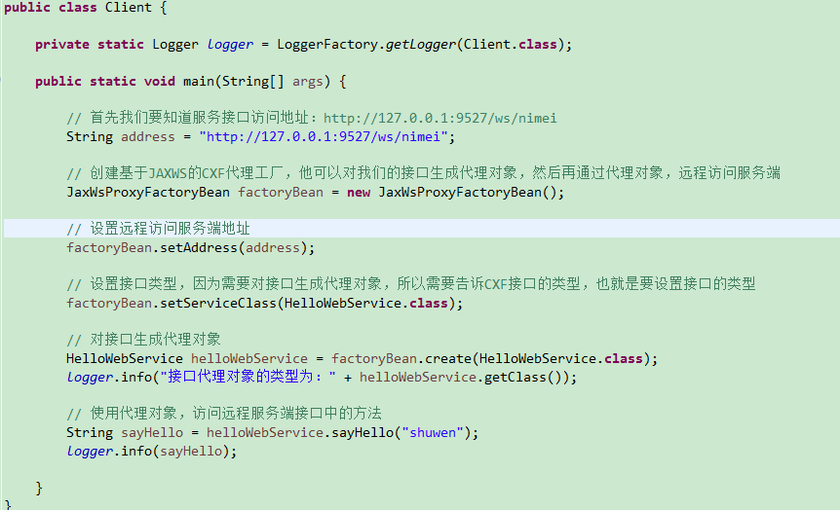

遇到的问题：
（1）in thread "main" javax.xml.ws.soap.SOAPFaultException: Unexpected wrapper element {http://service.cn.nantian.com/}nimei found. Expected {http://service.nimei.nantain.com/}nimei.
原因：客户端接口，与服务端接口包名不一致

（2）main" javax.xml.ws.WebServiceException: Could not send Message.
java.net.ConnectException: ConnectException invoking http://127.0.0.1:9527/ws/nimei: Connection refused: connect
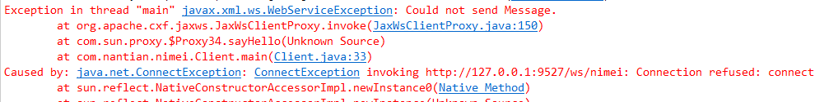
原因：客户端调用服务端地址与服务端发布地址端口号不一致,还有就是服务没起

(3)javax.xml.ws.WebServiceException: Could not find wsdl:binding operation info for web method sayHello.
原因是因为客户端的service中的方法没有和服务端的方法绑定,只需要在客户端的service接口上加注解@WebService,异常便可解决

日志拦截器
Log4j.properties配置文件
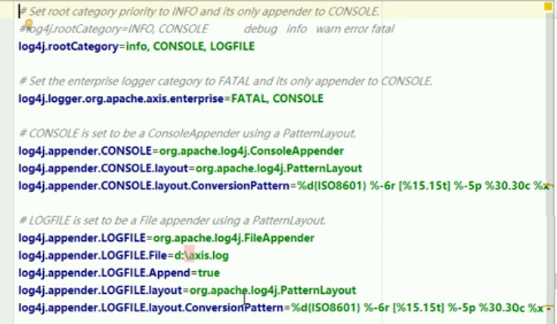
在服务端发布服务的方法中可以添加日志输入/输出拦截器，观察soap请求，soap响应的内容，查看客户端与服务端交互的数据格式怎样的

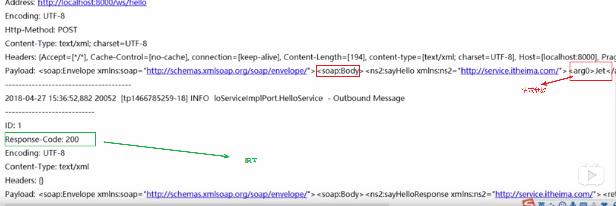
可以看到，soap请求，soap响应都是XML格式的数据来进行客户端和服务端的交互的、

Jaxws规范下Spring整合Apache CXF实现Web Service

服务端

创建web项目
在使用spring整合CXF中，当访问服务的时候，必须先经过CXF的Servlet所以我们需要创建web项目

添加依赖
我们需要添加的是spring的依赖还有CXF的依赖
参考资料：https://blog.csdn.net/yhahaha_/article/details/81395397

<dependencies>
<!-- 要进行jaxwas服务开发 -->
<dependency>
<groupId>org.apache.cxf</groupId>
<artifactId>cxf-rt-frontend-jaxws</artifactId>
<version>3.1.9</version>
</dependency>
<dependency>
<groupId>org.apache.cxf</groupId>
<artifactId>cxf-core</artifactId>
<version>3.1.9</version>
</dependency>
<dependency>
<groupId>org.apache.cxf</groupId>
<artifactId>cxf-rt-transports-http</artifactId>
<version>3.1.9</version>
</dependency>

<!-- spring-context依赖 -->
<dependency>
<groupId>org.springframework</groupId>
<artifactId>spring-context</artifactId>
<version>4.2.4.RELEASE</version>
</dependency>

<!-- spring-web依赖 -->
<dependency>
<groupId>org.springframework</groupId>
<artifactId>spring-web</artifactId>
<version>4.2.4.RELEASE</version>
</dependency>

<dependency>
<groupId>org.springframework</groupId>
<artifactId>spring-test</artifactId>
<version>4.2.4.RELEASE</version>
</dependency>

<dependency>
<groupId>org.slf4j</groupId>
<artifactId>slf4j-log4j12</artifactId>
<version>1.6.6</version>
</dependency>

</dependencies>

<build>
<pluginManagement>
<plugins>

<!-- 编译插件 -->
<plugin>
<groupId>org.apache.maven.plugins</groupId>
<artifactId>maven-compiler-plugin</artifactId>
<version>3.2</version>
<configuration>
<source>1.8</source>
<target>1.8</target>
<encoding>UTF-8</encoding>
<showWarnings>true</showWarnings>
</configuration>
</plugin>

<!-- Tomcat插件，运行方式：Tomcat7：run -->
<plugin>
<groupId>org.apache.tomcat.maven</groupId>
<artifactId>tomcat7-maven-plugin</artifactId>
<version>2.2</version>
<configuration>
<port>8081</port>
<path>/</path>
<uriEncoding>UTF-8</uriEncoding>
<server>tomcat7</server>
</configuration>
<executions>
<execution>
<phase>package</phase>
<goals>
<goal>run</goal>
</goals>
</execution>
</executions>
</plugin>

</plugins>
</pluginManagement>
</build>

web.xml配置CXFServlet
主要分两部分：（1）CXFServlet的配置 （2） spring容器的配置（配置监听）
<!-- CXFServlet的配置 -->
<servlet>
<servlet-name>CXFServlet</servlet-name>
<servlet-class>org.apache.cxf.transport.servlet.CXFServlet</servlet-class>
</servlet>
<servlet-mapping>
<servlet-name>CXFServlet</servlet-name>
<url-pattern>/ws/*</url-pattern>
</servlet-mapping>

<!-- spring容器的配置 -->
<context-param>
<param-name>contextConfigLocation</param-name>
<param-value>calsspath:applicationContext.xml</param-value>
</context-param>
<listener>
<listener-class>org.springframework.web.context.ContextLoaderListener</listener-class>
</listener>

服务接口、服务实现
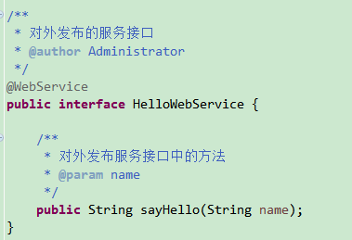
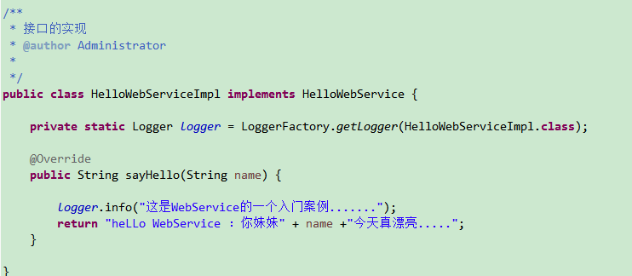

Spring整合CXF
（1）Spring的配置文件中要引入约束和命名空间

<beans xmlns="http://www.springframework.org/schema/beans"
xmlns:xsi="http://www.w3.org/2001/XMLSchema-instance"
xmlns:context="http://www.springframework.org/schema/context"
xmlns:aop="http://www.springframework.org/schema/aop"
xmlns:tx="http://www.springframework.org/schema/tx"
xmlns:mvc="http://www.springframework.org/schema/mvc"
xmlns:cxf="http://cxf.apache.org/core"
xmlns:jaxws="http://cxf.apache.org/jaxws"
xmlns:jaxrs="http://cxf.apache.org/jaxrs"
xsi:schemaLocation="
http://www.springframework.org/schema/beans http://www.springframework.org/schema/beans/spring-beans.xsd
http://www.springframework.org/schema/context http://www.springframework.org/schema/context/spring-context.xsd
http://www.springframework.org/schema/aop http://www.springframework.org/schema/aop/spring-aop.xsd
http://www.springframework.org/schema/tx http://www.springframework.org/schema/tx/spring-tx.xsd
http://www.springframework.org/schema/mvc http://www.springframework.org/schema/mvc/spring-mvc.xsd
http://cxf.apache.org/core http://cxf.apache.org/schemas/core.xsd
http://cxf.apache.org/jaxws http://cxf.apache.org/schemas/jaxws.xsd
http://cxf.apache.org/jaxrs http://cxf.apache.org/schemas/jaxrs.xsd">

- 配置服务地址、服务类
<!--
spring整合CXF发布服务，关键点
1.服务地址
2.服务类
服务的完整访问地址：http://localhost:8081/ws/hello
-->
<!--相当于：JaxWsServerFactoryBean factory = new JaxWsServerFactoryBean(); -->
<jaxws:server address="/hello">
<jaxws:serviceBean>
<bean class="com.nantian.cn.service.impl.HelloWebServiceImpl"></bean>
</jaxws:serviceBean>
</jaxws:server>

启动服务、发布服务
使用Tomcat插件
- 需要在maven的settings.xml文件中添加server配置
<server>
<id>tomcat</id>
<username>tomcatuser</username>
<password>tomcatpwd</password>
</server>

- 在pom.xml文件中添加Tomcat插件
<!-- Tomcat插件，运行方式：Tomcat7：run -->
<plugin>
<groupId>org.apache.tomcat.maven</groupId>
<artifactId>tomcat7-maven-plugin</artifactId>
<version>2.2</version>
<configuration>
<port>8081</port>
<path>/</path>
<uriEncoding>UTF-8</uriEncoding>
<server>tomcat7</server>
</configuration>
<executions>
<execution>
<phase>package</phase>
<goals>
<goal>run</goal>
</goals>
</execution>
</executions>
</plugin>

- 编译插件
<!-- 编译插件 -->
<plugin>
<groupId>org.apache.maven.plugins</groupId>
<artifactId>maven-compiler-plugin</artifactId>
<version>3.2</version>
<configuration>
<source>1.8</source>
<target>1.8</target>
<encoding>UTF-8</encoding>
<showWarnings>true</showWarnings>
</configuration>
</plugin>

访问wsdl说明书
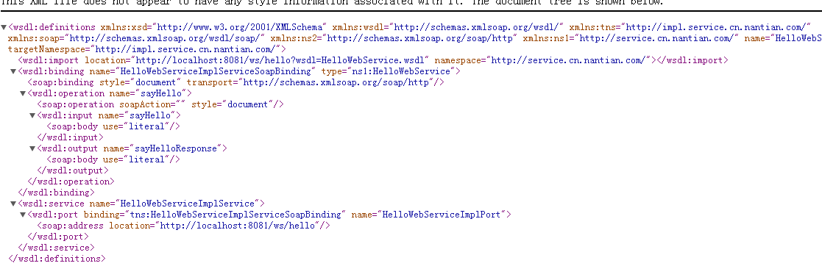

遇到的问题
- java.io.IOException: Could not find destination factory for transport http://schemas.xmlsoap.org/soap/http

- org.apache.cxf.BusException: No DestinationFactory was found for the namespace http://cxf.apache.org/transports/http.

- org.apache.cxf.service.factory.ServiceConstructionException

- org.springframework.beans.factory.BeanCreationException: Error creating bean with name 'org.apache.cxf.jaxws.spring.NamespaceHandler$SpringServerFactoryBean--369149233': Invocation of init method failed; nested exception is org.apache.cxf.service.factory.ServiceConstructionException

以上的问题都是由于jar包没导全，需要导入CXF的三个相关jar包即可解决主要是橙色标记的jar包
<dependency>
<groupId>org.apache.cxf</groupId>
<artifactId>cxf-rt-frontend-jaxws</artifactId>
<version>3.1.9</version>
</dependency>
<dependency>
<groupId>org.apache.cxf</groupId>
<artifactId>cxf-core</artifactId>
<version>3.1.9</version>
</dependency>
<dependency>
<groupId>org.apache.cxf</groupId>
<artifactId>cxf-rt-transports-http</artifactId>
<version>3.1.9</version>
</dependency>

客户端

创建项目
客户端项目的创建没有要求，可以创建web项目也可以创建java项目

添加依赖
同服务端server

客户端Service服务接口
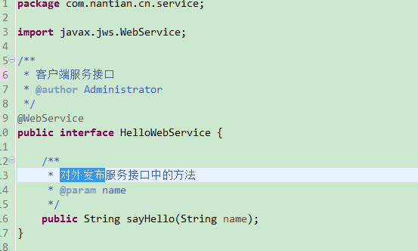

Spring整合CXF
把服务接口的代理对象交给spring容器去管理
- 约束、命名空间同服务端server
- 配置服务地址、服务接口类型，通过接口类型生成代理对象
<!--
spring整合CXF客户端配置，关键点
1.服务地址：http://localhost:8081/ws/hello
2.服务接口类型，这里配置的接口的类型,根据接口的类型，就能生成接口的代理对象,
id属性中的helloWebService就是代理对象

-->
<!--相当于：JaxWsProxyFactoryBean proxyFactoryBean = new JaxWsProxyFactoryBean(); -->
<jaxws:client id="helloWebService"
serviceClass="com.nantian.cn.service.HelloWebService"
address="http://localhost:8081/ws/hello"
>

</jaxws:client>

Junit测试
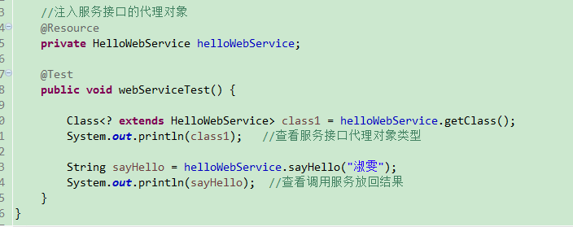
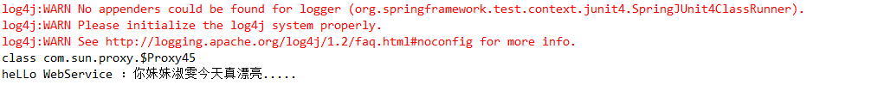

Jaxrs规范下实现Restful风格的web Service服务开发

Restful简介
一种软件架构风格，设计风格，而不是标准，只是提供了一组设计原则和约束条件。它主要用于客户端和服务器交互类的软件。基于这个风格设计的软件可以更简洁，更有层次，更易于实现缓存等机制
REST（英文：Representational State Transfer【表现层的状态转移】，简称REST）描述了一个架构样式的网络系统，比如 web 应用程序。它首次出现在 2000 年 Roy Fielding 的博士论文中，Roy Fielding是 HTTP 规范的主要编写者之一。在目前主流的三种Web服务交互方案中，REST相比于SOAP（Simple Object Access protocol，简单对象访问协议）以及XML-RPC更加简单明了，无论是对URL的处理还是对Payload的编码，REST都倾向于用更加简单轻量的方法设计和实现。值得注意的是REST并没有一个明确的标准，而更像是一种设计的风格。
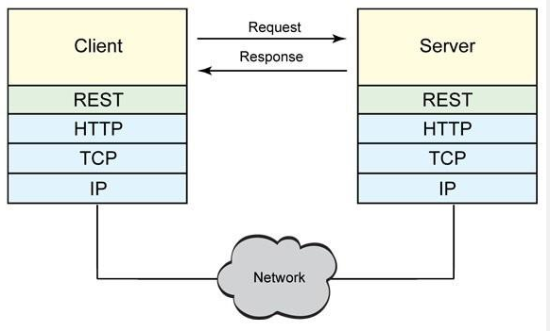
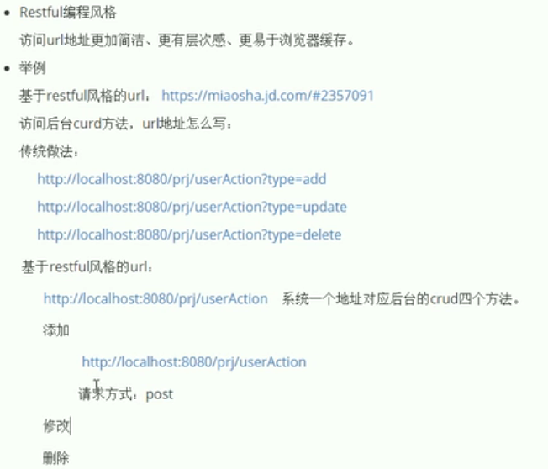

服务端

创建项目
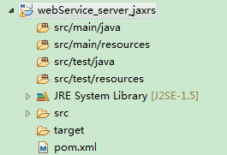

添加依赖
基于jaxrs的restful风格的web Service服务，客户端和服务端之间的通信可以传xml数据，也可以传json数据

<dependencies>

<!-- 要进行jaxrs服务开发 -->
<dependency>
<groupId>org.apache.cxf</groupId>
<artifactId>cxf-rt-frontend-jaxrs</artifactId>
<version>3.0.1</version>
</dependency>

<!-- 内置jetty web服务器 -->
<dependency>
<groupId>org.apache.cxf</groupId>
<artifactId>cxf-rt-transports-http-jetty</artifactId>
<version>3.1.9</version>
</dependency>

<!-- rs客户端调用依赖jar包 -->
<dependency>
<groupId>org.apache.cxf</groupId>
<artifactId>cxf-rt-rs-client</artifactId>
<version>3.0.1</version>
</dependency>

<!-- 对json数据格式支持的一些包 -->
<dependency>
<groupId>org.apache.cxf</groupId>
<artifactId>cxf-rt-rs-extension-providers</artifactId>
<version>3.0.1</version>
</dependency>
<dependency>
<groupId>org.codehaus.jettison</groupId>
<artifactId>jettison</artifactId>
<version>1.3.7</version>
</dependency>

<dependency>
<groupId>org.apache.cxf</groupId>
<artifactId>cxf-core</artifactId>
<version>3.1.9</version>
</dependency>

<dependency>
<groupId>junit</groupId>
<artifactId>junit</artifactId>
<version>4.12</version>
<scope>test</scope>
</dependency>
<dependency>
<groupId>org.slf4j</groupId>
<artifactId>slf4j-log4j12</artifactId>
<version>1.6.6</version>
</dependency>
</dependencies>

<build>
<pluginManagement>
<plugins>
<plugin>
<groupId>org.apache.maven.plugins</groupId>
<artifactId>maven-compiler-plugin</artifactId>
<version>3.2</version>
<configuration>
<source>1.8</source>
<target>1.8</target>
<encoding>UTF-8</encoding>
<showWarnings>true</showWarnings>
</configuration>
</plugin>
</plugins>
</pluginManagement>
</build>

服务接口、实现、实体类
- 创建实体类
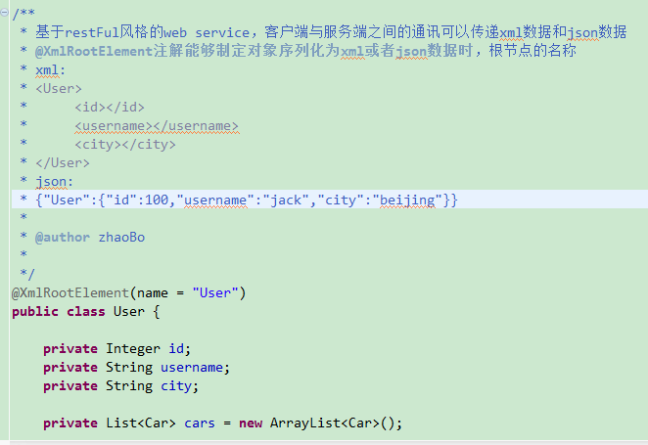

- 服务接口

@Path("/userService")
@Produces("*/*")
public interface UserService {

@POST
@Path("/user")
@Consumes({"application/xml","application/json"})
public void saveUser(User user);

@PUT
@Path("/user")
@Consumes({"application/xml","application/json"})
public void update(User user);

@DELETE
@Path("/user/{id}")
@Consumes({"application/xml","application/json"}) //服务器支持的请求参数数据类型，有参数用@Consumes注解
public void deleteUser(@PathParam("id") Integer id);

@GET
@Path("/user")
@Produces({"application/xml","application/json"}) //服务器支持的返回值类型，也就是有返回值时用@Produces注解
public List<User> findAllUser();

@GET
@Path("/user/{id}")
@Consumes("application/xml")
@Produces({"application/xml","application/json"})
public User findUserById(@PathParam("id") Integer id);

}

- 服务接口实现
public class UserServiceImpl implements UserService {

private Logger logger = LoggerFactory.getLogger(UserServiceImpl.class);

@Override
public void saveUser(User user) {
logger.info("你妹的，保存User成功了哦!" +user);
}

@Override
public void update(User user) {
logger.info("你妹的，更新User成功了哦！" + user);
}

@Override
public void deleteUser(Integer id) {
logger.info("你妹的，删除User成功了哦！" + id);
}

@Override
public List<User> findAllUser() {
List<User> users = new ArrayList<User>();
User user1 = new User();
user1.setId(1);
user1.setUsername("小淑雯");
user1.setCity("宜春");

List<Car> carList1 = new ArrayList<Car>();
Car car1 = new Car();
car1.setId(101);
car1.setCarName("保时捷");
car1.setPrice(3000000d);
carList1.add(car1);

Car car2 = new Car();
car1.setId(102);
car1.setCarName("雪佛兰科迈罗");
car1.setPrice(390000d);
carList1.add(car2);
user1.setCars(carList1);

users.add(user1);

User user2 = new User();
user2.setId(1);
user2.setUsername("小张慧");
user2.setCity("荆州");

List<Car> carList2 = new ArrayList<Car>();
Car car3 = new Car();
car3.setId(101);
car3.setCarName("宝马760");
car3.setPrice(3000000d);
carList2.add(car3);

Car car4 = new Car();
car4.setId(102);
car4.setCarName("保时捷-卡宴");
car4.setPrice(4000000d);
carList2.add(car2);
user2.setCars(carList2);

users.add(user2);

logger.info("查询列表成功！列表已返回");
return users;
}

@Override
public User findUserById(Integer id) {
if(id==1) {
User user1 = new User();
user1.setId(1);
user1.setUsername("小淑雯");

List<Car> carList1 = new ArrayList<Car>();
Car car1 = new Car();
car1.setId(101);
car1.setCarName("保时捷");
car1.setPrice(3000000d);
carList1.add(car1);

Car car2 = new Car();
car1.setId(102);
car1.setCarName("雪佛兰科迈罗");
car1.setPrice(390000d);
carList1.add(car2);
user1.setCars(carList1);
logger.info("根据id查询用户成功！已返回用户对象");
return user1;
}
return null;
}

}

发布服务
public class Server {

private static Logger logger = LoggerFactory.getLogger(Server.class);

public static void main(String[] args) {

//创建发布服务的工厂
JAXRSServerFactoryBean factory = new JAXRSServerFactoryBean();

//设置服务地址
String address = "http://localhost:8001/ws/";
factory.setAddress(address);

//设置服务类
factory.setServiceBean(new UserServiceImpl());

//添加日志输入、输出拦截器
factory.getInInterceptors().add(new LoggingInInterceptor());
factory.getOutInterceptors().add(new LoggingOutInterceptor());

//发布服务
factory.create();

logger.info("restful风格的webservice服务发布成功,服务地址："+address+",端口号：8001");
}
}

遇到的问题：
org.apache.cxf.transport.servlet.ServletDestination: method <init>(Lorg/apache/cxf/Bus;Lorg/apache/cxf/transport/http/DestinationRegistry;Lorg/apache/cxf/service/model/EndpointInfo;Ljava/lang/String;Z)V not found
原因：jar包版本不一致，因为jaxrs等相关jar包导的都是3.0.1而cxf-rt-transports-http-jetty这个包导的的是3.1.9的
修改前：
<!-- 要进行jaxrs服务开发 -->
<dependency>
<groupId>org.apache.cxf</groupId>
<artifactId>cxf-rt-frontend-jaxrs</artifactId>
<version>3.0.1</version>
</dependency>

<!-- 内置jetty web服务器 -->
<dependency>
<groupId>org.apache.cxf</groupId>
<artifactId>cxf-rt-transports-http-jetty</artifactId>
<version>3.1.9</version>
</dependency>

修改后：问题得以解决
<!-- 要进行jaxrs服务开发 -->
<dependency>
<groupId>org.apache.cxf</groupId>
<artifactId>cxf-rt-frontend-jaxrs</artifactId>
<version>3.0.1</version>
</dependency>

<!-- 内置jetty web服务器 -->
<dependency>
<groupId>org.apache.cxf</groupId>
<artifactId>cxf-rt-transports-http-jetty</artifactId>
<version>3.0.1</version>
</dependency>

客户端

创建项目
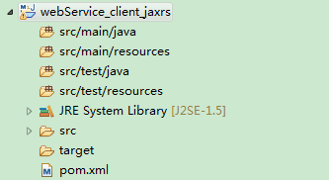

添加依赖
<dependencies>

<!-- 要进行jaxrs服务开发 -->
<dependency>
<groupId>org.apache.cxf</groupId>
<artifactId>cxf-rt-frontend-jaxrs</artifactId>
<version>3.0.1</version>
</dependency>

<!-- 内置jetty web服务器 -->
<dependency>
<groupId>org.apache.cxf</groupId>
<artifactId>cxf-rt-transports-http-jetty</artifactId>
<version>3.0.1</version>
</dependency>

<!-- rs客户端调用依赖jar包 -->
<dependency>
<groupId>org.apache.cxf</groupId>
<artifactId>cxf-rt-rs-client</artifactId>
<version>3.0.1</version>
</dependency>

<!-- 对json数据格式支持的一些包 -->
<dependency>
<groupId>org.apache.cxf</groupId>
<artifactId>cxf-rt-rs-extension-providers</artifactId>
<version>3.0.1</version>
</dependency>
<dependency>
<groupId>org.codehaus.jettison</groupId>
<artifactId>jettison</artifactId>
<version>1.3.7</version>
</dependency>

<dependency>
<groupId>org.apache.cxf</groupId>
<artifactId>cxf-core</artifactId>
<version>3.1.9</version>
</dependency>

<dependency>
<groupId>junit</groupId>
<artifactId>junit</artifactId>
<version>4.12</version>
<scope>test</scope>
</dependency>
<dependency>
<groupId>org.slf4j</groupId>
<artifactId>slf4j-log4j12</artifactId>
<version>1.6.6</version>
</dependency>
</dependencies>

<build>
<pluginManagement>
<plugins>
<plugin>
<groupId>org.apache.maven.plugins</groupId>
<artifactId>maven-compiler-plugin</artifactId>
<version>3.2</version>
<configuration>
<source>1.8</source>
<target>1.8</target>
<encoding>UTF-8</encoding>
<showWarnings>true</showWarnings>
</configuration>
</plugin>
</plugins>
</pluginManagement>
</build>

写Junit远程访问服务端
- 需要实体类，entity和服务端保持一致即可
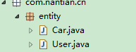
- 通过WebClient远程调用服务端

WebClient中的方法
.create() //指定服务端地址
.type() //指定请求数据格式
.accept() //指定响应数据格式
.post()/put()/delete()/get() //指定请求类型
public class Client {

private Logger logger = LoggerFactory.getLogger(Client.class);

@Test
public void testSave() {

User user1 = new User();
user1.setId(1);
user1.setUsername("小淑雯");
user1.setCity("宜春");

List<Car> carList1 = new ArrayList<Car>();
Car car1 = new Car();
car1.setId(101);
car1.setCarName("保时捷");
car1.setPrice(3000000d);
carList1.add(car1);

Car car2 = new Car();
car1.setId(102);
car1.setCarName("雪佛兰科迈罗");
car1.setPrice(390000d);
carList1.add(car2);
user1.setCars(carList1);

WebClient.create("http://localhost:8001/ws/userService/user")
.post(user1);
logger.info("保存User成功！");
}
}

Jaxrs规范下Spring整合CXF实现restful风格的Web Service服务开发

服务端

创建web项目
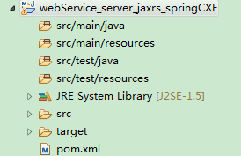

添加依赖
<dependencies>

<!-- 要进行jaxrs服务开发 -->
<dependency>
<groupId>org.apache.cxf</groupId>
<artifactId>cxf-rt-frontend-jaxrs</artifactId>
<version>3.0.1</version>
</dependency>
<dependency>
<groupId>org.apache.cxf</groupId>
<artifactId>cxf-core</artifactId>
<version>3.0.1</version>
</dependency>
<dependency>
<groupId>org.apache.cxf</groupId>
<artifactId>cxf-rt-transports-http</artifactId>
<version>3.0.1</version>
</dependency>

<!-- rs客户端调用依赖jar包 -->
<dependency>
<groupId>org.apache.cxf</groupId>
<artifactId>cxf-rt-rs-client</artifactId>
<version>3.0.1</version>
</dependency>

<!-- 对json数据格式支持的一些包 -->
<dependency>
<groupId>org.apache.cxf</groupId>
<artifactId>cxf-rt-rs-extension-providers</artifactId>
<version>3.0.1</version>
</dependency>
<dependency>
<groupId>org.codehaus.jettison</groupId>
<artifactId>jettison</artifactId>
<version>1.3.7</version>
</dependency>

<!-- spring-context依赖 -->
<dependency>
<groupId>org.springframework</groupId>
<artifactId>spring-context</artifactId>
<version>4.2.4.RELEASE</version>
</dependency>

<!-- spring-web依赖 -->
<dependency>
<groupId>org.springframework</groupId>
<artifactId>spring-web</artifactId>
<version>4.2.4.RELEASE</version>
</dependency>

<dependency>
<groupId>org.springframework</groupId>
<artifactId>spring-test</artifactId>
<version>4.2.4.RELEASE</version>
</dependency>

<dependency>
<groupId>org.slf4j</groupId>
<artifactId>slf4j-log4j12</artifactId>
<version>1.6.6</version>
</dependency>

</dependencies>

<build>
<pluginManagement>
<plugins>

<!-- 编译插件 -->
<plugin>
<groupId>org.apache.maven.plugins</groupId>
<artifactId>maven-compiler-plugin</artifactId>
<version>3.2</version>
<configuration>
<source>1.8</source>
<target>1.8</target>
<encoding>UTF-8</encoding>
<showWarnings>true</showWarnings>
</configuration>
</plugin>

<!-- Tomcat插件，运行方式：Tomcat7：run -->
<plugin>
<groupId>org.apache.tomcat.maven</groupId>
<artifactId>tomcat7-maven-plugin</artifactId>
<version>2.2</version>
<configuration>
<port>8081</port>
<path>/</path>
<uriEncoding>UTF-8</uriEncoding>
<server>tomcat7</server>
</configuration>
<executions>
<execution>
<phase>package</phase>
<goals>
<goal>run</goal>
</goals>
</execution>
</executions>
</plugin>

</plugins>
</pluginManagement>
</build>

Web.xml配置
<!-- CXFServlet的配置 -->
<servlet>
<servlet-name>CXFServlet</servlet-name>
<servlet-class>org.apache.cxf.transport.servlet.CXFServlet</servlet-class>
</servlet>
<servlet-mapping>
<servlet-name>CXFServlet</servlet-name>
<url-pattern>/ws/*</url-pattern>
</servlet-mapping>

<!-- spring容器的配置 -->
<context-param>
<param-name>contextConfigLocation</param-name>
<param-value>classpath:/applicationContext.xml</param-value>
</context-param>
<listener>
<listener-class>org.springframework.web.context.ContextLoaderListener</listener-class>
</listener>

服务接口、实现、实体类
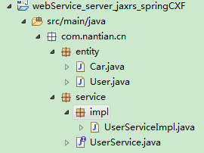

Spring整合CXF
提供applicationContext.xml配置文件，约束、命名空间同spring整合cxf基于jaxws实现
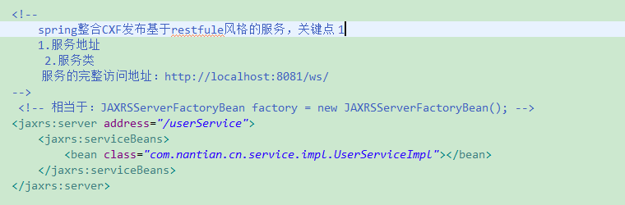

发布服务
启动项目，容器加载，bean初始化，服务发布

客户端

创建项目
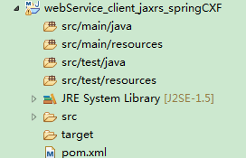

添加依赖
<dependencies>

<!-- 要进行jaxrs服务开发 -->
<dependency>
<groupId>org.apache.cxf</groupId>
<artifactId>cxf-rt-frontend-jaxrs</artifactId>
<version>3.0.1</version>
</dependency>
<dependency>
<groupId>org.apache.cxf</groupId>
<artifactId>cxf-core</artifactId>
<version>3.0.1</version>
</dependency>
<dependency>
<groupId>org.apache.cxf</groupId>
<artifactId>cxf-rt-transports-http</artifactId>
<version>3.0.1</version>
</dependency>

<!-- rs客户端调用依赖jar包 -->
<dependency>
<groupId>org.apache.cxf</groupId>
<artifactId>cxf-rt-rs-client</artifactId>
<version>3.0.1</version>
</dependency>

<!-- 对json数据格式支持的一些包 -->
<dependency>
<groupId>org.apache.cxf</groupId>
<artifactId>cxf-rt-rs-extension-providers</artifactId>
<version>3.0.1</version>
</dependency>
<dependency>
<groupId>org.codehaus.jettison</groupId>
<artifactId>jettison</artifactId>
<version>1.3.7</version>
</dependency>

<!-- spring-context依赖 -->
<dependency>
<groupId>org.springframework</groupId>
<artifactId>spring-context</artifactId>
<version>4.2.4.RELEASE</version>
</dependency>

<!-- spring-web依赖 -->
<dependency>
<groupId>org.springframework</groupId>
<artifactId>spring-web</artifactId>
<version>4.2.4.RELEASE</version>
</dependency>

<dependency>
<groupId>org.springframework</groupId>
<artifactId>spring-test</artifactId>
<version>4.2.4.RELEASE</version>
</dependency>

<dependency>
<groupId>org.slf4j</groupId>
<artifactId>slf4j-log4j12</artifactId>
<version>1.6.6</version>
</dependency>

</dependencies>

<build>
<pluginManagement>
<plugins>

<!-- 编译插件 -->
<plugin>
<groupId>org.apache.maven.plugins</groupId>
<artifactId>maven-compiler-plugin</artifactId>
<version>3.2</version>
<configuration>
<source>1.8</source>
<target>1.8</target>
<encoding>UTF-8</encoding>
<showWarnings>true</showWarnings>
</configuration>
</plugin>

<!-- Tomcat插件，运行方式：Tomcat7：run -->
<plugin>
<groupId>org.apache.tomcat.maven</groupId>
<artifactId>tomcat7-maven-plugin</artifactId>
<version>2.2</version>
<configuration>
<port>8081</port>
<path>/</path>
<uriEncoding>UTF-8</uriEncoding>
<server>tomcat7</server>
</configuration>
<executions>
<execution>
<phase>package</phase>
<goals>
<goal>run</goal>
</goals>
</execution>
</executions>
</plugin>

</plugins>
</pluginManagement>
</build>

实体类
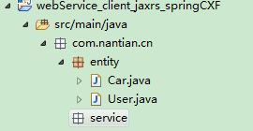

测试
同基于restful风格的的测试一样

