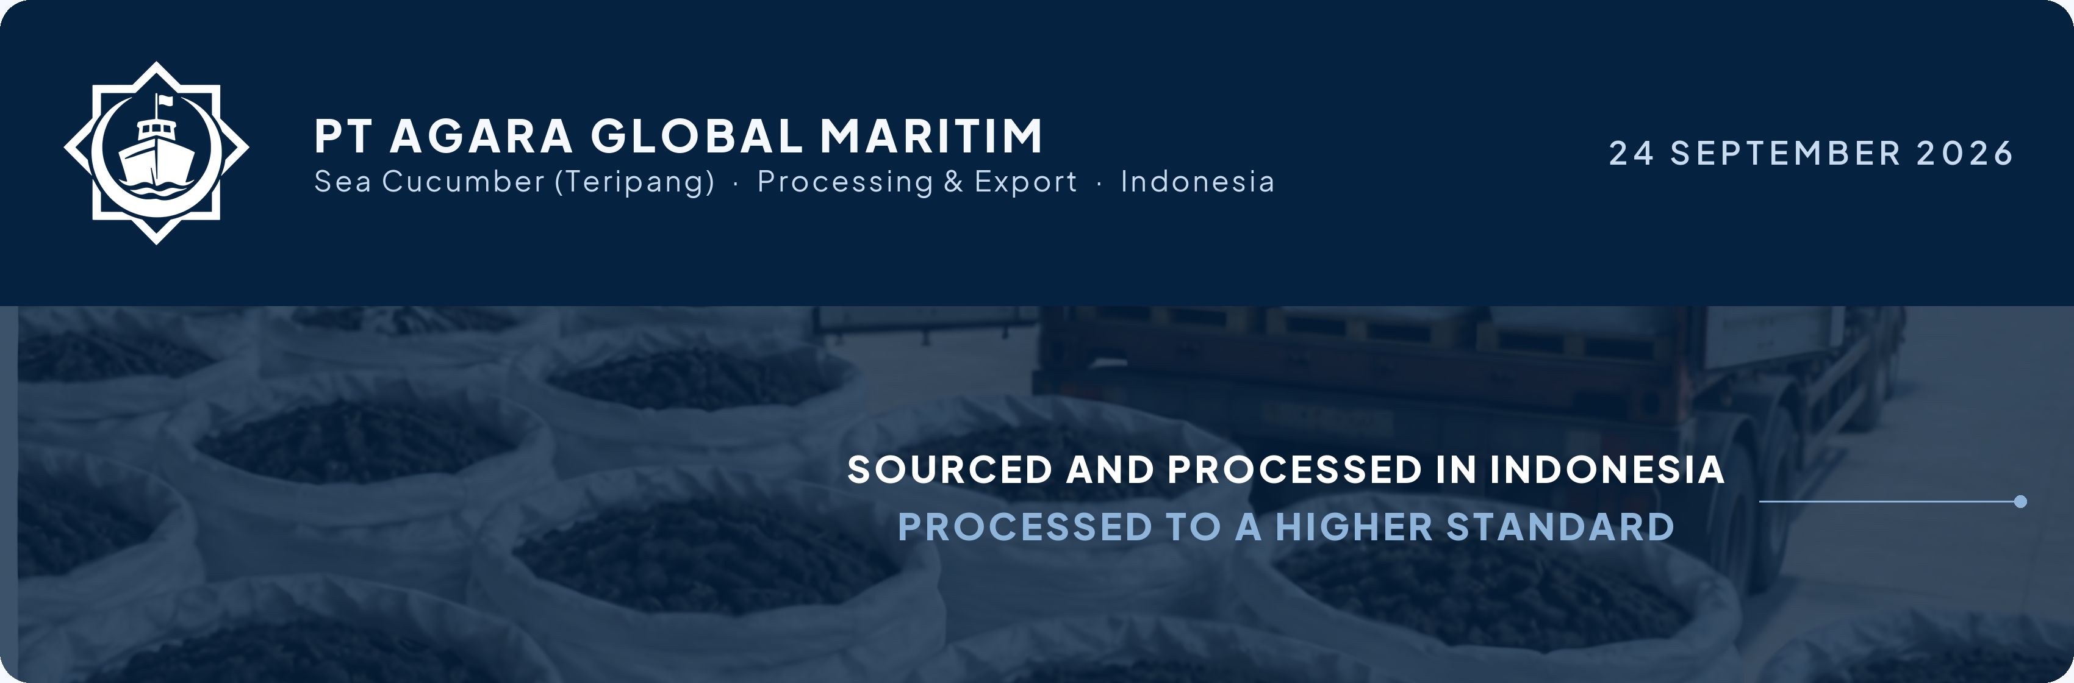
INFORMATION REQUEST
Document Title Goes Here
Prepared by PT Agara Global Maritim for Counterparty Name

Opening paragraph. One or two sentences saying why this document exists and what the reader is being asked to do with it.
Second paragraph. Set out the scope: what the document covers, what it deliberately leaves out, and anything the reader should have to hand before they start.
Third paragraph. State how precise the answers need to be, and say plainly that an incomplete answer is better than no answer.
HOW TO RESPOND
Type each answer into the shaded box beneath the question. The boxes expand as you type, and they also print as blank boxes if you prefer to write by hand.
A useful answer gives the figure or position first, then any conditions, then whether it is final or indicative.

WHAT THIS DOCUMENT COVERS

Context | Where this came from | 1 question
Scope | What is being asked for | 2 questions
Commercials | What it costs and who pays | 2 questions

CONTEXT Where this came from

01 | First question. Keep it to one idea, phrased so the answer can be a figure, a position or a short statement.
 | RESPONSE

SCOPE What is being asked for

02 | Second question, sitting under its own section band.
 | RESPONSE

03 | Third question. Sections can hold as many items as needed and the numbering runs continuously across the whole document.
 | RESPONSE

COMMERCIALS What it costs and who pays

04 | Fourth question.
 | RESPONSE

05 | Fifth question, a longer one, to show how a question that runs to two or three lines sits against its number in the gutter and stays locked to its own response box.
 | RESPONSE

ANYTHING ELSE WE SHOULD KNOW
Context, constraints or corrections that the questions above do not reach.

YOUR CONTACT AT PT AGARA GLOBAL MARITIM
Name Surname
PT Agara Global Maritim · Marunda, North Jakarta, Indonesia
corporate@stratconagaraglobal.com · +62 819-231-001



