
Rolling Beans
Business Plan and Cashflow Forecast
14 August 2026

1. Business Details
Rolling Beans is a mobile coffee cart business operating within the Whangarei region of Northland, New Zealand. The business specialises in barista-crafted espresso beverages served directly at markets, outdoor events, and similar community gatherings, bringing café-quality coffee to customers at the point of their activity rather than requiring them to seek it out. Rolling Beans is structured as a sole trader operation, run part-time by founder Paula Bean, and is scheduled to begin trading in August 2026.
The concept originated from a straightforward market observation. While attending the Whangarei Growers Market, Paula identified that no coffee vendor was present, leaving a clear and unmet demand among the regular foot traffic of shoppers and market-goers. This gap forms the foundation of the business model. Rolling Beans maintains an online presence through its website at rollingbeans.co.nz and across Facebook and Instagram under the handle Rollingbeans, supporting brand awareness between trading days. The business meets all relevant legal obligations and operates from Whangarei as its primary base.

2. Market & Customers
The realistic market for Rolling Beans is defined by the weekly foot traffic at Whangarei's established outdoor markets, particularly the Whangarei Growers Market, and the broader local demand for quality coffee at community events across the Northland region. Rather than drawing on national industry figures, the relevant opportunity is more immediate: a consistent stream of market-goers who are already present, already spending, and currently without access to a quality coffee option on site. At a conservative estimate of 150 to 250 cups per market day and an average price of $5.50 to $6.50, a single-cart operation could realistically generate $40,000 to $70,000 in annual revenue across regular markets and booked events. This is the segment Rolling Beans can genuinely capture at its current scale and staffing level.
The competitive landscape includes several meaningful alternatives that customers already use. Established CBD cafés such as Caffeine Whangarei carry genuine strengths, including a loyal customer base, a comfortable environment, and a well-earned reputation for consistent quality that takes years to build. Food and beverage vendors at the Whangarei Night Markets bring real experience in outdoor trading and existing familiarity with repeat crowds, which is a meaningful advantage in relationship-driven market environments. Supermarket café kiosks benefit from habitual foot traffic and price-driven convenience, and many market-goers simply arrive with their own coffee, which costs nothing and requires no queuing.
Where Rolling Beans can compete is in the combination of location and craft. Fixed cafés require customers to leave the market entirely, and supermarket kiosks rarely deliver a genuinely skilled barista experience. Rolling Beans removes the trade-off between quality and convenience by positioning directly within the market environment, serving customers where they already are, without interrupting their shopping or requiring a separate trip.

3. Vision & Position

Vision
By 2027, Rolling Beans will be the most recognised and sought-after mobile coffee cart among Whangarei coffee lovers, known for bringing quality espresso directly to the people who want it most.

Position Statement
For people who need a great coffee while shopping, Rolling Beans is a superior barista experience that meets customers where they are, satisfying any caffeine fix without asking them to leave what they came to do.

Values
- Quality and freshness in every cup served
- Value for money that respects the customer
- Convenience that removes the friction from great coffee

4. Goals & Achieving Them

Goal 1: Secure exclusive vendor status with market organisers by end of Q2
Rolling Beans will approach the Whangarei Growers Market organisers directly to request a formal meeting and present a compelling vendor proposal. The pitch will highlight the unique customer benefit of on-site specialty coffee, the professional setup Rolling Beans brings, and a fee or revenue-sharing structure that makes an exclusive arrangement attractive to organisers. A polished proposal document, prepared using tools such as Canva or Google Slides, will support the meeting, alongside a small budget of $200–$500 for branding materials and a trial market day to demonstrate operational readiness.

Goal 2: Launch a loyalty stamp card within 30 days targeting 40% repeat customer conversion
A double-sided stamp card offering a free coffee after eight purchases will be designed, printed, and handed personally to every customer from the first market day of trading. Paula will briefly explain the reward at the point of sale and track redemptions weekly using a simple tally sheet or a free app such as Stamp Me. Printing costs are estimated at $50–$150 through a local Whangarei provider, with card design handled through Canva.

Goal 3: Book six paid catering events annually to reduce weather-dependent revenue risk
Paula will build a simple corporate catering pitch package including a pricing menu, setup photographs, and a one-page capabilities sheet, then personally reach out to 10–15 local businesses, event planners, and market contacts who regularly host staff or client functions. A limited-time introductory offer will help secure the first bookings, and satisfied market customers will be encouraged to refer Rolling Beans to their workplaces. A budget of $200–$400 covers printed materials and a basic digital portfolio, with 3–5 hours per week dedicated to outreach and engagement with networks such as the Whangarei Chamber of Commerce.

Goal 4: Recruit and train one relief barista by month three
Paula will identify and bring on a part-time relief barista to eliminate the single-operator coverage risk. The approach and specific resources for this goal still need to be decided.

Goal 5: Expand to two additional Northland markets by year end
Paula will research and apply to suitable Northland markets, targeting options such as Kerikeri and Dargaville, assessing foot traffic, fees, and scheduling viability before committing.

Team & Resources
Rolling Beans currently operates as a part-time sole trader with Paula Bean as the only team member. The goals outlined above are expected to generate approximately 2,002 additional sales units with no additional expenses projected beyond those already accounted for.

5. Financial Position

Opening Position
Rolling Beans begins trading in August 2026 with a $5,000 opening bank balance, $20,000 in assets, no debt, and total equity of $25,000. This conservative but workable foundation reflects the low-overhead nature of a mobile cart operation and gives Paula a modest buffer as the business finds its feet in those first market weeks.

Shape of the 12-Month Forecast
Revenue builds gradually through the first quarter as customer awareness grows, then stabilises across the middle months as market attendance becomes routine. The business targets roughly 150–250 cups per market day at an average price of $5.50–$6.50, pointing toward annual revenue in the $40,000–$70,000 range depending on weather, event bookings, and how quickly the loyal customer base develops. The six catering events targeted across the year provide a meaningful second income stream that helps smooth the weather-dependent dips inevitable in outdoor trading.
Total annual operating expenses sit at approximately $7,212, with vehicle costs ($3,000) and communications and insurance ($1,200 each) forming the three largest ongoing cost lines. Marketing spend of $1,056 annually is modest but sufficient to support the loyalty card programme and basic digital presence. Legal costs of $600 reflect sensible early-stage compliance activity.

Cash Flow Pressures and Closing Position
The months most likely to tighten cash are the winter trading months of June and July 2027, when both foot traffic and willingness to stand outdoors for coffee typically soften in Northland. Holding the $5,000 opening balance in reserve through those months is a practical safeguard.
After accounting for $2,400 in tax payments and a net $2,000 asset movement, the business is projected to close the 12-month period in a stronger position than it began, with improving equity and a cash balance that supports continued trading into the following year.

Graphs
Units Sold & Monthly Sales, Expenses Breakdown, Net Profit/(Loss) and Closing Bank Balance charts appear below.
Financial Graphs
Units Sold & Monthly Sales
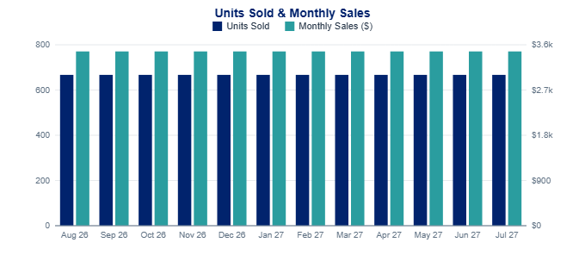
Expenses Breakdown
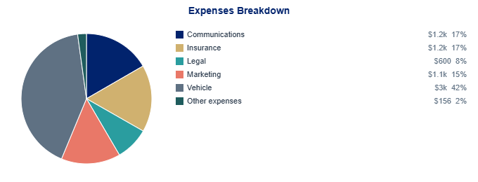
Net Profit / (Loss)
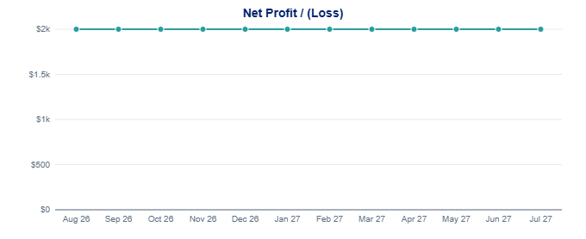
Closing Bank Balance
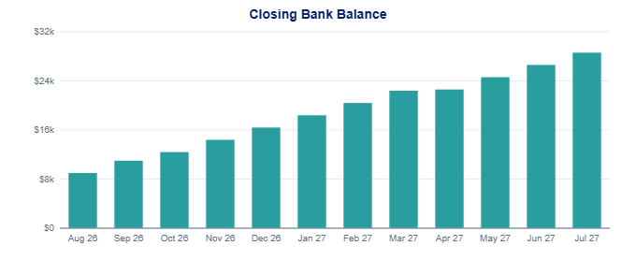

12-Month Cashflow Forecast
Item | Aug 2026 | Sep 2026 | Oct 2026 | Nov 2026 | Dec 2026 | Jan 2027 | Feb 2027 | Mar 2027 | Apr 2027 | May 2027 | Jun 2027 | Jul 2027 | Total
Key Drivers
Units Sold | 667 | 667 | 667 | 667 | 667 | 667 | 667 | 667 | 667 | 667 | 667 | 667 | 8,004
Avg Price | $5 | $5 | $5 | $5 | $5 | $5 | $5 | $5 | $5 | $5 | $5 | $5
Avg Cost | $1 | $1 | $1 | $1 | $1 | $1 | $1 | $1 | $1 | $1 | $1 | $1
Revenue
Products/Services | $3,468 | $3,468 | $3,468 | $3,468 | $3,468 | $3,468 | $3,468 | $3,468 | $3,468 | $3,468 | $3,468 | $3,468 | $41,616
Other Revenue
Total Revenue | $3,468 | $3,468 | $3,468 | $3,468 | $3,468 | $3,468 | $3,468 | $3,468 | $3,468 | $3,468 | $3,468 | $3,468 | $41,616
Cost of Sales
Cost of Sales | $867 | $867 | $867 | $867 | $867 | $867 | $867 | $867 | $867 | $867 | $867 | $867 | $10,404
Gross Profit | $2,601 | $2,601 | $2,601 | $2,601 | $2,601 | $2,601 | $2,601 | $2,601 | $2,601 | $2,601 | $2,601 | $2,601 | $31,212
Gross Profit % | 75.0% | 75.0% | 75.0% | 75.0% | 75.0% | 75.0% | 75.0% | 75.0% | 75.0% | 75.0% | 75.0% | 75.0% | 75.0%
Expenses
Communications | $100 | $100 | $100 | $100 | $100 | $100 | $100 | $100 | $100 | $100 | $100 | $100 | $1,200
Insurance | $100 | $100 | $100 | $100 | $100 | $100 | $100 | $100 | $100 | $100 | $100 | $100 | $1,200
Legal | $50 | $50 | $50 | $50 | $50 | $50 | $50 | $50 | $50 | $50 | $50 | $50 | $600
Marketing | $88 | $88 | $88 | $88 | $88 | $88 | $88 | $88 | $88 | $88 | $88 | $88 | $1,056
Vehicle | $250 | $250 | $250 | $250 | $250 | $250 | $250 | $250 | $250 | $250 | $250 | $250 | $3,000
Other expenses | $13 | $13 | $13 | $13 | $13 | $13 | $13 | $13 | $13 | $13 | $13 | $13 | $156
Total Expenses | $601 | $601 | $601 | $601 | $601 | $601 | $601 | $601 | $601 | $601 | $601 | $601 | $7,212
Net Profit/(Loss) | $2,000 | $2,000 | $2,000 | $2,000 | $2,000 | $2,000 | $2,000 | $2,000 | $2,000 | $2,000 | $2,000 | $2,000 | $24,000
Other Transactions
Asset transactions | $2,000 |  |  |  |  |  |  |  |  |  |  |  | $2,000
Tax payments |  |  | -$600 |  |  |  |  |  | -$1,800 |  |  |  | -$2,400
Total Other Transactions | $2,000 |  | -$600 |  |  |  |  |  | -$1,800 |  |  |  | -$400
Cashflow
Net Cashflow | $4,000 | $2,000 | $1,400 | $2,000 | $2,000 | $2,000 | $2,000 | $2,000 | $200 | $2,000 | $2,000 | $2,000 | $23,600
Closing Balance | $9,000 | $11,000 | $12,400 | $14,400 | $16,400 | $18,400 | $20,400 | $22,400 | $22,600 | $24,600 | $26,600 | $28,600

