TREASURE ISLAND — APP FLOW & USER JOURNEY
UPDATED FOR HTML/CSS/JAVASCRIPT + WORDPRESS • MVP v1.0 • DOCUMENT REV 1.1
This document defines the navigation and user experience for the browser-based version of Treasure Island.
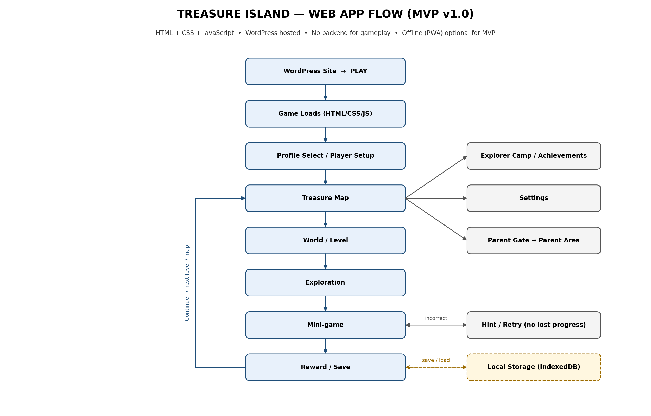

1. Entry & Deployment Flow
Step | Flow
1 | User visits the WordPress website.
2 | User selects PLAY TREASURE ISLAND.
3 | WordPress routes the user to /games/treasure-island/ or embeds the game page.
4 | HTML/CSS/JS game initializes in the browser.
5 | Local storage is checked for existing explorer profiles (up to three).
6A | One or more profiles → Profile Select → resume that explorer's Treasure Map.
6B | No profile → Player Setup.

2. Global App Flow
From | Action | To
Launch | Play game | Profile Select / Player Setup
Profile Select | Choose explorer | Treasure Map
Profile Select | Add explorer (max 3) | Player Setup
Player Setup | Save nickname, age band, avatar | Treasure Map
Treasure Map | Select world | World Detail
World Detail | Select unlocked level | Level Intro
Level Intro | Start | Exploration
Exploration | Discover challenge | Mini-game
Mini-game | Correct | Reward
Mini-game | Incorrect | Hint / Retry
Reward | Continue | Next Level / Map
Treasure Map | Camp | Explorer Camp
Treasure Map | Awards | Achievements
Treasure Map | Parent | Parent Gate → Dashboard
Treasure Map | Settings | Settings

3. First-Time User Journey
- Open WordPress website.
- Tap PLAY TREASURE ISLAND.
- Game loads its HTML/CSS/JavaScript assets.
- Enter a nickname (no full name) and select age/difficulty band.
- Choose explorer avatar.
- Meet Kiki (pre-recorded English voice; audio starts after the first tap).
- Complete the short tutorial.
- Enter Pirate Beach.
- Complete the first counting/observation challenge.
- Receive 1–3 stars and coins.
- Save progress locally.
- Return to the Treasure Map.
- Continue to the next unlocked level.

4. Returning User Journey
- Open the game URL.
- Game reads local profiles and progress.
- If more than one profile exists, the child picks their explorer on Profile Select.
- Show Treasure Map.
- Highlight the next recommended level.
- Player continues the adventure or visits Camp/Achievements.
- Save progress after meaningful actions.

5. Level Flow
Level Intro → Exploration → Mini-game → Feedback → Reward → Local Save → Next Level / Map
- Stars (1–3) reflect attempts and hints used; replaying a level can improve stars.
- Coins are earned on every completed level and are spent in Explorer Camp.
- Gems are awarded only for completing a world or earning an achievement.

6. Mini-Game Decision Flow
State | Player Action | Result
Challenge appears | Read/listen | Start interaction
Attempt | Tap/drag/select/arrange | Evaluate answer locally
Correct | Continue | Reward + progress
Incorrect | Retry or Hint | Friendly feedback; no lost progress
Completed | Continue | Save result locally
Milestone | Continue | Unlock achievement/item (+ gems if earned)
World complete | Continue | All 10 levels done → map piece + gems + next world unlocked

7. World Unlock Flow
World | Entry Condition
Pirate Beach | Available after player setup
Mystery Jungle | All 10 Pirate Beach levels completed (map piece 1 awarded)
Crystal Cave | All 10 Mystery Jungle levels completed (map piece 2 awarded)
Ancient Temple | All 10 Crystal Cave levels completed (map piece 3 awarded)
Treasure Island | All 10 Ancient Temple levels completed and all four map pieces collected
Each world has 10 levels that unlock one after another. Stars do not block progress; any completed level counts. Treasure Island adds geography challenges such as map reading and compass directions.

8. Child-Facing Screen List
Screen | Main Purpose | Primary Action
Splash | Brand/game initialization | Continue
Profile Select | Choose or add explorer (max 3) | Select / Add
Player Setup | Nickname + age band + avatar | Start Adventure
Treasure Map | Main navigation | Explore
World Detail | Level selection | Play Level
Level Intro | Mission briefing | Start
Exploration | Discover objects/clues | Interact
Mini-game | Solve challenge | Submit
Success/Retry | Explain outcome | Continue / Retry
Reward | Show progress | Continue
Camp | Personalization (spend coins/gems) | Equip/Place
Achievements | Milestones | View
Settings | Preferences | Save/Back

9. Parent Flow
Step | Screen/Action
1 | Parent holds/taps the Parent Area entry.
2 | Complete a simple parent gate.
3 | Open local Parent Dashboard.
4 | View levels, stars, challenge categories and local play-time summary for each profile.
5 | Optionally open settings, including anonymous analytics on/off.
6 | Reset one profile or all data, only after confirmation.
7 | Return to game.

10. Local Storage Flow
The browser is the persistence layer for the MVP.
Data | Storage | Example
Profile | IndexedDB | Nickname/age band/avatar (up to 3 profiles)
Progress | IndexedDB | Unlocked worlds/levels, map pieces (per profile)
Rewards | IndexedDB | Coins/gems/stars
Achievements | IndexedDB | Badge completion
Settings | localStorage | Audio on/off, analytics on/off, last profile
Checkpoint | IndexedDB | Current level state

11. WordPress Integration Flow
Recommended structure:
WordPress Website
↓
PLAY TREASURE ISLAND
↓
yourdomain.com/games/treasure-island/
↓
index.html
├── CSS
├── JavaScript
├── JSON content
└── local assets
- WordPress should not manage level state or execute game logic.
- The game should be deployable as a self-contained static web application.
- An iframe is possible, but direct navigation/full-screen game mode is preferred.
- Do not make the game dependent on a WordPress plugin unless there is a clear future need.

12. Responsive Navigation
Device | Design Approach
Mobile | Portrait-first, full-screen game, large touch controls
Tablet | Responsive centered game area with expanded map
Desktop | Larger game viewport with map and side information where useful

13. Offline / PWA Flow (Optional for MVP)
Offline play is optional for the MVP and planned in full for V1.2. When PWA caching is enabled, the flow is:
- User loads the game while online for the first time.
- Browser downloads the game assets.
- Optional service worker caches static game assets.
- User can later reopen the game without network access.
- Game reads local profile and progress.
- Core gameplay continues locally.
- Progress is saved locally.
The first load still requires the game assets to be available. Offline replay depends on successful browser caching/service-worker setup.

14. Error & Edge Cases
- Browser refresh during a level → restore latest safe checkpoint.
- No network → if PWA caching is enabled and assets are cached, continue; otherwise show a clear "connect to the internet to play" message.
- Incorrect answer → retry/hint, never erase progress.
- Local storage unavailable → show a clear message and avoid pretending progress was saved.
- Corrupt local data → offer Parent Area reset.
- Small screen → scale/reflow controls rather than clipping content.
- Audio blocked by browser autoplay policy → start audio after the player's first interaction.
- Analytics blocked or unreachable → game continues normally; events are dropped silently.
- Fourth profile requested → explain that three explorers is the limit; a parent can reset one in the Parent Area.

15. Developer Build Order
- Create static HTML/CSS/JS project shell.
- Create responsive game viewport and navigation.
- Implement local state, IndexedDB/localStorage and up to three profiles.
- Build Treasure Map.
- Build one complete Pirate Beach level.
- Build the reusable mini-game framework and all eight engines.
- Add rewards (stars, coins, gems), map pieces and world unlocks.
- Add remaining four worlds.
- Add Camp and Achievements.
- Add Parent Area.
- Add animation, recorded Kiki voice and question read-aloud audio.
- Add optional privacy-safe analytics; add PWA caching only if chosen for this release.
- Deploy under WordPress hosting.
- Test mobile, desktop, refresh, offline and save/recovery scenarios.

16. Recommended URL Structure
URL | Purpose
/ | WordPress home
/parents/ | Parent information
/games/ | Game landing page
/games/treasure-island/ | Actual game application
/games/treasure-island/assets/ | Static assets
/games/treasure-island/data/ | Game content JSON

17. Definition of Done
- Game can be opened from WordPress with one clear PLAY action.
- New child can complete the first level without external instructions.
- Returning child picks their profile and resumes saved progress (up to three profiles).
- All five worlds unlock in order when the previous world's 10 levels are completed.
- 50 levels are playable in each of the three age bands.
- Rewards persist across refresh.
- Mobile and desktop layouts are usable.
- Core game does not require backend/API access.
- If PWA caching is enabled, the cached game can be replayed offline (optional for MVP).
- Parent Area and local reset work correctly.
- Analytics is anonymous, can be switched off, and never blocks gameplay.

