HELLENIC MEDITERRANEAN UNIVERSITY

SCHOOL OF ENGINEERING

DEPARTMENT OF ELECTRICAL AND COMPUTER ENGINEERING

# **ARTIFICIAL NEURAL NETWORKS**

***Professor*:** George M. Papadourakis, Ph.D.

## EXERCISES #3

1. Below is a diagram of a self–organizing map:

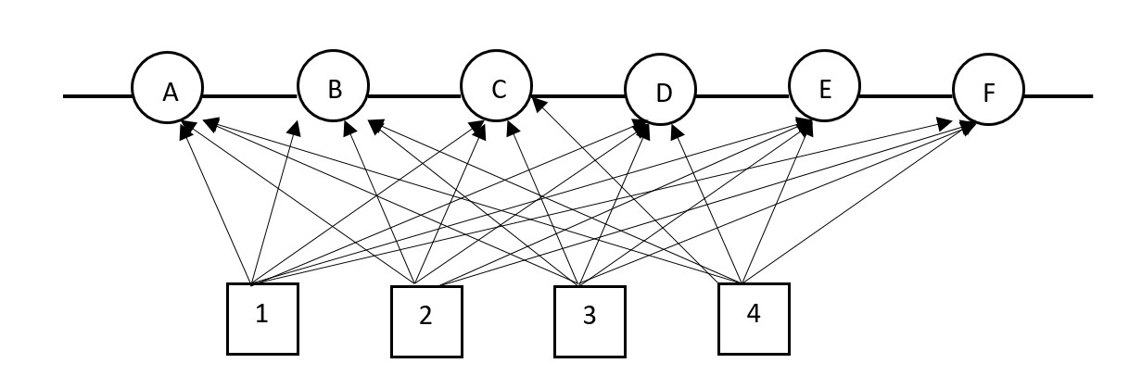

Answer the following questions:

1. How many input nodes does this SOM have?
2. How many output nodes does this SOM have?
3. How many dimensions are in the input space that this SOM is analyzing?
4. How many weights does each of the output nodes have?
5. How many dimensions does the output lattice of this SOM have?
6. How many output nodes can fire simultaneously?
7. Is it important what value the output node sends when it fires?
8. How many clusters can this SOM detect in the input data?
9. If node D is the winner, which output nodes are its immediate neighbors?
10. Consider the following self–organizing map:

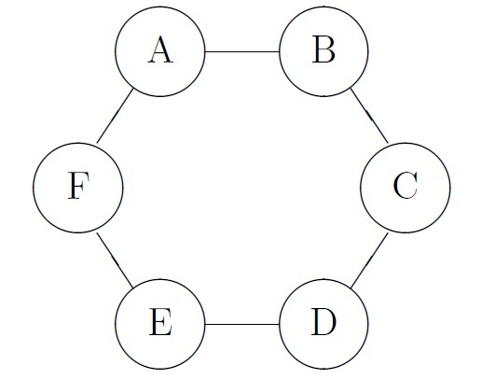

The output layer of this map consists of six nodes, A, B, C, D, E and F, which are organized into a two–dimensional lattice. Each of the output nodes has two inputs $x_{1}$ and $x_{2}$ (not shown on the diagram). The values of the weights for all output in the SOM nodes are given in the table below:

|  |  |  |  |  |  |  |
| --- | --- | --- | --- | --- | --- | --- |
| Node | A | B | C | D | E | F |
| *w1* | 0.1 | 0 | 0.3 | -0.2 | 0.3 | -0.4 |
| *w2* | 0.2 | 0.4 | -0.2 | -0.3 | 0.2 | 0.1 |

1. Calculate which of the six output nodes is the winner if the input pattern is $x$ = (0.2,−0.4).
2. After the winner for a given input ***x*** has been identified, the weights of the nodes in SOM are adjusted using adaptation formula:

$$w\left(t+1\right)=w\left(t\right)+ηh[x-w\left(t\right)]$$

where $η$ is the learning rate, and $h$ is the neighborhood function. Let $η=0.5$ and the neighborhood be defined as:

$$h=\left\{\begin{aligned} 1 if the node is the winner \\ 0.5 if the node is immediate neighbor \\ 0 otherwise \end{aligned}\right.$$

Adjust the weights in the SOM.

1. What are the main similarities and differences between feed–forward neural networks and self–organizing maps?
2. In a Kohonen neural net with 1000 constant training cycles and initial learning rate 0.15, in how many cycled the learning rate will become 0.03?
3. Below is a diagram of a self–organizing map:

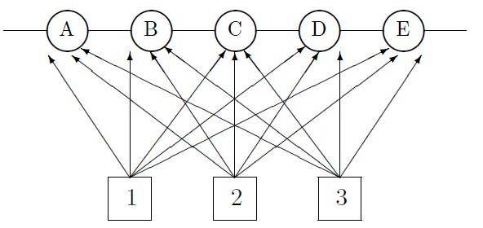

The SOM is used to classify types of airplanes based on three parameters: Size, speed and passenger load. The weights of the output nodes are shown in the table below:

|  |  |  |  |  |  |
| --- | --- | --- | --- | --- | --- |
| Node | A | B | C | D | E |
| *w1* | 0.6 | 1.0 | 0.2 | 0.4 | 1.0 |
| *w2* | 0.4 | 0.2 | 1.0 | 0.6 | 0.4 |
| *w3* | 1.0 | 0.2 | 0.2 | 0.4 | 1.0 |

Each of the three parameters is assessed on a scale from 0.2 to 1. For example, small airplanes have size 0.2, while huge planes would have value 1. Each plane is represented as a three–dimensional vector with coordinates corresponding to these three parameters. Answer each of the following questions justifying your answers

1. How many types of planes can this SOM classify?
2. Which node will be the winner, if a vector representing a fighter jet (0.3,0.9,0.2), is fed into the input? Show your calculations.
3. Which node will be the winner, if a vector representing a jumbo passenger jet (0.9,0.5,0.9), is fed into the input? Show your calculations.