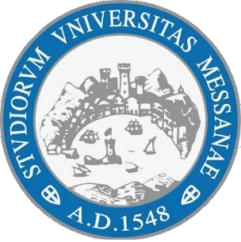
UNIVERSITY OF MESSINA
DEPARTMENT OF ENGINEERING
Master's Degree in ……………………………………………

Title of the thesis
Supervisor: | Candidate:
Prof. Francesco Longo | Name Surname
Co-supervisor:
Prof. Name Surname
ACADEMIC YEAR 20…/20…

