Question 1

What is the URL for the submitted dashboard?

Please make sure this URL brings up the dashboard immediately so that no additional user interaction is needed.

The data should be public so no user authentication should be required.

URL

[**https://public.tableau.com/app/profile/aaron.miller1614/viz/PastDecadeCaliforniaCountiesEducationandEarnings/Dashboard?publish=yes**](https://public.tableau.com/app/profile/aaron.miller1614/viz/PastDecadeCaliforniaCountiesEducationandEarnings/Dashboard?publish=yes)

​Title

**Past Decade California Counties Education and Earnings**

​

Caption

**This dashboard represents California counties with higher rates of education correlated with higher fiscal earnings. It was created from data in the CSV file "Merged_California_County_Data_BLS_DataUSA_FRED_FCC.csv". The CSV file's data is derived from the Bureau of Labor Statistics, Data USA, Federal Reserve Economic Data, and Federal Communications Commission data. The CSV can be found at:** [**https://uillinoisedu-my.sharepoint.com/:f:/g/personal/aaronm6_illinois_edu/Emma1qabqAtFjd5gYdmP9X0BQosa0IURqC2ZxBfDsY8ZjA?e=y0vRza**](https://uillinoisedu-my.sharepoint.com/:f:/g/personal/aaronm6_illinois_edu/Emma1qabqAtFjd5gYdmP9X0BQosa0IURqC2ZxBfDsY8ZjA?e=y0vRza)

**or**

[**https://uillinoisedu-my.sharepoint.com/personal/aaronm6_illinois_edu/_layouts/15/onedrive.aspx?id=%2Fpersonal%2Faaronm6%5Fillinois%5Fedu%2FDocuments%2FSchool%2Fcs416%2Dsu25%2Fdashboard%20project&ga=1**](https://uillinoisedu-my.sharepoint.com/personal/aaronm6_illinois_edu/_layouts/15/onedrive.aspx?id=%2Fpersonal%2Faaronm6%5Fillinois%5Fedu%2FDocuments%2FSchool%2Fcs416%2Dsu25%2Fdashboard%20project&ga=1)

**or**

[**https://github.com/StrawHatAaron/CS416DashboardProject/blob/main/Merged_California_County_Data_BLS_DataUSA_FRED_FCC.csv**](https://github.com/StrawHatAaron/CS416DashboardProject/blob/main/Merged_California_County_Data_BLS_DataUSA_FRED_FCC.csv)

**2.**

Question 2

**This picture represents how the the Bachelor Degree or Higher Group selected to represent counties with a high percentages of adults that have obtained a bachelors degree or higher. We can see the trend for the average of all years (All Years Average) in this photo.**

Upload a screenshot of your dashboard answering that question by showing two or more simultaneously displayed charts. Make sure the screenshot contains the entire contents of both charts, as demonstated in the example image of the problem specification.

The image should either be uncompressed or use a lossless compression method, such as TIFF or PNG. Check your operating system to determine how to create a screenshot, and then your favorite photo editing software to make sure you save it in the right lossless format.

Upload File

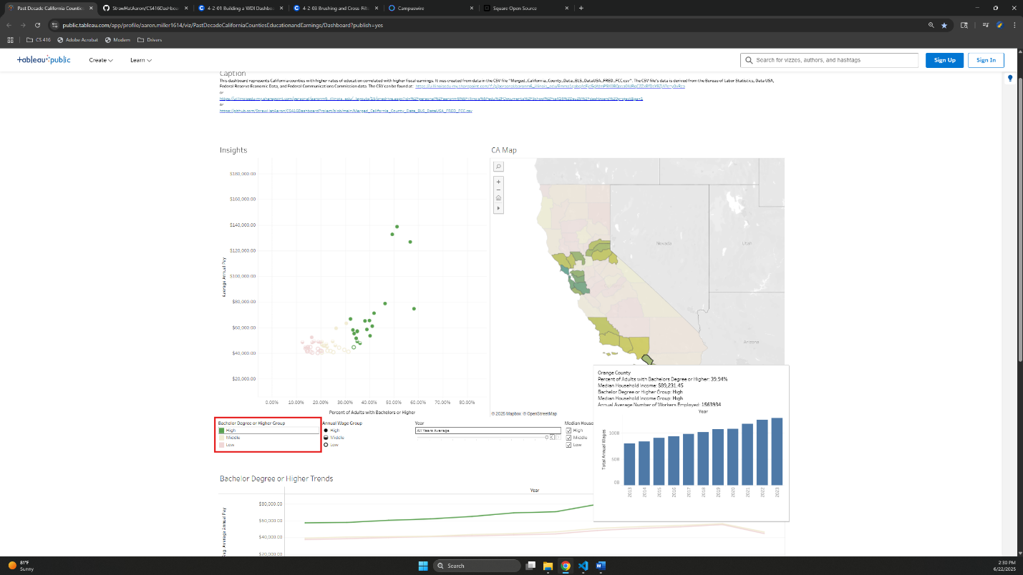

**Aaron%20Miller%20-%20Dashboard%20Project%20Screenshot%202025-06-22%20143020.png**

363KB

Uploading... 100% Complete

-------------------------------------------------------------------------------------------------------------------------------------------------------------------

Question 3

What is one question that the dashboard can answer by utilizing two or more simultaneously displayed charts?

**Do counties in California with a high Percent of Adults with Bachelor’s Degree or Higher geographically cluster together and create pockets with larger fiscal earnings compared with the rest of the state?**

What is the answer?

**Yes, we can see this trend over the decade time span of 2013 to 2023.**

How do these two charts indicate the answer?

**The CA Map shows the greener counties as a larger Percent or Adults with a Bachelor’s Degree or Higher geographically cluster in 2 to 3 areas center (center-west, center-east) and south-west. We can select High in the Bachelor Degree or Higher Group cross highlighter and see in the CA Map these 2 to 3 geographic clusters in California. Furthermore, in the worksheet Insights to the top left we can see the Average Annual Pay is larger than the Middle and Low Bachelor Degree or Higher Group(s) thus these higher educated geographic areas have higher fiscal earnings. We can also see areas with the largest percentage of higher education have the larger ratios of Total Annual Wages with respect to their Annual Average Number of Workers Employed when hovering the courser over counties in the CA Map.**

Please carefully and completely answer all three questions, and especially how the combination of both charts

provides the answer to the observer's question. Make sure the question that the two charts answer requires both charts,

and is a reasonable question that hasn't been ridiculously contrived for this assignment.

﻿

-------------------------------------------------------------------------------------------------------------------------------------------------------------------

Question 4

How does the layout of these charts promote visual understanding of the data across multiple charts? Make sure your explanation describes color consistentcy, alignment and any other ways the layout improves visual understanding.

**Using the color scheme red, yellow, and green we can see clearly Low, Middle and High tertiles for the Bachelor Degree or Higher Group. This allows us to easily perceive where the bulk of counties lay within Annual Average Wage Group, Median Household Income, and Percent of Adults with Bachelors or Higher geographic location.**

**Across multiple worksheets I use dollars, percentage points and geographic location to represent what type of measurement the user is focusing on.**

**Details on demand have also been appropriately grouped organized within their respective tooltips.**

-------------------------------------------------------------------------------------------------------------------------------------------------------------------

Question 5

Indicate which chart is the "first" chart. Then justify the choice of this chart type, its axes and marks based on the data variables it shows.

**The CA Map to the top right shows that when green High for Percent of Adults with Bachelors Degree or Higher is selected, there are 2 to 3 geographic clusters in California across all the years 2013 to 2023 and All Years Averaged values. This CA Map confirms the first part of my question that California counties have a high Percent of Adults with Bachelor’s Degree or Higher geographically clustering together. Furthermore, when we use the cursor to hover over counties in the map we can see the green counties tend to have the largest Total Annual Wages while the red less higher educated counties tend to have lower Total Annual Wages respective to the Annual Average Number of Workers Employed.**

**One reason for this may be that Californians prefer to live around well urbanized coastal and Lake Tahoe areas due to convenience of modern infrastructure and pleasure of natural beauty in these areas. Another reason for this may be that the number of economic opportunities of specialized labor surrounding Silicone Valley, Hollywood, and Lake Tahoe require a Bachelor Degree or Higher.**

﻿

-------------------------------------------------------------------------------------------------------------------------------------------------------------------

Question 6

Indicate which chart is the "second" chart. Then justify the choice of this chart type, its axes and marks based on the data variables it shows.

**Insight worksheet in the top left.**

**When High for Percent of Adults with Bachelors Degree or Higher is selected, we can see the Insight worksheet shows 14 to 17 out of 19 counties in the High Annual Wage Group and High Median Household Income Group depending on the year selected. This reveals a strong correlation between counties with high fiscal earnings and Percent of Adults with Bachelors Degree or Higher. This builds off the “first” chart and confirms that these highly educated geographically clustered locations have several measures that correlate with higher fiscal earnings on a macro county level and micro individual level compared to the rest of the state.**

﻿ **When we chose the averaged values for all years (All Years Averaged) in the Years filter we can see this trend in one view that supports the answer to my proposed question.**

-------------------------------------------------------------------------------------------------------------------------------------------------------------------

Question 7

How does your dashboard provide details on demand?

**Insights worksheet provides exact details and numbers of each county for the year selected during action cursor hover/select: County Name, Average Annual Pay, Percent of Adults with Bachelors or Higher, Annual Wage Group, Bachelor Degree or Higher Group, Avg Annual Pay Trend for an individual overall years for that county**

**CA Map worksheet provides details and numbers of each county for the year selected during action cursor hover/select: County Name, Percent of Adults with Bachelors or Higher, Median Household Income, Bachelor Degree or Higher Group, Median Household Income Group, Annual Average Number of Workers Employed, Total Annual Wages for the entire county overall years.**

**Bachelor Degree or Higher Trends worksheet provides details and numbers of all counties during action cursor hover/select: Bachelor Degree or Higher Group, Year, AVG(Average Annual Pay), AVG(Median Household Income), AVG(Over-the-Year Average Annual Pay Percent Change)**

﻿

-------------------------------------------------------------------------------------------------------------------------------------------------------------------

Question 8

How does your dashboard support cross-filtering between these two charts? The cross filtering must be bi-directional, such that a selection made in the first chart is reflected in the second chart, and a selection made in the second chart is reflected in the first chart.

﻿**The filters Year and Median Household Income Group provide cross-filtering between the Insights and CA Map. We can also see that when a county or counties is/are selected in Insights or CA Map, the respective selection is made in the other worksheet.**