**ME424 Project 3 Report**

Name: 江轶豪 SID: 11912404

1. **solution:**

$$u+w=IR+L\dot{I}+V_{c}$$

$$I=C\dot{V_{c}}$$

Knowing that 

then 

where 

1. **solution:**



where 



1. **solution:**
2. First define the system



where 

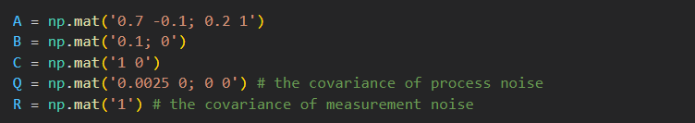

1. Second, start the simulation process in N = 200 steps in total

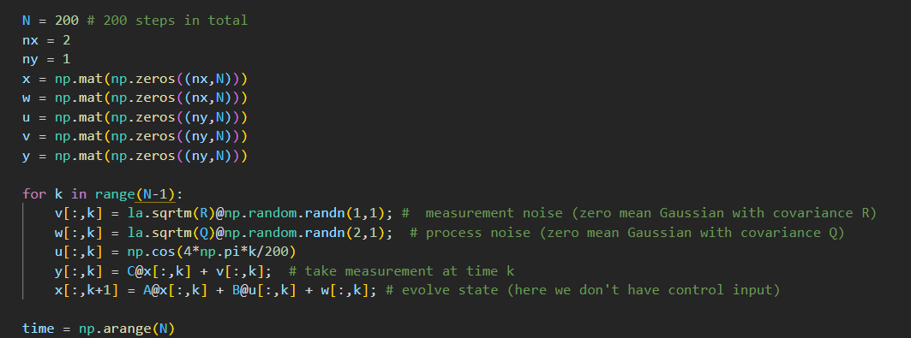

1. Third, save the result as ground truth and plot them as comparison

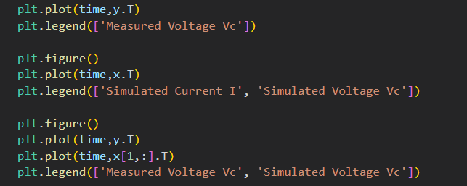

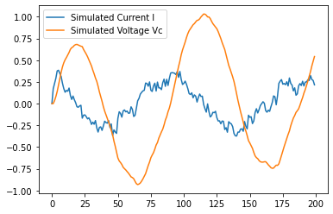

**figure 1: the plotting of *xk* (simulated current & simulated voltage)**

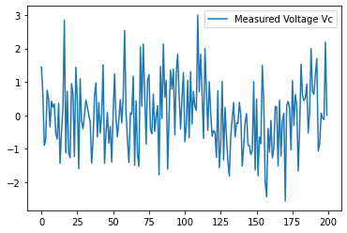

**figure 2: the plotting of *yk* (Measured voltage)**

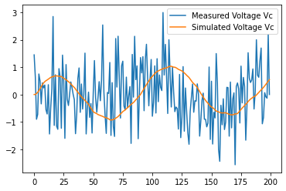

**figure 3: the comparison of *xk,2* & *yk* (simulated voltage & measured voltage)**

1. Implement of the Kalman Filter

solution:



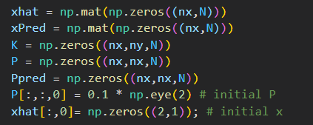

The simulation process with Kalman Filter:

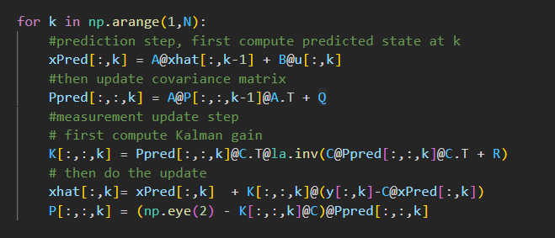

The code of the plotting of the result:

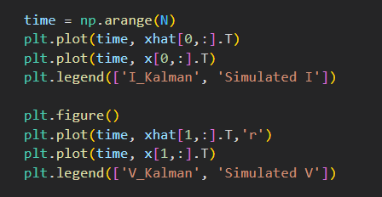

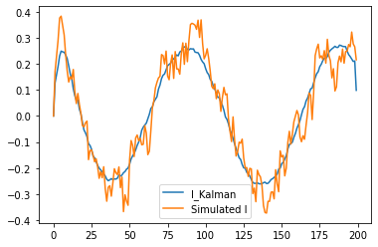

**figure 4: the plotting of estimated current & simulated current**

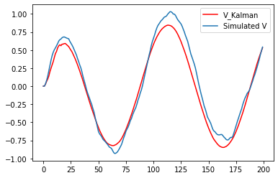

**figure 5: the plotting of estimated voltage & simulated voltage**

Compute and plot the measurement error *vk* and estimation error (Here I used the **absolute value** to define the error):

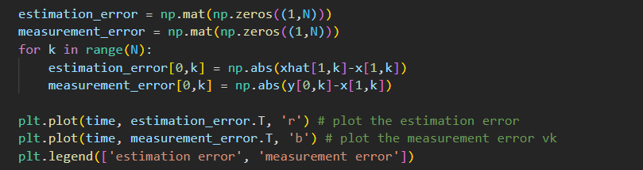

The result is shown as below:

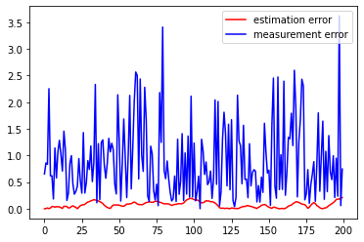

**figure 6: the plotting of estimation error & measurement error**

From the figure above we can see the result of the estimation error and the measurement error. We can see that **the measurement error without Kalman Filter is larger than the estimation error after Kalman Filter**, which shows that Kaiman Filter has the precision of estimate the data involving the measurement and the prediction.

1. Modified Kalman Filter

solution:

1. Modify the Kalman Filter and add it into the new update model:

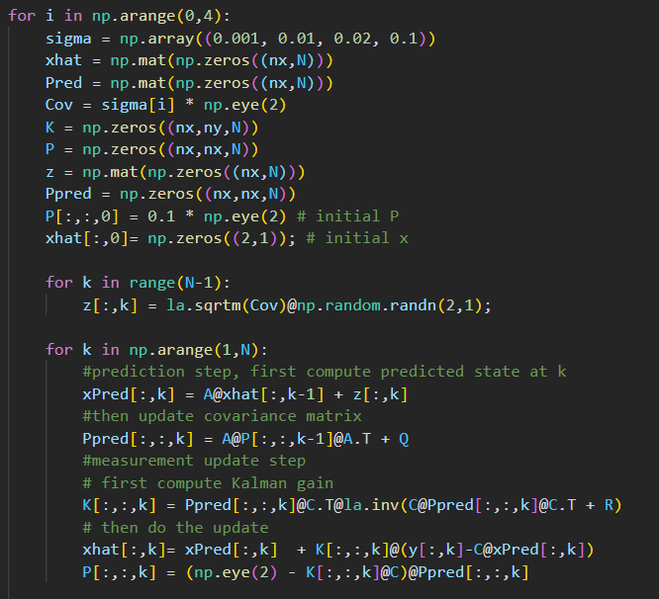

1. Store the value for $σ$ = 0.001, 0.01, 0.02, 0.1

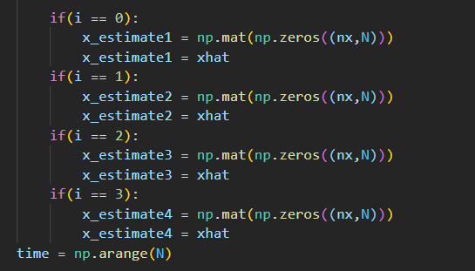

1. Plot the result

$σ$ = 0.001

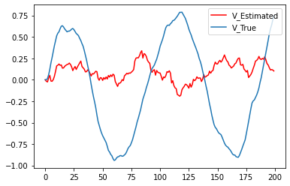

**figure 7: the plotting of estimation voltage & true voltage under $σ$ = 0.001**

$σ$ = 0.01

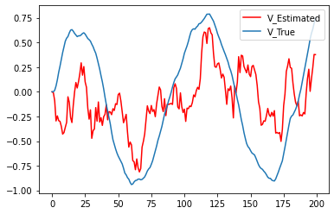

**figure 8: the plotting of estimation voltage & true voltage under $σ$ = 0.01**

$σ$ = 0.02

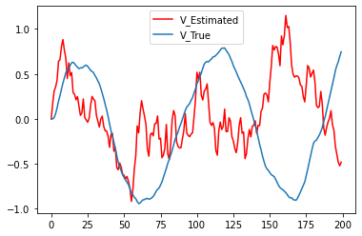

**figure 9: the plotting of estimation voltage & true voltage under $σ$ = 0.02**

$σ$ = 0.1

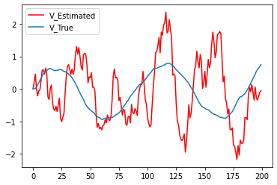

**figure 10: the plotting of estimation voltage & true voltage under $σ$ = 0.1**

1. **compute the average squared error:**

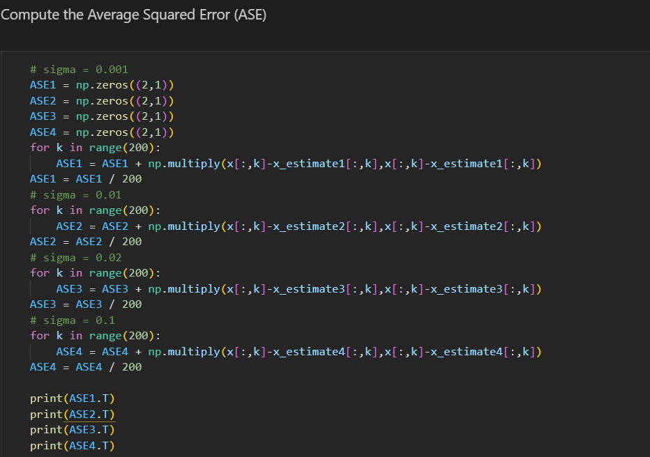

The result is shown as below:

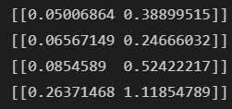

The first one is the average squared error of $σ$ **= 0.001**;

The second one is the average squared error of $σ$ **= 0.01**;

The third one is the average squared error of $σ$ **= 0.02**;

The last one is the average squared error of $σ$ **= 0.1**;

Explanation:

We can see that as $σ$ grows, the value of the average squared error shows a increasing trend although there might be some fluctuation. Since $σ$ is called scale parameter in the Gauss’ distribution, which defined the degree of the discretization of the Gauss’ distribution model with the data. As $σ$ grows, the value of a larger input *zk* have a larger value more prospectively, which will cause a larger error.