Noor Ul Hana Transport LLC
Delivering Reliability.
Moving Your Business Forward.
Dubai-UAE

Company Overview
Noor Ul Hana Transport LLC is a UAE-based logistics and transportation company providing reliable, efficient, and cost-effective transport solutions across various industries. With a strong commitment to professionalism and timely delivery, we ensure safe movement of goods, construction materials, and commercial cargo across the UAE. Our experienced team and well maintained fleet allow us to handle a wide range of transportation requirements including container transport, construction logistics, and general cargo movement.

Mission:
To provide reliable and cost-effective transportation solutions while ensuring safety, efficiency, and complete customer satisfaction.
Vision:
To become a trusted logistics and transportation partner in the UAE by delivering consistent service quality and innovative transport solutions.

Our Services:
- Sand, Aggregate & Raw Material Transport – Reliable delivery of construction and industrial materials.
- Fodder & Animal Feed Transport – Safe and timely transportation of animal feed and fodder.
- Light & Heavy Truck Cargo Transport – Reliable transport of goods using light and heavy trucks.
- Container Transportation – Safe movement of containers between ports, warehouses, and project sites.
- Flatbed & Trailer Transport – Transportation of heavy equipment, machinery, and oversized cargo.
- Construction Logistics – Dedicated transport solutions for construction projects and materials.
- Loose Cargo Transportation – Efficient handling and delivery of loose cargo for commercial clients.
- Equipment & Machinery Transportation – Specialized trailers used for moving heavy equipment and machinery.

Our Fleet
- Flatbed Trailers (40, 45, 50 ft) – Available now
- Curtain Side Trailers – Available now
- Container Transport Trailers – Coming Soon
- Heavy Equipment Transport Vehicles – Coming Soon
- Staff Buses – Coming Soon

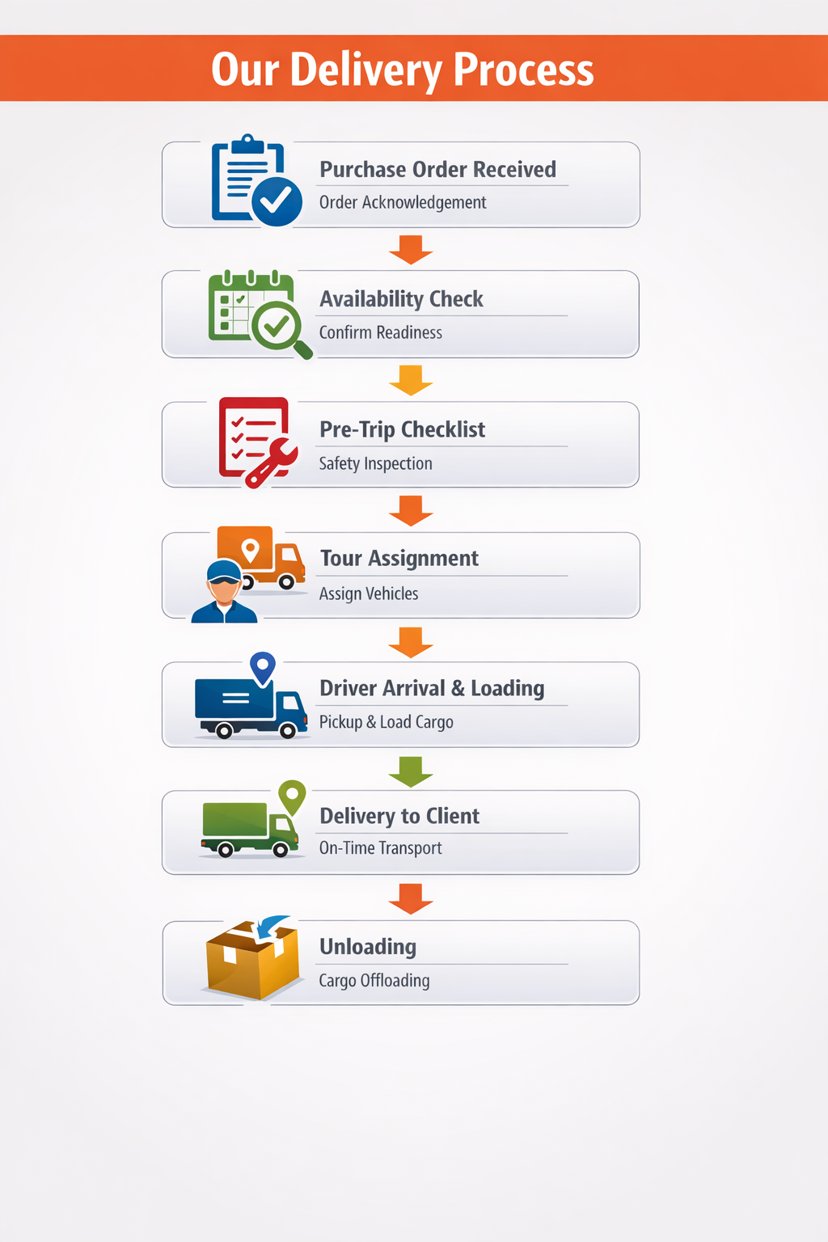
Why Choose Noor Ul Hana Transport?
- Experience – Over a decade of reliable service across the UAE
- Timely Delivery – Ensuring your cargo reaches on schedule
- Cost Efficiency – Competitive solutions without compromising quality
- Flexibility – Availability tailored to client needs, despite constraints
- Commitment – Dedicated to excellence and customer satisfaction

Current Stats:

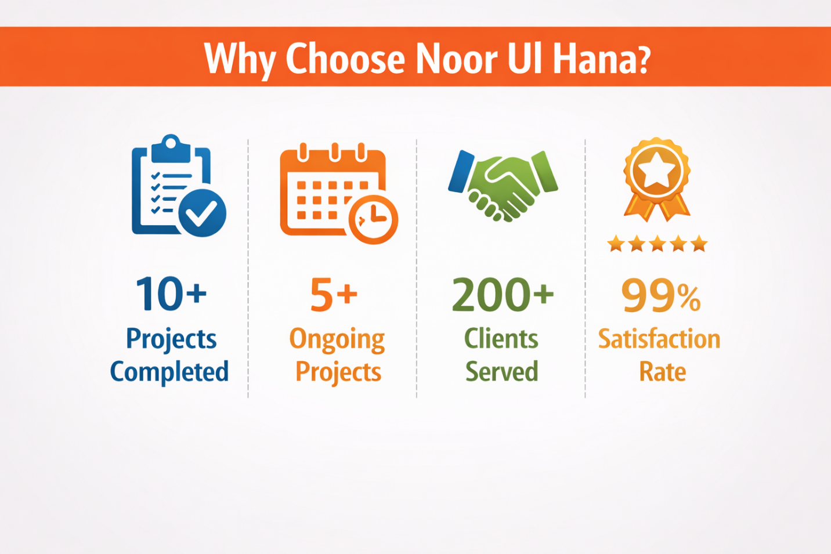

Contact Us N
Noor Ul Hana Transport LLC
Ras Al Khor Industrial Second, Dubai, United Arab Emirates
Phone: +971553423828
Email: info@noorulhana.com

