**Description of the idea**

Our idea is a website containing videogames. The user will be able to pick between 10 or more different games. The website that provides classic lite games like Snake and Tic-Tac-Toe, designed for quick and enjoyable play. Our website is accessible via any web browser, ensuring convenient access for all.

**Personas**

### General Target Group Description

Rocket Cosmo's target audience comprises casual gamers aged 18 to 35, seeking an online platform for leisurely gaming. These users have varying levels of gaming experience, from occasional players to dedicated enthusiasts. They are looking for a website that provides classic lite games like Snake and Tic-Tac-Toe, designed for quick and enjoyable play. Our website is accessible via any web browser, ensuring convenient access for all.



**Age**: 24  
**Occupation**: Student  
**Background**: John is a full-time university student at the HFU with a busy schedule. When studying, he likes short breaks to relax and distract himself for a couple of minutes. He is not a hardcore gamer but enjoys lite and easy-to-understand games such as Tic-Tac-Toe as it does not require a significant time commitment. He often plays on his tablet during short study breaks as well as during his free time and is looking for a platform to access such lite games.

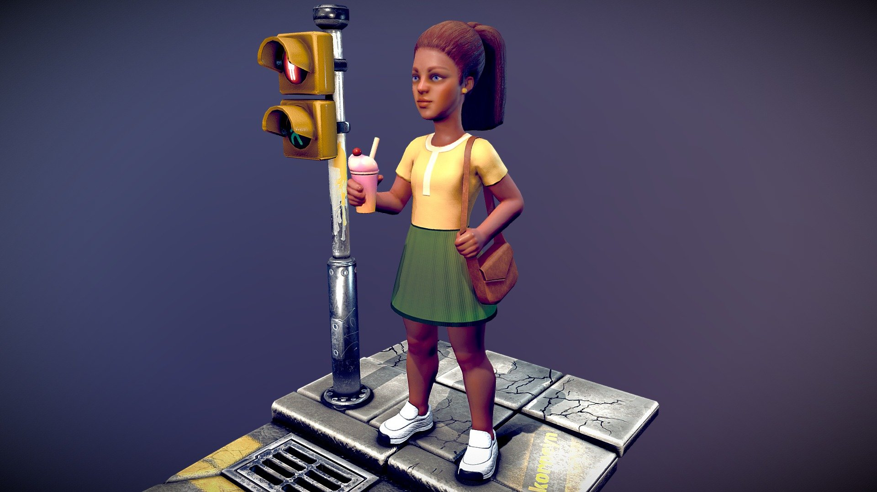



**Age:** 30 **Occupation:** Software Developer **Background**: Analyze is tech-savvy with a passion for gaming. As a developer, Analyze appreciates well-designed classic games. Although she is more familiar with more high-end developed games, Analyze has a huge interest in old-school games and enjoys challenging her colleagues to a multiplayer game or single-player game during her lunch breaks. She prefers games that are accessible through a web browser without requiring complicated installations.

**Age**: 25

**Occupation**: Parent who stays at home by profession

**Background**: Martha is a mother looking for 2D family games to play with her children. She likes to play age-appropriate, simple-to-understand games. Martha appreciates games that give her family time and give her kids educational opportunities. Martha thinks that video games can be an effective teaching tool. She searches for 2D games that teach her kids important life lessons like creativity and problem-solving in addition to being entertaining. Martha views gaming as an additional educational tool for her kids.

**Age:** 35

**Occupation:** Graphic designer

**Background:** Henry has a strong affection for vintage 2D games that remind him of his favorite childhood games. He likes video games that evoke the spirit of gaming periods and appreciates pixel art. Henry looks for game creators who make games with a throwback feel. Henry has a secret ambition of making his own 2D game in the future, motivated by his love of vintage 2D games. He frequently engages in online forums and communities to talk about game development and learn from other enthusiasts. Henry sees game design as a way to express his love for the medium.

**Information architecture and a wireframe**

Wireframe for the page, where different games will be played. (**Main Page**):

**Name of the website**

Welcoming user to our website

Slider for choosing the game

Arrow (back) Arrow (front)

Game name

Button (to the description page of the chosen game)

Thanking animation

Thanking text for viewing our website.

Wireframe for the page, where games’ info will be displayed. (**Second Page**):

Text description, rules and controls of the game

**Picture of the game**

**Button to Play**

Wireframe for the page, where game will be displayed. (**Gaming Page**):

**GAME**

**Information architecture**

Main page:

* Name of the website
* Game selection slider
* Game selection buttons
* Thanking for using the site

Second page:

* Picture of the chosen game
* Description, configurations and rules for the game
* Button to start the game

Game page:

* Game title
* Game