CHAPTER XYZ

Analysis of an Ontological Proof Proposed by Leibniz

Matthias Bentert, Christoph Benzmüller, David Streit
and Bruno Woltzenlogel Paleo

[… TODO ..] Talk about Leibniz’s ambitious project of the Catholic Demonstrations

But his project was never fully realized

And we will realize it now!

One of the main points of the paper will be to show that, within Leibniz’s algebra of concepts, there is a difference between being “necessary” and being “necessary to exist”. Leibniz wrongly equates these two notions. As we have shown, the proof fails with the former notion, but goes through with the latter.

Discuss structure of the paper

A Brief History of Leibniz’s Arguments for God’s Existence

Leibniz’s first argument for the existence of God was a special case of the cosmological argument resting on the idea that the moving universe requires an incorporeal substance of infinite power (by definition, God) to set it in motion. This argument was presented in his Dissertation on the Art of Combinations in 1666 in a very methodical form, with axioms, definitions and a concise step-by-step demonstration. The same argument was presented in an expanded textual form three years later (1669), in his Confession of Nature against Atheists. (TODO: cite “Introduction: Leibniz as Philosopher”, page 87, Confession of Nature against God )

Between the November 18 and 21 1676, Leibniz visited Spinoza in The Hague (TODO: cite biography page 177) and discussed, among other topics, Spinoza’s at that time still unpublished Ethica, which contains an argument for the existence of God, defined as “a substance consisting in infinite attributes, of which each expresses eternal and infinite essentiality”. Spinoza’s argument is ontological, since it relies on the idea God’s essence. Soon after the discussion, Leibniz criticized Spinoza’s argument in his Two Notations for Discussion with Spinoza (November and December 1676), noting gaps in the argument. It is also in these notes that Leibniz famously criticized Descartes’ earlier ontological argument (and by extension also Anselm’s), where the concept of God is that of “a supremely perfect being” (Ens perfectissum), for being incomplete as it takes for granted that such a concept is possible, without contradiction. Leibniz continued to criticize Spinoza’s argument in 1678 (one year after Ethica’s publication and Spinoza’s death) in his notes On the Ethics of Benedict de Spinoza and in 1707 in his Comments on Spinoza’s Philosophy (TODO: cite Christopher Noble “Leibniz’s Comments on Spinoza’s Philosophy” http://www.gwleibniz.com/lsna_houston/abstracts/noble.pdf ). A major point of contention is the pantheism implied by Spinoza’s argument, with Leibniz having stated that: “Among other things, he [Spinoza] believes that the world and God are but a single substantial thing, that God is the substance of all things, and that creatures are only modes or accidents. But I noticed that some of his purported demonstrations, that he showed me, are not exactly right. It is not as easy as one thinks to provide true demonstrations in metaphysics.” (TODO: Cite biography page 178).

In January 1678, Leibniz sent a Letter to Henning Huthmann (TODO: Cite collection of letters) containing an alternative ontological proof in which God is taken to be an Ens a se, seu Ens ex cujus essentia sequitur existentia, seu Ens necessarium (a self-sufficient being, a being from whose essence its existence follows, a necessary being).

TODO: Question: in which of his papers did Leibniz first complete the ontological argument by arguing that all perfections are compossible? This appears in the Monadology in a summarized form, but it should have appeared in more detail somewhere else before. I remember seeing it, but I don’t remember where.

Towards the end of his life, in his Monadology (1714), Leibniz presents two arguments for God’s existence. The first one can be considered as a more abstract version of his first cosmological argument, relying not on the need for a final cause for the physical universe’s movements, but on the need for sufficient reason with a final cause for contingent truths. The second one is the ontological argument with God as an Ens necessarium, completed with the following justification for the possibility of this concept of God: “since nothing can prevent the possibility of that which is without any limits, without any negation, and consequently without any contradiction, this fact alone [i.e. that if God is possible, it necessarily exists] suffices to know the existence of God a priori”.

From Metaphysics to Logic

Leibniz’s metaphysical and theological goals seem to have served as a major source of motivation for the development of his logic and mathematics throughout his life. This can already be seen in his Dissertation on the Art of Combinations (1666), which already contains preliminary ideas of his logic and begins with a proof of God’s existence. Furthermore, God is mentioned in practically all of his earlier papers on logic (e.g. On the General Characteristic (1679), On Universal Synthesis and Analysis, or the Art of Discovery and Judgment (1679), Two Studies in the Logical Calculus (1679), Meditations on Knowledge, Truth and Ideas (1684)).

In his work On the Correction of Metaphysics and the Concept of Substance (1694), he said:

“I find that most people who take pleasure in the mathematical sciences shrink away from metaphysics, because they find light in the former but darkness in the latter.” […] “Yet it seems to me that light and certainty are more needed in metaphysics than in mathematics itself, because mathematical matters carry their own tests and verification with them, this being the strongest reason for success in mathematics. But in metaphysics we lack this advantage entirely. And so a certain distinctive order of procedure is necessary, which, like a thread in a labyrinth, will serve us, no less than the method of Euclid, to analyze our questions in the form of a calculus, yet nonetheless preserving the clarity which should never be lacking from popular speech.”

Even in the last years of his life, one of his last works, The Metaphysical Foundations of Mathematics (1714), indicates that he had not lost his interest in conciliating the two disciplines.

Leibniz’s Algebra of Concepts

Leibniz developed his logical formalism to its most advanced stage in a series of papers from 1686 to 1687 (cf. TODO: Collected Works). From a modern perspective, the language of Leibniz’s logic is a standard first-order language, where terms denote concepts. It has two primitive function symbols, denoting conjunction and negation of concepts, and one primitive binary relation symbol, denoting containment of one concept into another. From this small set of primitive functions and relations, others can be defined, such as subtraction of concepts and, most interestingly, predicates for possibility and necessity of concepts. In contrast to the modern modal logic notions of possibility and necessity, which apply to propositions, Leibniz notions apply to concepts. A concept is defined to be possible if it does not contain a contradiction (i.e. a conjunction of a concept and its negation), and necessary if its negation is not possible (cf. Notiones, Definitiones, Characteres and Definitiones: Ens, Possibile, Existens and Generales Inquisitiones de Analysis Notionum et Veritatum). A formalization in Isabelle/HOL of the language of Leibniz’s algebra of concepts is shown in Figure TODO(Fig1):Number.

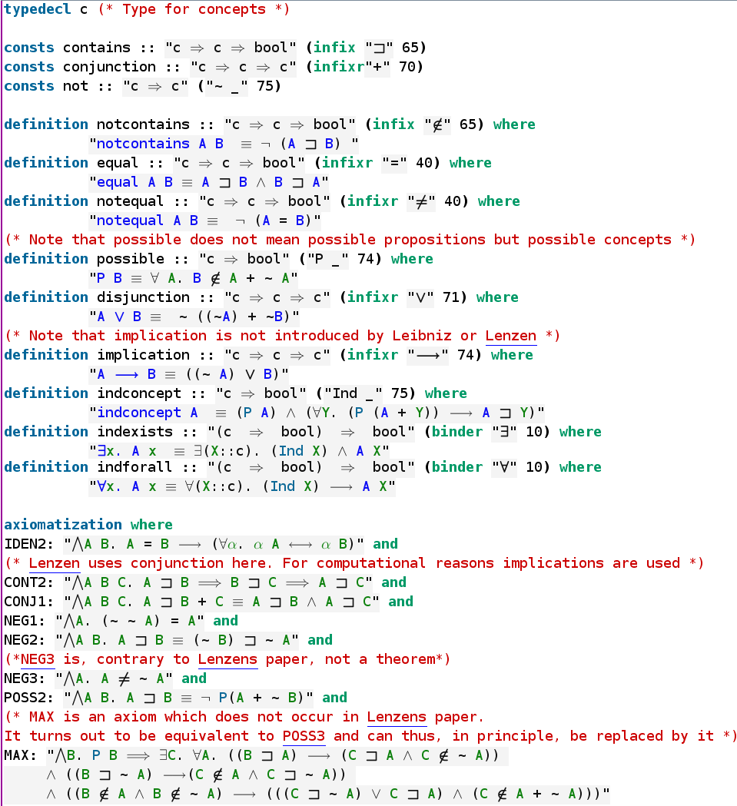

Isabelle/HOL is an interactive proof assistant based on a higher-order logic. Its expressiveness and user-friendly graphical interface allows the embedding or axiomatization of simpler logical formalisms, such as Leibniz’s algebra of concepts, in the form of accessible and human-readable higher-order logic theory files.

In addition to the function symbols for conjunction and negation of concepts used by Leibniz, our formalization also declares symbols for disjunction and implication of concepts, defining them in the usual classical way in terms of the primitive symbols (e.g. disjunction of two concepts is the negation of the conjunction of their negations). Importantly, such defined symbols can be regarded as mere abbreviations for complex expressions and, therefore, do not extend the set of theorems provable in Leibniz’s logical formalism.

The consistency of all axioms and definitions shown in Figure TODO(Fig1):number can be shown by calling Nitpick, an automated model finder, as shown in Figure TODO(Fig2):number below. Nitpick finds a model. Hence, Leibniz’s algebra of concepts, axiomatized as a higher-order logic theory, is consistent.

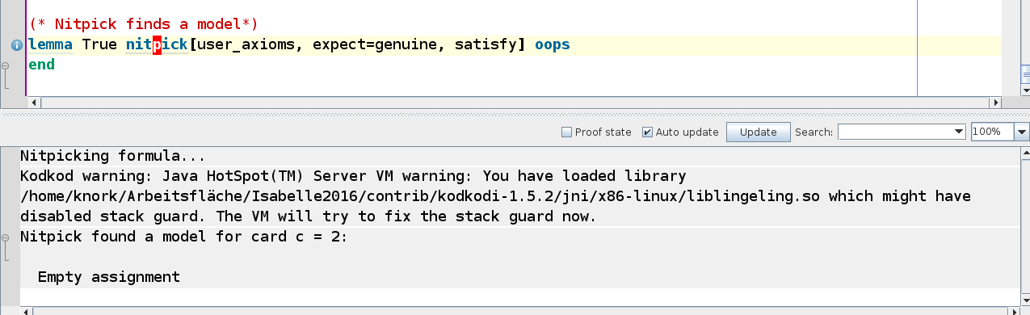

From the definitions and axioms shown in Figure TODO(Fig1):number above, several useful lemmas can be proven, as listed in Figure TODO(Fig3): number.

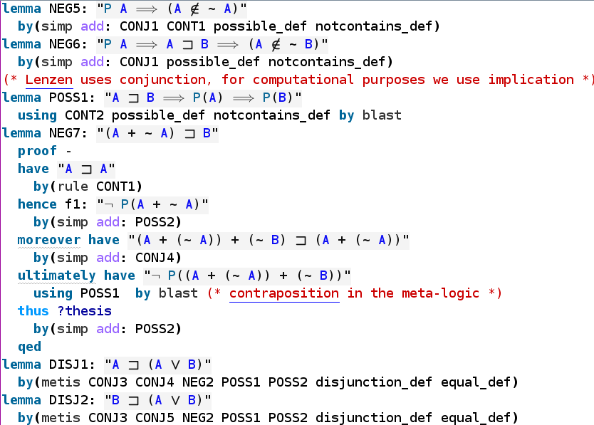

Leibniz’s Argument for the Existence of the Ens Necessarium

Among all of Leibniz’s arguments for God’s existence, the first ontological argument (of three) in his Letter to Henning Huthmann (1678) is the most interesting for a computer-assisted analysis based on Leibniz’s own algebra of concepts. This argument is reproduced below:

Theorem: Si Ens necessarium est possibile, actu existet.
Proof: Nam ponamus non existere, inde ratiocinabor hoc modo:
- Ens Necessarium non existit, ex hypothesi.
- Quicquid non existit, illud possibile est non existere.
- Quicquid possibile est non-existere
illud falso dicitur non posse non-existere.
- Quicquid falso dicitur non posse non existere,
illud falso dicitur esse necessarium.
Nam necessarium est quod non potest non existere.
- Ergo Ens necessarium falso dicitur esse necessarium.
- Quae conclusio est vel vera vel falsa.
- Si est vera, sequitur quod Ens necessarium implicet contradictionem, seu sit impossibile, quia de eo demonstrantur contradictoria, scilicet quod non sit necessarium.
Conclusio enim contradictoria non nisi de re contradictionem implicante ostendi potest.
- Si est falsa, necesse est aliquam ex praemissis esse falsam, sola autem ex praemissis falsa esse potest hypothesis, quod scilicet Ens necessarium non existat.
- Ergo conclusimus
Ens necessarium vel esse impossibile, vel existere.
- Si ergo Deum definiamus Ens a se, seu Ens ex cujus essentia sequitur existentia, seu Ens necessarium, sequitur Deum si possibilis sit actu esse.

Our translation to English, which is based on Lenzen’s translation (TODO:cite) with some modifications, is shown below:

Theorem: If the necessary being is possible, it actually exists.
Proof: For if we assume it does not exist, one may reason as follows:
- The necessary being doesn’t exist, by hypothesis.
- For whatever doesn’t exist, for it it is possible not to exist.
- For whatever it is possible not to exist,
of it it is false to say that it cannot not exist.
- Of whatever it is false to say that it cannot not exist,
of it it is false to say that it is necessary.
For necessary is what cannot not exist.
- Therefore, of the necessary being it is false to say it is necessary.
- This conclusion is either true or false.
- If it is true, it follows that the necessary being contains a contradiction, i.e. is impossible, because contradictory assertions have been proved about it, namely that it is not necessary. For a contradictory conclusion can only be shown about a thing which contains a contradiction.
- If it is false, it is needed that one of the premises is false. But the only premise that can be false is the hypothesis that the necessary being doesn’t exist.
- Hence we conclude that
the necessary being either is impossible, or exists.
- So if we define God as an “Ens a se”, i.e. a being from whose essence existence follows, i.e. a necessary being, it follows that God, if It is possible, actually exists.

This argument is interesting, because it is relatively concise, in comparison to Leibniz’s other arguments, and because it uses an informal natural language style and content that seems already quite close to the formal language of his algebra of concepts, which was only fully developed 8 to 9 years later. Nevertheless, Leibniz never produced a more rigorous version of the argument above, and thus the question remains: can Leibniz’s argument be formalized in his own algebra of concepts?

Computer-Assisted Analysis

Our computer-assisted investigation revealed interesting surprises. Figure TODO(Fig4):number shows that, if we axiomatize the concept of God as an Ens necessarium, i.e. if we state “N(G)” as an axiom, then the argument fails. Nitpick finds a counter-model for the seventh step in Leibniz’s argument. The countermodel is of cardinality 4. No countermodels can be constructed for smaller cardinalities.

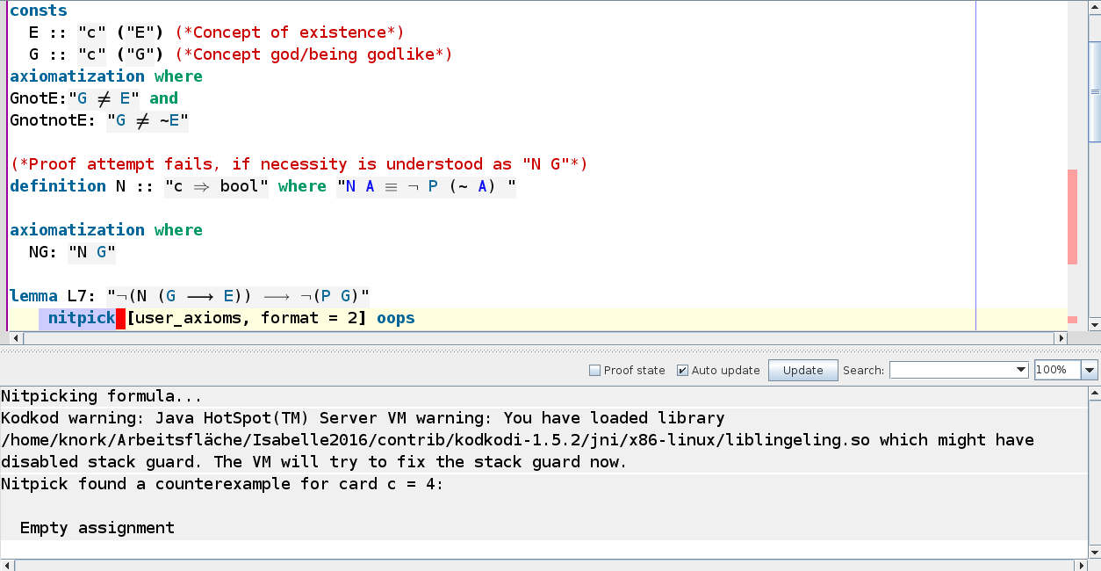

However, if we axiomatize the concept of God as an Ens ex cujus essentia sequitur existentia, i.e. if we state “N(G→E)” as an axiom (where “sequitur” is understood as concept implication), the argument goes through. All of Leibniz’s steps are verified by Isabelle/HOL, as shown in Figure TODO(Fig5): number.

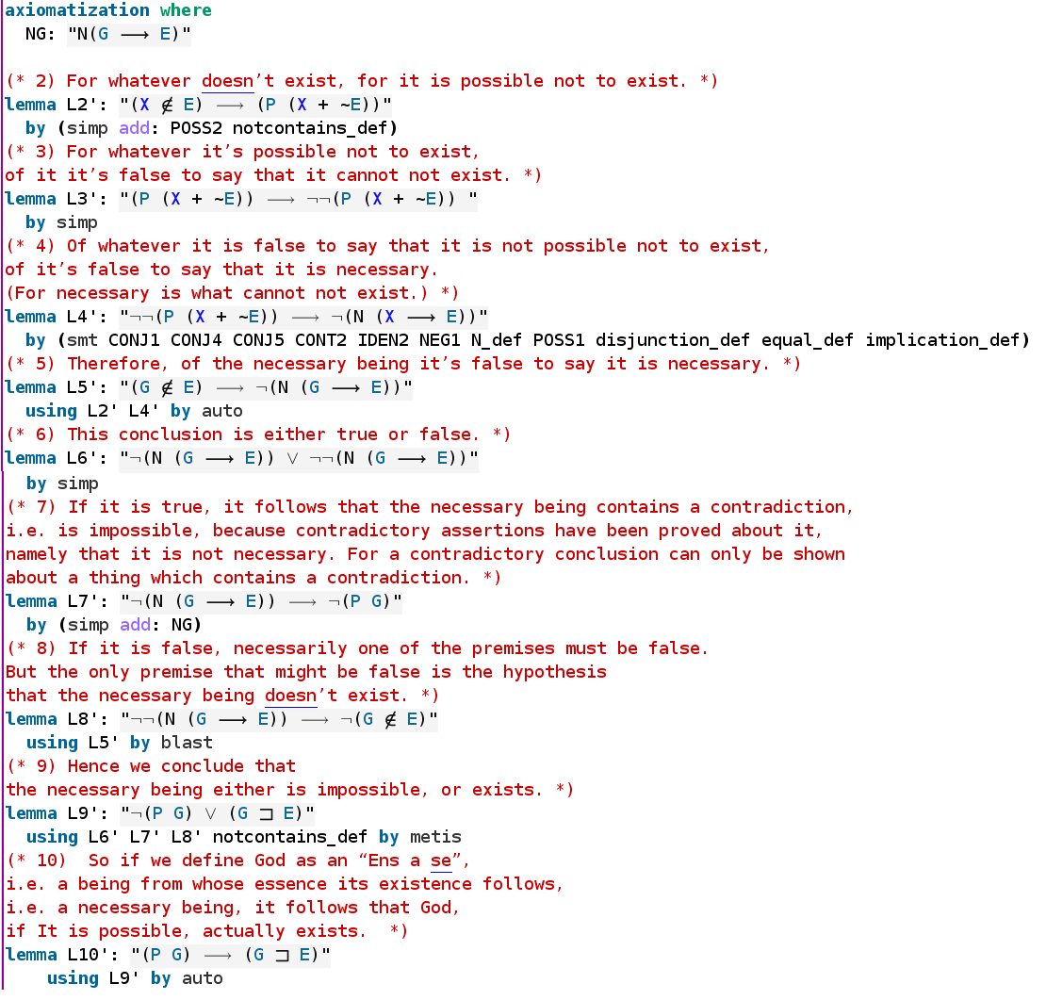

Step 10 in Leibniz’s proof indicates that Leibniz identified the Ens necessarium and the Ens ex cujus essentia sequitur existentia. However, our investigations show that, with Leibniz’s own definitions of necessity, possibility and existence, these two notions of God are distinct.

Furthermore, it is possible to show that, in the case of the Ens ex cujus essentia sequitur existentia, the proviso of possibility (in step 10) is not needed, as shown in Figure TODO(Fig6=Fig7):Number . Therefore, Leibniz’s criticism that the ontological arguments of Descartes and Anselm are incomplete because they do not establish the possibility of the concept of God does not apply to this version of his ontological argument, even though he apparently did not notice this.

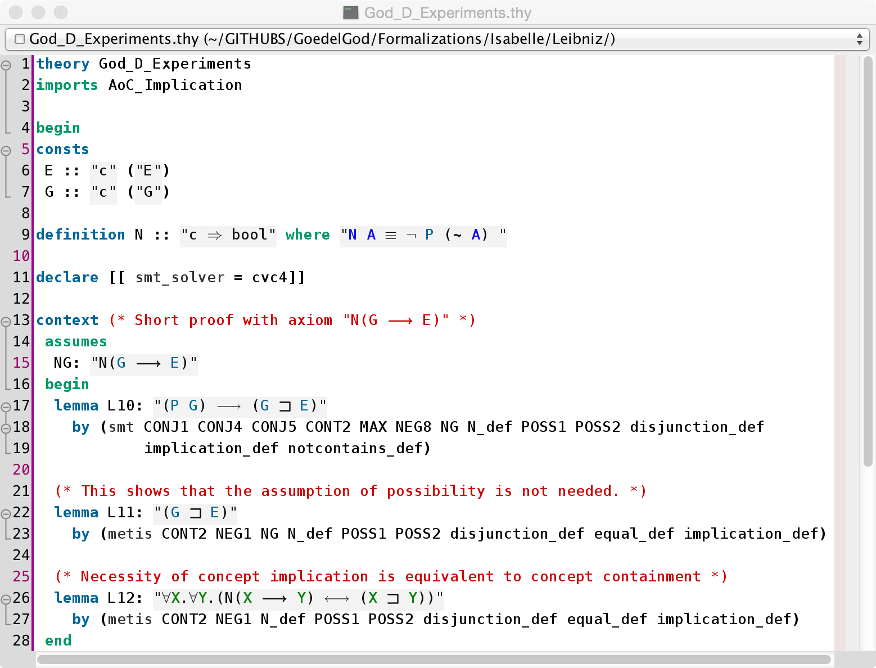

Interestingly, in Leibniz framework, for any two concepts, it is necessary that one implies the other if and only if one contains the other (cf. Figure TODO(Fig6=Fig7):Number). Therefore, the necessity operator can be regarded as a reflection operator between the type of concepts and the type of propositions.

Other points where Leibniz’s informal text lacks precision are his uses of the word “necessarium” (“necessary”). In his later algebra of concepts, “necessary” is clearly the dual of “possible”. In his ontological argument, however, he says that “necessary is what cannot not exist”. That is why occurrences of “it is necessary” in the ontological argument have been formalized as “N(X → E)” instead of “N(X)”. The adequacy of this interpretation of “necessary” and of this formalization is reinforced by the notion of Ens ex cujus essentia sequitur existentia, which conveys the intuition of concept implication.

For the observations above to be valuable, it is important to establish that Leibniz’s algebra of concepts remains consistent when it is extended with the axiomatization for the Ens ex cujus essentia sequitur existentia. For otherwise, anything follow. This can be done with Nitpick, as shown in Figure TODO(Fig8):Number.

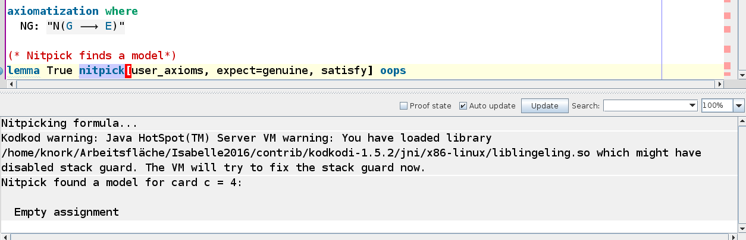

It can also be shown that, in Leibniz’s theory, there may be possible concepts that do not actually exist. This is shown in Figure (TODO:Number) for the concept of unicorn.

TODO: Include screenshot of counter-model for unicorn.

TODO: Discuss that Leibniz would have used a syllogistic, whereas we used the logical calculi of the theorem provers.

TODO: Consistency

Unicorns: TODO: show with Nitpick that there are possible concepts that do not exist.

Although the formal proofs shown before verified Leibniz’s argument step-by-step, Isabelle/HOL has automated methods that are already powerful enough to prove the final theorem without relying on intermediary lemmas. This is shown in Figure TODO:Number.

TODO: Include screenshot

Modal Logics: From Leibniz to Lenzen and Gödel

TODO: argue why kripke-style modal logics would not be adequate for this ontological argument.

“There is no need of many worlds to increase the multitude of things, for there is no number which is not contained in this one world and, indeed, even in any one of its parts.”

“To introduce another kind of existing things, and another world, so to speak, which is also infinite, is to abuse the word ‘existence’, for we cannot say whether or not these things exist now”
(Two Notations for Discussion with Spinoza, December 1676, page 261)

“If all possibles existed, no reason for existence would be needed, and possibility alone would suffice.” (Two Notations for Discussion with Spinoza, December 1676, page 262)

TODO: discuss differences to Gödel’s proof.

TODO: Relate to our previous work and cite it.

Conclusions

TODO:

Possibly useful quotations

“And, although learned men have long since thought of some kind of language or universal characteristic by which all concepts and things can be put into beautiful order, and with whose help different nations might communicate their thoughts and each read in his own language what another has written in his, yet no one has attempted a language or characteristic which includes at once both the arts of discovery and of judgment, that is, one whose signs or characters serve the same purpose that arithmetical signs serve for numbers, and algebraic signs for quantities taken abstractly.”

“Mais pour rendre cette methode ou art d’inventer aise ́e a` connoistre et a` employer aux esprits les plus grossiers, j’ay trouve ́ un moyen de la revestir pour ainsi dire d’un corps palpable et agreable tout a` la fois. Et ce moyen est le projet que j’ay d’une langue ou e ́criture nouvelle, qui se pourroit apprendre en une semaine ou deux, qu’on ne sc ̧auroit quasi oublier, et qu’on pourroit meˆme retrouver l’ayant oublie ́e, qui auroit bien tost cours dans le grand monde, lors qu’elle seroit connue et qu’elle auroit eue l’approbation de quelques grands personnages; mais qui outre l’usage du commerce et la communication des peuples divers (: ce qui la pourroit meˆmes rendre plausible au vulgaire: ) auroit des avantages incomparablement plus grands: car elle donneroit moyen de raisonner sur les matieres capables de raisonnement par une espece de calcul infallible, pour veu qu’on y apportaˆt la meˆme exactitude qu’a` chifrer, et les erreurs ne seroient que des erreurs de calcul. Il y auroit meˆme des preuves semblables a` celles du novenaire dont on se sert dans l’arithmetique; il n’y auroit point de contestation entre ceux qui voudroient y compromettre; et non seulement on trouveroit la` dedans des voyes infallibles, pour arriver a` la solution des problemes qui se peuvent resoudre par la seule force du raison- nement, mais lors meˆme qu’il s’agit d’une question de fait, et qu’il reste encor des experiences a` faire, qui ne sont pas tousjours dans le pouvoir des hommes, ce calcul seroit suffisant pour nous conduire en attendant le mieux qu’il est possible de faire suivant la raison, sur les connoissances de ́ja donne ́es.” (Letter to Johan Friedrich von Hannover, page 681 of the collected letters.)

“Je croy donc que cette Methode revestue de la forme d’une langue ou characteristique est la plus importante chose que les hommes puissent jamais entreprendre pour l’avancement des sciences, par ce qu’elle rendroit ce grand secret populaire, et familier, et neantmoins les grands esprits iroient encor infiniment au dela` du vulgaire, et auroient le moyen de faire paroistre veritablement la force de leur genie, car l’eloquence et la sagesse n’estant alors qu’une meˆme chose, ceux qui auroient plus de feu, plus de memoire, et plus d’attention d’esprit, feroient valoir veritablement et incontestablement les avantages de la nature. Tout de meˆme qu’il y a les uns plus eloquens que les autres, soit en e ́crivant ou en parlant dans les langues vulgaires, et tout de meˆme qu’un arithmeticien ou Algebriste peut estre incomparablement au dessus d’un autre a` l’egard de la promtitude et de l’exactitude, quoyque ces sciences consistent dans un calcul infallible. Or je suis asseure ́ par demonstration que cette methode ne fera pas moins dans les sciences en general, que l’Analyse dans les mathematiques.” (Letter to Johan Friedrich von Hannover, page 682 of the collected letters.)

need for logic (letter to Johan Friedrich, page 234, 1679)

wrong statement by Leibniz: “It is indeed an excellent privilege of the divine nature that it needs only its possibility or essence in order to actually exist, and this is precisely what we mean by an ens a se”. (Discourse on Metaphysics, page 490, 1686)

By modern standards, Leibniz’s argument is written in an unnecessarily convoluted way. For instance, step 5 of his argument is just an instance of the law of excluded middle, and a detour through a case distinction on this instance just makes the argument unnecessarily longer. Figure TODO shows a direct formal proof of the theorem, without detours:

TODO: include here screenshot of direct proof (both automatic and interactive) in Isabelle.

Leibniz notes that “Descartes’s reasoning about the existence of a most perfect being assumed that such a being can be conceived or is possible. If it is granted that there is such a concept, it follows at once that this being exists, because we set up this very concept in such a way that it at once contains existence. But it is asked whether it is in our power to set up such a being, or whether such a concept has reality and can be conceived clearly and distinctly, without contradiction. For opponents will say that such a concept of a most perfect being, or a being which exists through irts essence, is a chimera.” (Cite Two Notations for Discussion with Spinoza, page 260)

If controversies were to arise, there would be no more need of
disputation between two philosophers than between two
accountants. For it would suffice to take their pencils in their
hands, to sit down to their slates, and to say to each other \ldots :
Let us calculate. \\ \phantom{bla} \, \hfill (Translation by Russell)
\end{minipage} \hfill
\begin{minipage}{7cm} \small
Quo facto, quando orientur controversiae, non magis disputatione opus erit inter
duos philosophos, quam inter duos Computistas. Sufficiet enim calamos in
manus sumere sedereque ad abacos, et sibi mutuo \ldots dicere: calculemus.
\hfill (Leibniz, 1684)

Bibliography
Leibniz, G. W. (1678, January). Letter to Henning Huthmann. Sämtliche Schriften und Briefe, 1(2006), 2, 585--586. Akademie Verlag.

[ETC. ETC.]

Author order is alphabetical by surname.
Our exposition of Leibniz formalism is based on (and agrees with) Lenzen’s book Das System der Leibniz’schen Logik (1990), unless explicitly stated otherwise.
In Leibniz’s works, conjunction of two concept terms A and B is usually either denoted by simply concatenating them (i.e. AB) or by using the infix function symbol ⊕.
It is important to distinguish conjunction/negation of concepts from conjunction/negation of propositions.
Leibniz often adopts equality, depicted as “∞” instead of “=”, as the primitive relation symbol, instead of containment. But equality and containment are inter-definable, and we follow Lenzen in choosing containment.
Leibniz actually did not use symbols for the predicates of possibility and necessity, nor for the relation of containment. Such relations were written down in natural language.
The words “Theorem” and “Proof” and the numbering of steps are not in the original. Our numbering is the same as Lenzen’s TODO:cite .
Verb conjugation in Latin is richer than in English. In our translation (as in Lenzen’s), Leibniz’s uses of the subjunctive mood are lost, because we (as Lenzen) preferred to employ the indicative mood uniformly. For our purposes, this loss is harmless and even clarifying, because neither Leibniz’s algebra of concepts nor any mainstream modern logic has a language capable of expressing mood differences.
The main difference between Lenzen’s translation and ours is that Lenzen translates “quicquid” as “whenever something” whereas we translate it as “for/of whatever”. Although Lenzen’s choice sounds more natural in modern English, we believe “for/of whatever” clearly conveys universal quantification, as intended by Leibniz, whereas the translated sentences with “whenever something” contain donkey pronouns and may suggest existential quantification to readers who are unaware of the pitfalls of donkey anaphora.
When an impersonal Latin verb is translated to modern English, an auxiliary pronoun “it” has to be added. In our translation, all occurrences of such pronouns are stricken through, as “it”.
In contrast to modern English, ellipsis of pronouns are common in Latin. We underline referring pronouns that have been inserted in the translation but omitted through ellipsis in the original.
We translate “non posse” and “non potest” to “cannot”, because “posse” and “potest” are conjugated forms of the verb “possum” (“can”). Nevertheless, an alternative translation for step 3, for instance, could be “… to say that it is not possible that it doesn’t exist”. This alternative would be more similar to the formal language of Leibniz’s algebra of concepts, but less similar to his actual original text in Latin.
“necesse” could also have been translated as “necessary”. However, we reserve “necessary” for translations of “necessarium”. Translating both as “necessary” would create confusion, especially considering that “necessarium” plays an important role in Leibniz’s argument and algebra of concepts, whereas this occurrence of “necesse” is negligible from a logical point of view.

