To deploy site on your machine you have to install following things:

* SQL Server Management Studio 2014
* Visual Studio 2015

All this stuff you can find on Microsoft.com

Connect to SQL server and open file “SitecoreLibraryDB.sql” which can be found in Database folder. Press button “Execute”.

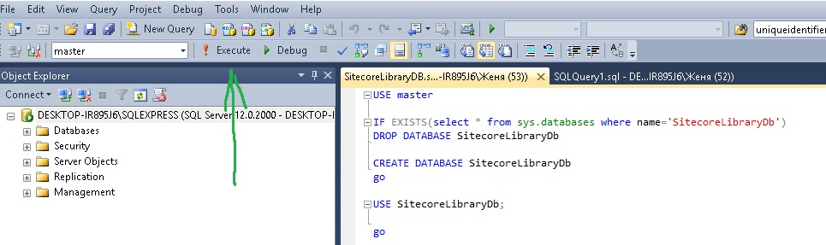

After that, open SitecoreLibrary/SitecoreLibrary.sln. Rebuild project to download packages. Everything should work.

In case of problems, you can also download .sln at

<https://github.com/Strelokdp/SitecoreLibrary>