**On the main page, you can see the list of all books in database.**

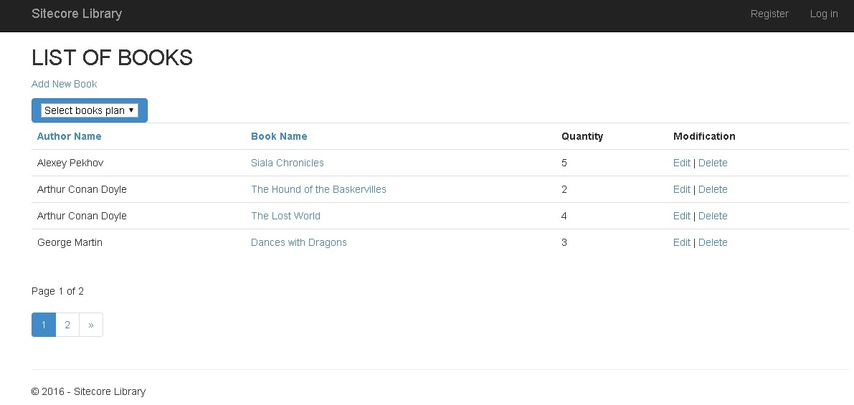

**Without being logged in you can:**

**Create, Edit and Delete books.**

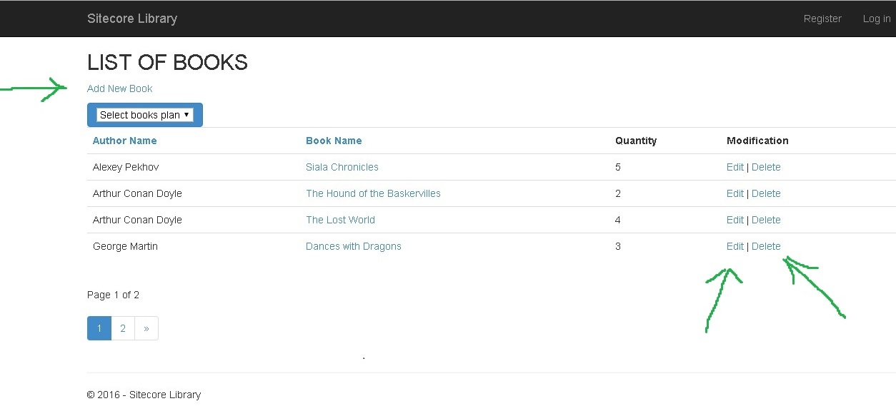

**Sort books by name or author name by clicking “Author Name” / “Book Name”**

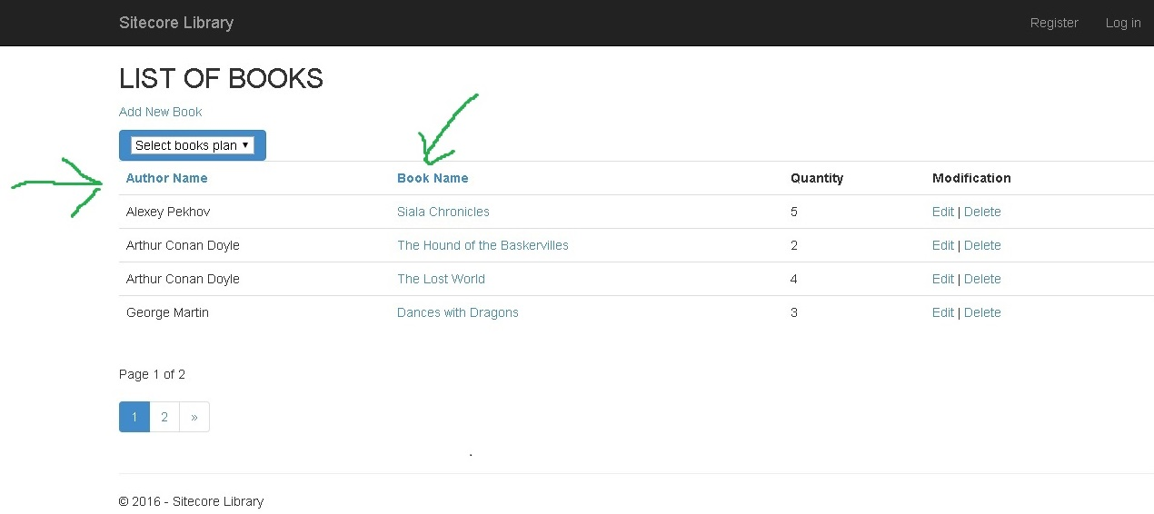

**Filter out already taken books or just available ones.**

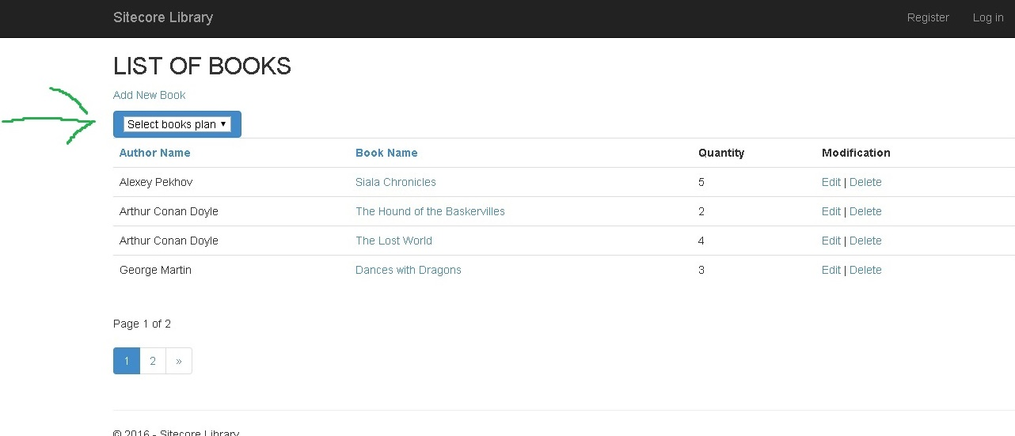

**Watch record of books’ history.**

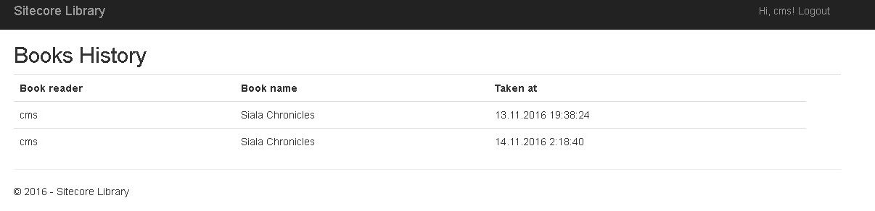

**After been registered and logged:**

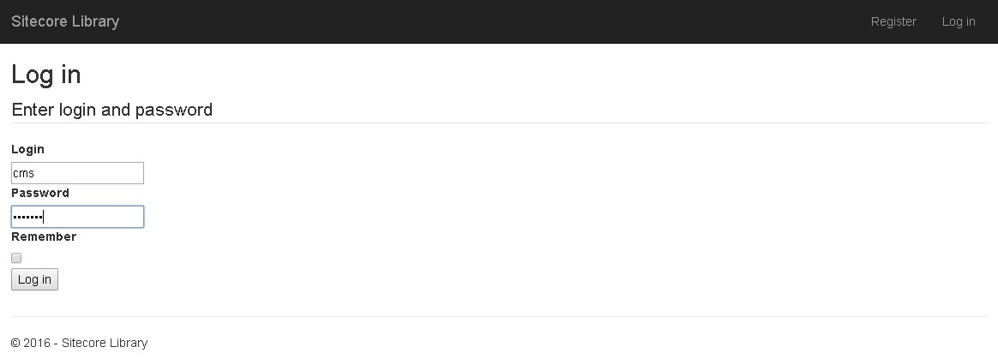

**You are able to take book or return it in case you have taken it previously.**

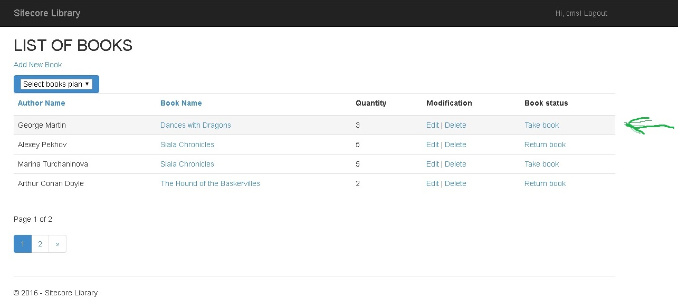

**Every time you take/return book – you get e-mailed about this action.**

