References:
- A Reference
- An unused Reference
- Another Reference

Ref [1] is used here and Ref [3] here.
If you are not allowed to have unused references in the reference list, run the macro “CheckRefDocsUsed” and enter the number of the last reference in the list:
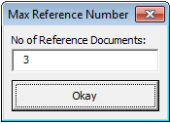

Figure 1: Reference Check Dialog
It will then tell you which references are not used:
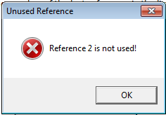
Figure 2: Unused Reference found

This text references the following Figures: Figure 1, Figure 2 and Error! Reference source not found.
To find broken cross-references run “CheckCrossReferences”. The macro will take you to the first broken cross-reference or tell you that there are no broken references.
Run it again after fixing the reference to find the next problem. Repeat until no more broken references are found. The macro does not automatically update references as this can take a long time in long documents. You should do that manually before running the macro the first time.
The macro searches for fields containing the string “Error! Reference source not found.”, the word “Fehler” (in case office is run in German), or nothing but the number “0” (for ‘Section 0’ references).

