**Project Synopsis/Project Concept Document**

|  |  |
| --- | --- |
| Project number | **10** |
| Project Title | **InHobi: A Social Good App** |
| Document | DASS Project Concept Document |
| Creation date | **Jan 21st, 2020** |
| Created By | **Chaitanya, Arjun, Joseph, Adarsh** |
| Client | **Bhupesh, InHobi** |

**Description**

InHobi is an online learning platform, where users can learn their desired passion/ skills from Influencers/ Industry experts. Users can also showcase their talent, interact with likeminded people, get timely feedback about their work from community managers using InHobi’s social features. InHobi is driven by communities with specific learning tracks threaded by the community managers, and content providers. Community members can share and discuss content, attend classes, webinars and immerse into a smart learning environment.

**Profile of Users**

Primary Audience: Children ( 8th Std - 10th Std)

This app is built primarily focusing on teenagers who are normally busy with their hectic schedules and studies and hence cant follow their passions. This app gives them a platform to learn and improve their skills in many hobbies or talents. Under the guidance of the community managers they will be able to learn anywhere and everywhere whenever they are free. Also the assignments is verified by that specific community, so suggestions and feedback will also be given. Also they will be able to see and learn a lot of other interesting talents too which they may try.

Secondary Audience : Children (Primary school and above (may differ depending on the course) )

Any child who is interested to learn special skills can use this app to develop those skills/talents under the guidance of the community managers from a young tender age itself. Also the parents have a way of introducing their children to a wonderful world different from the one filled with academics and daily life.

College Students:

College students who have always wanted to develop some special skills or the ones who had to stop practising due to many reasons also get an opportunity to continue their passions. They can use their spare time developing these talents. They could also act as mentors who can guide the new ones in that community.

Adults:

Adults who had to stop their practice or the ones who want to learn new skills now won’t have to now spend a lot of effort trying to find a suitable place to learn. Also they get the flexibility to learn whenever they want so that it does not affect their work nor family life. They could learn along with their kids as a joint venture where this would be another way to spend more time with the kids in a productive way.

Admins : Community Managers :

Community Managers are the adults who have practised these skills for a long time and are ready to teach others. Every course/skill will have a specific community which in turn will be having a community manager. They will be the ones who have control over all the people in that community. They will be monitoring the assignments done by the participants in that community. They will have admin access. The courses will be pre recorded sessions by the community manager.

**Usage Model and Diagrams (if any)**

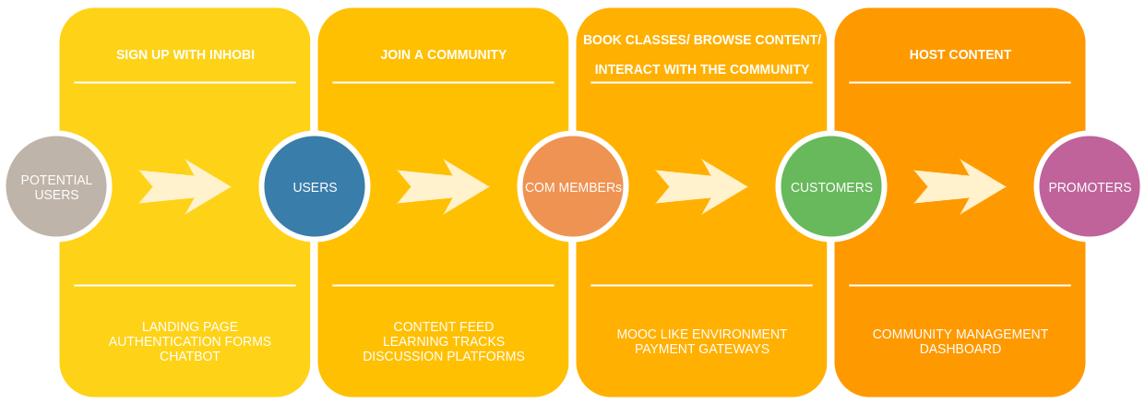

**FIG 1. USAGE MODEL**