**Software Requirements Specification (SRS) Document**

Adarsh Dharmadevan, Joseph John Cherukara, Arjun Andra & Chaitanya Agarwal 

**Brief problem statement**

InHobi is an online learning platform, where users can learn their desired passion/ skills from

Influencers/ Industry experts. Users can also showcase their talent, interact with likeminded

people, get timely feedback about their work from community managers using InHobi’s social

features. InHobi is driven by communities with specific learning tracks threaded by the

community managers, and content providers. Community members can share and discuss

content, attend classes, webinars and immerse into a smart learning environment

**System requirements**

Django REST (Backend)

ReactJS (Frontend)

Python (Backend)

JavaScript (Frontend)

Docker (To have the Software in containers)

Heroku (For continuous integration of the programs)

**Users profile**

Admin:   Admin is the person who assigns all the access control for the other types of users. He is also the one who posts all the course material (Sessions and assignments) for all the courses. He assigns the community managers. He also has the full control of InHobi TV.

User:  The Audience. They are the ones who visit the site, signup/login, join open groups, watch the InHobi TV videos, see and buy courses. They can access their profile and courses from their dashboard.  They can complete sessions and assignments of their courses by accessing them from the dashboard. They can also share any other projects or media related to that skill in the virtual support group, where the other users can also express their views on the topic under the supervision of the community manager. Users can also buy courses for others (even in a bulk as part of a sponsorship for a group).

Community Manager: The Community Manager manages the Virtual Support Group and corrects the assignments of all the users who have enrolled for that specific course. She can also nominate/recommend videos of the assignments or projects done by some users to be added to the InHobi TV database.

Instructor: The Admin assigns instructors to record sessions and make the assignments for the courses. Mostly they will be experts in that particular field with some accreditations. The instructor profiles can be viewed from the home page itself. Users will not be having any communication directly with the instructors.

**Feature requirements (described using use cases)** 

|  |  |  |  |
| --- | --- | --- | --- |
| **No.** | **User Case Name** | **Description** | **Release** |
|  | User-Signup (One time only) | Signup using google, Facebook or by using email address (which will be verified). Create a username and password for future login. | R1 |
|  | User login | To access the personal dashboard, enter username or email-id and password. Credentials will be stored across sessions until log out or deletion of cache. | R1 |
|  | Course material addition | Admin can add the material (videos, assignments) for each course to the central database to be accessed by any user who buys that specific course. | R1 |
|  | Community Manager assignment | Admin gives access to the community manager with a personalized dashboard. CM can monitor the Virtual Groups and checks the assignments. | R2 |
|  | Assignments | User must complete an assignment after every lesson in the course to progress to the next lesson. The assignment will be corrected by the Community Manager who will unlock the next lesson for that user. | R2 |
|  | Viewing Instructor Profiles | The Basic profile consisting of the instructor name, courses taught, and accreditations will be displayed on the home page. A more detailed page will be displayed on clicking that user profile which gives more details on the instructor and a brief description on the courses offered by that instructor | R1 |
|  | Buying a course | A user can visit the course page from the instructor profile page. Then he/she can buy the course if interested. On clicking the “Buy course” button they will be directed to the payment Gateway for completing the payment. | R2 |
|  | Viewing Course Page | This page contains all the details regarding the course including number of lessons and assignments, instructor profile link, Community Manager details, Reviews and ratings. | R1 |
|  | Using Course Group | This is a closed group for each community wherein everyone can share their views and add any projects (images, audio or videos) they have done. | R2 |
|  | Using Dashboard | Each type of user will have a specific personalized dashboard containing the courses (bought or offered) details and progress, rating and review of courses, updates/notifications on any competition or event interested (related to the courses) and user profile showing linked accounts. | R1 |
|  | Giving Rating, Reviews | Each user can rate, review a course and its instructor through their dashboard. These will be monitored by the Admin for future use | R1 |
|  | Providing Sponsorship | The user can buy courses for others also as sponsors | R2 |

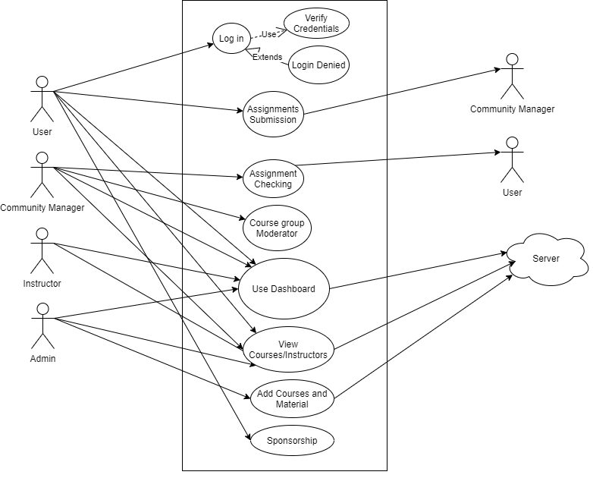UML Use case Diagram

|  |  |
| --- | --- |
| **Use Case Number:** | UC-01 |
| **Use Case Name:** | User Sign Up |
| **Overview:** | Signup using google, Facebook or by using email address (which will be verified). Create a username and password for future login. |
| **Actors:** | User, Admin, Instructor, Community Manager |
| **Pre condition:** | Users must have a google or Facebook account or another email account |
| **Flow:** | User Enters name, school, other details to complete Profile.  Then he enters email id, User name and password and validates account with email id  Or  He can choose to Sign in with Google or Sign in with Facebook |
| **Post Condition:** | Once Verification is completed User is directed to Home page |

|  |  |
| --- | --- |
| **Use Case Number:** | UC-02 |
| **Use Case Name:** | User Login |
| **Overview:** | User can login using which verification method he used to validate his account i.e.  Sign in with Google or Facebook or by entering username and password. |
| **Actors:** | User, Admin, Instructor, Community Manager |
| **Pre condition:** | Users must have a google or Facebook account or another email account |
| **Flow:** | User Enters name, school, other details to complete Profile.  Then he enters email id or chooses the option Sign in with Google or Sign in with Facebook |
| **Post Condition:** | Once Logged in user is directed to Home page and will get access to Dashboard, Closed and Course groups and can buy courses.  Else the user can only view the website and the open groups. |

|  |  |
| --- | --- |
| **Use Case Number:** | UC-03 |
| **Use Case Name:** | Course Material Addition |
| **Overview:** | Admin will add the Course material and assignment for all the courses |
| **Actors:** | Admin |
| **Pre condition:** | Admin has logged in to his account (Admin account specifically)  Admin also has recorded the Course material |
| **Flow:** | Admin will go to his Dashboard and choose the Courses Option.  There he can choose add new course ( to add material for a new course ) or choose an existing course ( to update or add material of an existing course ).  He will add the course content in the order of lessons. |
| **Post Condition:** | Once the material is added, the new course content is visible to all the users across the website. The new course page will be linked to its respective instructor page too |

|  |  |
| --- | --- |
| **Use Case Number:** | UC-04 |
| **Use Case Name:** | Community Manager Assignment |
| **Overview:** | Admin gives access to the community manager with a personalized dashboard. CM can monitor the Open Groups and corrects the assignments |
| **Actors:** | Admin, Community Manager |
| **Pre condition:** | Admin will have sent a unique code to the user who is to become the CM of a course group |
| **Flow:** | User, during Sign-Up, will have to choose the CM role when asked type of User and enter the unique code provided by the Admin. |
| **Post Condition:** | This will give the CM access to a personalized Dashboard containing all the course details, Assignments page (to correct the Assignments) and a page to post content to InHobi TV |