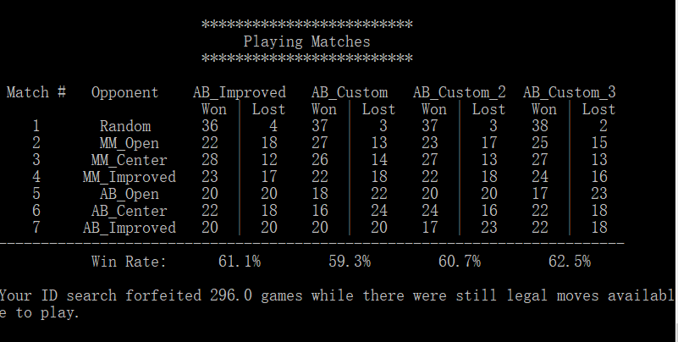

My code still has some bug, so there are near 300 forfeited games even there were legal moves.

My custom functions and analysis:

1 The first custom function is the square of the difference of player and opponent possible move. It should be same compared to no square version. The idea is, since isolation is trying to limit opponent’s moves. So, the possible moves of two player is a good indicator of the situation of the games. To use such custom function will encourage AI agent try to avoid limit moves by opponent and limit opponent moves

2 The second function is calculating the distance of the player’s position to the center of the board. As discussed in lectures, player who occupy the center of the board usually win.

3 The third function is the sum of the first two function. The idea is it can learn from perspective of both method and it seems achieve better result than single model.

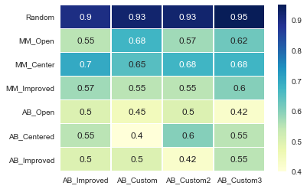

From result, we can see the combined method achieved best result. Second method is worst. I guess it because to occupy the center only works for the start, after the start, the score is not good indicator of the board status.

So, I will choose the third function based on the results. It combines two different strategies as trying to occupy the center and limit the opponent moves. The calculation time may be little longer but still in the same order of the single function 1 and 2.