Using Network to fix network -- Toxic Comment Classification via DeepLearning Networks

CSE802 Project Proposal

Zhuangdi Zhu Wei Wang Zhiming Jiang

Department of computer Science and Engineering

Michigan State University

East Lansing, Michigan, USA

{zhuzhuan, wangwe90, jiangzh7}@msu.edu

*Abstract*— In this project, we aim to provide a tool which recognizes toxic comments presented on social networks. Digital abuse is a critical issue worldwide. The abuse of toxic comments on the internet can be harmful to both individuals and the society as a whole. Since the approach of manually rating toxic comments works with a huge cost, we aim to build a multi-headed model that can automatically detect different types of toxicity like threats, obscenity, insults, and identity-based. We aim to use different neural networks to build the model, and compare the powerfulness with traditional models such as regression

*Keywords—machine learning; natural language processing, deep learning; neural networks.*

# Introduction

In this project, we aim to provide a tool which recognizes toxic comments presented on social networks.

Digital abuse is a critical issue worldwide. Due to the prevalence of social platforms such as YouTube and Twitter, people have more channels to express their opinions on the internet, for better or for worse. On one hand, the anonymity feature of the network leave people less constrained when making comments. Some people may make reckless comments without taking any consequences. On the other hand, some people may give inappropriate comments even without awareness because of the culture difference or misunderstanding.

The abuse of toxic comments (i.e. comments that are rude, disrespectful or otherwise likely to make someone leave a discussion) on the internet can be harmful to both individuals and the society as a whole. For individuals, the threat of abuse and harassment online means that many people stop expressing themselves and give up on seeking different opinions. Victims of severe digital abuse may even end up with depression, taking the loss of reputation or privacy. For companies, they have to struggle to effectively facilitate conversations, leading many communities to limit or completely shut down user comments.

Depriving users’ rights of expressing comments is not the right solution to digital abuse. Many online platforms and communities are hiring labors to manually rate toxic comments in order to take reactions. However, the manual rating approach works at large cost. First, manual detection of toxic comments is time consuming and non-efficient. The burst of negative events on the internet can generate large amount of information in a short time, which overwhelms the human raters. Besides time, money spent on paying toxic comment raters is also a huge expenditure. Moreover, being exposed to toxic comments hours and days leave human raters under big pressure. All of these issues can be addressed if we build a detection model which automatically detects toxic comment.

In this project, we aim to build a multi-headed model that is capable of detecting different types of toxicity like threats, obscenity, insults, and identity-based. Especially, we abstract the problem as a multi-label classification problem: given a text , we want to predict the probability that this text belongs to certain toxicity types:

Here, is a text composed of English words; is a probability vector of dimension , as we have possible toxicity types; the value in each dimension of indicates the likelihood that this text belongs to a certain toxicity type. We are given a dataset of which is a collection of labeled texts. For each sample in D, we have a label , which is a binary vector of dimension . In practice, we use a dataset of comments from Wikipedia’s talk page edits.

# Proposed Methods

We consider four stepwise tasks in this project: data collection and pre-processing, feature extraction, model selection, and the performance evaluation.

## Data preprocessing

The dataset we use is from Wikipedia’s talk page edits. It contains a large number of Wikipedia comments which have been labeled by human raters for toxic behavior. The types of toxicity are:

|  |  |
| --- | --- |
|  |  |

The dataset is available online [1].

We take two steps to pre-process the dataset. First, for each text in the dataset, we clean it by removing some stopping words, special characters and punctuations. Stopping words are frequently used words such as *the, an, a, will, shall*, etc. Next, we tokenize each text into a list of words, so that we can get the vocabulary of the whole dataset, where each word in the vocabulary is a one-bit-hot vector: , so that only one bit in is one, and the dimension of this vector is vocabulary size.

Before we extract features from this dataset, we conducted a word-frequency analysis. We separate the training dataset into two groups: the neutral subset and the negative subset. The neutral subset contains all texts that are not labeled as any toxicity type, while negative subset contains texts that are labeled as at least one toxicity type. We use a graphical tool [2] to show the difference between these two subsets:

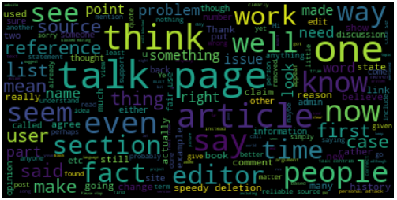

1. Pin2vec

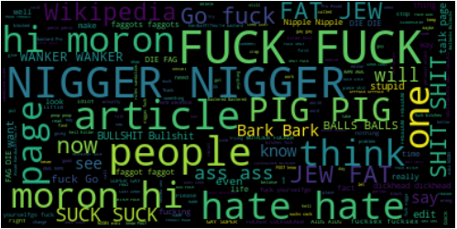

## Feature Extraction

(To be continued).

### Count Vectorization

Count vectorization is a procedure that calculate the occurrence(frequency) of a particular token appeared in one document normalized by all tokens across all documents. Token is learned when taking all documents into account. Each individual token occurrence is treated as a feature; the vector containing all token frequencies for a given document is used to train classifier model.

### Tf-idf Vectorization

Tf-idf (term frequency-inverse document frequency), is a numerical statistic that is intended to reflect how important a word is to a document in a collection or corpus. The tf-idf weight is often used in information retrieval and text mining. The importance of a word is related with the appearance and the frequency in the document. Tf-idf is often used by searching engines in scoring and ranking a document’s relevance given a user query.

The tf-idf weight contains two parts, the normalized term frequency and the inverse document frequency. For a document and a word , tf-idf is calculated as following:

## Model Training

(To be continued)

### Approach 1

### XGBoost Classifier

XGBoost(Extreme Gradient Boosting), is an optimized distributed gradient boosting library. It provides a parallel tree boosting framework, using gradient boosting to speed up machine learning algorithms. We plan to use logistic regression classifier in XGBoost.

Logistic regression is widely used on natural language processing, for example, in topic classification, text categorization, detection of spam pages. Logistic regression measures the relationship between an output variable (category) and one or more independent variables, which are usually continuous, by using probability scores as the predicted values of the dependent variable.

For input feature vectors , outcome ranges between 0 and 1 which represents the prediction of probability. For probability greater than 0.5, we would classify the observation as positive, otherwise, as negative. The probability of the out is assumed to follow a parametric model given by the sigmoid function:

## Performance Evaluation

To be continued

# Proposed Timeline

(To be continued)

1. Template Table

|  |  |  |  |  |
| --- | --- | --- | --- | --- |
|  | Training Data | Label Type | Objective | Model |
| V1 | Memboost | Relevance pair | RankSVM loss | Linear |
| V2 | Individual sessions | Relevance pair | Pairwise loss | Linear |
| V3 | Individual sessions | Relevance pair | RankNet loss | GBDT |
| V4 | Individual sessions | Binary | Logistic loss | GBDT |

##### Conclusion

前面都是我编的。我编不下去了.

##### References

1. Data link for Kaggle competition: toxic comment classification: <https://www.kaggle.com/c/jigsaw-toxic-comment-classification-challenge/data>
3. Covington, Paul, Jay Adams, and Emre Sargin. "Deep neural networks for youtube recommendations." Proceedings of the 10th ACM Conference on Recommender Systems. ACM, 2016.