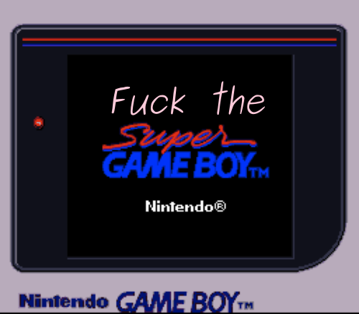


Fuck the Super Game Boy

Christine Love
Love Conquers All Games

2025 eBook version edited by
Joni Carr

© 2010, 2025 Christine Love

Part One: Introduction
The Super Game Boy is probably the coolest piece of video game hardware in existence.

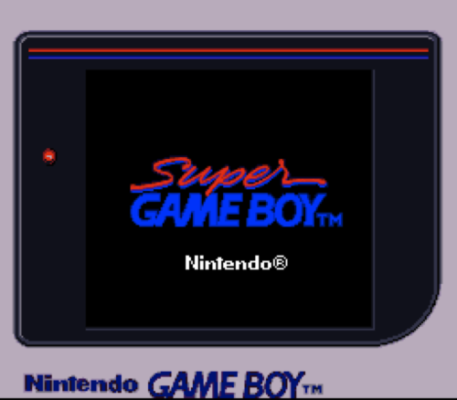

It’s also probably the biggest wasted opportunity in video games.

It’s been pretty much entirely forgotten about now, because – as is pretty common with neat hardware made by Nintendo – very, VERY few games ever really took advantage of it at all. And it’s a shame, because the unique visual style of Super Game Boy-compatible games, in addition to just looking really neat, can teach a lot about effectively using colour in games. The ones that do work exist in a really bizarre stylistic place.
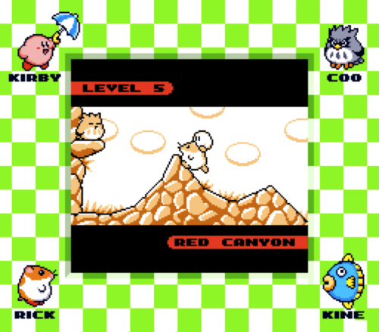

Games don’t look like this. They never have, and never will; unless you’re using a Super Game Boy.
So I’d like to take a few posts to look at a few noteworthy Super Game Boy compatible games, explain what they do, both from an artistic standpoint and a technical one, but trying to keep it straightforward as possible. I’m going to assume you probably know what one is, if only in the context of “that weird thing for the SNES that let you play GB games,” but haven’t given much thought as to what the hell it actually does.

So what the hell does it actually do?
If you’re playing a non-Super Game Boy compatible game, not much. It puts a border around the game (since the GB has a much smaller resolution than the SNES), and lets you worry about picking the colours. For a small handful of pre-SGB games, there are default palettes included, but they apply to the entire game.
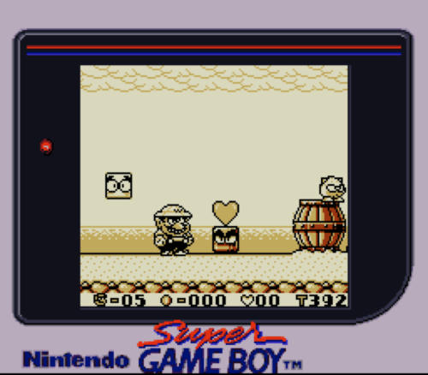
If it’s a Super Game Boy-compatible game, however… well, it probably still didn’t do that much. The vast majority of SGB games simply threw in a custom border and called it a day. They don’t look particularly pretty, either.
But of course the thing is way more powerful than that. A small handful of games go above and beyond, and change the palette through the course of the game. And there’s a bunch of neat colourization techniques that let a well designed game go even further.

Okay, so explain this palette shit to me.
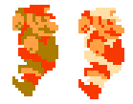
The most important thing to understanding how the Super Game Boy works is to understand how palettes work. On game consoles, you don’t ever think of things in terms of individual colours. You think of them in terms of palettes.
The classical example of this is Super Mario Bros., for the NES. When he picks up a fire flower, the sprite doesn’t change; it’s the exact same image file on the cartridge. His suspenders aren’t ever “red,” they’re just colour 1. When it needs to change his colours, it swaps the palette, so colour 1 is now white instead of red.
So let’s break down what this means for a Super Game Boy game.
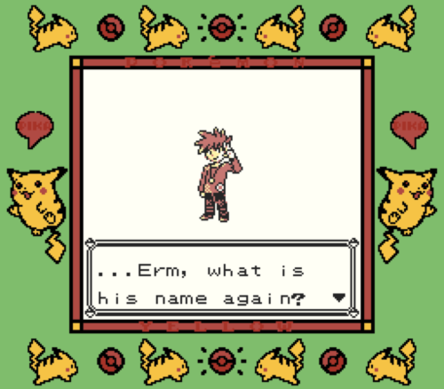
The border is stored on the cartridge, and used only by the SGB. It’s not subjected to any colour limitations other than the SNES’s. The inner screen is what matters.
The Game Boy is limited to a palette of four colours, which is exactly how many shades of grey the screen can render. So you can’t have a palette with more than four colours. You can change palettes as often as you want, but you can’t ever have more than four colours.

On the left is what it looks like on the Super Game Boy. On the right, the Game Boy Pocket. As you can see, the whole inner screen is drawn with a palette using four shades of red.
But, if you go outside…
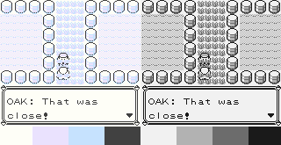
It changes the palette to whatever is specifically designated. As opposed to Wario Land, wherein the whole game will be in that yellow-y orange, Super Game Boy games still have the restriction of a palette of four colours– since they’re still Game Boy games– but have control over what that palette will actually be.

It’s really important to understand that part before continuing. So this is what a Pokémon battle in Yellow looks like.
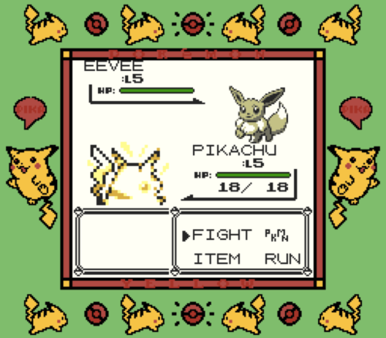

Wait a minute! That’s WAY the fuck more than four colours!
Here’s the neat thing about Super Game Boy palettes: they don’t have to apply to the entire screen (although they usually do). They can be applied specifically to a given region of the screen. There are, in fact, three seperate palettes being applied to the screen in that example image. Let me break it down.

It’s completely unique: nothing has ever had a resolution as high as the Game Boy’s and shared the same palette imitations. In consoles, increases in resolution also coincided with sprites getting lots of colours. Super Game Boy games are detailed, but don’t have the luxury of using anything but extremely minimalistic colour use. It’s not an exaggeration; it really is completely unprecedented, and remains so to this day.
Or if running on an original Game Boy, four different hideous shades of yellow.

