|  |
| --- |
| Cave Adventure |
| 2D Platformer Game Document |
| Version 1.1 All work Copyright © 2015 by Cistronix Games. All rights reserved. Jason Huang (300818592) and Jeffrey Li (300604587) Dec.4th,2015 |
|  |



Table of Contents

Version History 2

Game Document 2

Detailed Game Description 2

Controls 2

Interface Sketch 2

Title Screen 2

The screen after Play is pressed. 2

Play can shoot at Enemies 3

The Player can Jump to avoid spikes 3

The Player collect coins 3

Game over Screen 3

Level Sketch Version 1 3

Level Sketch Version 2 3

Game World 3

Levels 4

Characters 4

Enemies 4

Weapons 4

Items 4

Scoring 4

Sound Index 4

Art / Multimedia Index 4

# Version History

Project Github Link: https://github.com/Strifez/Cave-Adventure-2D

# Game Document

## Detailed Game Description

The goal of the game is to survive by killing enemies and jumping over hazards and reach the end of the level and killing the boss. The mechanics of the game a fairly simple, mostly jumping on platforms, over spikes, or enemies. Player is can shoot to kill the enemies but take damage when they touch hazards or the enemy. All the enemies patrol on the platform they are on and they do not shoot any projectiles at the player except for the boss.

## Controls

The player movements are the standard arrow keys (Up, Down, Left, Right) to move left, right, and can climb up and down ladders. In addition, the “Z” key will allow the player to jump and the “X” key will allow the player to shoot arrows.

## Interface Sketch

### Title Screen

### The screen after Play is pressed.

Consists of Life counter, Coin counter and Kill counter (all incremented by 1).

### Play can shoot at Enemies

### The Player can Jump to avoid spikes

### The Player collect coins

### Game over Screen

### Level Sketch Version 1

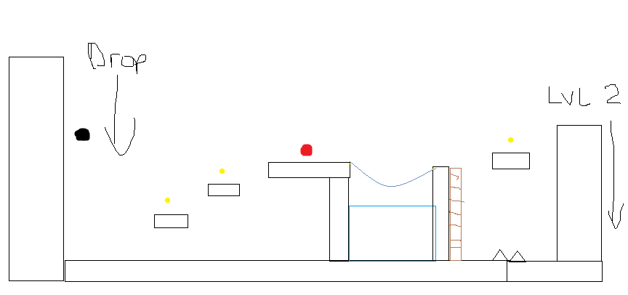

Black- Player Red – Enemies Yellow- Coins

### Level Sketch Version 2

## Game World

The setting is in a dark mysterious dungeon, Buj is a treasure hunter and an explorer. The dungeon is full of surprises and dangers that waits for Buj.

## Levels

There is only one level currently; more levels will be implemented in the future versions. The first level is fairly simple and no too many enemies to deal with. The hazards that the player fights are separated in to parts. The goal of the first level is to get the player familiar with the controls and the jump distance of the character.

## Characters

Buj is a treasure hunter and he recently heard a rumor that there are infinite treasures found in a dungeon deep down below the surface of the ground. Buj desperately searched for the secret dungeon but all his hard efforts have been wasted when he accidently fell into a hole and fell deep underground. Little did he know, he tumbled into the cave of Infinite Treasures.

## Enemies

 Slobs are rare creatures that are rarely seen but are found to be abundant wherever there is treasure. These round creatures are usually harmless but if you touch their treasure beware they become dangerous.

## Weapons

Buj uses a bow and arrow to defend himself in case of any encounters he may face during his solo expeditions to find treasure.

## Items

Coins are regular items found in the game, and the player collects them from level to levels.

## Scoring

The scoring in the game is separated into two categories, coins and kills. Each coin the player picks up it adds 1 to the score and each player the kills also adds one to the score.

## Sound Index

Background Music by: Kay Lu

## Art / Multimedia Index

Source: OpenGameArt

(Purchased a Sprite Pack)

Player, Enemies and TileMaps by Merve Talun

<https://www.assetstore.unity3d.com/en/#!/content/42013>

Tiled Program used to create the level by Thorbjorn Lindeijer

<http://www.mapeditor.org/>

Tiled2Unity Program used to import level into Unity by Sean Barton

<http://www.seanba.com/tiled2unity>