Multivariate Regression Composer
Author: Mikhail Kuznetsov
Moscow Institute of Physics and Technology
Supervisor: V.V. Strijov
Course: Machine Learning and Data Analysis, Fall 2013
Date: 24.12.2013
Table of Contents
1 Introduction 1
1.1 Project description 1
1.1.1 Abstract 1
1.1.2 Motivation 1
1.1.3 Literature 1
1.2 System architecture 1
1.2.1 Problem statement filename 1
1.2.2 A1 diagram 2
1.2.3 A2 diagram 2
1.3 Project structure 2
2 Basic data structures 2
2.1 Primitives 2
Basic structure: primitive 2
Basic methods 3
2.2 Model 3
Basic structure: Model 3
Basic methods 4
2.2.1 Creating Model 4
CreateModelByString.m 4
CreateRandomModel.m 4
2.2.2 Learn model parameters 5
LearnModelParams.m 5
2.2.3 Model operations 5
ExtractSubModel.m 5
ReplaceSubModel.m 5
CrossoverModels.m 6
MutateModel.m 6
Generation of Z matrices (GenZfs.m function) 7
Recursive cycle in GenZfs (recursive_cycle.m function) 7
2.3 Population 8
Basic structure: Model 8
Basic methods 8
2.3.1 Population creating 8
CreatePopulation.m 8
CreateRandomPopulation.m 8
2.3.2 Learn population 9
LearnPopulation.m 9
2.3.3 Population operations 9
CrossoverPopulation.m 9
MutationPopulation.m 10
SelectBestPopulationElements.m 10
3 Module interfaces (for synthetic data) 11
main.m 11
4 Real data processing 11
4.1 Data download 11
DownloadModels.m 11
DownloadPrimitives.m 11
5 Test modules list 12
test_creatematbystring.m 12
test_extraxtsubmodel.m 12
test_model2tex.m 12
test_replacesubmodel.m 12
test_updatemodelhandle.m 12
6 System launch and testing 12
6.1 System launch 12
6.2 System testing 12
6.3 System performance 12
7 The project is located ON: 12

Introduction

Project description

Abstract
Multivariate Regression Composer generates and selects non-linear regression models. A model is selected from an inductive generated set of the trial models according to the notion of adequacy: the model must be simple, stable and precise. These criterions are target functions and they are assigned according to given data. Experts could also make initial models for inductive modification. When generated models are tuned, the model of the optimal structure is selected.

Motivation
- Project goal (main purpose of research and development, the expected result)
The main goal is to construct a method for non-linear regression model selection. The expected result is an optimal model which can be interpreted by an expert. The model must be optimal by the set of criteria.
- Project application (where and how the project result will be applied)
Results obtained can be used for model superpositions constructing in the different areas of machine learning: classification, regression problems, time series forecasting, pattern recognition.
- Historical data description (timing, formats and structures)
A design matrix should contain set of columns corresponding to the independent variables and a set of columns corresponding to the target variable/-es. The target variable can be empty for, e.g., clusterization problems, or in can contain any number of columns for multivariate regression / time series prediction problems.
- Quality criteria (target functions, error functions, how the project quality is measured)
The optimal models should optimize a set of quality criteria. This criteria can be given by an expert or can be a part of a mathematical or statistical inference (e.g. MSE, model evidence etc.)
- Requirements for the project implementation (must be satisfied for successful project end)
The obtained model should be interpreted by an expert and should optimize a set of quality criteria. All results (optimal model parameters, criteria values, visual report) also should be provided.
- Feasibility of the project (how to prove the project feasibility, list of possible risks and complications)
Feasibility of the project is guaranteed by the proved theorems in the problem statement.
- Methods and solutions (project roadmap, methods and algorithms)
A model is selected from an inductive generated set of the trial models according to the notion of adequacy: the model must be simple, stable and precise. These criterions are target functions and they are assigned according to given data. It is supposed that given data carries the information on the searched model and the noise as well. The hypothesis of the probability distribution function defines a data generation hypothesis and as follows, the target functions.
The outline of the automatic model creation is the following. A sample data, which consist of several independent variables and one dependent variable are given. Experts makes set of terminal function. These models are arbitrary superposition, inductively generated using terminal functions. Experts could also make initial models for inductive modification. When generated models are tuned, a model of the optimal structure is selected.

Literature
http://sourceforge.net/p/mlalgorithms/code/HEAD/tree/BSThesis/Varfolomeeva2013/Bsthesis.pdf

System architecture

Problem statement filename
The mathematical problem statement can be found at the address
<TO DO by A.V.>

A-0 diagram
System architecture is described with the IDEF0 format.
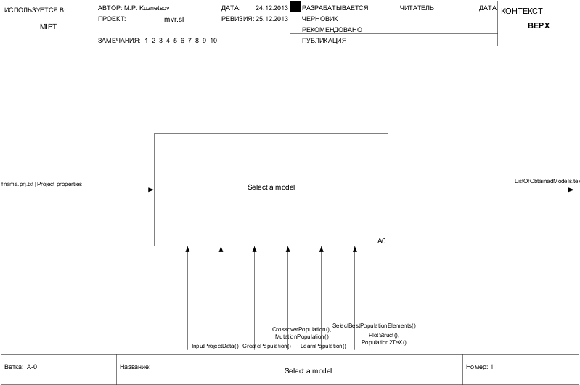

A0 diagram
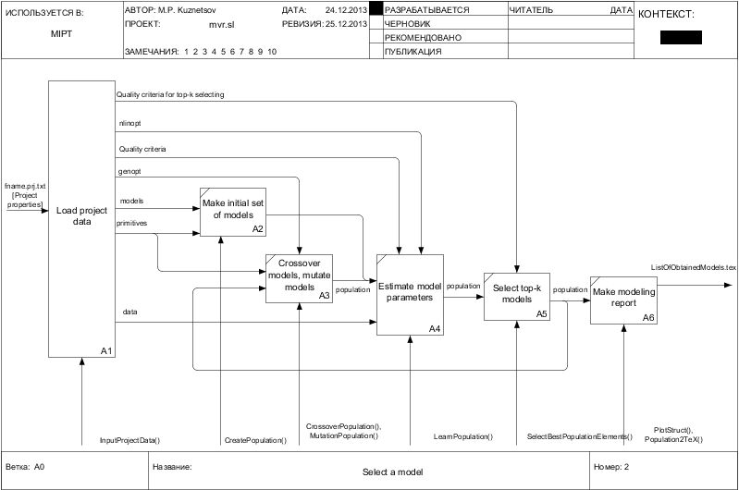

A1 diagram (Data loading)
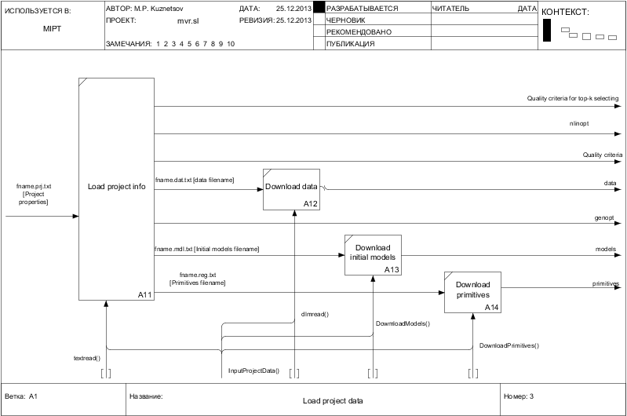

Project structure
System files are located in folders:
- report – the project documentation and report;
- code – the model construction procedures;
- func – primitives lib;
- data – synthetic and real example data, possible data preprocessors and loaders.

Basic data structures
This section provides basic data structures and interfaces that are used by system functions

Primitives
Cell array of model generating functions

Basic structure: primitive
TODO special cases for f(x)=x independent variable function
Primitive | Basic generation function
name | [string] | Name of a primitive
Form | [string] | Form for evaluation by matlab @ function or by a function from a library
Commute | [int] | Indicates groups of commuting arguments: if for some two arguments values of “Commute” vector match, then this arguments commute
Nargmax | int | Number of arguments for the primitive (domain dimension), e.g. primitive.Nargmax = 1
ArgDom | [int]  2*Nargmax x 1 | Domain of arguments, e.g. primitive.ArgDom = {[-Inf, Inf]}
Nvecmax | int | Number of output function values (codomain dimension)
Cod | [int]  2*Nvecmax x 1 | Codomain of output function values
InitParams | [double] | Vector of default parameters for function. E.g. function “f(x) = ax^2+bx+c” has three parameters: a, b, c. If primitives.par=[1 0 0] then initially f(x)=x^2.
ParDom | {} | Domain of parameters. E.g. for “f(x)=w * e^x” primitives.wdom={[0 +Inf]}
NumParams | int | Number of parameters for a primitive
tex | string | Function representation for TeX

Basic methods

Model

Basic structure: Model
Model | Models composed from functions from “primitives” structure. Models structure store and evaluate regression models.
Handle | string | Superposition of primitives as an anonymous function string
Mat | [bool]  p x p | Array to store connections between functions in superposition. Similar to Incidence matrix for graph. An element i,j equals “1” if there exists a connection between tokens i and j.
Tokens | {string}  p x 1 | Cell array of tokens used in model. Token can be a primitive name (e.g. “plus”) or a variable name (e.g. “x1”)
InitParams | {[double]}  p x 1 | Vector of initial (default) parameters for model stored in a cell array where each cell element is a vector corresponding to the initial parameters of a token. (e.g. {[], [0, 1], [])
ParDom | {[double]}  p x 1 | Domain of parameters. E.g. for “f(x)=log(w)” primitives.ParDom={[0 +Inf]}
ArgDom | [{double}]  p x 1 | Domain of independent variables in the model
ParamNums | [int]  p x 1 | vector of parameters number for each token
FoundParams | [double]  n x 1 | Array of parameters found by a n optimization procedure. The field doesn’t exist before optimization procedure is calling
ParamsCov | [double]  n x n | Matrix of founded parameters covariation. The field doesn’t exist before optimization procedure is calling
MSE | double | Mean squared error on a learning dataset. The field doesn’t exist before optimization procedure is calling
Error | double | Model error value. The field doesn’t exist before optimization procedure is calling
tex | {string}  p x 1 | Function Tex representation for each used primitive

Basic methods

Creating Model

CreateModelByString.m
function [ model ] = CreateModelByString( modelString, primitives, initParams )

% Creates model structure using model in a string form, cell array of
% primitives and array of initial parameters for the model

input
modelString | string | Model name, e.g. “times_(sin(x1),x2)”
primitives | Cell  p x 1 | Cell array of primitives
initParams | [double]  n x 1 | Array of initial parameters for the model
output
model | struct | Output model

CreateRandomModel.m
function [ model ] = CreateRandomModel( primitives, numTotalVariables, numPrimitives )

% Creates model structure using array of primitives, total variables number
% and desired number of primitives in a model

input
primitives | Cell  p x 1 | Cell array of primitives
numTotalVariables | int | Total number of independent variables, n
numPrimitives | int | Number of primitives for generating the model
output
model | struct | Output model

Learn model parameters

LearnModelParams.m
function model = LearnModelParams(model, y, x, nlinopt)
% Find model parameters solving an optimization problem;
% Calcullate model MSE and error

input
model | Struct | Input model
y | [double]  n x 1 | Vector of target variables
x | [double]  m x n | Design matrix of independent variables
nlinopt | {} | Options for nlinfit (nonlinear regression adjustment) method
output
model | Struct | Output model necessary with the fields .FoundParams, .ParamsCov, .MSE, .Error

Model operations

ExtractSubModel.m
function [ subModel ] = ExtractSubModel( model, vertexIdx )

% The function extracts submodel from an initial model with a root indexed by “vertexIdx”

input
model | Struct | Input model
vertexIdx | int | Index of a token which must be a root of the extracted model
output
SubModel | Struct | Extracted submodel

ReplaceSubModel.m
function [ coModel ] = ReplaceSubModel( model, vertexIdx, subModel )

% The function replaces one submodel to another

input
model | Struct | Input model
vertexIdx | int | Index of a token which must be a root of the replaced submodel
subModel | struct | Submodel to replace
output
coModel | Struct | Model with a replaced part

CrossoverModels.m

function [ firstCoModel, secondCoModel ] = CrossoverModels( firstModel, firstModelIdx, secondModel, secondModelIdx )

% Makes models crossover; can be used in an evolutionary optimum search
%

input
firstModel | Struct | First input model
firstModelIdx | int | Index of a subtree (submodel) root in the first model which should be replaced by a subtree of the second model
secondModel | Struct | Second input model
secondModelIdx | int | Index of a subtree (submodel) root in the second model which should be replaced by a subtree of the first model
output
firstCoModel | Struct | First model after crossover
secondCoModel | Struct | Second model after crossover

MutateModel.m
function [ mutatedModel ] = MutateModel( model, vertexIdx, primitives, numVariables, numPrimitives )

% Performs model mutation; can be used in an evolutionary optimum search

input
model | Struct | Input model
vertexIdx | int | Index of a subtree (submodel) root which shouls be replaced by a random model
primitives | Cell  p x 1 | Cell array of primitives, used for random submodel construction
numVariables | int | Total number of independent variables, n
numPrimitives | int | Number of primitives for generating the submodel
output
mutatedModel | Struct | Model after mutation

TODO:

Generation of Z matrices (GenZfs.m function)
GenZfs.m generates all possible superpositions with given primitives and restrictions on them. Optional fields are italic.
input
primitives | [N x L] | Primitives to construct superpositions. Primitives include one or several independent variables. N is amount of primitives.
nprimmax | [N x 1] | npirmmax(i) equals to maximum number of usages of function №i [function in primitives(i,:)]
lstprim | {1,N} | lstprim=sum(nprimmax) - maximum number of all functions can be used to build a model. Define size of Z matrix.
output
Zfs | [1..M, lstprim x lstprim] | All Z matrices could be built. M - amount of Z matrices.

Recursive cycle in GenZfs (recursive_cycle.m function)
Optional fields are italic.
input
nprimmax2 | [N x N] | The same as nprimmax in GenZfs.m
arity(func) | [N x 1] | Arity of all function in primitives structure. For functions with no particular arity (like sum or multiplication) the maximum number of possible arguments written here.
nprimleft0 | [N x N] | nprimleft0 define how many primitives still can be used in superposition according to nprimmax2 restriction.
temp | [string] | String made from numbers for Z matrix representation. Functions are divided to groups according their arity. Allows to use less than 255-arity functions.
tit | [string] | String made from numbers for Z matrix representation. Functions are represented by column number in primitives structure. Allows to use less than 255 different functions.
output | The same arguments used for input

Population
Cell array of models

Basic structure: Model

Basic methods

Population creating

CreatePopulation.m
function [ population ] = CreatePopulation( models, initParams, primitives )
% Creates cell array of models
input
models | Cell | cell array of model strings
primitives | Cell  p x 1 | Cell array of primitives
initParams | Cell | Array of initial parameters for each model
output
population | Cell  1 x p |  | Cell array of models

CreateRandomPopulation.m
function [ population ] = CreateRandomPopulation( populationSize, primitives, numTotalVariables, numPrimitives)

% Creates cell array of models chosing each model randomly

input
populationSize | int | Size of population
primitives | Cell  p x 1 | Cell array of primitives
numTotalVariables | int | Total number of independent variables
numPrimitives | int | Desired number of primitive functions for each model
output
population | Cell  1 x p |  | Cell array of models

Learn population

LearnPopulation.m
function [ population ] = UpdatePopulation( population, X, y, nlinopt, pltopt )
% Adjust parameters for each model in a population
input
population | Cell  1 x p | Cell array of models
y | [double]  n x 1 | Vector of target variables
x | [double]  m x n | Design matrix of independent variables
nlinopt | cell | Options for nlinfit (nonlinear regression adjustment) method
pltopt | cell | Plotting options
output
population | Cell  1 x p |  | Cell array of models with adjusted parameters

Population operations

CrossoverPopulation.m
function [ populationNew ] = CrossoverPopulation( population, crossingAmount )

% Population crossover; population is a cell array of models
% Parameters for the crossover are chosen randomly; it should be fixed

input
population | Cell  1 x p | Cell array of models
crossingAmount | int | Number of models crossover iterations so that output number of models equals crossingAmount * 2
output
populationNew | Cell  1 x CrossingAmount * 2 | Population after crossover

MutationPopulation.m
function [ populationNew ] = MutationPopulation( population, primitives, numVariables, mutationAmount)

% Population mutation; population is a cell array of models
% Parameters for the mutation are chosen randomly; it should be fixed

input
population | Cell  1 x p | Cell array of models
primitives | Cell  p x 1 | Cell array of primitives, used for random submodels construction
numVariables | int | Total number of independent variables, n
mutationAmount | int | Number of models to be mutated
output
populationNew | Cell  1 x mutationAmount | Population after mutation

SelectBestPopulationElements.m
function [ population ] = SelectBestPopulationElements( population, maxAmount )
% Select best k (maxAmount) models from population according to the model errors
input
population | Cell  1 x p | Cell array of models
maxAmount | int | number k of top-k models
output
population | Cell  1 x maxAmount | cell array of top-k models

Module interfaces (for synthetic data)
This section provides list of the basic algorithms.

main.m
function [ population ] = main(PrjFname)
% The main function of the MVR

Real data processing
This section describes modules for real data processing and conversion

Data download

DownloadModels.m
function [ models, initParams ] = DownloadModels( ModelsFullFname )
% Download model names (strings) and initial parameters from file
input
ModelsFullFname | string | Models filename
output
models | {string}  K x 1 | Cell array of model names
initParams | {[int]}  K x 1 | Strings of model initial parameters

DownloadPrimitives.m
function [ primitives ] = DownloadPrimitives( PrimitivesFullFname )
% Download model primitives from file
input
PrimitivesFullFname | string | Primitives filename
output
primitives | Cell  p x 1 | Cell array of primitives

Test modules list

test_creatematbystring.m

test_extraxtsubmodel.m

test_model2tex.m

test_replacesubmodel.m

test_updatemodelhandle.m
Located in code/UnitTests
Launch: startUnitTests.m

System launch and testing

System launch

Installation
This software is a Matlab toolbox so you need the Matlab system. To use the software you should connect your SVN shell extension to sourceforge.net. To do that you need:
- download and install TortioseSVN;
- make the folder somedrive:\somefolder\mvr.sl;
- click the folder to get the context menu and choose Tortoise->Checkout;
- put URL of Repository https://svn.code.sf.net/p/mvr/code;
- this will download the software.

Run demo project
To watch the MVR demo you must run main.m — demo project. You can run it with the demo example ‘demo.prj,txt’:

main('demo.prj.txt') two-variate regression

Make your own project
To make your own project you have to do the following.
- Make data file "filename.dat.txt" with the content
y, x1, x2, ..., xn ... y, x1, x2, ..., xn
see for example "demo.dat.txt"
- Make registry file "filename.reg.xls" with the content
function_, filename or handle, #outputs, #arguments, params domain, …
default param values, args domain, args commute, codomain, latex
See more examples in "demo.reg.xlsx". The file "function_.m" must be placed in the folder"mvr\func\" with the content
function y=function_(w,x) y = w(1)*x;
See more examples in this folder, and note the main rules:
  - no matter what a shape x has, scalar, vector or matrix, y must be of the same shape.
  - use parameter vector w as a set of scalars say, w(1), ..., w(k). See example above.
  - function names are "function[number of arguments][a|l]_.m", where
    - a for the affine transformation of the argument, say y = sqrt(w(2)* x + w(1));
    - l for the linear transformation, say y = sqrt(w(1)* x);
    - the sign "_" is used to avoid possible collision with the other Matlab functions
- Make the initial model file "filename.mdl.txt" with the content
foo2_(foo_(foo2_(x1, foo_(x2))),...)
all function foo_, foo2_ must be in the registry file. See more examples in "demo.mdl.txt".
- Make the project file "filename.prj.txt" with the content

- DataFile = 'filename.dat.txt';
- ModelsFile = 'filename.mdl.txt';
- RegistryFile = 'filename.reg.txt';
...
etc. see for example "demo.prj.txt".
- Place these files in the folder "mvr.sl\data\" and run main('filename.prj.txt').

System testing
<TODO for Research and Development in 2014> How to test the system.

System performance
Profiler report, operating time on test examples.

The project is located ON:
https://svn.code.sf.net/p/mvr/code
December 24, 2013; Fall semester

