Mark S Fleet jr

Bellevue University

DSC 500, Professor Shankar Parajulee

Term Project, Milestone 2

Marriage is a very hard commitment, and as experts will suggest, it takes practice, communication, and a lot of love. Unfortunately, not all couples survive marriage’s many ups and downs. Divorce consumes almost 50% of all marriages nationwide. Although statistics will tell you divorce rates are down, that is to be expected considering marriages overall have decreased as well. Divorce used to be sacrilege and frowned upon by society, but its acceptance grew over the past several decades. Today, most Americans statistically would rather not get married at all. This fallout will have its own repercussions but for those that do tie the knot, it’s a tough road ahead. Couples get divorced for many reasons from financial stress to infidelity. Americans’ curiosity in divorce is surprising though. Depending on where you might reside couples may be more interested in annulling recent marriages or concerned with who gets the family dog. Whatever the case, Americans do their research ahead of time, and affordability, ultimately, determines whether they pursue a divorce in the end. We use Google’s Trend to analyze American’s thirst for information on divorce and compare search results with geographical data.

Free Divorce

Americans were raised to believe nothing in life is free, but could a divorce be free? Interestingly, Americans in the deep south tend to think that it is! Arkansas, Mississippi, Oklahoma, Alabama, and Texas round out the top five states with free divorce search criteria. There are fault-based divorces in some of these states that may suggest a felony conviction for your spouse may be a free way out, but demographically speaking, the deep south has historically been tied to low wages, unemployment, and poverty. Google Trends suggests a correlation between divorce searches and poverty searches, although geographically, there is a stronger tie between divorce and the Northeast United States.

“free divorce” keyword analysis

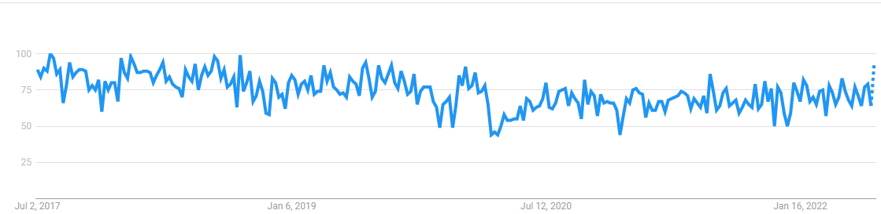

“divorce compared to poverty” keyword analysis

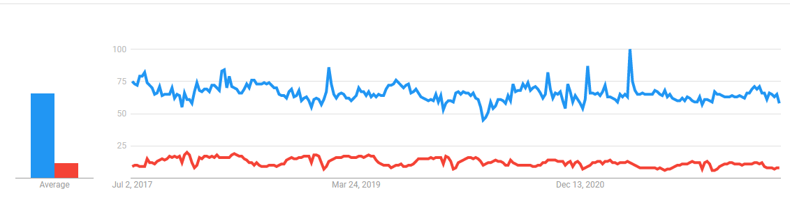

Custody

One factor that may determine whether a couple decides to take the divorce dive, is children. As most would suspect, each parent holds themselves in high regard as to why they would make the better parent. It seems the common tactic is to try to convince a judge that they need full custody. Why would you want to go through a divorce and lose your kids? What are my chances of keeping the kids based on my situation or scenario? What was the outcome of custody for someone in my situation? Alaska ranks as the number one state in couples searching for child custody and one of the highest in “moving/moving companies/moving” categorical searches. What the data suggests is that couples concerned with custody might be concerned with the ex-wife or ex-husband moving to the lower United States. Alaska is detached and a considerable distance from contiguous states. Divorce may impact travel, costs, and time. When averaging the ranking of all 51 states (this includes District of Columbia) based on divorce, custody, and moving, couples in Alaska rank third overall. It’s also worth noting that according to the 2017 Census Bureau data as reported by Grant Suneson of USA TODAY, Alaska’s married population amounts to 48.9% and ranks eighth highest in divorce rate and only the twentieth highest for marriage rate. This simply tells us that a fair number of Alaskans are getting married but there are a lot of couples that divorce.

Keyword analysis representation below where yellow indicates keyword “moving”, red indicates “divorce”, and blue indicates “child custody”.

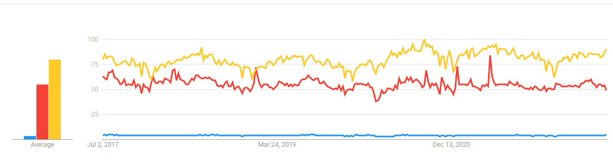



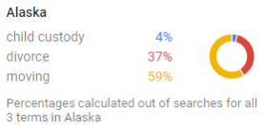

Child Support

A common side effect to divorces that often accompanies child custody orders and rulings is the financial responsibility each parent will bear to ensure the children are provided for based on the parent’s income. This is known as child support. Child support calculations vary from state to state, but where you get divorced could cost you double and even triple the lowest of child support rates. A study by Custody X Change, as reported by CBS News, lists Kansas as having one of the highest calculated rates in determining child support costs. Kansas also ranks number one is averaging search criteria for Divorce, Custody, and Moving. They also rank eighth in searches for “avoid child support”. The data tells us it’s costly to divorce if child support is a factor, and residents are worried about it so much they look at ways to avoid it. When do residents search for avoiding child support? Christmas takes the top prize here. Ironically, Kansas ranks as the sixth lowest in divorce rate in the same Census Bureau data from 2017 as reported by USA TODAY. Maybe the child support costs have couples rethinking, is it worth it?

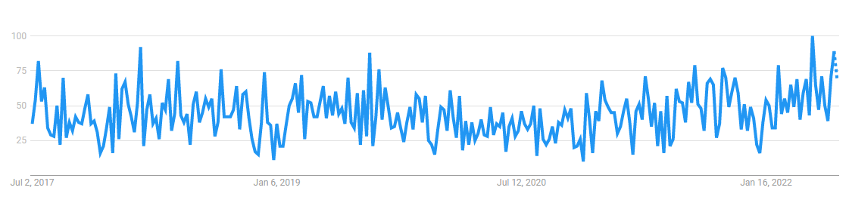

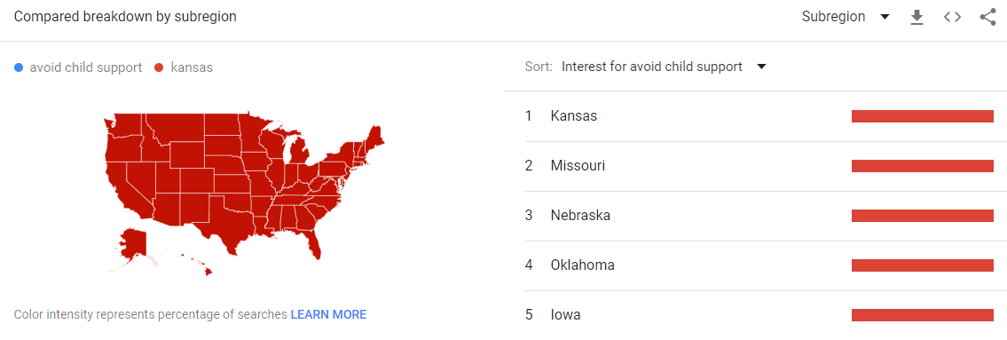

Alimony or Spousal Support

The other common side effect of divorce is spousal support. Laws across the country provide not just children adequate support but the divorcees. Spousal support is commonly determined by taking a percentage of the difference between both individuals net income. Depending on whether children are involved or not may affect the percentage calculated. This support is provided to the lower income earner individual and is only authorized for a specified time. In researching alimony, one must consider the various names this support can be called. Searches returned for alimony, spousal support, and spousal maintenance, all point to a common location, California. Couples in California are often searching these terms, and even keywords like spousal calculator. Some related searches Californians are also considering are whether alimony is deductible income, whether there are taxes on alimony, and even palimony! In California, if you reside with someone and are unmarried, separation can even cost you!

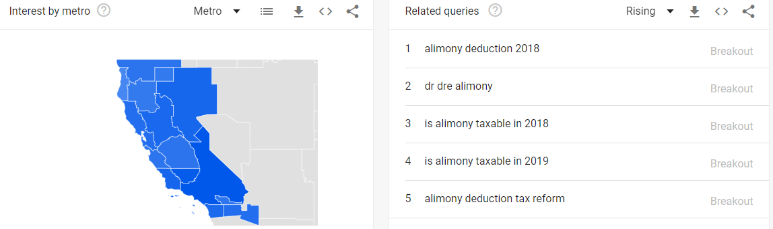

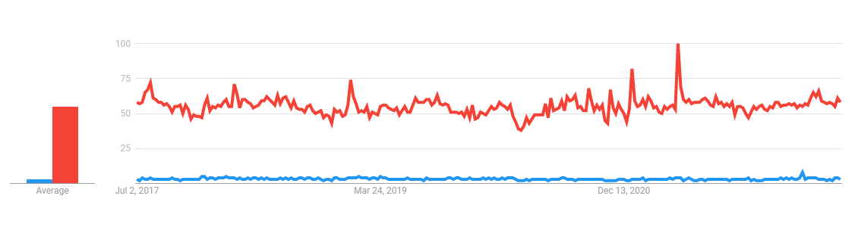

Infidelity

Most known as cheating. I don’t think we need to define this any further. It happens in all states, but in Wyoming and Vermont more couples are searching “wife cheating” than “husband cheating” by 100 to 1. While Connecticut searches report a more balanced finding. According to trending related searches, overall, couples are more concerned with doorbells catching cheating husbands, and husbands killing cheating wives. My theory is husbands are searching how not to get caught, and as the saying goes, “those that worry are often at fault”. This would explain why there is not a single state that has more searches for men cheating than women cheating. Maybe women trust men more? Or possibly women have better things to do then search whether their man is cheating?

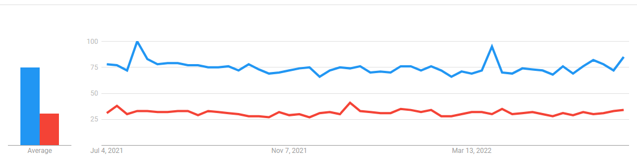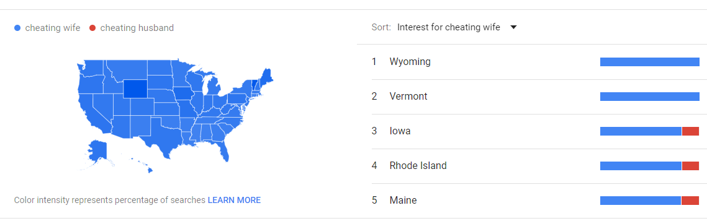

Findings/Next Steps

One leading assumption with divorce data, is that divorces are in decline. The decline is linear to the drop in overall marriages. Although cause for divorce is still subject to a multitude of reasons, it can be assumed that these top causes of divorce will remain consistent as they have for decades. Beyond the data that is available, historical books often portray similar cause for “separation” between couples. Historically speaking, marriage held a higher merit than it does today. Divorce was not always as common, but infidelity was dealt with far greater punishment then a court hearing in today’s world. It is also assumed that statistically, normality, linearity, and equality of variance will be consistent. I think identifying any cause of divorce as an independent variable, through random sampling will poise to show equality in differences and variance. There is however, variance differences that would be noticeable at the state level of sampling. As we have seen previously, states geographically are tied to different moral upbringings, have different environments, and are held under different laws all causing differences in equality. At a national level, though, we should see linear representation of the data in a year over year comparison. The population still shows high signs of morally allowing divorce. There are ethical concerns with collection of data, particularly divorce data. Ne would need to look to algorithm fairness and privacy rights when collecting data in a more in-depth study. Bias knows no boundary and can creep into the study through many avenues. It should also be noted that one issue is data collection as the baseline of divorce events does not provide a well-rounded study. Data does suggest that couples do sometimes get re-married, or divorces are cancelled. We also do not include annulments, which is defined in a range of views depending on the state but is not considered a divorce by definition. In a study on divorce, I would hope that there could be research done on the what’s and why’s and be able to provide couples with a means of avoiding a premature divorce, or allowing for interjection of social services that may save a marriage. Studies do show that often couples seek assistance for their marriage but by the time that they do, they have already decided on divorce. How can we get to couples before they are past the red line? Marriage and divorce are a very tricky subject especially for anyone seeking data and measuring its culpability. This is often the most private of private information in the larger society. I would only assume most couples would not publicly announce divorce symptoms or provide data that could be measured.

In the end, divorce is a very bulky but private topic for research. It is particularly interesting as it has played a role secondarily in how generations have been raised. I think one can conclude that divorce has played a role in the degradation of the nuclear family and has been a contributor to several societal breakdowns we are currently seeing. When peering into divorce reasoning and using data science to capture trends and map predictions, there may be a way to curb its future. Understanding the why’s and analyzing its effects on other family issues may preserve the tradition that is, marriage.

Sources

Bureau, U. S. C. (2021, October 8). *Marriage and divorce*. Census.gov. Retrieved July 2, 2022, from https://www.census.gov/topics/families/marriage-and-divorce.html

Leefeldt, E. (2019, June 18). *Child support payments vary wildly from state to state*. CBS News. Retrieved July 2, 2022, from https://www.cbsnews.com/news/child-support-payments-vary-wildly-from-state-to-state/

N/A, C. D. C. (2020). *National marriage divorce rates - centers for Disease Control and ...* https://www.cdc.gov/nchs/data/dvs/national-marriage-divorce-rates-00-20.pdf. Retrieved July 2, 2022, from https://www.cdc.gov/nchs/data/dvs/national-marriage-divorce-rates-00-18.pdf

Suneson, G., & Sauter, M. B. (2018, September 7). *These are the 25 worst cities in the U.S. to raise children*. USA Today. Retrieved July 2, 2022, from https://www.usatoday.com/story/money/economy/2018/08/17/worst-cities-raise-children/37381225/

**Screenshot data and analysis provided by Google Trends.  "Data source: Google Trends (<https://www.google.com/trends>)."