**Invitation Card App**

**Clearly articulate and document the application idea for your passion project. This should be summarized with a few sentences and could be communicated over the course of an elevator ride (ie. an Elevator Pitch).**

It is a free download invitation card app for birthday parties. This app will allow hosts to choose invitation cards based on many predefined design templates. The package up to 50 invitations will costs $10.00 after that an additional invitation would cost of $0.10 each.

* Hosts will be able to add all the basic information of the event as well as pictures of the host.
* A RSVP has to be set. (YES/NO)
* If a menu variety is present, guest will be able to choose what kind of meal they are going to eat. Otherwise, this part would be disable if there is only one option.
* Payment methods would be set for 3 ways only (Paypal, credit card or present gift).
* In case of present gift will allow to hosts specify their preferences if they want either toys, books, clothes or all of them for their children.
* After invitation is done, hosts would be able to send invitations through email.
* Hosts will able to see invitations list.

**Develop a list of functional and non-functional requirements. Remember these are broad concepts that will be more clearly understood through the related features.**

|  |  |
| --- | --- |
| **Functional requirements** | **Non-functional requirements** |
| 1. Create account 2. Templates 3. Create invitations 4. Send invitations 5. Responses 6. Event management | * Color: Light blue and white * Logo: Not defined * Designer Copyright * Ensure templates will be stored in a database * Store hosts and guests email in a database * 24 hours available * Reimbursement policy |

**Create a prioritized feature list. Break your features into “Must Have” and “Nice to Have”.**

|  |  |
| --- | --- |
| **Must have** | **Nice to have** |
| * 1. Register   2. Log in   3. Upload template   4. See template   5. Unable to download templates nor invitations   6. Select template   7. Set basic information   8. Set RSVP   9. Set gift method; if is an e-money gift, third party will be used.   10. Send invitations by email   11. Guest able to RSVP   12. Guest able to select gift method   13. Show invitations response   14. Show gift method that would be received | * 1. Show gender category templates   2. Set Meal Menu   3. Set present gift preferences |

**Using a tool (ie. Draw.io or Visio), create an entity relationship diagram.**

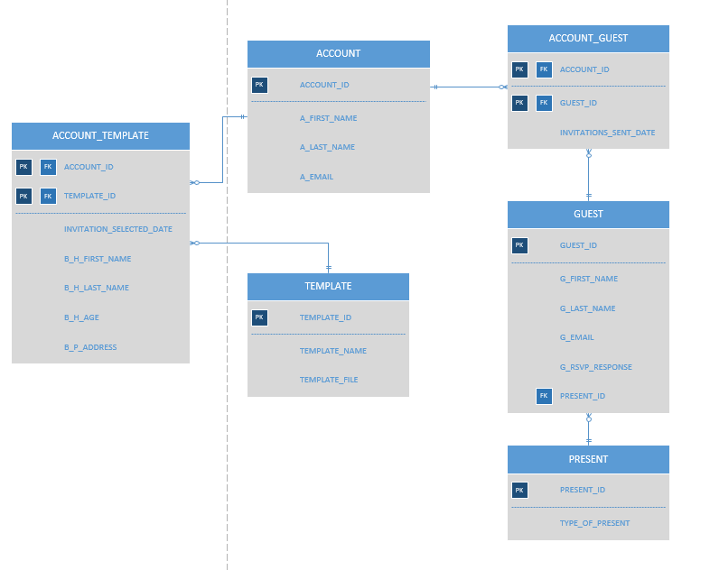

**Create a high-fidelity prototype that accurately summarizes the different user flows for your must-have features.**

https://app.moqups.com/LM7BQHpPh3/view