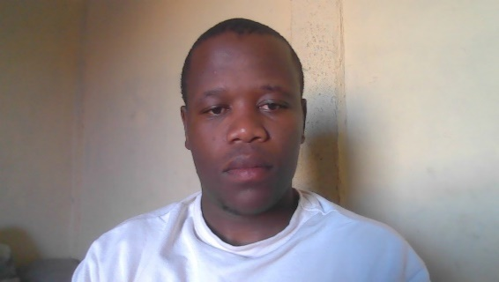

**EXPERIENCE**

**Mentor Jan 2022 until Dec 2022**

Central University of Technology, Welkom Faculty of Engineering, Built Environment, and Information Technology.

Awarded Certificate of Recognition

**Duties performed:**

• Welcomed new students through orientation and site tours.

• Maintained sensitive student information.

• Answered student questions and concerns taking phone calls and replying to emails.

• Held meetings with students and advised on admission processes.

• Updated students about CUT courses, and events.

• Participate in team projects, demonstrating an ability to work collaboratively and effectively.

**EDUCATION**

**Gabigabi Secondary** **2015 - 2019**

Qualification - Grade 12

**Central University of Technology** **2021 - 2023**

Qualification - Diploma in Information Technology

Year of graduation – 2024

**SBONGAKONKE SITHOLE**

CONTACT

Dedicated and hardworking team player with expertise in completing various office tasks and offering staff support. Responsible, punctual, and productive professional when working with little to no supervision. Organised and dependable successful at managing multiple priorities with a positive attitude. Willingness to take on added responsibilities to meet team goals. Always striving for perfection , I also have been awarded merit certificate for academic excellence from the faculty.



065 729 0039



Sbongakonkesihle31@gmail.com



SANKONTSHE AREA MR430 HOUSE NO. 30936 HAMMASRDALE 3700



https://www.linkedin.com/in/sbongakonke-sithole-b26a9b223/

SKILLS

* Microsoft Office
* Ability to multitask.
* Fast Learner
* Communication skills
* Reliable
* Report generation
* Time management
* Mobile Development (Flutter)
* Software Development (Asp.Net)
* Programming Languages Dart and C#
* Basic Networking
* Basic Graphic Design

Swazi

◼◼◼◼◼

ISIXHOSA

◼◼◼◼◼

SESOTHO

◼◼◼◼◼

ISIZULU

◼◼◼◼◼

ENGLISH

◼◼◼◼◼

LANGUAGES

**Student Assistant Jan 2023 until Dec 2023**

Central University of Technology, Welkom Faculty of Engineering, Built Environment, and Information Technology.

**Duties performed:**

• Assist during practical classes.

• Invigilation during class tests.

• Answered student questions and concerns.

• Looking after computer labs.

• Participate in team projects, demonstrating an ability to work collaboratively and effectively.