Creating a point cloud:

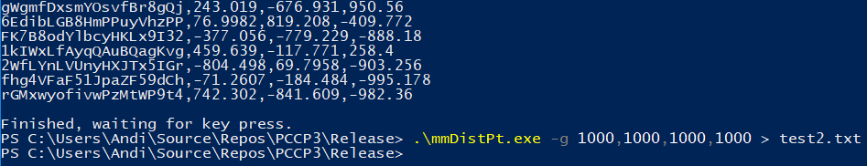

Calculating minimum and maximum distance:

