49 AIC, AICc - Explain Video - 14.01.2021 (21.01)

In the course of the lecture, you were introduced to various concepts for evaluating the goodness of fit or performing a model selection with regard to some parameter estimate. Among these methods was AIC and AICc.
- (a) state the kind of statistical problem it is applicable to (e.g. a regression problem or some simpler setup)
→ (model fitting )
- (b) state what it measures (directly or indirectly) and which assumptions it makes about the nature of the problem
→ (Are using the same data between models, Have a sample of infinite size)
- c) state how you use it and for what purpose exactly (maybe some of these concepts only give a theoretical insight?)
→ see below, comparing if you don’t have a validation set (doesn’t give objective measure)
- (d) try to think of cases where it would not be applicable and where other measures would be preferable. (answer on the upper page.3)
→ There are cases where AIC is used and some cases where BIC is used for example
(https://towardsdatascience.com/introduction-to-aic-akaike-information-criterion-9c9ba1c96ced)

SCRIPT
INCLUDE A COMPETITION / JUDGE NOTION AS ANALOGY TO EXPLAIN
__________________________________________________________
Introduction:
Hey everybody, today we will give you a quick intro, and a little background to the akaike information criterion. (+ Überleitung)

1. Where are we situated? /Storytelling
Imagine, you and your friend have some data samples and every one of you have a model. On its own, these models aren’t very useful to you and you both want to help each other to generalize from the data that you have. And that’s why you want to find out whether which model explains the data better (in the best case not only the data- but also, from where the distribution comes from.)
Both of you are pondering: We both have models but can we take a methode to find out which model does not only fit the data the best, but also is not complex? (it’s easy to find a low-error model but it’s difficult to find a simplified and fitting model)
Answer: The AIC (Akaike-Information-Criterion) can help us to find out which model fits our data the best and is also simple.
(We can note here that we might be in the special situation where we don’t have a validation set! We do that by comparing)

2. How?/What does AIC do (general info)

The high level idea (Race/Competition) :
AIC boldly said is a ranking score, so one metric. If we have (at least two) competing models and we want to know which one does both well (fitting and being simple :D).We can compute our AIC scores and the smaller value wins!
→ we can show them the formula and explain why

3.
the llh that our data was indeed produced by our model & penelizes high # of parameters. (everyone is supposed to give their best shot. easy stuff is rewarded, but good stuff also)
-> like we said before… a low AIC score wins.
(Python code(!?))

4. Pitfalls of AIC
But (It is important to keep in mind that just as in any other competition):
- AIC can only help you choose what is better, if you have comparable alternatives. (trained on the same data. measuring the same outcome variables)
- And even the better option can be crappy, (pest & colera)
Using AIC we don’t take into account how much data we got, but we assume that we have enough (infinite) samples. That’s how it comes that When our sample size is very small, AIC is imprecise.
(This error: converges to 0 with increasing sample size but helps us be more just in small # cases.)
→ We can use AICc (corrected) (show formula)
→ We can use the BIC (as the bayesian alternative to AIC or a more recent alternative)
→ We can use WAIC. it takes uncertainty of our score respective to our sample size into account. (If you want to really dig into your ranking job)

5.
SUMMARY
Conclusion
For most calculations where one has enough data, the best (and easiest) way to accurately test your model’s performance is to use a train, validation, and test set, in good machine learning practice. But if circumstances arise where that is not possible (with small data, or time series analysis), AIC may be a better go-to test of performance.

OPEN Qs
- why exactly doesn’t AICc have the same problem as AIC?
- make AIC formlar explanation nicer, more concrete

BRAIN DUMP
__________________________________________________________
What is AIC and AICc:

In plain words, AIC is a single number score that can be used to determine which of multiple models is most likely to be the best model for a given dataset that is computed . It estimates models relatively, meaning that AIC scores are only useful in comparison with other AIC scores for the same dataset. A lower AIC score is better.

AIC -
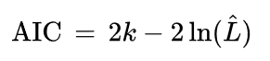

AICc - corrected for smaller samples
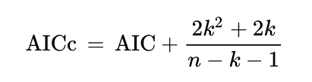
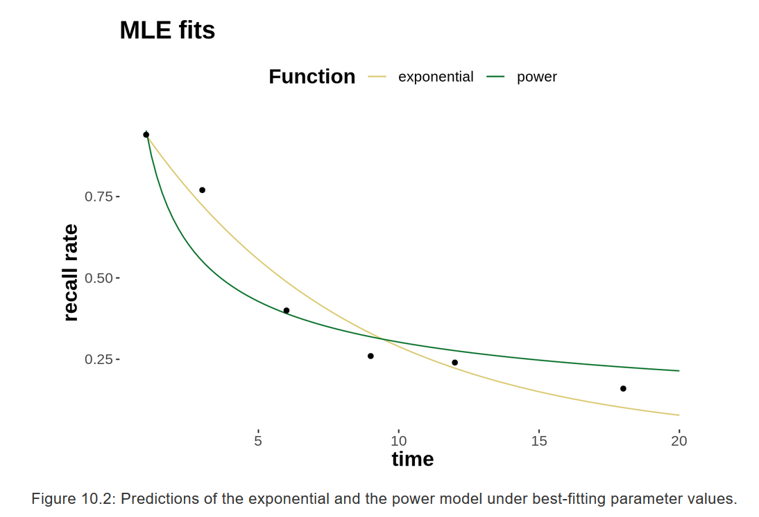
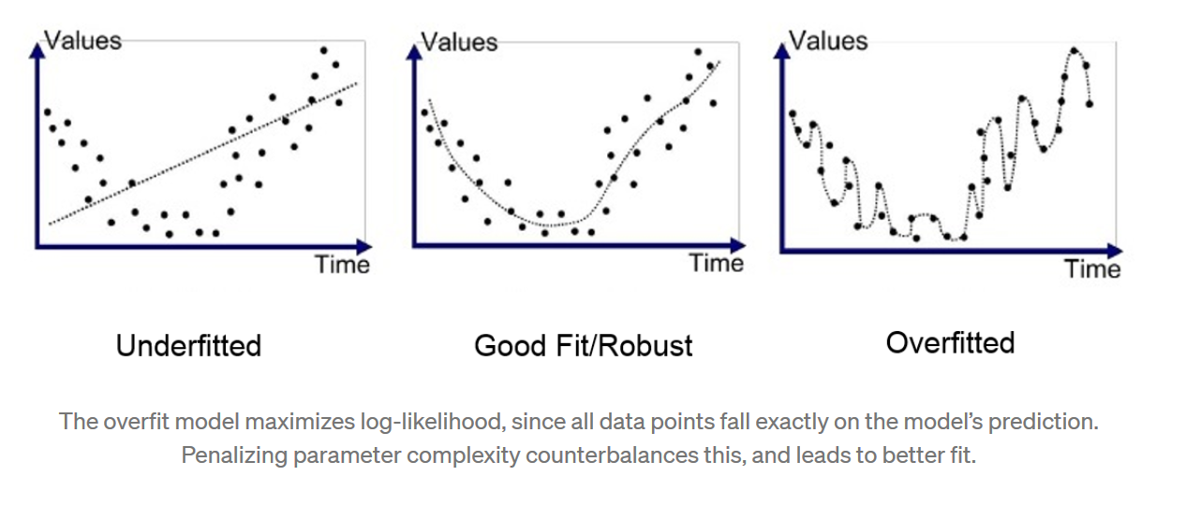

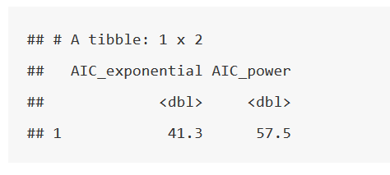

__________________________________________________________

AIC is most frequently used in situations where one is not able to easily test the model’s performance on a test set in standard machine learning practice (small data, or time series). AIC is particularly valuable for time series, because time series analysis’ most valuable data is often the most recent, which is stuck in the validation and test sets. As a result, training on all the data and using AIC can result in improved model selection over traditional train/validation/test model selection methods.
__________________________________________________________

Short summary:

measures: overall:
directly: LLH of the model (goodness of fit) + complexity (to not overfit)
assumptions: there is an underlying structure, occam’s razor

use:
when we don’t have new data to check
very basic
apply to diff options (models) -> choose lowest aic score

other measures:
better include that we are using samples by resampling? (https://www.youtube.com/watch?v=xS4jDHQfP2o)
small samples, that are not enough to viz. the datas character

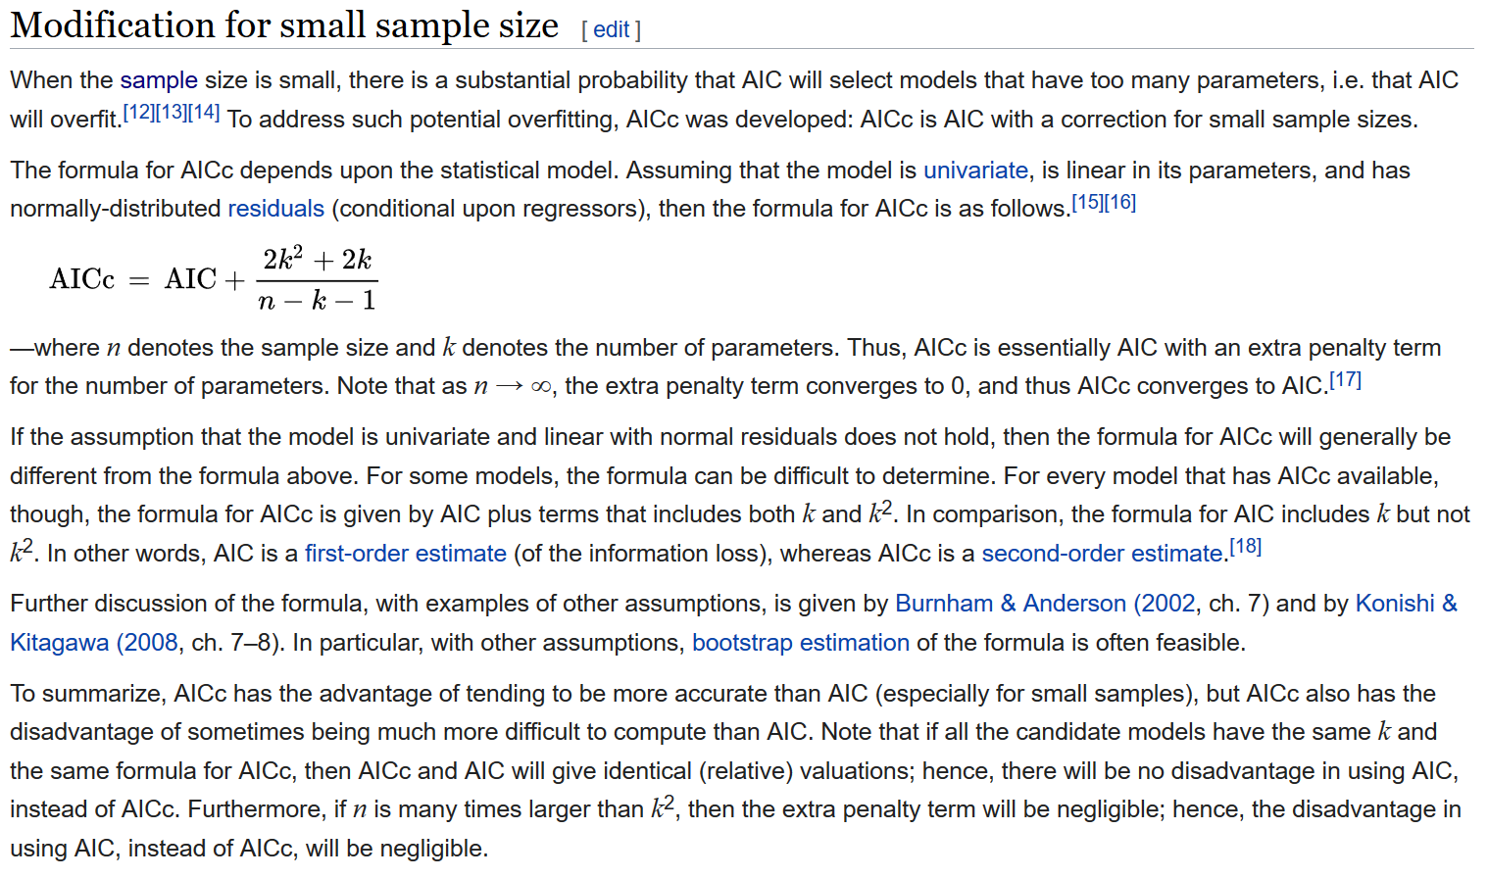

__________________________________________________________
AIC needs to make a priori assumptions:

(SARIMA Note: AIC makes an assumption that all models are trained on the same data, so using AIC to decide between different orders of differencing is technically invalid, since one data point is lost through each order of differencing.) For a list of other technical “Facts and Fallacies of AIC” that apply across contexts, check out Rob Hyndman’s blog post.
You must be able to fulfill AIC’s assumptions. AIC makes assumptions that you:
- Are using the same data between models
- Are measuring the same outcome variable between models
- Have a sample of infinite size
That last assumption is because AIC converges to the correct answer with an infinite sample size. Often a large sample is good enough to approximate, but since using AIC often means that you have a small sample size, there is a sample-size adjusted formula called AICc, which adds a correction term that converges to the AIC answer for large samples, but gives a more accurate answer for smaller samples.
__________________________________________________________
The interpretation of AIC scores can be difficult:

Wikipedia has a great example on this, with two sample AIC scores of 100 and 102 leading to the mathematical result that the 102-score model is 0.368 times as probable as the 100-score model to be the best model. An AIC of 110 is only 0.007 times as probable to be a better model than the 100-score AIC model. While this means that you can never know when one model is better than another from AIC (it is only using in-sample data, after all), there are strategies to handle these probabilistic results:

__________________________________________________________

4. Pitfalls of AIC
As a reminder, AIC only measures the relative quality of models. This means that all models tested could still fit poorly. As a result, other measures are necessary to show that your model’s results are of an acceptable absolute standard (calculating the MAPE, for example).
AIC is also a relatively simple calculation that has been built upon and surpassed by other more computationally complicated — but also typically more accurate — generalized measures. Examples of these include DIC (Deviance Information Criterion), WAIC (Watanabe-Akaike Information Criterion), and LOO-CV (Leave-One-Out Cross-Validation, which AIC asymptotically approaches with large samples).
__________________________________________________________

Conclusion
For most calculations where one has enough data, the best (and easiest) way to accurately test your model’s performance is to use a train, validation, and test set, in good machine learning practice. But if circumstances arise where that is not possible (with small data, or time series analysis), AIC may be a better go-to test of performance.

