**Supplemental Material**

**Supplemental Videos**

Supplemental videos 1–6 are available in the repository at https://github.com/ dtabuena/FunctionalStates/tree/main/SupplementalVideos.

**Video Captions**

**Video 1 -** Spontaneous Ca2+ activity under in the Persistently Active state recorded in adult mouse cortex.

**Video 2 -** Spontaneous Ca2+ activity under in the Slow Wave state recorded in adult mouse cortex.

**Video 3 -** Triggered average of the Ca2+ responses after visual stimulation with and LED flash in the persistently active state.

**Video 4 -** Triggered average of the Ca2+ responses after visual stimulation with and LED flash in the the slow wave state.

**Video 5 -** Triggered average of the Ca2+ responses after somatic electrical stimulation of the hind paw in the persistently active state.

**Video 6 -** Triggered average of the Ca2+ responses after somatic electrical stimulation of the hind paw in the slow wave state.

**Supplemental Figures**

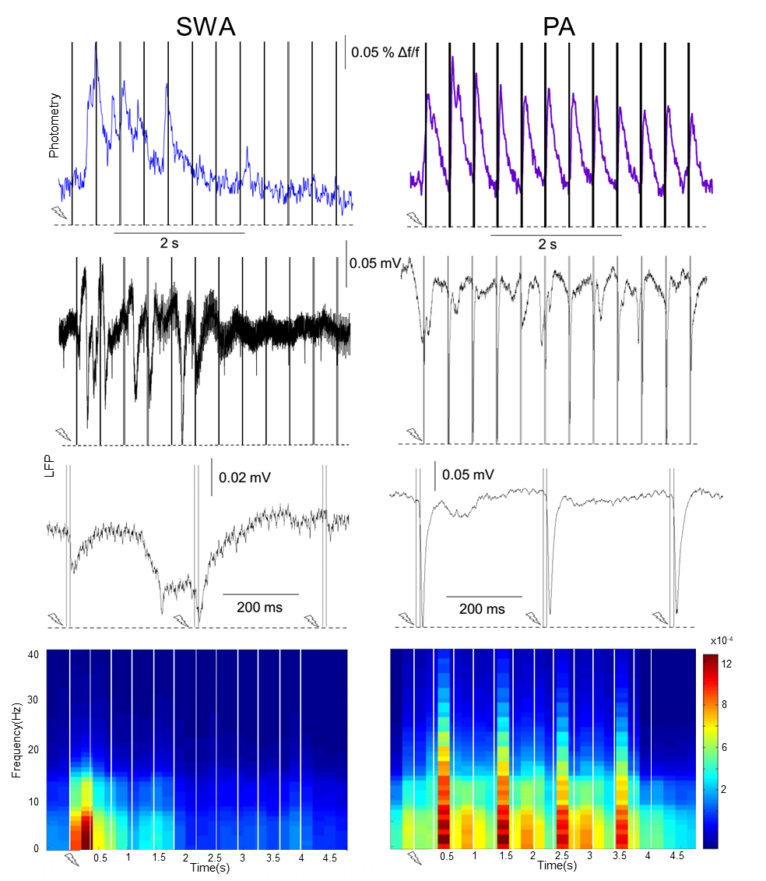

**Supplementary Figure 1. Local dynamics of functional states during sensory-evoked activity (stimulus trains).** (A) During slow wave activity (blue, left trace) stimulus trains of 3 Hz, 4 s lead to calcium waves comparable to the ones evoked by single pulses (cp. Figure 3.3 B). During persistent activity (purple, right trace) short-latency responses are elicited by every stimulus pulse of the train upon the same stimulation paradigm. (B) LFP recordings reveal similar signal characteristics upon 3 Hz 4 s stimulation as in above calcium, a stereotypic slow wave event is elicited during slow wave activity (left) whereas persistent activity is characterized by short-latency LFP spikes upon every pulse of the stimulus train (right). (C) A magnification of pulse 3-5 of the stimulus train in (B) shows that during slow wave activity a stereotypical wave event was elicited upon the stimulation, which is not responsive upon consecutive stimulus pulses, whereas during persistent activity every stimulus pulse was encoded by stimulus-locked LFP spike (right). (D) Stimulus-locked spectrograms reveal different response types upon 3 Hz 4 s stimulation paradigm for slow wave activity (left) and persistent activity (right) in their time-frequency profile. Vertical scales are the same for both plots.

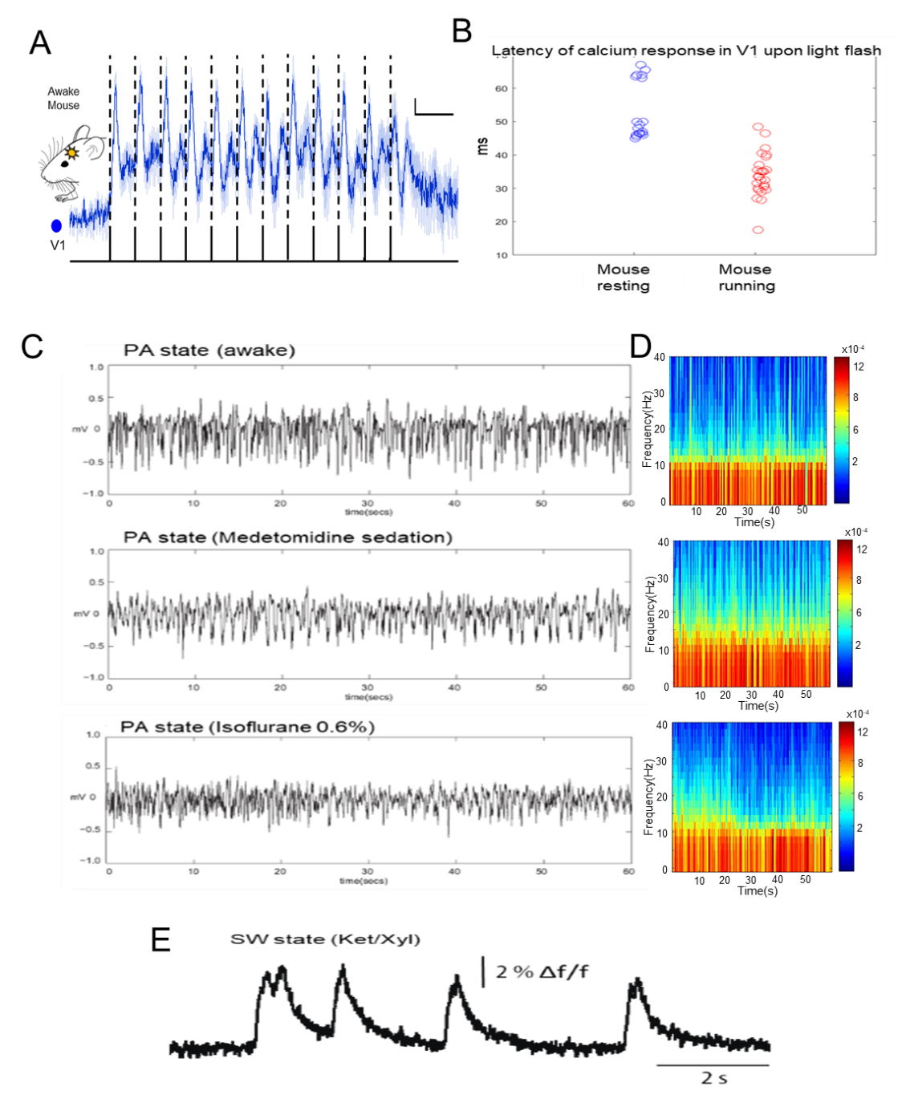

**Supplementary Figure 2. Spatiotemporal dynamics in awake and sedated condition.** (A) Responses occur locally in the area of respective sensory afferents in the awake mouse. Similar to the calcium responses in medetomidine sedated animals, visual stimulation leads to short-latency primary responses in the calcium signal of V1 (mean latency 25 ms ± 3 ms; 10 events) recorded in an awake mouse (averages of 10 stimulus trains of 3 Hz for 4 s events, line = mean, shading = SEM of 10 evoked events; vertical scale bars = 1 % Δf/f, horizontal scale bars = 500 ms). (B) Latency distributions of V1 calcium responses upon visual stimulation during rest and running. In this animal during a prolonged period of rest (> 30 s), visually evoked calcium responses in V1 (blue circles) occurred with a mean latency of 53 ms (± 2 ms; 18 events). When the animal was running on the tracking ball, visual stimulation evoked calcium responses in V1 with a mean latency of 34 ms (± 1 ms; 26 events). The medians of the distributions are statistically different (rank sum test, p <0.0001). (C) Examples of individual animal’s LFP traces during PA state under different conditions. (D) Spectrograms corresponding to traces shown in (C). (E). Example of SWA state with spontaneously occurring slow wave events under Ket/Xyl anesthesia.

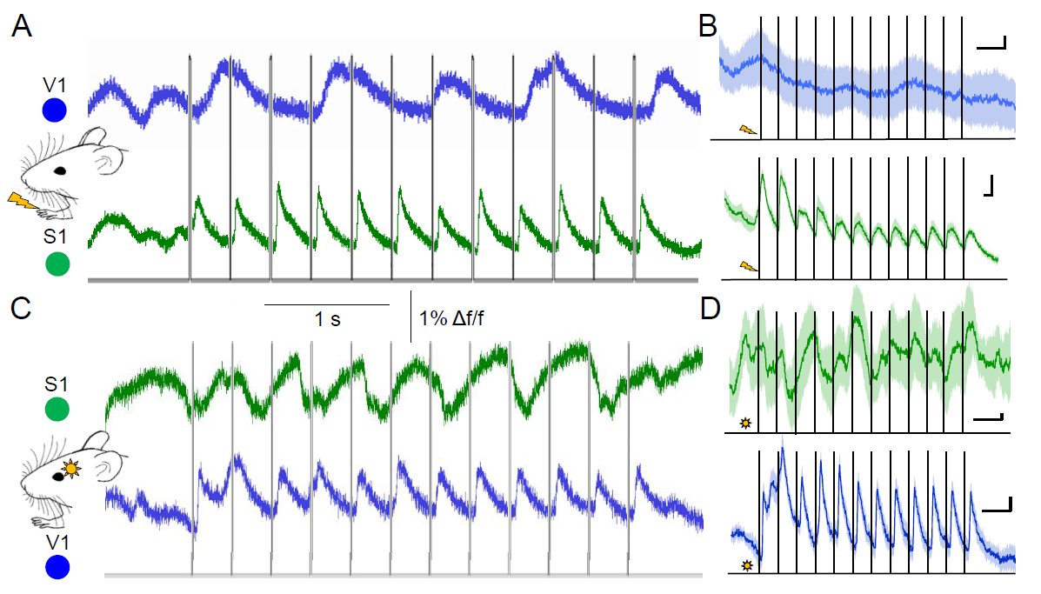

**Supplementary Figure 3. Responses occur locally in the area of respective sensory afferents during PA.**

(A) Upon forepaw stimulation (trains of 3 Hz for 4 s), short-latency calciumtransients are observable in S1, while no stimulus-locked responses are visible in V1. (B) Averages of responses of traces in (A) (averages of 10 events, line = mean, shading = SEM of 10 evoked events; vertical scale bars = 1 % df/f, horizontal scale bars = 0.5 s). (C) Same as in (A) but for visual stimulation, the same stimulation paradigm applied with LED light to the contralateral eye evoked primary responses in V1 while the photometry signal in S1 stays unperturbed by the stimulation. (D) Averages of responses in (C) (averages of 10 events, line = mean, shading = SEM of 10 evoked events; vertical scale bars = 1 % df/f, horizontal scale bars = 0.5 ms). (A-D) are contralateral (S1/V1) recordings.

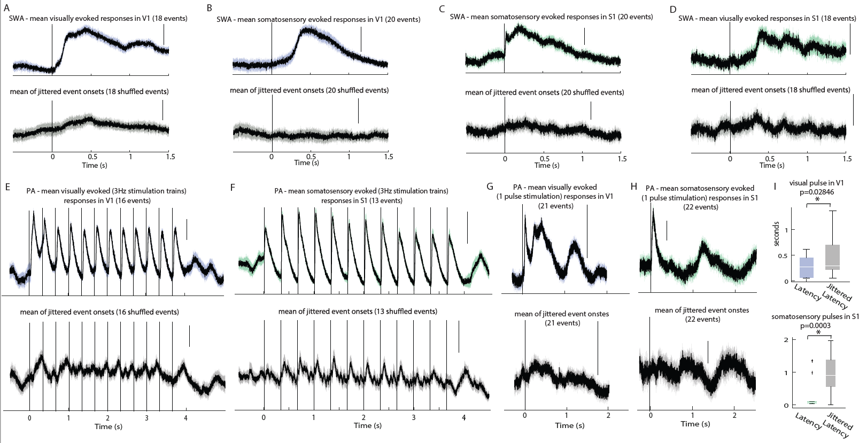

**Supplementary Figure 4. Average photometry responses in S1 and V1 upon different types of sensory stimulation during SWA (A-D) and PA (E-I) compared to jittered stimulus onset times.** (A) Mean SWA response in V1 upon visual stimulation (1 pulse of 10ms duration every 10 s; top) compared to the mean response upon onset times which were temporally shuffled randomly in a range of 2 s around every real stimulus event of the same recording trace (bottom). (B) Same as in (A) but for forepaw stimulation (1mA pulse of 10ms duration every 10s) evoked responses in V1. (C) Mean SWA response in S1 upon forepaw stimulation (1 mA pulse of 10ms duration every 10s; top) compared to the mean response upon onset times which were temporally shuffled randomly in a range of 2s around every real stimulus event of the same recording trace (bottom). (D) Same as in (A) but for visual stimulation (1 pulse of 10 ms every 10 s) evoked responses in S1. (E) Mean PA response in V1 upon visual stimulation (12 pulses of 10 ms duration at 3 Hz every 10 s; top) compared to the mean response upon onset times (of the first pulse in the subsequent stimulus train) which were temporally shuffled randomly in a range of 2s around every real stimulus event of the same recording trace (bottom). (F) Same as in (E) but for forepaw stimulation (same stimulus timing as in E) in S1. (G) Mean visually evoked PA response upon single pulse stimulation (1 pulse of 10ms duration every 10s) in V1 (top) compared to jittered event onsets (bottom). (H) Same as in (G) but for responses in S1 upon forepaw pulses. (I). Statistical comparison of latencies (defined as the maximum amplitude within a 2s window after real or jittered stimulus onset) for PA responses. Top: in V1 upon visual stimulation (taken from G top) compared to latencies upon jittered onset times in the same recording trace (from G bottom), p-value = 0.02846. Bottom: in S1 upon forepaw stimulation (taken from H top) compared to latencies upon jittered onset times in the same recording trace (from H bottom), p-value = 0.0003. (A-I) All vertical scale bars are 2 % df/f.