Lab 2 Section 3.1 Outline
Team Black - Strome InFusion
ODU CS 411 W
  - Functional Requirements (Bliss)
The requirements necessary to build a functional prototype that will prove the viability of a solution to Strome Entrepreneurial Center’s lack of ability to make, maintain, and track connections. Each of the following sections will address specific portions of the digital solution, how they will be used, and their constraints.
    - Database (Bliss)
Implementing a PostgreSQL database provides a structured format for saving, editing, and accessing data for a given concept of the prototype. Figure 1 shows the tables and their primary and foreign keys. Data shall be saved to meet the following requirements and formats:
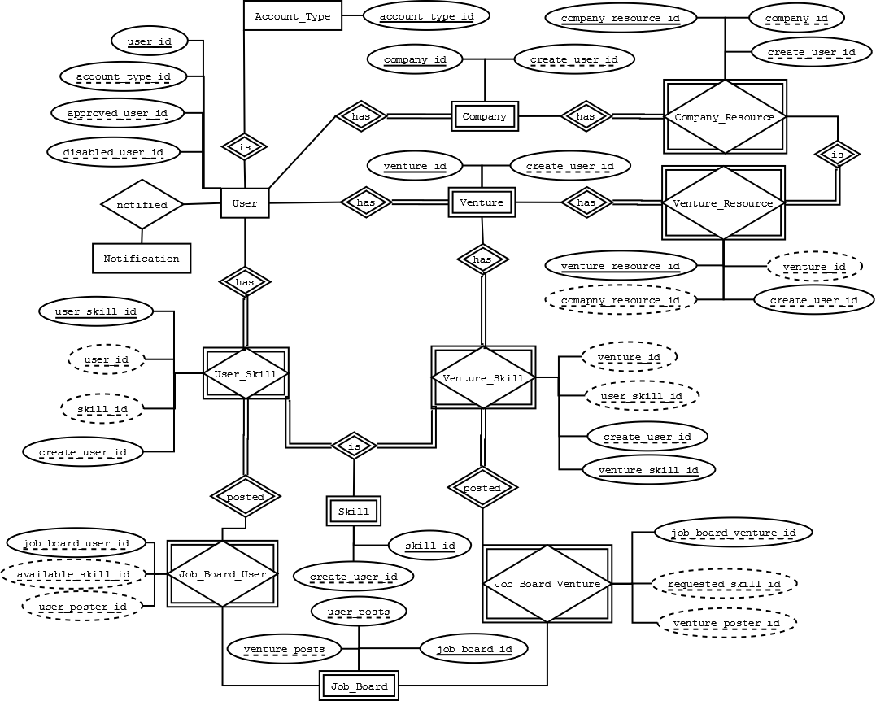
Figure 10. Database schema of tables and keys.
      - User Table (Strong)
Attribute | Datatype | Key | Requirement | Null | Notes
user_id | BigSerial | Primary key | Must auto-increment starting at 1 | Not Null
last_name | Text |  |  | Not Null
first_name | Text |  |  | Not Null
email | Text |  | Must be unique | Not Null
password | Text |  |  | Not Null
register_dttm | Timestamp |  |  | Null | Populated after email verification
create_dttm | Timestamp |  | Must default to SYSDATE when record is created | Not Null
account_type_id | Integer | Foreign key to Accout_Type (acount_type_id) |  | Not Null
approved_dttm | Timestamp |  |  | Null | Null value assumes user is not approved
approved_user_id | Integer | Foreign key to User (user_id) |  | Null
disabled_dttm | Timestamp |  |  | Null | Null value assumes user is active
disabled_user_id | Integer | Foreign key to User (user_id) |  | Null
gcm_token | Text |  |  | Null
Table 2. User table for database.
Space left intentionally blank.

      - User Account Types (Strong)
Attribute | Datatype | Key | Requirement | Null | Notes
account_type_id | BigSerial | Primary key | Must auto-increment starting at 1 | Not Null
name | Text |  | Must be unique | Not Null
description | Text |  |  | Null
Table 3. User account types table for database.

      - Ventures (Bliss)
Attribute | Datatype | Key | Requirement | Null | Notes
venture_id | BigSerial | Primary key | Must auto-increment starting at 1 | Not Null
description | Text |  |  | Null
create_user_id | Integer | Foreign key to User (user_id) |  | Not Null
create_dttm | Timestamp |  | Must default to SYSDATE when record is created | Not Null
public_info | Text |  |  | Null
approved_dttm | Timestamp |  |  | Null
approved_user_id | Integer | Foreign key to User (user_id) |  | Null
Table 4. Ventures table for database.

      - Skills (Bliss)
Attribute | Datatype | Key | Requirement | Null | Notes
skill_id | BigSerial | Primary key | Must auto-increment starting at 1 | Not Null
name | Text |  | Must be unique | Not Null | i.e. Web Developer
description | Text |  |  | Null
create_dttm | Timestamp |  | Must default to SYSDATE when record is created | Not Null
create_user_id | Integer | Foreign key to User (user_id) |  | Not Null
Table 5. Skills table for database.

Space left intentionally blank.

      - User Skill (Bliss)
Attribute | Datatype | Key | Requirement | Null | Notes
user_skill_id | BigSerial | Primary key | Must auto-increment starting at 1 | Not Null
user_id | Integer | Foreign key to User (user_id), partial key (user_id, skill_id) |  | Not Null
skill_id | Integer | Foreign key to Skill (skill_id), partial key (user_id, skill_id) |  | Not Null
create_dttm | Timestamp |  | Must default to SYSDATE when record is created | Not Null
create_user_id | Integer | Foreign key to User (user_id) |  | Not Null
Table 6. User skills table for database.

      - Venture Skill (Bliss)
Attribute | Datatype | Key | Requirements | Null | Notes
venture_skill_id | BigSerial | Primary key | Must auto-increment starting at 1 | Not Null
venture_id | Integer | Foreign key to Venture (venture_id), partial key (venture_id, user_skill_id) |  | Not Null
user_skill_id | Integer | Foreign key to User_Skill (user_skill_id), partial key (venture_id, user_skill_id) |  | Not Null
create_dttm | Timestamp |  | Must default to SYSDATE when record is created | Not Null
create_user_id | Integer | Foreign key to User (user_id) |  | Not Null
Table 7. Venture skills table for database.

Space left intentionally blank.

      - Companies (Bliss)
Attribute | Datatype | Key | Requirements | Null | Notes
company_id | BigSerial | Primary key | Must auto-increment starting at 1 | Not Null
name | Text |  | Must be unique | Not Null | i.e. Olive Garden
description | Text |  |  | Null
create_dttm | Timestamp |  | Must default to SYSDATE when record is created | Not Null
create_user_id | Integer | Foreign key to User (user_id) |  | Not Null
Table 8. Companies table for database.

      - Company Resources (Bliss)
Attribute | Datatype | Key | Requirements | Null | Notes
company_resource_id | BigSerial | Primary key | Must auto-increment starting at 1 | Not Null
name | Text |  | Must be unique | Not Null | i.e. Kitchen Space
description | Text
company_id | Integer | Foreign key to Company (company_id)
create_dttm | Timestamp |  | Must default to SYSDATE when record is created
create_user_id | Integer | Foreign key to User (user_id)
Table 9. Company resources table for database.

Space left intentionally blank.

      - Venture Resources (Bliss)
Attribute | Datatype | Key | Requirements | Null | Notes
venture_resource_id | BigSerial | Primary key | Must auto-increment starting at 1 | Not Null
venture_id | Integer | Foreign key to Venture (venture_id), partial key (venture_id, resource_id) |  | Not Null
company_resource_id | Integer | Foreign key to Company_Resource (company_resource_id), partial key (venture_id, company_resource_id) |  | Not Null
create_dttm | Timestamp |  | Must default to SYSDATE when record is created | Not Null
create_user_id | Integer | Foreign key to User (user_id) |  | Not Null
Table 10. Venture resources table for database.

      - Job Board (Strong)
Attribute | Datatype | Key | Requirements | Null | Notes
job_board_id | BigSerial | Primary key | Most auto-increment starting at 1 | Not Null
user_posts | Integer | Foreign key to Job_Board_Users (job_board_user_id)
venture_posts | Integer | Foreign key to Job_Board_Venture (job_board_venture_id)
Table 11. Job board table for database.

Space left intentionally blank.

      - Job Board Users (Strong)
Attribute | Datatype | Key | Requirements | Null | Notes
job_board_user_id | BigSerial | Foreign key to Job_Board(job_board_id) | Most auto-increment starting at 1 | Not Null
available_skill_id | Integer | Foreign key to Skill(skill_id), partial key (user_id, skill_id)
user_poster_id | Integer | Foreign key to User(user_id), partial key (skill_id, user_id)
Table 12. Job board users table for database.

      - Job Board Ventures (Strong)
Attribute | Datatype | Key | Requirements | Null | Notes
job_board_venture_id | BigSerial | Foreign key to Job_Board(job_board_id) | Most auto-increment starting at 1 | Not Null
requested_skill_id | Integer | Foreign key to Skill(skill_id), partial key (venture_id, skill_id)
venture_poster_id | Integer | Foreign key to User(user_id), partial key (skill_id, venture_id)
Table 13. Job board ventures table for database.

Space left intentionally blank.

      - Notification (Strong)
Attribute | Datatype | Key | Requirements | Null | Notes
notification_id | BigSerial |  | Must auto-increment starting at 1 | Not Null
message | Text |  |  | Not Null
read_dttm | Timestamp |  |  | Null | Null values assumes message not read
create_dttm | Timestamp |  | Must default to SYSDATE when record is created | Not Null
create_user_id | Integer | Foreign key to User (user_id) |  | Not Null
to_user_id | Integer | Foreign key to User (user_id) |  | Not Null
Table 14. Notifications table for database.
    - Web Service (API) (John S.)
The Web service shall support the front end of the application by providing an interface for common functions of the database. The web service shall restrict access to data contained in the database based on the specifications of the Access Control Table, as shown in Table 1.

      - User Services (John S.)
User services shall provide any logged in user with the ability to
        - Register
Shall allow a visitor to register as a SI user
        - Midas Login
Shall allow a visitor to login using their Midas credentials
        - SI Login
Shall allow a visitor to login as an SI user
        - Lookup User Profile
Shall lookup information about a single user
        - Edit User Profile
Shall modify a single user profile
        - Push Notification Registration
Shall register a device to a user for google cloud messaging
        - User Profile Associate Skill
Shall add a skill to a user profile
        - User Profile Remove Skill
Shall remove a skill from a user profile
        - User Profile Notifications Lookup
Shall retrieve unread notifications for a user
        - Retrieve Users with Skill
Shall return a list of users with a specified skill

      - Venture Services (Shawn)
Venture services shall provide any logged in user the ability to
        - Create a new venture
Shall create a new venture to modify
        - Lookup an existing venture
Shall lookup existing ventures user has created in order to perform various operations upon them
        - Edit ventures the user owns
Shall modify the current venture projects they own
          - Update progress of current venture
          - Add user roles for users involved in current venture
          - Request companies join current venture
          - Manipulate privacy settings of venture profile
        - Request a meeting with SEC personnel
Shall request meetings with SEC mentors to discuss various aspects of current venture
        - Request a meeting with Company personnel associated with current venture
Shall request meetings with company mentors associated with current venture or request help for specific parts of the venture
        - Add other users to current venture
Shall add other SEC, Company, or Student users to current venture as members in various roles to assist in current venture
        - Remove other users from current ventures
Shall remove a user who is no longer involved in current venture
        - Request a company resource
Shall request a resource posted by a Company as an available resource to venture needs
        - Add resource request
Shall add a specific resource need to current venture through the Job Board
        - Remove resource request
Shall remove a specific resource need to current venture through the Job Board

      - Company Services (Shawn)
Company services shall provide companies various means to manage their involvement in SI by
        - Creating a Company
Shall create a profile for a company to be represented in SI in various roles
        - Modifying a Company
Shall modify current company profile to reflect various aspects of the company
          - Update company information
          - Update company users
          - Add a venture company is associated with
          - Remove a venture company is associated with
          - Manipulate privacy settings of company profile
        - Offering Resources
Shall offer resources
        - Removing a Resource Offering
Shall remove resources offered to SI ventures

      - Resources Services (Shawn)
Resources service provides an interface for users to
        - Create a new resource
Shall make a new resource
        - Create a new resource request
Shall create a request for a specific resource and post to job board
        - Search for Resource
Shall search through database to find specific resources available

        - Notification Services (John S.)
Notification services shall provide an interface to
          - Create New Notification
Shall create a new unread notification targeting a list of users.
          - Get Unread Notifications
Shall provide the authenticated user with a list of notifications that have not yet been read by the user
          - Get All Notifications
Shall retrieve all notifications for the authenticated user with a flag for whether or not that user has read the notification
          - Read Notification
Shall mark a pending notification of the authenticated user as read
          - Send Aggregate Email
Shall send an email message containing any unread notifications to that user’s email address

      - Admin Services(Shawn)
Admin services shall provide an interface to.
        - Add Domain Whitelist
Shall add specific domains to a whitelist to allow for quicker registration under that domain
        - Remove Domain Whitelist
Shall remove specific domains from the whitelist for any reason
        - Add Test User
Shall add a test user for SEC Admin to manipulate
        - Approve User
Shall approve user for full access to SI based on user type
        - Deactivate Test User
Shall remove test user once SEC Admin no longer needs said user
        - Remove User
Shall remove a user from SI for any reason

RED restricted access
Yellow requires prerequisites
Green allowed
 | SEC Staff | ODU Student | External Company
General
Automatic Registration
Send Notifications
View Notifications
Create User
Add SEC Staff
Add/Remove Domain Whitelist
Student
View Student Profile
View Student Skills
Add Skill
Delete Skill
Venture
Search Venture
View Venture
Request Venture
View Venture Skills
Add/Remove Members
Edit Venture Details
Approve Venture
Delete Venture
Approve Join Venture Request
Request Skills/Resources
Request to Join Venture
Company
Search Companies
View Company Profile
Edit Company Profile
Add Company Resource
Remove Company Resource
Approve Company
Delete Company Profile
Job Board
Search Job Board
View Job Board Listing
Post to Job Board
Remove Posted Listing
Report Spam
View Spam Reports
Remove Job Board Listing
Table 15. Access Control Table, green indicates the action is accepted, red indicates it is not allowed, and yellow indicates a scenario with pre-requisites.

    - Web Application Interface (John S)
The web interface shall provide users with a front end interface for interacting with data accessible via the web service (Section 3.1.2). The interface must be well optimized and tested to work with mobile devices. The interface must also adapt in order to only show features allowed by the Access Control Table, as shown in Table 1.

      - Users (Matthew)
        - Registration
A registration page will allow users to register a new account with the Strome Entrepreneurial Center by supplying their first name, last name, and either a valid ODU email address or another email address that has been preapproved the Strome Entrepreneurial Center
        - Login
A login page will allow users to login to their accounts using their email address and a password that is initially supplied to them that they can change once logged in for the first time, assuming that they are properly registered first
        - Profile
Each user will have an individual profile page that will be visible to all other registered users that will include details about who they are, and what assets and abilities they would be able to supply to a venture
        - Profile Edit
Each user will have the ability to edit their own personal profile

      - Ventures (Matthew)
        - Create
Student and Staff users will be able to create new venture resources.
        - Modify
Users will be able to modify venture resources and their respective profiles that they have created or that they have been given permission to modify.
        - Profile
Every venture will have its own profile page that all users will be able to view that will give important information on what the venture is, and what it needs to be successful

      - Job Board (Matthew)
        - Skill Search
Registered users will be able to search through a job board listing for jobs that they are skilled in
        - Skill Request
Strome Entrepreneurial Center staff and approved students and companies will be able to post requests for resources on the job board
        - Skill Offer
Registered users will be able to post themselves as resources on the job board listing what skills they are capable of

        - Companies (Matthew)
          - Create
Strome Entrepreneurial Center staff and preapproved external company users will be able to create company resources
          - Modify
Users will be able to modify company resources that they have created or that they have been given approval to modify
          - Profile
Every company resource created will have its own profile page detailing information about that company and what sort of resources they need

      - Notifications (John S.)
Notifications shall provide the user with an indicator in order to bring the user’s attention back into the application’s front end
        - Unread Notifications
Shall be indicated by an icon and number on all pages that can be expanded in order to mark notifications as read.
        - Read notifications
A notifications page shall allow the user to view all notifications including previously read notifications. Read/Unread notifications must be indicated as such

      - Administration (Shawn)
Administration allows SEC user to have control over other users’ access and accounts
        - Edit User Whitelist
Shall create whitelist rules for specific domains, edit current whitelist to add or remove a domain, or create whitelist for specific email addresses
        - Test User Create
Shall create a test user for SEC user to learn how SI works, teach others how SI works, or to test some functionality of SI. Shall also be able to remove Test user once done
        - Pending User Requests
Shall grant or deny access to new users that are not on whitelist
        - Send Notification
Shall send notifications through notification system to any or all users or create special user groups to send notifications to for any purpose

      - Notifications (John S.)
Notifications shall alert users that something needs their attention after they have closed the application. There shall be two methods outside of the web application’s user interface mentioned in section 3.1.3.5
        - Aggregate Email
Aggregate emails shall summarize the previous week’s unread notifications
          - Weekly Job
Notifications by email shall be sent as an aggregate email which includes all unread notifications of the previous week
          - Deep Link
Each notification item in the aggregate email shall link to a related page in the application
          - Unsubscribe
All emails shall include a direct link to unsubscribe from the weekly aggregate emails
        - Mobile Application
Users who access the service using the downloadable android application shall receive notifications via push notification service and have access to
        - Register Mobile Device
On first launch the device shall be registered to receive pushes notifications
          - Receive Notification
Notifications sent by the web services shall be received by the device to
            - Notify
Shall display a native notification
            - Deep Link
On tap shall link the user to a related page in the application
            - Mark as Read
On tap shall mark the notification as read
        - Web View
The webview shall provide the same user experience as in section 3.1.3 but launched as an android application

