**NAME: AKALAZU EMMANUEL**

**REG NO:**

**SERIAL NO:**

**DEPARTMENT: COMPUTER SCIENCE**

**COURSE CODE: CIT 302 PRACTICAL ASSIGNMENT**

**QUESTION:**

**THE PROGRAM:**

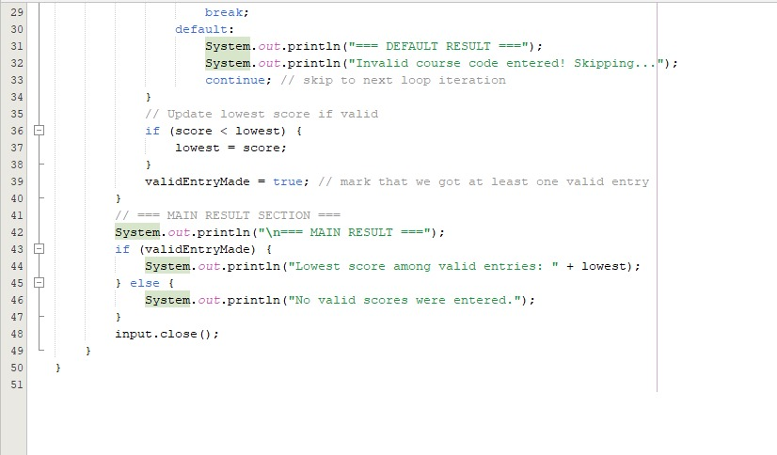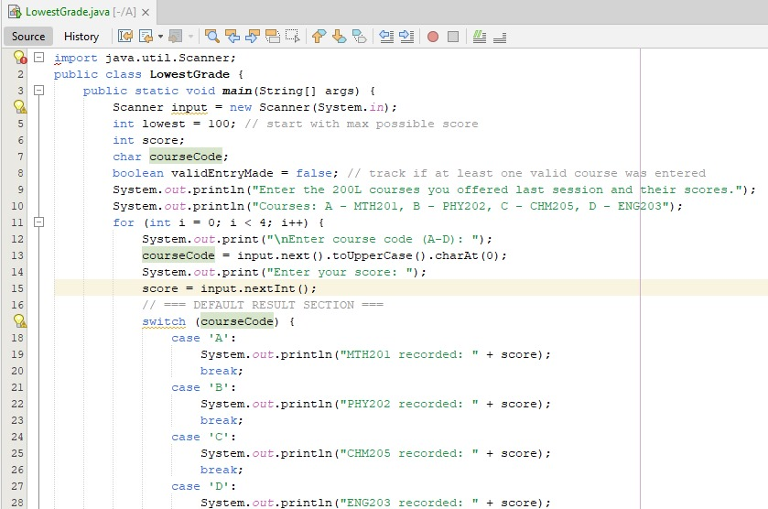

**EXPECTED OUTPUT:**

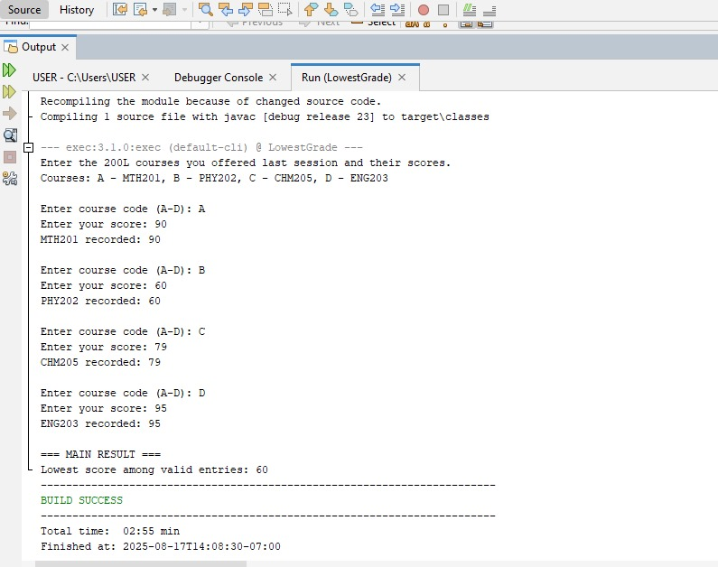

**DEFAULT OUTPUT:**

