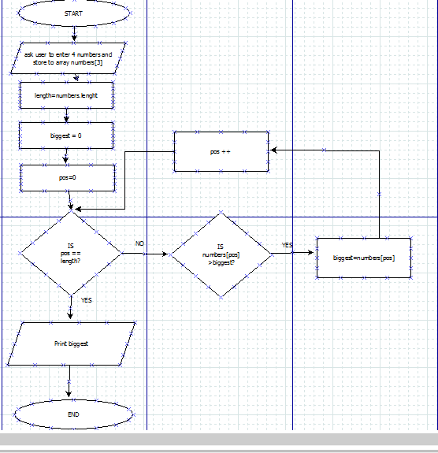Part 1

Dia source file *Part 1 can also be found in lab 5 folder part 1*

*Step1:start program*

*Step2: read in number and store to array numbers[3]*

*Step3: initialize variables- length=numbers.length*

*Biggest=0 and pos=0*

*Step 4: if pos == length. If true ….. is numbers[pos] greater than biggest ? if true biggest = numbers[pos]*

*Step 5 increment pos + 1*

*Step 6 if pos == length (after 4 loops) its false and exit loop*

*Step 7: print biggest and end progra*

Part 2

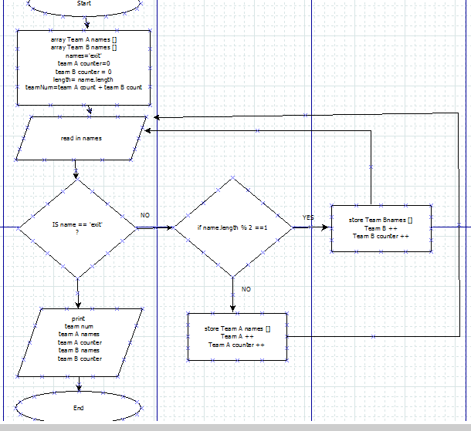

Dia source file *Part 2 can also be found in lab 5 folder part 2*

Step1: start program

Step 2: initialize variables {array Team A, array Team B, names=’exit’, team A counter=0, team B counter=0, length=names.length, teamNum= teamA counter + teamB counter}

Step 3: prompt user to enter their name

Step 4: If name==’exit’ end loop(proceed to step7 ). If not then….

Step5: if name.length % 2 ==1. True = store name to Team B names[ ], Team B counter +1.

Step 6 if name.length %2 ==1. False= store name to Team A names[], Team A counter +1

Step 7: if name==’exit’ then print Team A names, Team B names, Team A counter, Team B counter and teamNum for overall count.

Step 8: end program