# Consent form

# Questionnaire 1

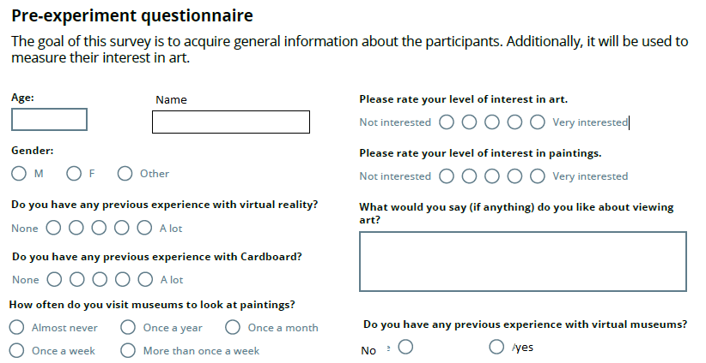

Which VR devices

# Tutorial instructions

* Comment on VR museum experience from Questionnaire 1. If yes ask more.
* *You are going to visit a Virtual Reality museum. You are first going to visit a tutorial floor. There are three doors leading to three rooms. Each room has one painting in it.*
* Show the three icons on paper. *The doors have icons on them. Each icon corresponds with a different type of room. Each icon occurs once.*
* Show headset. Explain sliders. Put on headset. *You are in a hallway. Move the lenses until you can see clearly.*
* *Turn your chair around. You can look around the entire room in this way. Do you see the elevator behind you? You can go to the next floor with it.*
* *You can now see the three doors with the icons on them. You are going to enter the room with a <No effect icon> first.*
* *You can admire the painting. If you are done, the door back to the hallway is behind you. Tell me when you are back in the hallway.*
* ­­­­*×2 You are going to enter the room with the <First effect icon>.*
* *When you are finished with this floor, you can use the elevator.*
* *Take of your headset. We are going to talk about what you saw.*

# Informal interview 1 after questionnaire

Ask the following questions, skip a question if they already made a specific statement about it.

*What did you think of the different rooms?*

*Which room did you like the most? Why?*

*What did you like most about it?*

*What did you dislike?*

Make sure they have made some statements about each illusion.

*Now that you have seen this setup, what do you think of VR museums?*

*Would you like to visit VR museums like this one? Why?*

*Would you like to visit VR museums if they did not have visual effects like the ones you just saw? Why?*

*Would you like to visit real museums if they added effects like these? Why?*

# Explore instructions before real experiment

*You are now going to visit a three floor museum. You can explore the rooms in any order you want, and visit them as often as you'd like. After you have visited each room, you can use the elevator to go to the next floor. You can only visit each floor once. The elevator does not go down.*

# Panas questionnaire + Informal interview

# Informal interview 2 after real test

Ask the following questions, skip a question if they already made a specific statement about it.

*Which rooms did you like the most? Why?*

*What did you like most about it?*

*What did you dislike?*

Make sure they have made some statements about each illusion.

*What do you think of VR museums after seeing this more elaborate setup?*

*Would you like to visit VR museums like this one now? Why?*

*Would you like to visit VR museums if they did not have visual effects like the ones you just saw? Why?*

*Would you like to visit real museums if they added effects like these? Why?*

*Do you have a different view about art now?*

# End Questionnaire

Todo: Enjoyment likert scale questions

Todo: Memory test