Uncertainty-Aware Calibration of Chlorine Wall Decay in the Net3 Benchmark Water Distribution Network

Abstract
Maintaining an adequate free chlorine residual is essential for safeguarding water quality in drinking water distribution networks. However, chlorine decay is difficult to characterise because it is influenced by hydraulic residence time, bulk-water reactions, pipe-wall reactions and uncertainty in chlorine observations. This study develops an uncertainty-aware calibration workflow for chlorine wall-reaction modelling using the Net3 benchmark water distribution network as a controlled synthetic case study.

Spatially heterogeneous wall decay is represented using three synthetic pipe-wall reactivity groups: high, medium and low wall decay. Synthetic chlorine observations are generated by running the WNTR/EPANET model with known grouped wall reaction coefficients and then adding Gaussian observation noise to selected monitoring-node time series. The inverse problem is formulated as the estimation of the grouped wall reaction coefficients from noisy synthetic chlorine observations, while the bulk decay coefficient is treated as a fixed model input.

A deterministic grid-search calibration is first used as a diagnostic recovery check. The main uncertainty-aware calibration is then performed using the Generalised Likelihood Uncertainty Estimation (GLUE) framework, which retains behavioural parameter sets rather than relying only on a single best-fitting parameter vector. The retained GLUE ensemble is propagated through the Net3 network to quantify chlorine prediction uncertainty and to estimate the probability that residual chlorine falls below a threshold of 0.2 mg/L.

The study demonstrates how a synthetic benchmark experiment can be used to evaluate wall-decay parameter recovery, assess the effect of measurement uncertainty and translate calibrated parameter uncertainty into network-wide low-chlorine risk maps.
The GLUE analysis showed that a deterministic best fit could recover the imposed coefficients, but the grouped wall-decay coefficients had unequal identifiability. The resulting risk map identified low-chlorine risk mainly in the old-pipe zone and distal dead-end nodes, showing that the framework can convert parameter uncertainty into spatially interpretable threshold-risk information.

- Introduction
Free chlorine is commonly used in drinking water distribution networks to maintain disinfection capacity after water leaves the treatment works. The remaining residual helps protect water quality during transport through pipes, storage tanks, and service reservoirs. If the residual concentration becomes too low, parts of the network may be exposed to increased microbiological risk (LeChevallier et al., 1996; WHO, 2013). For this reason, water utilities are concerned not only with average chlorine concentrations, but also with whether concentrations at critical locations remain above a required minimum threshold.

Chlorine residual decreases as water travels through a distribution system. This decay is influenced by reactions in the bulk water, reactions at the pipe wall, residence time, hydraulic conditions, pipe material, and local network operation (Rossman et al., 1994; Vasconcelos et al., 1997; Hallam et al., 2002). Locations with long water age, low turnover, or unfavourable hydraulic conditions are often more likely to experience low chlorine residual. Modelling chlorine decay can therefore support the identification of high-risk areas in the network, but the reliability of such modelling depends strongly on how well the decay parameters are represented and calibrated (Rossman et al., 1994; Vasconcelos et al., 1997).

A key challenge is that chlorine decay parameters are difficult to estimate directly. The bulk decay coefficient can often be characterised under controlled conditions, for example through laboratory jar tests, because it represents the natural decay of chlorine in the water itself (Vasconcelos et al., 1997; Hallam et al., 2003). In contrast, the wall decay coefficient is more dependent on local pipe conditions, including pipe material, age, roughness, biofilm activity, and hydraulic regime (Rossman et al., 1994; Hallam et al., 2002). It is therefore harder to measure directly and often has to be inferred indirectly by comparing simulated chlorine concentrations with monitoring data (Shang and Uber, 2007). This creates an inverse modelling problem: given hydraulic conditions and chlorine measurements at selected monitoring points, the aim is to estimate the decay parameters that allow the model to reproduce observed chlorine behaviour.

Although chlorine decay modelling has been widely used to support water distribution system analysis, the calibration of wall decay coefficients remains challenging because these coefficients cannot normally be measured directly and may absorb inaccuracies associated with model structure and field observations (Fisher et al., 2017; Monteiro et al., 2020). Conventional calibration studies commonly estimate decay coefficients by minimising the difference between measured and simulated chlorine concentrations, often using least-squares or related optimisation methods (Nejjari et al., 2014). However, such deterministic calibration does not explicitly represent uncertainty in the monitoring observations. This limitation becomes important when online sensor data exhibit variable sensitivity and measurement quality, particularly when the magnitude of the uncertainty is non-negligible relative to the specified chlorine residual threshold. In such cases, measurement uncertainty can affect both the estimated decay parameters and the assessment of whether chlorine residual is likely to remain above the required level.

This issue is particularly important when chlorine concentrations are close to the operational threshold. Online chlorine measurements may be affected by sensor sensitivity, measurement variability, calibration and maintenance conditions, and short-term changes in local water quality and hydraulic conditions (EPA, 2009; Aisopou and Stoianov, 2024). When the measured concentration is close to the threshold, even a relatively small measurement error may alter the interpretation of whether the underlying chlorine residual is above or below the required value (EPA, 2009). Calibration and threshold-risk assessment should therefore account for measurement uncertainty rather than treating observed chlorine data as exact values.

Time-series chlorine observations at multiple locations provide information not only about concentration levels, but also about the temporal shape and spatial variation of chlorine residual across a network (Aisopou and Stoianov, 2024; Taha et al., 2020). In a controlled synthetic setting, such observations can be used to test whether an inverse calibration procedure can recover spatial variation in wall decay behaviour from a limited set of monitoring nodes (Wang et al., 2022; Kazma et al., 2024).

The aim of this study is to develop and test an uncertainty-aware calibration workflow for estimating spatially varying chlorine wall reaction coefficients in the Net3 benchmark water distribution network. The study uses synthetic chlorine observations generated from known grouped wall reaction coefficients, allowing the inverse calibration procedure and uncertainty propagation workflow to be evaluated under controlled conditions.
The specific objectives are to:

1. implement a WNTR/EPANET chlorine transport model for the Net3 benchmark network;
2. construct a controlled synthetic wall-decay field using grouped pipe-wall reaction coefficients;
3. generate noisy synthetic chlorine observations at selected monitoring nodes;
4. formulate grouped wall-decay estimation as an inverse calibration problem;
5. compare deterministic grid-search recovery with GLUE-based uncertainty-aware calibration;
6. propagate the retained GLUE ensemble into chlorine prediction uncertainty and threshold-based low-chlorine risk across the Net3 network.

The main contribution of this study is an uncertainty-aware workflow that links wall-decay calibration to threshold-based residual chlorine risk assessment. Instead of reporting only a best-fitting wall decay coefficient, the proposed workflow propagates the retained parameter uncertainty into the probability that residual chlorine falls below an operational threshold. This provides a more directly interpretable risk metric for identifying potentially vulnerable locations in the network.

The scope of this study is limited to chlorine decay modelling and calibration within the Net3 synthetic case study. The work focuses on free chlorine residual, hydraulic model outputs, synthetic observation uncertainty, and grouped wall reaction coefficient estimation. Bulk decay is treated as a fixed model input rather than the main calibration target. The study does not aim to develop a new chlorine reaction model, redesign a monitoring system, or assess microbiological risk directly. Instead, it evaluates how uncertainty-aware calibration can support the interpretation of synthetic chlorine observations and the identification of Net3 locations where residual chlorine may be at risk of falling below the selected threshold.
- Background
  - Chlorine decay in water distribution networks
Free chlorine residual is maintained in drinking water distribution networks to provide continuing disinfection after treated water enters the pipe system. Although primary disinfection occurs at the treatment works, a residual disinfectant is needed because water may remain in the distribution network for many hours or days before reaching consumers. During this time, the residual helps limit microbial regrowth and provides an operational indicator of water quality protection. Low disinfectant residuals have been associated with increased risk of microbial regrowth in distribution systems, particularly in areas with poor turnover or long residence time (LeChevallier et al., 1996; WHO, 2013).

Chlorine residual is not conservative. Its concentration decreases as water is transported through pipes, storage tanks, and service reservoirs. This decay is commonly described through two main processes: bulk decay and wall decay. Bulk decay refers to reactions occurring within the water itself, for example reactions between chlorine and natural organic matter, ammonia, reduced compounds, or other reactive substances present in treated water. This component depends on water chemistry, temperature, pH, and initial chlorine concentration. Because bulk decay represents the behaviour of the water under controlled conditions, it can often be characterised through laboratory bottle or jar tests (Vasconcelos et al., 1997).

Wall decay refers to chlorine consumption at or near the pipe wall. This can include reactions with pipe material, corrosion products, deposits, biofilms, and substances attached to the internal pipe surface. Unlike bulk decay, wall decay is strongly influenced by local pipe characteristics and hydraulic conditions. Pipe material, age, roughness, diameter, biofilm activity, and corrosion state can all affect the rate at which chlorine is consumed at the wall. For this reason, the wall decay coefficient is generally more spatially variable and more difficult to measure directly than the bulk decay coefficient (Rossman et al., 1994; Vasconcelos et al., 1997).

Hydraulic behaviour also has a strong influence on chlorine residual. Water age is particularly important because it represents the time available for chlorine reactions to occur, and EPANET explicitly includes water age and reactive water-quality transport as part of distribution network simulation (Rossman, 2000; Rossman et al., 1994). Areas with long residence time, low demand, storage effects, or poor turnover are therefore more likely to experience lower residual concentrations. Flow velocity can also affect chlorine decay by changing both residence time and mass transfer between the bulk water and the pipe wall (Rossman et al., 1994; Rossman, 2000). Pipe diameter is relevant because smaller pipes have a larger wall surface area relative to the volume of water, which can increase the relative importance of wall reactions. As a result, chlorine residual patterns are shaped by the interaction between reaction kinetics and the hydraulic structure of the network (Rossman et al., 1994; Rossman and Boulos, 1996).

In water quality modelling, chlorine decay is often represented using first-order reaction kinetics, where the decay rate is proportional to the chlorine concentration. In simplified form, this can be expressed as:
$C\left(t\right)= C_{0}e^{-kt}$(1)
where C(t) is the chlorine concentration after time t, C₀ is the initial concentration, and k is an apparent first-order decay coefficient. This simplified expression is used to illustrate first-order decay conceptually. In EPANET, however, bulk and wall reactions are represented by different coefficients with different units, and the effect of wall reaction depends on pipe geometry and mass transfer.

EPANET simulates chlorine transport by using the hydraulic solution of the network to route water quality constituents through pipes, junctions, and tanks. Chlorine decay can be represented through bulk reaction coefficients in the water and wall reaction coefficients assigned to pipes, allowing the model to account for both water-phase and pipe-wall chlorine consumption (Rossman et al., 2020). This provides the basis for simulating spatial and temporal variation in chlorine residual across the network.

The wall decay coefficient is a key parameter because it controls the part of chlorine loss associated with local pipe conditions, including reactions with pipe-wall material, corrosion products, deposits, and biofilm (Rossman et al., 1994; Rossman, 2000). In practice, this parameter can strongly affect simulated chlorine residuals, especially in older pipes, small-diameter pipes, or areas with long water age, where wall reactions and residence time may have greater influence on chlorine loss (Rossman et al., 1994). However, it is difficult to assign confidently because it cannot usually be observed directly from routine monitoring and can vary spatially across the network.

For this study, the distinction between bulk and wall decay is important because bulk decay is treated as a defined model input, while wall decay is the main parameter requiring calibration. Wall decay is represented using spatially varying wall decay coefficients assigned to selected pipes or network zones. This motivates the parameter estimation problem discussed in the next section, where monitoring uncertainty is also considered.
  - Monitoring uncertainty and parameter estimation
Chlorine monitoring data provide the observational basis for calibrating water quality models, but these data should not be treated as exact representations of the true chlorine concentration. Online chlorine sensors can provide high-frequency measurements and reveal short-term temporal variation that would not be captured by occasional grab samples. However, their data quality can be affected by sensor noise, calibration drift, fouling, changes in sensor sensitivity, maintenance conditions, and differences between online measurements and reference sampling methods. Additional uncertainty can also arise from missing data, outliers, time synchronisation errors between hydraulic simulations and measurements, and local hydraulic variability at the monitoring location. These issues are particularly important for free chlorine because operationally relevant concentrations may be close to the minimum residual threshold (EPA, 2009; Aisopou and Stoianov, 2024).

Measurement uncertainty directly affects parameter estimation because calibration is based on the difference between observed and simulated model outputs. If monitoring data contain noise or bias, a calibration procedure may adjust model parameters to compensate for measurement error rather than true physical behaviour. Because wall decay coefficients are inferred indirectly from chlorine observations, uncertainty in the observations can propagate into uncertainty in the estimated coefficients. This means that a calibrated wall decay coefficient should not be interpreted independently of the quality and uncertainty of the monitoring data used to estimate it.

The estimation of wall decay coefficients can be understood as an inverse modelling problem. In a forward water quality simulation, the hydraulic model, reaction coefficients, and boundary conditions are specified, and the model predicts chlorine concentrations across the network. In the inverse problem, the direction is reversed: chlorine measurements are available at selected monitoring locations, and the aim is to estimate the parameter values that allow the model to reproduce these observations. In this study, the main unknown parameters are the wall decay coefficients, while the hydraulic conditions and bulk decay assumptions are treated as model inputs. This follows the general inverse problem framework in which model parameters are inferred from observations through comparison between measured and predicted outputs (Tarantola, 2005; Aster et al., 2018).

A common approach to parameter calibration is residual minimisation, where the difference between measured and simulated chlorine concentrations is reduced by adjusting the model parameters (Tarantola, 2005; Aster et al., 2018). This can be implemented using unweighted or weighted least-squares objectives, likelihood-based methods, Bayesian inference, or ensemble-based approaches. When measurement uncertainty is available, observations with higher uncertainty can be assigned lower influence in the calibration process. Under assumptions of independent normally distributed measurement errors, weighted least squares is closely related to maximum likelihood estimation.

In water distribution networks, the inverse problem can be ill-conditioned because different combinations of wall decay coefficients may produce similar chlorine concentrations at the available monitoring points (Tarantola, 2005; Aster et al., 2018). This issue is particularly likely when monitoring locations are sparse relative to the number of pipe groups or zones being calibrated. Even with dense monitoring data, identifiability can remain challenging if the monitored locations do not provide enough information about the pipes or zones where decay parameters are being estimated, because water-quality observability depends on sensor placement and hydraulic conditions (Taha et al., 2020; Kazma et al., 2024). As a result, a single best-fitting parameter set may not fully represent the uncertainty in the calibration result.

For this reason, uncertainty-aware calibration is important. The objective is not only to find the parameter values that minimise the difference between simulated and measured chlorine time series, but also to consider how reliable those estimated values are and how measurement uncertainty affects subsequent interpretation. This is especially relevant when calibrated model outputs are used to assess whether chlorine residual may fall below a required threshold. A concentration close to the threshold may be interpreted differently depending on the uncertainty of the measurement and the uncertainty introduced through calibration. Therefore, uncertainty-aware parameter estimation provides a more appropriate basis for linking chlorine decay modelling with threshold-based water quality risk assessment.

  - GLUE-based uncertainty analysis
Several approaches can be used for chlorine decay model calibration. Deterministic optimisation methods, such as least-squares minimisation, grid search, and genetic algorithms, aim to identify the parameter set that gives the best agreement between simulated and observed chlorine concentrations. These methods are useful for finding best-fitting parameters, but they may provide limited information about parameter uncertainty when different parameter combinations produce similar model outputs. Bayesian approaches can represent parameter uncertainty more formally through posterior distributions, but they require explicit assumptions about prior distributions, likelihood functions, and measurement error models, and may be computationally more demanding.

The Generalised Likelihood Uncertainty Estimation (GLUE) framework provides an alternative uncertainty-aware approach (Beven and Binley, 1992). Instead of relying only on a single best-fitting parameter set, GLUE evaluates many candidate parameter sets and retains those that reproduce the observations within an acceptable error range. These are referred to as behavioural parameter sets. This is suitable for wall reaction coefficient calibration because different combinations of wall reaction coefficients may generate similar chlorine residual time series at the available monitoring locations. The behavioural parameter sets can then be used to describe uncertainty in the estimated wall reaction coefficients and to propagate this uncertainty into threshold-based chlorine risk assessment.
However, GLUE also involves subjective choices, including the definition of the likelihood measure, the behavioural threshold, the parameter ranges, and the sampling strategy. Therefore, GLUE results should be interpreted as a practical uncertainty representation rather than a unique statistical posterior distribution.
- Method and approach
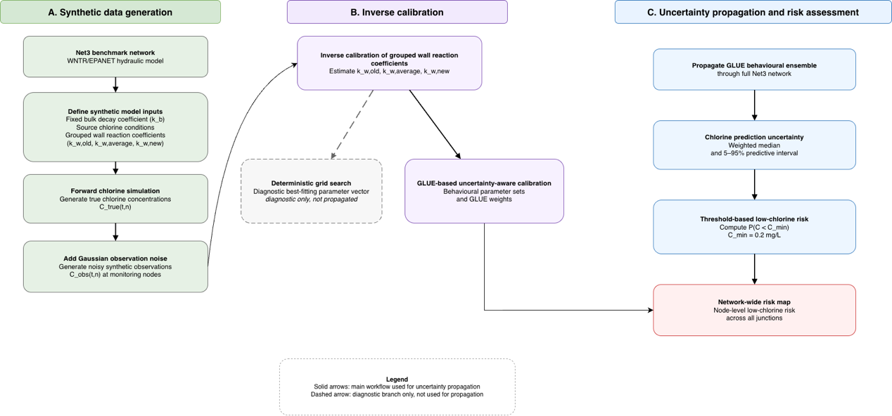

  - Net3 synthetic case-study workflow
The study system is the Net3 benchmark water distribution network implemented in WNTR with the EPANET simulation engine (Klise et al., 2017; Rossman et al., 2020). Net3 is used as a controlled synthetic case study because its network topology, hydraulic properties, demand patterns, reservoirs, tanks and pipe characteristics are predefined. This makes it possible to prescribe known wall reaction coefficients and observation uncertainty explicitly, and then evaluate whether the inverse calibration procedure can recover the imposed wall-decay behaviour from noisy synthetic chlorine observations.

The overall workflow consists of two linked parts: synthetic data generation and inverse uncertainty analysis. In the synthetic data generation stage, a fixed bulk decay coefficient and predefined grouped wall reaction coefficients are assigned to the Net3 model. The WNTR/EPANET model is then run forward to produce the underlying true chlorine concentration time series at selected monitoring nodes. Random observation error is subsequently added to these model-generated concentrations to produce noisy synthetic monitoring observations.

In the inverse calibration stage, the noisy synthetic observations are treated as the calibration data. Candidate grouped wall reaction coefficients are tested by repeatedly running the WNTR/EPANET chlorine transport model and comparing simulated chlorine concentrations with the synthetic observations. A deterministic grid-search calibration is first used as a diagnostic recovery check. The main uncertainty-aware calibration is then performed using the Generalised Likelihood Uncertainty Estimation (GLUE) framework, which retains behavioural parameter sets rather than relying only on a single best-fitting parameter vector.

The retained GLUE behavioural ensemble is finally propagated through the full Net3 network to quantify predictive uncertainty in simulated residual chlorine. This ensemble is then converted into a threshold-based low-chlorine risk metric, defined as the probability that simulated residual chlorine falls below a specified minimum threshold. The workflow therefore links synthetic chlorine observation generation, grouped wall-decay calibration, parameter uncertainty propagation and network-wide low-chlorine risk assessment within one controlled Net3 experiment.
  - Hydraulic and chlorine transport modelling
Hydraulic and free chlorine transport simulations were carried out in WNTR using the EPANET simulation engine (Klise et al., 2017; Rossman et al., 2020). Free chlorine was modelled as a reactive water-quality constituent transported through the Net3 hydraulic network. The hydraulic simulation provides the flow directions, pipe flows, velocities, tank behaviour and mixing conditions required for chlorine transport modelling. Chlorine is transported by advection through pipes and mixed at junctions and storage tanks according to the EPANET water-quality model.

Chlorine decay was represented using bulk reaction in the water and wall reaction at the pipe boundary. In the Net3 simulations, both reactions were represented using first-order kinetics. The bulk decay coefficient was treated as a fixed model input and was set to $k_{b}= -0.5 {day}^{-1}$. The wall reaction coefficient was treated as the calibration target. Unlike the bulk coefficient, which has units of $time^{-1}$, the first-order EPANET wall reaction coefficient has units of length per time because wall reaction is applied at the pipe boundary and its effective influence depends on pipe geometry and mass transfer. Wall reaction coefficients are therefore reported in $m day^{-1}$ in this thesis.

All reaction coefficients are reported in conventional daily units for consistency with chlorine-decay literature and EPANET-style model interpretation. In the WNTR implementation used in this study, simulation time variables were handled in seconds, so coefficients assigned programmatically were converted to seconds-based units before running the model. Bulk decay coefficients reported in day⁻¹ were converted to $s^{-1}$ using

$k_{\left\{b,s\right\}}=\frac{k_{\left\{b,d\right\}}}{86400}$,

where $k_{\left\{b,d\right\}}$ is the bulk decay coefficient reported in $day^{-1}$ and $k_{\left\{b,s\right\}}$ is the value used internally in the simulation. Similarly, first-order wall reaction coefficients reported in m day⁻¹ were converted to m s⁻¹ using

$k_{\left\{w,s\right\}}=\frac{k_{\left\{w,d\right\}}}{86400}$.

For example, the fixed bulk decay coefficient k_b = -0.5 day⁻¹ corresponds to -5.79 × 10⁻⁶ s⁻¹. The imposed wall reaction coefficients k_w = -1.0, -0.1 and -0.05 m day⁻¹ correspond to -1.16 × 10⁻⁵, -1.16 × 10⁻⁶ and -5.79 × 10⁻⁷ m s⁻¹, respectively. Model outputs are reported as chlorine concentration in mg/L and simulation time in hours.

The chlorine boundary condition was imposed at the source nodes. In the baseline Net3 synthetic simulations, the reservoir chlorine concentration was set to 1.0 mg/L and the initial tank chlorine concentration was set to 0.5 mg/L. These values define the upstream and storage water-quality conditions from which chlorine residual is transported, mixed and decayed through the network.

To ensure that the same forward modelling procedure was used consistently throughout the analysis, the WNTR/EPANET simulation was implemented through a reusable Python simulation wrapper, referred to in the code as simulate_chlorine. For a specified Net3 model, bulk decay coefficient, pipe-level or group-level wall reaction coefficients, source chlorine conditions, simulation duration, time-step settings, warm-up period and output nodes, the wrapper assigns the reaction parameters and source quality conditions, runs the EPANET water-quality simulation through WNTR, removes the warm-up period and returns chlorine concentration time series.

This wrapper was used in three stages of the analysis. First, it generated the synthetic true chlorine concentrations under the imposed wall reaction coefficients. Second, it was repeatedly called during inverse calibration to evaluate candidate grouped wall reaction coefficient vectors. Third, it was used to propagate the retained GLUE behavioural parameter sets through the network for predictive uncertainty and threshold-based low-chlorine risk assessment.

The Net3 simulations were run over a 72 h period. The hydraulic time step was set to 1 h, the reporting time step was set to 1 h and the water-quality time step was set to 5 min. The first 24 h were excluded as a warm-up period to reduce the influence of arbitrary initial water-quality conditions. The post-warm-up hourly chlorine concentration time series were then used for synthetic observation generation, inverse calibration and uncertainty propagation.
A preliminary numerical check compared water-quality time steps of 60 s and 300 s (5 min). Pointwise chlorine concentrations differed by up to about 0.06 mg/L at long-residence monitoring nodes, but the resulting shift in the estimated effective first-order decay coefficient was small relative to observation-noise uncertainty (on the order of 0.001 day⁻¹, about 2% of the noise-driven spread of the estimate). The 5 min water-quality time step was therefore retained for the main Net3 experiments, balancing acceptable numerical error against the computational cost of the many repeated forward runs required by grid search and GLUE. This preliminary check is not repeated as a separate Results subsection; the retained 5 min setting is used throughout the reported experiments.

As a preliminary model check, the relative effect of bulk and wall decay was examined by comparing simulations with both bulk and wall reactions enabled against simulations in which the wall reaction coefficient was set to zero. This bulk-only comparison was used to verify that the WNTR/EPANET chlorine model responded consistently to the two reaction mechanisms and to confirm that pipe-wall reaction made a non-negligible contribution to residual chlorine loss in the Net3 case. Removing wall decay increased simulated residual chlorine, particularly at downstream nodes and during periods when water remained longer in the network. This confirmed that wall reaction was sufficiently influential to justify its treatment as the main calibration target, while the bulk decay coefficient was retained as a fixed model input. This bulk-only check was treated as a preliminary model verification and is not reported separately in Results. Quantitative spatial contrasts in Results instead use the all-new-pipe baseline defined in Section 3.4.

  - Water-age diagnostic
In addition to the reactive chlorine simulations, a water-age diagnostic simulation was performed using the same Net3 hydraulic model. Water age represents the residence time of water within the distribution network and provides a hydraulic indicator of the time available for chlorine decay reactions to occur. In this study, water age was used as an explanatory diagnostic rather than as a calibration variable. It was not included in the RMSE objective function, the deterministic grid-search calibration, or the GLUE behavioural screening. It is therefore not presented as a primary quantitative Results output with dedicated water-age tables or maps; residual chlorine fields and threshold-risk maps provide the main quantitative evidence.

The water-age simulation was run using the same hydraulic configuration, simulation duration, reporting interval and warm-up treatment as the chlorine simulations. After removing the 24 h warm-up period, water-age time series were extracted at the monitoring nodes and, where required, across the full set of junction nodes. These outputs were used to interpret the spatial and temporal patterns of simulated residual chlorine.

The purpose of this diagnostic was to distinguish hydraulic exposure from wall-decay reactivity. Low residual chlorine cannot be explained by wall reaction coefficients alone, because chlorine decay also depends on how long water remains in the network and how it moves through pipes, junctions and storage tanks. The water-age diagnostic therefore helped interpret why some locations were more likely to approach the low-chlorine threshold, particularly where longer residence time coincided with higher pipe-wall reactivity. Absolute water-age values and rankings at long-residence nodes may also vary with simulation duration; the diagnostic is therefore used only for qualitative interpretation within the same 72 h / 24 h warm-up window as the chlorine runs.

  - Synthetic wall-decay grouping in Net3
To create a controlled spatially heterogeneous wall-decay field in the Net3 network, pipes were assigned to three synthetic pipe-wall reactivity groups. These groups represent high-, medium- and low-wall-decay behaviour and are used to generate the synthetic true chlorine concentrations for the calibration experiment. The grouping is synthetic and should not be interpreted as verified pipe age or material information in the original Net3 network.

The three pipe-wall reactivity groups were labelled as old, average and new. The old group represents high pipe-wall reactivity, the average group represents intermediate wall reactivity, and the new group represents low wall reactivity. The imposed first-order wall reaction coefficients were:

$$k_{w,old}=-1.0 m/day$$

$$k_{w,average}=-0.1 m/day$$

$$k_{w,new}=-0.05 m/day$$

Negative values indicate chlorine consumption at the pipe wall. These coefficients were imposed during synthetic data generation and therefore represent the known reference values against which the inverse calibration results can be evaluated.

The pipe groups were assigned using a spatial zoning rule based on the coordinates of the pipe end nodes. Pipes located in the eastern zone were assigned to the old, high-wall-decay group. Pipes located in the southern zone were assigned to the average, intermediate-wall-decay group. Pipes located in the western zone were assigned to the new, low-wall-decay group. If both end nodes of a pipe were located within the same zone, the pipe was assigned to that zone. If a pipe crossed a zone boundary, it was assigned to the weaker-decay, newer side of the boundary. This rule was used so that the high-wall-decay group contained only pipes located entirely within the high-reactivity zone.

In the current spatially zoned Net3 implementation, this grouping produced 14 old pipes, 37 average pipes and 66 new pipes. The resulting wall-decay field is therefore spatially heterogeneous but still low-dimensional, because the inverse calibration estimates only three grouped wall reaction coefficients rather than one coefficient for every pipe.

The imposed grouped wall-decay vector can be written as

$$θ_{true}=\left(k_{w,old},k_{w,average},k_{w,new}\right)=\left(-1.0, -0.1, -0.05\right) m/day.$$

This true parameter vector was used in the forward WNTR/EPANET chlorine simulation to generate the underlying synthetic chlorine concentration field. The subsequent inverse calibration procedure then treated the grouped wall reaction coefficients as unknown and attempted to recover plausible values from the noisy synthetic monitoring observations. The grouped formulation deliberately reduces the dimensionality of the inverse problem, making it possible to test whether limited monitoring data can recover spatially structured wall-decay behaviour.
In addition to the three-zone truth field, an all-new-pipe baseline simulation was defined by assigning the low wall-decay coefficient of the new group to every pipe in the network, while keeping the same bulk decay coefficient, source chlorine boundary conditions, simulation duration and warm-up treatment. Comparing the three-zone truth against this all-new baseline isolates the effect of the imposed spatial wall-decay heterogeneity on monitoring-node residuals and is the contrast reported in Results Section 4.1.
As a sensitivity test, an alternative interleaved pipe-group arrangement was also examined. In this scenario the same three wall-reactivity classes were assigned cyclically across the pipe list, producing 39 old, 39 average and 39 new pipes distributed throughout the network. This test was used to examine how the imposed pipe-group arrangement affects parameter identifiability and threshold-risk patterns. Relative to the contiguous three-zone case, both the spatial distribution of reactive pipes and the number of pipes assigned to each reactivity class were changed, while the same imposed wall reaction coefficient values were retained.
  - Synthetic monitoring observations and measurement uncertainty

3.5.1 Baseline synthetic observation uncertainty
Synthetic monitoring observations were generated from the Net3 forward chlorine simulations. Because the Net3 experiment is a controlled synthetic case study, the underlying true chlorine concentration is known from the model simulation using the imposed wall reaction coefficients. These model-generated chlorine concentrations were treated as the reference true concentrations before observation uncertainty was added.

Synthetic chlorine observations were extracted at six selected monitoring nodes in the Net3 network: 107, 113, 15, 145, 209 and 231. These nodes were chosen to provide two monitoring locations in each of the three wall-reactivity zones: nodes 107 and 113 in the western near-source new zone, nodes 15 and 145 in the eastern downstream old zone, and nodes 209 and 231 in the southern average zone. This placement provides two monitoring locations within each synthetic wall-reactivity zone, while still limiting the inverse problem to a sparse monitoring set. The actual information content for each grouped coefficient nevertheless depends on hydraulic connectivity, residence time and chlorine sensitivity at those locations. The resulting time series are used to test whether the inverse calibration procedure can infer grouped wall reaction behaviour from these limited monitoring locations.

For each monitoring node $n$ and time step $t$, the model-generated true chlorine concentration is denoted as

$$C_{true}(t,n).$$

Measurement uncertainty was represented by adding independent random observation error to the true chlorine time series. The synthetic observed chlorine concentration was defined as

$$C_{obs}(t,n)=max\left(0, C_{true}(t,n)+ϵ(t,n)\right),$$

where $C_{obs}(t,n)$ is the noisy synthetic observation, $C_{true}(t,n)$ is the underlying true concentration generated by the model, and $ϵ(t,n)$ is the observation error. The maximum operator was used to prevent physically impossible negative chlorine concentrations after noise addition.

The baseline observation error model assumes independent Gaussian noise:

$$ϵ(t,n)∼N(0,σ^{2}).$$

In the main grouped Net3 calibration experiment, the standard deviation of the observation error was set to

$$σ=0.1 mg/L.$$

This value is substantial relative to the low-chlorine threshold used later in the risk assessment, $C_{min}=0.2 mg/L$. It was therefore used to examine how observation uncertainty affects grouped wall reaction coefficient calibration and threshold-based low-chlorine risk interpretation.

The first 24 h of simulation were excluded as a warm-up period before calibration. The post-warm-up noisy chlorine time series at the six monitoring nodes were then used as the synthetic observations in the inverse calibration procedure.

This uncertainty model is a simplified representation of monitoring error. It represents random observation noise but does not explicitly model systematic sensor bias, calibration drift, time-alignment error, missing data or hydraulic representativeness error. These sources of uncertainty are acknowledged as limitations. The present analysis focuses on how random observation uncertainty affects wall reaction coefficient calibration, GLUE-based parameter uncertainty and threshold-based low-chlorine risk assessment.

3.5.2 Measurement-noise sensitivity check

In addition to the baseline observation-uncertainty scenario used in the main grouped Net3 calibration, a measurement-noise sensitivity check was performed to examine how the magnitude of observation noise affects the estimated decay coefficient. This sensitivity check used a simplified global calibration experiment, in which a single effective (lumped) first-order decay coefficient was estimated from noisy synthetic chlorine observations. This lumped coefficient is reported in day⁻¹ as an effective one-parameter summary and is not a substitute for the three-parameter grouped wall calibration (m day⁻¹) used in the main Net3 experiment.

The purpose of this check was not to replace the grouped wall-decay calibration used in the main analysis. Instead, it was used to assess whether increasing random measurement noise mainly increases the spread of the estimated effective first-order decay coefficient, or whether it also shifts the mean estimated value. This provides a preliminary test of how sensor-noise magnitude affects calibration reliability.

Synthetic observations were generated using three Gaussian observation-noise levels:

$$σ=0.02, 0.05, 0.10 mg/L.$$

For each noise level, 200 independent Monte Carlo noise realisations were generated. In each realisation, random Gaussian error was added to the same underlying true chlorine time series, and the effective first-order decay coefficient was re-estimated using the same calibration procedure. This produced a distribution of estimated effective first-order decay coefficients for each assumed noise level.

The sensitivity results were summarised using the mean and standard deviation of the estimated effective first-order decay coefficient distribution for each noise level. The mean was used to assess whether increasing measurement noise introduced systematic bias in the fitted coefficient, while the standard deviation was used to quantify how the uncertainty of the estimate increased with observation-noise magnitude.$σ$

This noise-sensitivity check was used as supporting evidence for the uncertainty-aware calibration framework. The main grouped Net3 calibration still used the baseline observation-uncertainty scenario. Any persistent offset of the lumped estimate from individual grouped wall coefficients is expected under this simplification and does not quantify three-zone recovery error.$σ=0.1 mg/L$

  - Inverse calibration of grouped wall decay coefficients

3.6.1 Parameter vector and objective function
The inverse calibration problem was formulated as the estimation of grouped wall reaction coefficients from noisy synthetic chlorine observations. The hydraulic model, source chlorine boundary conditions, bulk decay coefficient and pipe-group assignment were treated as fixed model inputs. The unknown calibration parameters were the three grouped wall reaction coefficients assigned to the synthetic old, average and new pipe-wall reactivity classes.

The parameter vector was defined as

$$θ=\left(k_{w,old},k_{w,average},k_{w,new}\right),$$

where $k_{w,old}$, $k_{w,average}$ and $k_{w,new}$ represent the wall reaction coefficients for the high-, medium- and low-wall-reactivity pipe groups, respectively. Negative values indicate chlorine consumption at the pipe wall.

For a given candidate parameter vector $θ$, the WNTR/EPANET model was run forward using the same hydraulic and chlorine transport settings described in Section 3.2. This produced simulated chlorine concentrations at the monitoring nodes:

$$C_{sim}(t,n;θ),$$

where $t$ denotes the post-warm-up time step and $n$ denotes a monitoring node. These simulated concentrations were compared with the noisy synthetic observations,

$$C_{obs}(t,n),$$

generated as described in Section 3.5.

The model-data mismatch for each candidate parameter vector was quantified using the root mean square error, RMSE:

$$RMSE(θ)=\sqrt{\frac{1}{N_{t}N_{m}}\sum_{t=1}^{N_{t}}{\sum_{n=1}^{N_{m}}{{\left[C_{sim}(t,n;θ)-C_{obs}(t,n)\right]}^{2}}}},$$

where $N_{t}$ is the number of post-warm-up time steps and $N_{m}$ is the number of monitoring nodes used for calibration.

A smaller $RMSE(θ)$ indicates better agreement between the simulated and noisy synthetic chlorine time series. This objective function was used consistently in both the deterministic grid-search diagnostic calibration and the subsequent GLUE-based uncertainty analysis. The deterministic grid search used RMSE to identify a single best-fitting parameter vector, while the GLUE analysis used RMSE to classify behavioural parameter sets and assign uncertainty weights.

3.6.2 Deterministic grid-search diagnostic calibration

Before applying the GLUE-based uncertainty analysis, a deterministic grid-search calibration was performed as a diagnostic check of the inverse modelling workflow. The purpose of this step was to verify whether the WNTR/EPANET forward simulator, synthetic observation generation, monitoring-node extraction and RMSE objective function were implemented consistently. Because the Net3 experiment uses known imposed wall reaction coefficients, the grid-search result can be compared against the synthetic truth as a recovery check.

The grid search evaluated candidate values of the three grouped wall reaction coefficients,

$$θ=\left(k_{w,old},k_{w,average},k_{w,new}\right),$$

over predefined physically plausible ranges. Candidate values were constrained to be non-positive because wall reaction represents chlorine consumption at the pipe boundary. The search ranges were selected to include weak, intermediate and strong wall-decay behaviour, with stronger wall reaction expected for the old pipe-wall reactivity group and weaker wall reaction expected for the new group.
In this implementation the three grouped coefficients were evaluated on a 7×7×7 grid spanning k_w,old in [-1.5, -0.2], k_w,average in [-0.2, -0.04] and k_w,new in [-0.10, -0.005] m/day, chosen so that the imposed synthetic values lay within the search range, although not necessarily on a grid node.
To assess the robustness of the deterministic recovery, the synthetic observation generation and grid-search calibration were repeated for ten independent noise realisations under the baseline sigma = 0.1 mg/L scenario.

For each candidate parameter vector $θ_{g}$, the WNTR/EPANET model was run forward using the same hydraulic model, source chlorine boundary conditions, fixed bulk decay coefficient, time-step settings and warm-up period described in Section 3.2. Simulated chlorine concentrations at the monitoring nodes were then compared with the noisy synthetic observations using the RMSE objective defined in Section 3.6.1.

The diagnostic best-fitting parameter vector was defined as the grid candidate with the minimum RMSE:

$${\hat{θ}}_{grid}=arg\min_{θ_{g}}RMSE(θ_{g}).$$

This deterministic result provides a useful check of whether the imposed grouped wall reaction coefficients can be approximately recovered under the synthetic Net3 setup. However, the grid search produces only a single best-fitting parameter vector. It does not describe the range of parameter combinations that may also be consistent with the noisy observations, nor does it propagate measurement uncertainty into chlorine predictions.

For this reason, the grid-search result was used only as a diagnostic benchmark. The main uncertainty-aware calibration result was obtained using the GLUE behavioural ensemble described in the following section.

3.6.3 GLUE-based uncertainty-aware calibration
The main uncertainty-aware calibration method used in this study was based on the GLUE framework (Beven and Binley, 1992). Unlike the deterministic grid search, which identifies a single best-fitting parameter vector, GLUE retains an ensemble of behavioural parameter sets that reproduce the synthetic chlorine observations within an acceptable error range. This is appropriate for the grouped wall-decay calibration problem because different combinations of wall reaction coefficients may produce similar chlorine time series at the available monitoring nodes.

In the GLUE analysis, candidate parameter vectors were sampled from predefined uniform ranges for the three grouped wall reaction coefficients:

$$k_{w,old}∼U(-1.5, -0.2)$$

$$k_{w,average}∼U(-0.2, -0.04)$$

$$k_{w,new}∼U(-0.10, -0.005)$$

where all wall reaction coefficients are reported in $m/day$, and negative values indicate chlorine consumption at the pipe wall. These sampling ranges were selected to include weak, intermediate and strong wall-decay behaviour around the imposed synthetic reference values.

A total of

$$N_{s}=2000$$

candidate parameter vectors were sampled. Each sampled parameter vector was denoted as

$$θ_{i}=\left(k_{w,old,i},k_{w,average,i},k_{w,new,i}\right),$$

where $i=1,…,N_{s}$. For each $θ_{i}$, the WNTR/EPANET model was run forward using the same hydraulic and chlorine transport settings as described previously. The simulated chlorine concentrations at the monitoring nodes were compared with the noisy synthetic observations using the RMSE objective defined in Section 3.6.1.

A behavioural threshold was then applied to identify parameter sets that reproduced the observations sufficiently well:

$$RMSE(θ_{i})<0.12 mg/L.$$

This threshold was selected to be close to, but slightly larger than, the assumed baseline observation uncertainty of $σ=0.1 mg/L$. It therefore allows for measurement noise and small residual model mismatch while still retaining only parameter sets that provide acceptable agreement with the synthetic observations.

The behavioural indicator was defined as

$$B_{i}=\left\{\begin{matrix}1, & RMSE(θ_{i})<0.12 mg/L \\ 0, & RMSE(θ_{i})≥0.12 mg/L\end{matrix}\right.$$

where $B_{i}=1$ indicates that parameter set $θ_{i}$ is retained as behavioural.

In addition to the behavioural classification, an informal Gaussian likelihood was assigned to each sampled parameter vector based on its RMSE:

$$L_{i}=exp\left[-\frac{1}{2}{\left(\frac{RMSE(θ_{i})}{σ_{L}}\right)}^{2}\right],$$

where

$$σ_{L}=0.1 mg/L.$$

This likelihood was used as an informal GLUE weighting function rather than as a formal Bayesian likelihood. It gives larger weights to behavioural parameter sets with smaller RMSE values, while parameter sets outside the behavioural threshold receive zero weight.

The final GLUE weight for each sampled parameter vector was calculated as

$$w_{i}=\frac{L_{i}B_{i}}{\sum_{j=1}^{N_{s}}{L_{j}}B_{j}}.$$

Non-behavioural parameter sets have $B_{i}=0$ and therefore receive zero weight. Behavioural parameter sets receive non-zero weights proportional to their informal likelihood values, normalised so that the weights sum to one.

The output of the GLUE calibration is therefore not a single calibrated wall-decay parameter vector. Instead, it is a weighted behavioural ensemble:

$${\left\{θ_{i}, w_{i}\right\}}_{i=1}^{N_{s}}.$$

This ensemble represents the remaining uncertainty in the grouped wall reaction coefficients after calibration against the noisy synthetic observations. The lowest-RMSE parameter vector can still be reported as a diagnostic best fit, but the main calibration output is the GLUE behavioural ensemble. This ensemble is used in the following sections to propagate wall-decay parameter uncertainty into chlorine prediction uncertainty and threshold-based low-chlorine risk assessment.

  - Propagation of GLUE ensemble to chlorine prediction uncertainty
After the GLUE-based calibration, the retained behavioural parameter sets were propagated through the WNTR/EPANET water-quality model to quantify how uncertainty in the grouped wall reaction coefficients affects simulated chlorine concentrations. The purpose of this step was to move from parameter uncertainty to prediction uncertainty.

For each behavioural parameter set,

$$θ_{i}=\left(k_{w,old,i},k_{w,average,i},k_{w,new,i}\right),$$

the Net3 chlorine transport model was run forward using the same hydraulic model, source chlorine boundary conditions, fixed bulk decay coefficient, simulation duration, time-step settings and warm-up period described previously. Each simulation produced a chlorine concentration time series over the post-warm-up period:

$$C_{sim,i}(t,n),$$

where $i$ denotes the behavioural parameter set, $t$ denotes the post-warm-up time step, and $n$ denotes a network node. In this propagation stage, chlorine predictions were extracted across the modelled network rather than only at the monitoring nodes used for calibration. Each simulation was associated with the GLUE weight $w_{i}$ calculated during the inverse calibration stage.

The resulting ensemble,

$$\left\{C_{sim,1}(t,n),C_{sim,2}(t,n),…,C_{sim,N_{b}}(t,n)\right\},$$

represents the range of chlorine predictions that are consistent with the noisy synthetic observations, the prior parameter ranges, the behavioural threshold and the GLUE weighting function. Here, $N_{b}$ is the number of behavioural parameter sets. The spread of this ensemble at a given node and time step reflects the effect of grouped wall-decay parameter uncertainty on predicted residual chlorine.

For each node $n$ and time step $t$, weighted quantiles were calculated from the GLUE prediction ensemble. The simulated chlorine values were first sorted in ascending order, and their corresponding GLUE weights were accumulated. The weighted quantile $Q_{p}(t,n)$ was defined as the chlorine concentration at which the cumulative weight first reached the probability level $p$:

$$Q_{p}(t,n)=inf\left\{c:\sum_{i:C_{sim,i}(t,n)≤c}{w_{i}}≥p\right\}.$$

In this study, the 5th, 50th and 95th weighted quantiles were used:

$$Q_{0.05}(t,n), Q_{0.50}(t,n), Q_{0.95}(t,n).$$

The median prediction is represented by $Q_{0.50}(t,n)$. The interval between $Q_{0.05}(t,n)$ and $Q_{0.95}(t,n)$ is interpreted as a 90% GLUE predictive interval. This interval is not a formal Bayesian credible interval, but an uncertainty band derived from the retained behavioural parameter ensemble and its GLUE weights.

This ensemble-based prediction step is important because a single deterministic best-fitting parameter vector would produce only one chlorine trajectory. In contrast, the GLUE ensemble produces a set of plausible chlorine trajectories and therefore identifies locations and time periods where predicted residual chlorine is robust, as well as locations where predictions remain sensitive to wall-decay uncertainty.

The predictive intervals represent uncertainty arising from the calibrated grouped wall reaction coefficients. They do not explicitly include additional uncertainty from hydraulic model error, demand uncertainty, source chlorine uncertainty, future observation noise or structural model error. These sources of uncertainty are outside the scope of the present Net3 synthetic analysis. The threshold-based low-chlorine risk metric is then calculated from this predictive ensemble in the following section.
  - Threshold-based low-chlorine risk assessment
After propagating the GLUE behavioural ensemble to chlorine predictions, the prediction ensemble was converted into a threshold-based low-chlorine risk metric. The purpose of this step was to move from chlorine prediction uncertainty to an interpretable node-level risk indicator.

In this study, low-chlorine risk was defined as the probability that simulated residual chlorine falls below a specified minimum residual threshold. The threshold used in the Net3 synthetic analysis was

$$C_{min}=0.2 mg/L.$$

This value was used as a representative operational threshold for identifying low residual chlorine conditions. It was not treated as a statutory compliance limit for Net3, but as a practical threshold for evaluating whether uncertainty in the calibrated wall reaction coefficients could affect the interpretation of residual chlorine adequacy.

For each behavioural parameter set $i$, the GLUE propagation stage produced a simulated chlorine concentration

$$C_{sim,i}(t,n),$$

where $t$ denotes the post-warm-up time step and $n$ denotes a network node. A below-threshold indicator was defined as

$$I_{i}(t,n)=\left\{\begin{matrix}1, & C_{sim,i}(t,n)<C_{min} \\ 0, & C_{sim,i}(t,n)≥C_{min}\end{matrix}\right.$$

where $I_{i}(t,n)=1$ indicates that node $n$ is below the chlorine threshold at time $t$ under behavioural parameter set $i$.

The GLUE weight $w_{i}$, obtained during the inverse calibration stage, was then used to calculate the weighted below-threshold probability at each node and time step:

$$P_{n}(t)=\sum_{i=1}^{N_{b}}{w_{i}}I_{i}(t,n),$$

where $N_{b}$ is the number of behavioural parameter sets. This quantity represents the GLUE-weighted probability that node $n$ has residual chlorine below $C_{min}$ at time $t$, given the retained wall-decay parameter uncertainty.

To obtain a single spatial risk value for each node, the time-varying below-threshold probability was averaged over all post-warm-up time steps:

$$P_{n}=\frac{1}{N_{t}}\sum_{t=1}^{N_{t}}{P_{n}}(t),$$

where $N_{t}$ is the number of post-warm-up time steps. Equivalently, this can be written as

$$P_{n}=\frac{1}{N_{t}}\sum_{t=1}^{N_{t}}{\sum_{i=1}^{N_{b}}{w_{i}}}I_{i}(t,n).$$

The resulting value P_n was interpreted as the time-averaged probability that node n falls below the chlorine threshold under the calibrated GLUE wall-decay uncertainty. Nodes with $P_{n}$ close to zero are predicted to remain above the threshold for almost all behavioural simulations and time steps. Nodes with $P_{n}$ close to one are predicted to fall below the threshold consistently across the behavioural ensemble and simulation period. Intermediate values indicate locations where the low-chlorine classification is sensitive to the uncertain wall reaction coefficients.
For the network-level time series reported in the Results, the same ensemble indicator was aggregated across junctions at each time step. Let N be the number of junction nodes and let P_n(t) be the behavioural-ensemble probability that node n is below C_min at time t. The network fraction of nodes below threshold was defined as F(t) = (1/N) · Σ_n P_n(t). Equivalently, F(t) is the ensemble-mean fraction of junctions with simulated residual chlorine below C_min at time t under the calibrated wall-decay uncertainty.

The threshold-risk calculation was applied to all junction nodes in the Net3 network, not only to the monitoring nodes used during calibration. This allowed the calibrated uncertainty to be translated into a network-wide low-chlorine risk map. Risk estimates at unmonitored nodes should therefore be interpreted as model-predicted risks derived from the WNTR/EPANET simulation and the GLUE behavioural ensemble, rather than as directly observed risks.

This risk metric reflects uncertainty in the grouped wall reaction coefficients represented by the GLUE ensemble. It does not explicitly include additional uncertainty from hydraulic model error, demand uncertainty, source chlorine uncertainty, future measurement noise or structural model error. The resulting node-level values of $P_{n}$ provide the final risk-oriented output of the Net3 synthetic calibration workflow.

- Results
  - Hydraulic residence time and chlorine residual behavior
A water-age diagnostic was used only to interpret the spatial pattern of chlorine residuals. Nodes with longer residence time generally allow more reaction time and are more susceptible to low residuals, especially when located downstream of high wall-decay pipe groups; threshold risk therefore cannot be read from the wall coefficient alone. Water age remains an explanatory diagnostic rather than a complete predictor, because simulated chlorine also depends on source boundary conditions, tank mixing, flow paths, pipe diameter and the assigned wall reaction coefficients. No separate water-age figure or node-age table is reported; the diagnostic supports interpretation of the chlorine residual and risk patterns shown below.

Under the imposed three-zone wall-decay field, the forward simulation produced a strongly heterogeneous chlorine field. Relative to an all-new-pipe baseline, the mean residual over the final 24 h fell most at the eastern old-pipe monitoring nodes: node 15 dropped from 0.56 to 0.26 mg/L (a reduction of about 0.30 mg/L) and node 145 from 0.61 to 0.36 mg/L (about 0.25 mg/L), whereas the near-source new-zone nodes (107, 113) were essentially unchanged and the southern average-zone nodes (209, 231) showed only small reductions (about 0.03 and 0.07 mg/L). The lowest residuals across the whole network occurred at the eastern old-pipe extremities and low-turnover dead-ends. This pattern determines which observations carry information about which parameter: the signal of the old-group wall coefficient is concentrated at nodes 15 and 145, that of the average group at nodes 209 and 231, whereas the new-group coefficient has only a weak, network-wide effect.
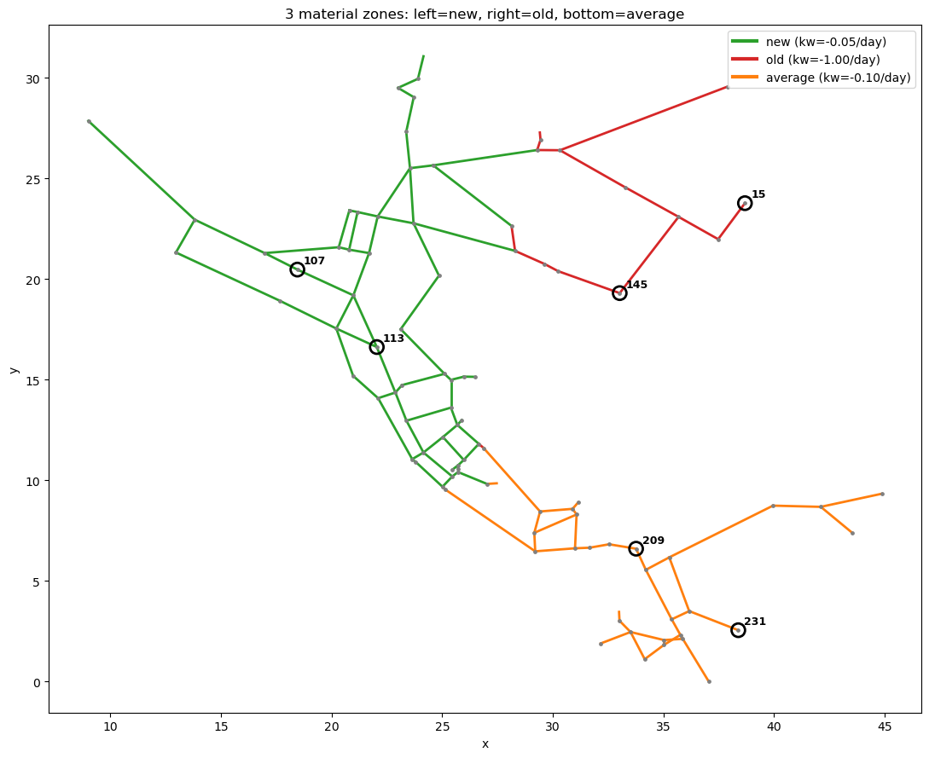
Figure. Three material zones (new / average / old) and the six monitoring nodes.
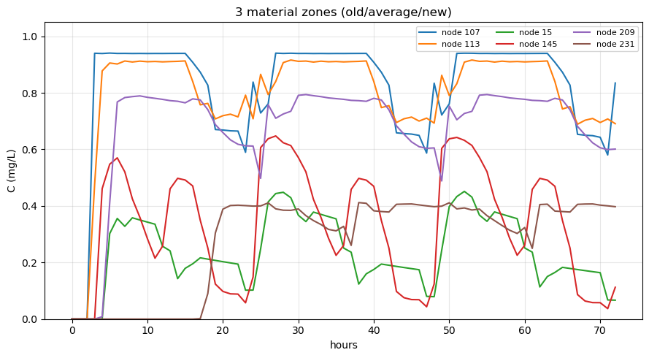
Figure. Free chlorine time series at the monitoring nodes (three-zone truth vs all-new baseline).
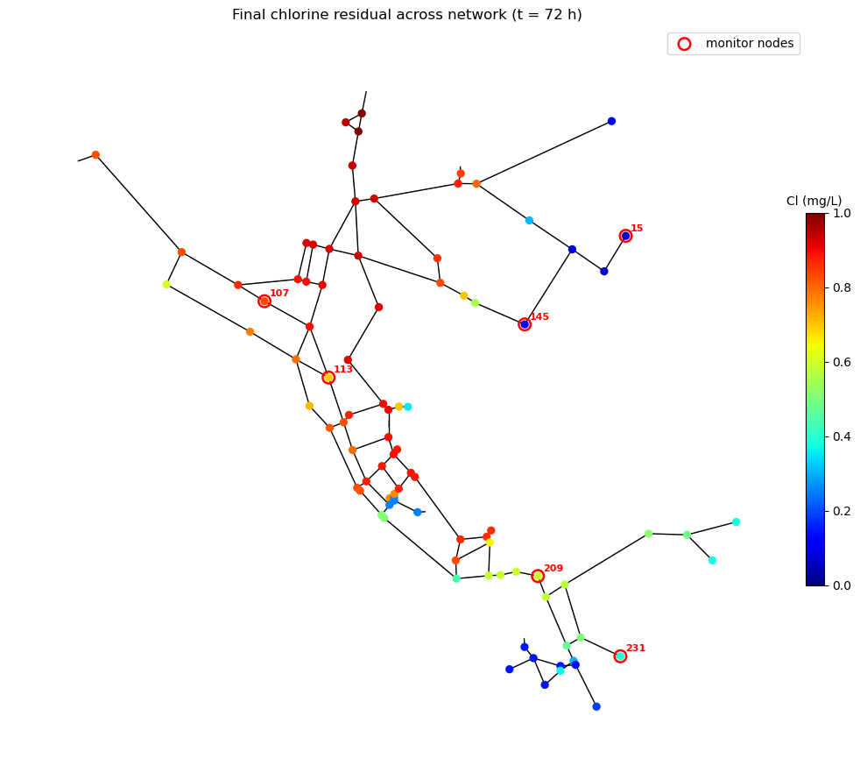
Figure. Network-wide final chlorine residual.
  - Baseline synthetic measurement uncertainty
Independent Gaussian noise with standard deviation sigma = 0.1 mg/L was added to the true chlorine time series at the six monitoring nodes. Across all monitored samples the realised noise RMSE was 0.092 mg/L, consistent with the specified level, and 28 of the 438 hourly observations across the full 72 h simulation (including the 24 h warm-up window) were clipped to zero because the added noise would otherwise have produced physically impossible negative concentrations at the lowest-concentration points. Inverse calibration and GLUE used only the post-warm-up portion of these noisy series.

The relative measurement uncertainty (sigma divided by the mean residual over the final 24 h) varied strongly between locations: about 12% at the high-residual new-zone nodes 107 and 113, but about 38.5% at node 15 and 27.5% at node 145 in the old zone, and about 26.7% at node 231. A fixed absolute sensor uncertainty therefore has a much larger relative effect at low-chlorine nodes, which makes the high-decay regions simultaneously the most operationally important (closest to the threshold) and the most statistically difficult to calibrate. This foreshadows the identifiability results reported in the GLUE calibration and Discussion below.
  - Measurement-noise sensitivity check
As a supplementary check, a single effective (lumped) first-order decay coefficient was estimated from noisy observations at three assumed noise levels, using 200 independent Monte Carlo noise realisations at each level. As the sensor-error standard deviation increased from sigma = 0.02 to 0.05 and 0.10 mg/L, the standard deviation of the estimated coefficient across realisations rose from 0.030 to 0.052 and 0.087 day⁻¹, while the mean estimate stayed almost constant (-1.147, -1.138 and -1.143 day⁻¹). Observation noise therefore mainly widens the spread of the estimate rather than biasing it. The lumped coefficient is an effective one-parameter fit (day⁻¹) to a spatially heterogeneous wall-decay field and is not directly comparable to the three grouped wall coefficients (m day⁻¹); any persistent offset from those grouped values is therefore expected under this simplification. The check supports representing measurement uncertainty explicitly rather than relying on a single best-fit coefficient, but it does not replace the three-zone wall calibration.
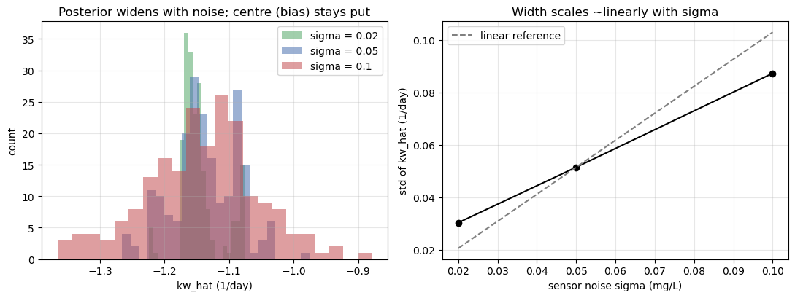
Figure. Measurement-noise sensitivity: estimated effective first-order decay coefficient over 200 Monte Carlo realisations at sigma = 0.02, 0.05 and 0.10 mg/L (left), and the near-linear scaling of estimate width with sensor noise (right).
  - Deterministic grid-search recovery of grouped wall decay coefficients
The deterministic grid search approximately recovered the imposed grouped wall-decay coefficients. Under the baseline noise level (sigma = 0.1 mg/L), the minimum-RMSE parameter vector was (k_w,old, k_w,average, k_w,new) = (-1.07, -0.09, -0.05) m/day, compared with the true values (-1.0, -0.1, -0.05) m/day; each estimate fell on the grid node nearest its true value. This confirms that the forward simulator, the synthetic-observation generation and the RMSE objective are implemented consistently and that the imposed behaviour is recoverable in principle.
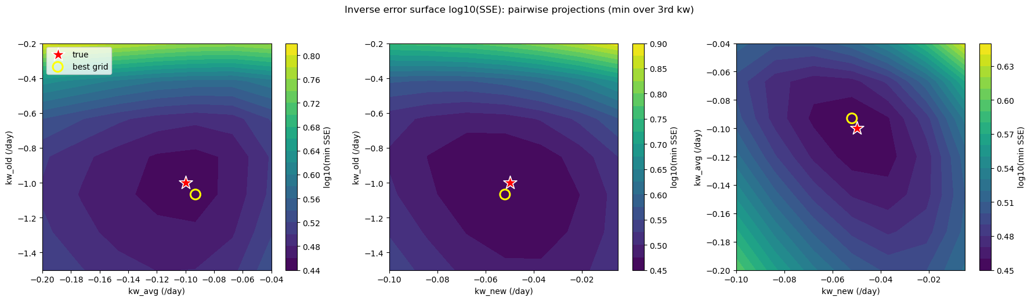
Figure. log10(SSE) pairwise projections of the three-dimensional grid search.
Repeating the full forward-noise-inverse experiment over ten independent noise realisations quantified the reliability of this point estimate. The recovered coefficients were k_w,old = -1.05 +/- 0.12, k_w,average = -0.101 +/- 0.012 and k_w,new = -0.051 +/- 0.008 m/day (mean +/- standard deviation). All three means lie within one grid step of the truth, but the spread is markedly largest for k_w,old, giving an early indication that this parameter, although physically dominant, is the least reliably identified.
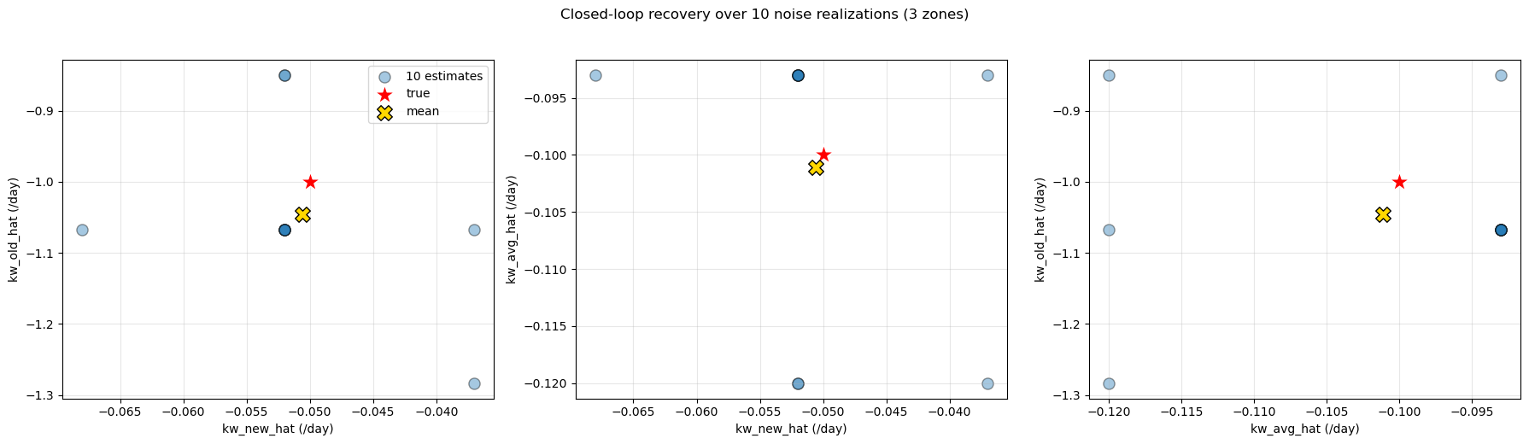
Figure. Recovered coefficients over ten noise realisations against the true values.
  - GLUE behavioural ensemble and parameter uncertainty
Of the 2000 parameter sets sampled from the uniform priors, 1685 were retained as behavioural (RMSE < 0.12 mg/L), with a minimum RMSE of 0.098 mg/L, close to the measurement-noise floor under the baseline observation uncertainty. The large behavioural fraction indicates that the three-parameter wall-decay space remains only weakly constrained by the six monitoring nodes: many dissimilar coefficient combinations still reproduce the noisy observations within the behavioural threshold. The likelihood-weighted behavioural distributions were k_w,old = -0.96 +/- 0.32, k_w,average = -0.12 +/- 0.045 and k_w,new = -0.053 +/- 0.027 m/day, reported as weighted mean +/- weighted standard deviation. The weighted mean of every group lies close to its true value, but the widths differ greatly.

The small differences between the weighted means and the imposed true values should not be interpreted as deterministic calibration bias. In the GLUE framework, the weighted mean is the centre of the retained behavioural ensemble under the chosen likelihood weighting, rather than a parameter value that is required to coincide with the synthetic truth. Because the calibration uses noisy observations and because different grouped wall reaction coefficients can partially compensate for each other, the behavioural mean may shift away from the imposed value even when the true value remains within the plausible behavioural range. The magnitude of this shift is therefore interpreted together with the width of the behavioural distribution: a close mean does not imply strong identifiability when the distribution remains broad (as for the new-group coefficient), and a small displacement from the true value does not indicate calibration failure when that displacement is much smaller than the behavioural uncertainty (as for the old-group coefficient).

This reveals a clear identifiability gradient that a single best-fit estimate conceals. The old-group coefficient carries by far the largest GLUE-weighted uncertainty (about +/-0.32 m/day): although it governs the strongest chlorine loss in the network, it acts in the eastern zone where residual is already low, sensitivity is small and relative measurement noise is largest, and it is informed by only two monitoring nodes. At the opposite extreme, the behavioural distribution of the new-group coefficient (+/-0.027 m/day) is essentially indistinguishable from its uniform prior, i.e. the observations carry almost no information about it, because the low-reactivity western zone lies near the source where wall decay has a negligible effect on residual. The average-group coefficient is only weakly constrained. The value of the uncertainty-aware formulation is precisely that it exposes which parameters are informed by the data and which are not, information hidden by the near-perfect deterministic fit.
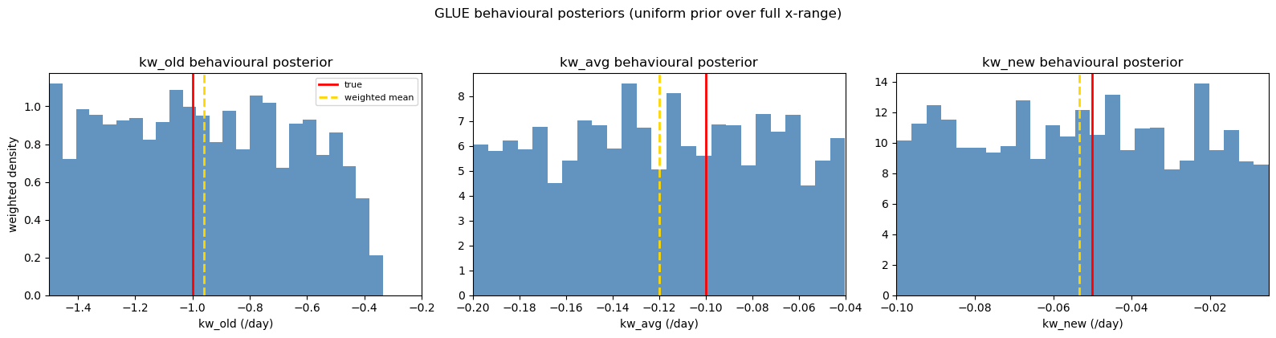
Figure. GLUE-weighted behavioural distributions of the three grouped wall reaction coefficients (prior range and true value shown).
  - Predictive uncertainty in chlorine residual
Propagating the behavioural ensemble forward produced, at each node, a 5th-95th-percentile GLUE predictive band rather than a single trajectory. At both a near-source and a downstream node the weighted-median prediction tracked the underlying truth. The band represents uncertainty in the calibrated grouped wall reaction coefficients only; it does not include an explicit observation-noise envelope, so noisy synthetic observations are not expected to lie entirely inside the 5-95% parameter-uncertainty band.

The width of the predictive band, however, varied strongly with location and mirrored the identifiability gradient described above. Averaged over the post-warm-up window, the 5-95% band was about 0.08 mg/L at node 107 (new zone, near source) but about 0.14 mg/L at node 15 (old zone, downstream), roughly 1.7 times wider. Node 15 lies in the zone governed by the weakly-identified old-group coefficient, so parameter uncertainty propagates into a substantially wider prediction, whereas node 107 lies where residual is insensitive to wall decay and its prediction is tight regardless of parameter uncertainty. Predictive confidence is therefore spatially non-uniform, and is lowest precisely in the low-residual locations that matter most for operational threshold-risk interpretation.
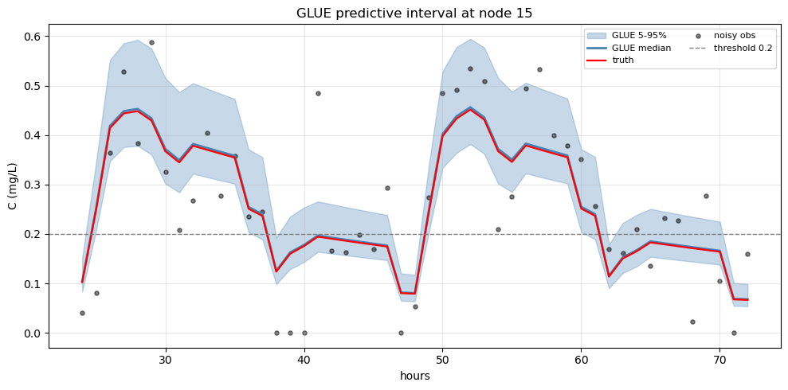
Figure. 5-95% GLUE predictive band at node 15 (old zone).
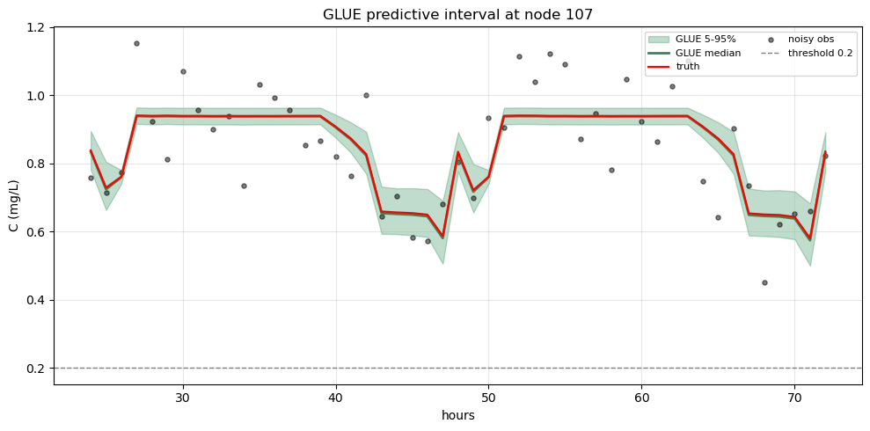
Figure. 5-95% GLUE predictive band at node 107 (new zone).
  - Network-wide threshold risk under GLUE uncertainty
The behavioural ensemble was propagated to all 92 network junctions to estimate the time-averaged probability that residual chlorine falls below the C_min = 0.2 mg/L threshold. Under the GLUE weighting, 25 of the 92 junctions had a non-zero time-averaged below-threshold probability. The highest-risk locations were concentrated in the eastern old-pipe zone and the distal dead-ends: node 131 had the highest risk (P_n ≈ 0.96), followed by nodes 243 (0.70), 141 (0.44), 139 (0.42), 15 (0.38) and 143 (0.35), whereas the near-source new-zone nodes carried essentially zero risk.
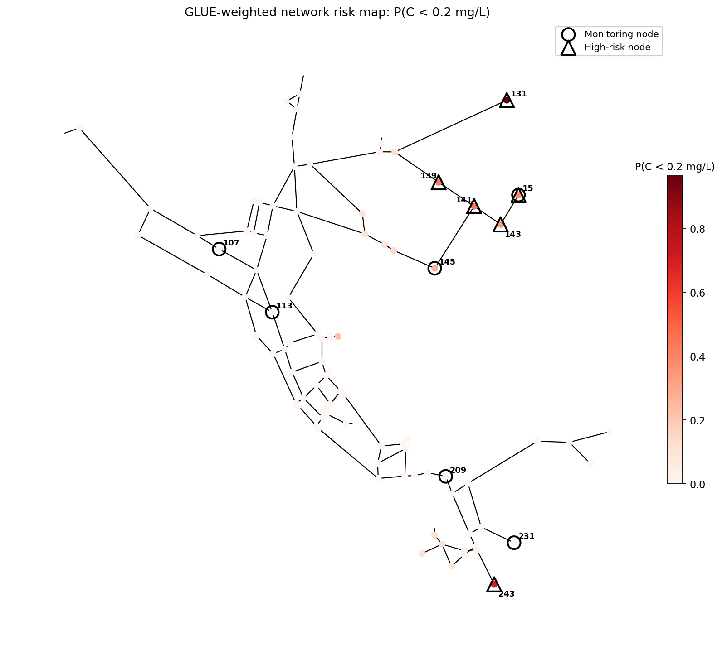
Figure. GLUE-weighted network risk map, P(C < 0.2 mg/L).
The spatial structure of the uncertainty in this risk is itself informative. Nodes with intermediate probabilities (roughly 0.3-0.7) lie almost entirely within the old zone, the region governed by the weakly-identified old-group coefficient, so their below-threshold classification is genuinely uncertain; in the average and new zones the outcome is effectively deterministic. Because risk was evaluated at every junction, including the unmonitored dead-ends where residual is lowest, the framework extrapolates a probabilistic risk assessment beyond the six monitored locations.
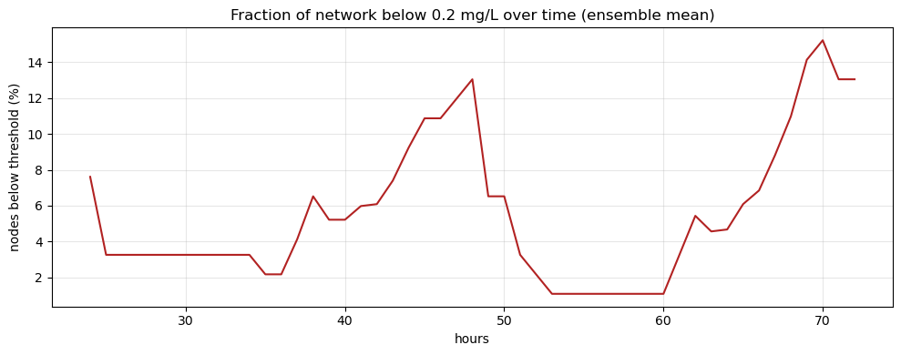
Figure. Fraction of network nodes below 0.2 mg/L over time.
  - Sensitivity to pipe-group spatial arrangement
To test how the imposed pipe-group arrangement affects the calibration, the experiment was repeated with the three reactivity classes interleaved across the network (assigned cyclically along the pipe list) rather than grouped into contiguous zones. This produced an equal split of 39 old, 39 average and 39 new pipes, with high-decay old pipes distributed throughout the network rather than concentrated in the east.
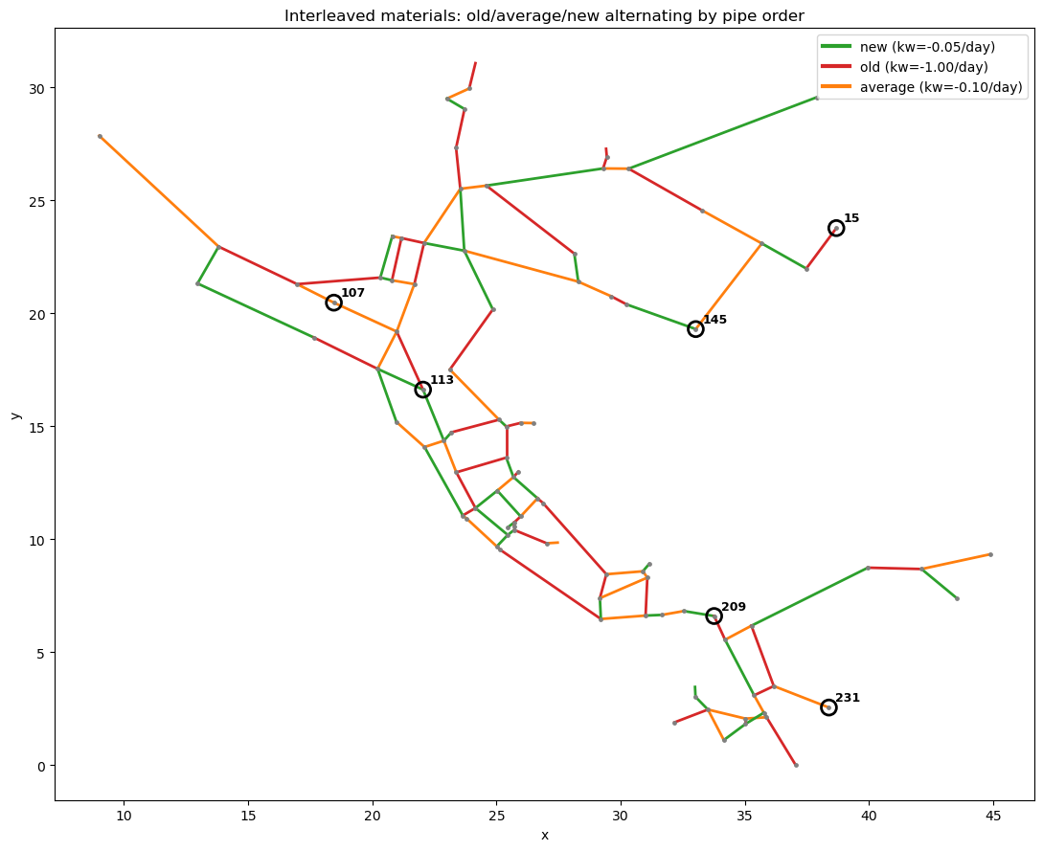
Figure. Interleaved pipe-group arrangement (old / average / new assigned cyclically) and the six monitoring nodes.
Under this arrangement every monitoring node showed a clear reduction relative to the all-new baseline, so the low-residual behaviour was no longer confined to one zone. The GLUE calibration retained 1388 of 2000 sets as behavioural (minimum RMSE 0.097 mg/L), with behavioural distributions k_w,old = -1.04 +/- 0.26, k_w,average = -0.12 +/- 0.045 and k_w,new = -0.053 +/- 0.027 m/day. Notably, the dominant old-group coefficient was better identified than in the zoned case (its behavioural distribution narrowed to about 69% of the prior width, versus about 85% when the old pipes were concentrated), because old pipes now lie on the paths to several sensors so more observations carry information about it.
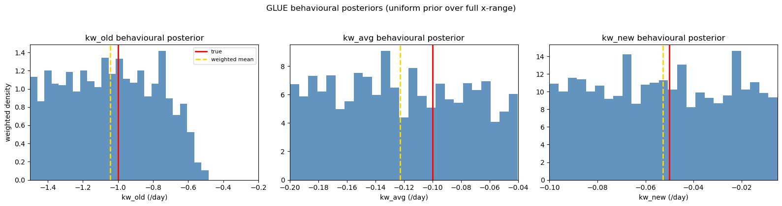
Figure. GLUE-weighted behavioural distributions of the three grouped wall reaction coefficients under the interleaved pipe arrangement (prior range and true value shown).
The network-wide risk was correspondingly more dispersed: 46 of 92 junctions had a non-zero time-averaged below-threshold probability, compared with 25 of 92 in the zoned case, with high-risk nodes spread across the network rather than clustered in one region. These results show that the same calibration workflow yields different identifiability and risk patterns depending on the imposed pipe-group arrangement, including both the spatial distribution of reactive pipes and the number of pipes assigned to each reactivity class. This confirms that parameter identifiability depends not only on the numerical value of k_w, but also on whether the reactive pipes are hydraulically visible to the selected monitoring nodes.
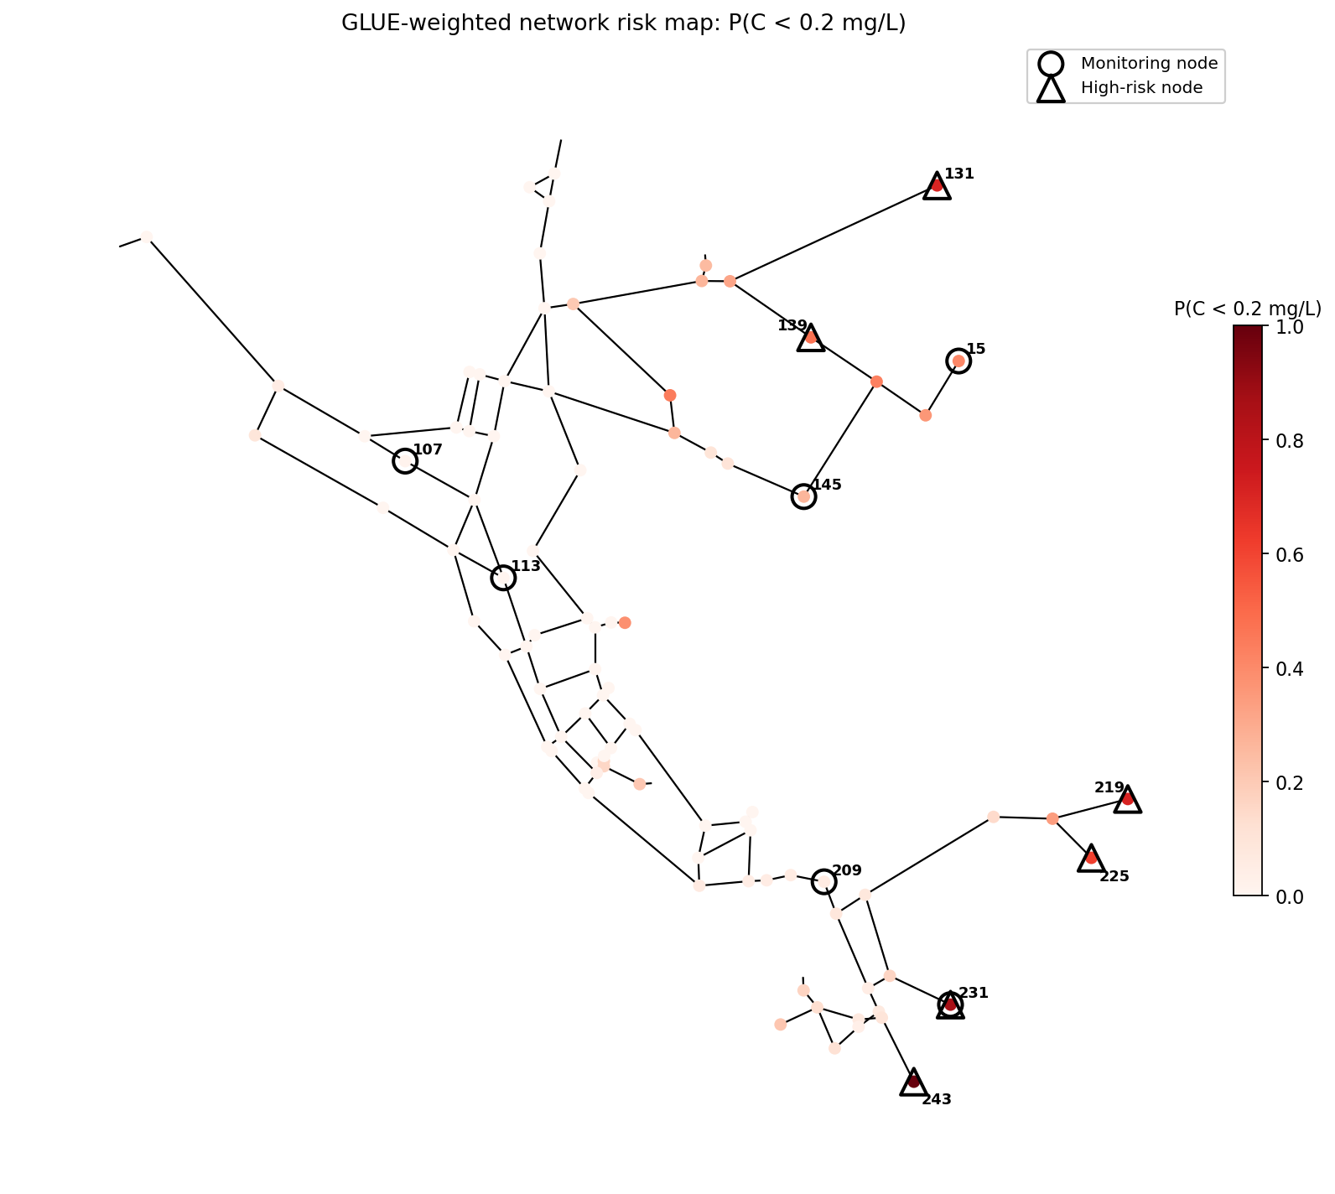
Figure. GLUE-weighted network risk map under the interleaved arrangement, P(C < 0.2 mg/L).

- Discussion
  - What the Net3 experiment demonstrates
The Net3 experiment shows that forward simulation, noisy synthetic monitoring, inverse recovery of grouped wall-decay coefficients, GLUE behavioural selection and network-wide threshold-risk mapping can be linked into one coherent workflow. The central contribution is that each stage passes an explicit representation of uncertainty to the next, rather than stopping at a single best-fitting decay vector. Whereas most reported wall-decay calibration studies conclude at a single best-fit coefficient set, the workflow demonstrated here retains and propagates the full behavioural ensemble, so the final threshold-risk statement inherits the calibration uncertainty instead of discarding it.
  - Identifiability of grouped wall decay
The most important interpretive result is that the three grouped wall-decay coefficients are not equally identifiable. The high-decay old group carries a clear signal but its behavioural distribution remains broad, while the low-decay new group is effectively unidentifiable because weak wall decay has little effect on residual concentration and therefore leaves almost no signature in the observations; its distribution width is close to its prior width. This is consistent with the ill-conditioned nature of the inverse problem described in the Background: with only six monitoring nodes, the observations do not contain enough independent information to constrain every group. This shows that identifiability is controlled not only by the magnitude of wall reactivity, but also by the hydraulic visibility of the reactive pipes to the selected monitoring nodes.

A practical consequence is that increasing the number of pipe groups is not automatically beneficial. Adding groups increases the dimensionality of the inverse problem without necessarily adding information, so the extra parameters are simply left poorly constrained. The complexity of the wall-decay parameterisation should therefore be justified by the information content of the available monitoring data rather than by the level of detail in the pipe inventory. The interleaved scenario reinforces this point, but it should be read as a comparison of two pipe-group arrangements rather than an isolated spatial-redistribution test: the cyclic assignment changed both the spatial layout of the three coefficients and the number of pipes in each class (39/39/39 versus 14/37/66), and this joint change altered how well the dominant coefficient could be identified.
  - Operational value of the risk map
Beyond parameter estimation, the network-wide risk map provides a risk-oriented output that is more directly interpretable than a single calibrated coefficient. Because it assigns every junction a GLUE-weighted probability of falling below the selected operational threshold, including unmonitored dead ends, it can be used to prioritise locations within the synthetic network. In this Net3 case, the high-probability old-pipe zone and distal dead ends would be the locations where further investigation, additional monitoring, or operational intervention would be considered first in a real-network application. The near-source new-zone nodes, by contrast, appear to be lower-priority under the assumptions of this synthetic experiment.
  - Implications for future real-network application
Applying the workflow to real monitoring data will require several elements that the Net3 experiment idealised. The inlet chlorine boundary condition must be represented as a measured, time-varying series rather than a fixed value; the observation model must account for real sensor behaviour, including calibration drift, fouling, missing data and time-alignment error between sensors and the hydraulic simulation; the pipe grouping should be based on real material, age and DMA information; and the hydraulic model itself carries uncertainty in demands and connectivity. Measurements near the low-chlorine detection limit may also be censored. As stated in the Methodology, the present uncertainty model deliberately represents only random observation noise and excludes systematic bias, drift, time-alignment and hydraulic-representativeness errors; these must be added before the framework can be relied on for operational data. Future work could also explore censored likelihood formulations for observations near the detection limit and information-based sensor-placement criteria for selecting monitoring nodes that better constrain the risk-governing coefficients.
  - Limitations
Several limitations follow from the synthetic design and should be read as the scope of this prototype stage rather than as flaws. The most important is that the same model is used both to generate and to calibrate the observations, so the recovery results are optimistic and carry an element of inverse crime (Kaipio and Somersalo, 2005); a future study should break this by generating the synthetic observations with a different model, or a finer spatial and temporal discretisation, than the one used for calibration. Net3 is a benchmark network rather than a real utility system, and the hydraulic model is assumed correct, the source chlorine is fixed and simple, and demand uncertainty is ignored. The GLUE likelihood is an informal, scaled measure rather than a formal Bayesian posterior, and the behavioural threshold, prior ranges and sample size are subjective choices (Beven and Binley, 1992; Beven, 2006). The reported GLUE intervals and risk probabilities should therefore be interpreted as practical ensemble-based uncertainty measures rather than as formally calibrated Bayesian credible intervals or externally validated failure probabilities. The interleaved scenario also remains synthetic and should be interpreted as a sensitivity test rather than as an alternative representation of a real pipe inventory.

Acknowledgements
a….

References
Aisopou, A. and Stoianov, I. (2024) ‘Evaluation of free-chlorine data from online sensors in a water supply network’, Engineering Proceedings, 69(1), 144. https://doi.org/10.3390/engproc2024069144

Aster, R.C., Borchers, B. and Thurber, C.H. (2018) Parameter Estimation and Inverse Problems. 3rd edn. Amsterdam: Elsevier.

Beven, K. and Binley, A. (1992) ‘The future of distributed models: model calibration and uncertainty prediction’, Hydrological Processes, 6(3), pp. 279–298. https://doi.org/10.1002/hyp.3360060305
Beven, K.J. (2006) ‘A manifesto for the equifinality thesis’, Journal of Hydrology, 320(1–2), pp. 18–36. https://doi.org/10.1016/j.jhydrol.2005.07.007
Fisher, I., Kastl, G. and Sathasivan, A. (2017) ‘New model of chlorine-wall reaction for simulating chlorine concentration in drinking water distribution systems’, Water Research, 125, pp. 427–437. https://doi.org/10.1016/j.watres.2017.08.066

Hallam, N., Powell, J.C., West, J. and Spencer, I. (2002) ‘The decay of chlorine associated with the pipe wall in distribution systems’, Water Research, 36(14), pp. 3479–3488.

Hallam, N.B., Hua, F., West, J.R., Forster, C.F. and Simms, J. (2003) ‘Bulk decay of chlorine in water distribution systems’, Journal of Water Resources Planning and Management, 129(1), pp. 78–81.

Kaipio, J.P. and Somersalo, E. (2005) Statistical and Computational Inverse Problems. New York, NY: Springer. https://doi.org/10.1007/b138659
Kazma, M.H., Elsherif, S.M. and Taha, A.F. (2024) ‘Observability and generalized sensor placement for nonlinear quality models in drinking water networks’. Available at: arXiv:2411.04202.

Klise, K.A., Bynum, M., Moriarty, D. and Murray, R. (2017) ‘A software framework for assessing the resilience of drinking water systems to disasters with an example earthquake case study’, Environmental Modelling & Software, 95, pp. 420–431. https://doi.org/10.1016/j.envsoft.2017.06.022
LeChevallier, M.W., Welch, N.J. and Smith, D.B. (1996) ‘Full-scale studies of factors related to coliform regrowth in drinking water’, Applied and Environmental Microbiology, 62(7), pp. 2201-2211.

Monteiro, L., Carneiro, J. and Covas, D.I.C. (2020) ‘Modelling chlorine wall decay in a full-scale water supply system’, Urban Water Journal, 17(2), pp. 121–130. https://doi.org/10.1080/1573062X.2020.1804595

Nejjari, F., Puig, V., Pérez, R., Quevedo, J., Cugueró, M.A., Sanz, G. and Mirats, J.M. (2014) ‘Chlorine decay model calibration and comparison: Application to a real water network’, Procedia Engineering, 70, pp. 1221–1230. https://doi.org/10.1016/j.proeng.2014.02.135

Rossman, L.A. (2000) EPANET 2 Users Manual. Cincinnati, OH: U.S. Environmental Protection Agency.

Rossman, L.A., Woo, H., Tryby, M., Shang, F., Janke, R. and Haxton, T. (2020) EPANET 2.2 User Manual. Cincinnati, OH: U.S. Environmental Protection Agency.

Rossman, L.A. and Boulos, P.F. (1996) ‘Numerical methods for modeling water quality in distribution systems: A comparison’, Journal of Water Resources Planning and Management, 122(2), pp. 137–146.

Rossman, L.A., Clark, R.M. and Grayman, W.M. (1994) ‘Modeling chlorine residuals in drinking-water distribution systems’, Journal of Environmental Engineering, 120(4), pp. 803-820.

Shang, F. and Uber, J.G. (2007) ‘Calibrating pipe wall demand coefficient for chlorine decay in water distribution system’, Journal of Water Resources Planning and Management, 133(4), pp. 363–371.

Taha, A.F., Wang, S., Guo, Y., Summers, T.H., Gatsis, N., Giacomoni, M.H. and Abokifa, A. (2020) ‘Revisiting the water quality sensor placement problem: Optimizing network observability and state estimation metrics’. Available at: arXiv:2012.05268.

Tarantola, A. (2005) Inverse Problem Theory and Methods for Model Parameter Estimation. Philadelphia: Society for Industrial and Applied Mathematics.

U.S. Environmental Protection Agency (EPA) (2009) Distribution System Water Quality Monitoring: Sensor Technology Evaluation Methodology and Results: A Guide for Sensor Manufacturers and Water Utilities. Cincinnati, OH: U.S. Environmental Protection Agency.

Vasconcelos, J.J., Rossman, L.A., Grayman, W.M., Boulos, P.F. and Clark, R.M. (1997) ‘Kinetics of chlorine decay’, Journal AWWA, 89(7), pp. 54-65.

Wang, S., Chakrabarty, A. and Taha, A.F. (2022) ‘Data-driven identification of dynamic quality models in drinking water networks’. Available at: arXiv:2207.05983.

World Health Organization (WHO) (2013) Measuring chlorine levels in water supplies. Technical Note 11. Geneva: WHO.

Appendices

