Residential Development
Feasibility assessment · 13 September 2026
MEETS THRESHOLD

Net profit | $1,246,038
Profit on cost | 28.3%
Threshold applied | 25%
Total cost | $4,399,212
Gross realisation | $5,790,000
Net realisation | $5,645,250
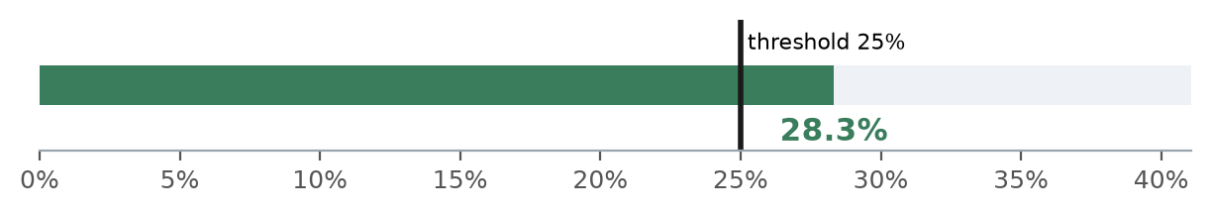
The scheme returns 28.3% on cost against a 25% threshold — 3.3 percentage points above the bar. Net profit is $1,246,038 on a total cost of $4,399,212.

1. The deal as entered
Average raw land value (per lot) | $300,000
Average retail value (per dwelling) | $965,000
Number of dwellings | 6
Build cost per dwelling | $310,000
Council contributions per dwelling | $28,000
Stamp duty | 5.5%
Professional fees | 7.0%
Contingency | 5.0%
Selling costs | 2.5%
Finance costs | 6.0%
1.1 Comparables used
# | Raw land | Retail
1 | $292,000 | $955,000
2 | $305,000 | $972,000
3 | $298,000 | $960,000
4 | $305,000 | $973,000
avg | $300,000 | $965,000
2. Where the money goes
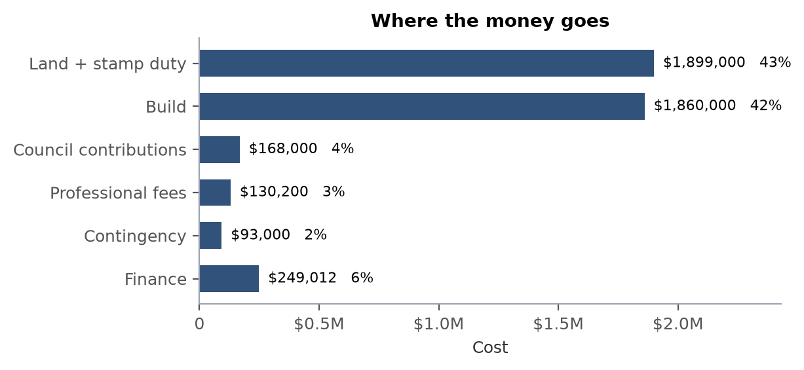
Land and stamp duty account for 43% of total cost, build for 42%. Together they are the only two lines large enough to change the verdict on their own.

3. What breaks it
Profit on cost if retail values and build costs move against the assumptions above. Bold figures clear the threshold.
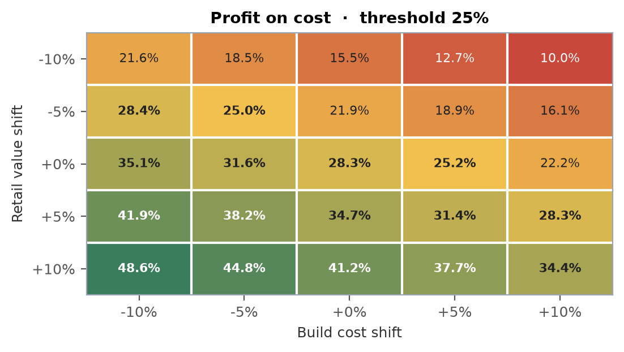
A 5% fall in retail values takes the return to 21.9%. A 5% rise in build cost takes it to 25.2%. The revenue side moves the answer roughly twice as hard as the cost side, which is why comparable selection deserves more scrutiny than the build estimate.
4. Method and limits
Gross realisation is average retail value times dwelling count. Net realisation deducts selling costs. Total cost is land plus stamp duty plus build, council contributions, professional fees, contingency and finance. Profit on cost is net profit divided by total cost, and the verdict tests it against the threshold entered on the sheet.
This is a screening tool, not a full feasibility study. It does not model GST or the margin scheme, a project timeline, staged finance drawdown, demolition or site servicing, or strata establishment. Figures are only as good as the comparables entered.

