SU Tactical Profile
MAC |  | TRAFFICKING | 26Z246 |  | 07/AUG/2026
IO | Ted SMITH 046838729
Sup | Dave LIONS 0462292

TARGETS (Hyperlinks to PHOTOBOARD)
Leila Samira HADDAD

(Hyperlinks to Person Details) Targets - Blue, Associates - White

 | 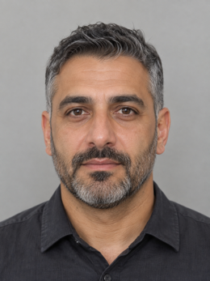 | 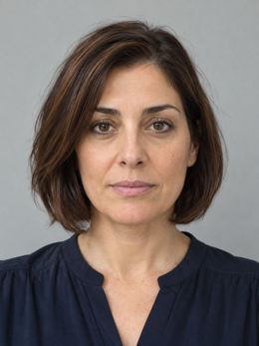

18/MAR/1988

NOTES FOR SU DEPLOYMENTS
DATE | TEAM | LOCATION / INFO TO SHARE |  |  | NOTES

Target’s and Associate’s Vehicles | Driver & Owner Details

Other Vehicles Sighted (Not Target or Associate’s) | Owner Details and Sighted at

 | Target | Leila Samira HADDAD
 | Age |  | Years | DOB |  | 14/04/1988
 | Description
 | TELCO  N/a | PD  Nil |  |  | LBS  Nil |  |  | EBM  Nil
 | INTERCEPT |  | STATUS N/A |  |  |  | MOB
Target Background
IDENTITY / DOCUMENT NOTES
Records use Leila Samira HADDAD, Laila Samira HADDAD and Leila S. HADAD. The alias 'Lulu' appears in a courier booking. Two passports and WA DL 7421908 resolve to the target; a separate Laila Samira HADDAD has a near-matching DOB and nearby address.

ADDRESS / VEHICLE NOTES
Current records show 7/31 Marine Parade, COTTESLOE WA 6011, while invoices omit the unit number and state 31 Marine Parade, COTTESLOE WA 6011. Vehicle registrations 1TDM414 and 1TMD414 are transposed but relate to different vehicles.

OBSERVATION LOG
10 September 2026: HADDAD arrived at Unit 4/17 Portside Drive, FREMANTLE WA 6160 in 1TDM414 (WA). NAJJAR attended at 0918 hours in 1KEN45 (WA) and transferred three sealed cartons to the warehouse.
13 September 2026: D'ANGELO met HADDAD at Suite 9/88 Stirling Highway, NEDLANDS WA 6009. A visitor register recorded 'Laila Hadad' and Vendor ID TFG-414.
17 September 2026: TFG414 (VIC) was recorded at the warehouse. The manifest showed consignment TM-CN-41028 and the contact compliance@tidemark.example.com.
21 September 2026: 1TMD414 (WA) was observed at 31 Marine Parade. HADDAD departed after receiving a document envelope from D'ANGELO.

EXTRACTION CHALLENGE
Resolve spelling variants, two similar people, a unit/no-unit address, transposed registrations, repeated company names, multiple passports, normalized phone formats and a consignment reference without merging unrelated entities.

Click here for full TRF

Warnings (relevant)
Nil
Alerts
Nil
WA MDL: Active

ADDRESSES | Home Address  7/31 Marine Parade, COTTESLOE WA 6011.  Other Frequented  Postal Address:  31 Marine Parade, COTTESLOE WA 6011.  Office Address:  Suite 9/88 Stirling Highway, NEDLANDS WA 6009.  Warehouse:  Unit 4/17 Portside Drive, FREMANTLE WA 6160.
 | Registered Vehicles  1TDM414 (WA) 2023 pearl white Lexus NX350h wagon.  1TMD414 (WA) 2021 white Toyota Kluger wagon.  TFG414 (VIC) 2020 silver |  | Linked Vehicles
BAIL | None
SOCIAL  MEDIA | Unknown – nil identified
LIFESTYLE


 |  |  |  | 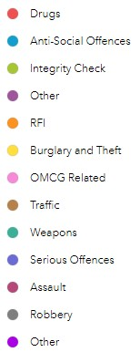

 | Target
 | Age |  | Years | DOB
 | Description
 | TELCO | PD  Nil |  |  | LBS 0477004282 |  |  | EBM  Nil
 | INTERCEPT |  | STATUS |  |  |  | MOB
Target Background

Click here for full TRF

Warnings (relevant)
Alerts
Nil
WA MDL: Never Held / Learners Revoked

ADDRESSES | Home Address  Other Frequented

 | Target |  |  |  |  |  |  |  |  |  | MDL 2025
 | Age |  | Years | DOB |  |  |  |  |  |  | MDL 2025
 | Description |  |  |  |  |  |  |  |  |  | MDL 2025
 | TELCO | PD |  |  | LBS |  |  |  |  | EBM  Nil | MDL 2025
 | INTERCEPT |  | STATUS |  |  |  |  |  | MOB |  | MDL 2025
 | Target Background  Click here for full TRF  Warnings (relevant) Nil  Alerts  WA MDL: Nil |  |  |  |  |  |  |  |  |  | MDL 2025
ADDRESSES | Home Address  Other Frequented
BAIL | None
 | Registered Vehicles |  |  |  |  |  |  | Linked Vehicles
INTEL

SOCIAL
MEDIA

 | Target
 | Age |  | Years | DOB
 | Description
 | TELCO | PD |  |  | LBS  Nil |  |  |  |  | EBM  Nil
 | INTERCEPT |  | STATUS N/A |  |  |  |  |  | MOB
Target Background

Click here for full TRF

Warnings (relevant)
Nil
Alerts
Nil
WA MDL: Expired FEB/2026

ADDRESSES | Home Address  Other Frequented
BAIL | None
 | Registered Vehicles  Nil |  |  |  |  |  |  | Linked Vehicles –
INTEL

SOCIAL
MEDIA

 | Target
 | Age |  | Years | DOB
 | Description
 | TELCO | PD |  |  | LBS |  |  | EBM  Nil
 | INTERCEPT |  | STATUS |  |  |  | MOB
Target Background

Click here for full TRF

Warnings (relevant)
Nil
Alerts
Nil
WA MDL: Active

ADDRESSES

BAIL

INTEL

 |  |  | Linked Vehicles
SOCIAL  MEDIA | facebook.com/jake.brennan.182180 (Private account)
 | 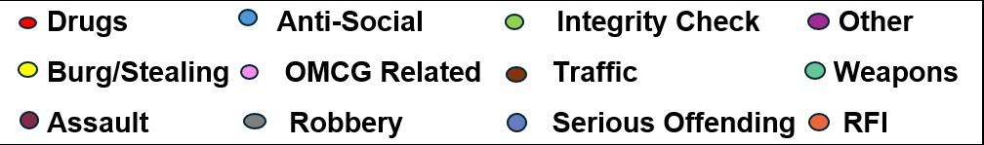

Karim Elias NAJJAR |  |  |  | 16 Olive Street, SUBIACO WA 6008.
 | : 03/11/1981
 | Years
 |  |  |  | Associate of Target
Warnings (Relevant)  Nil  Alerts  Nil  Linked Ops |  |  |  | WA MDL: Active  Registered Vehicles  1KEN45 (WA) 2022 grey Ford Ranger utility.  Linked Vehicles  Nil
TELCO |  |  | NO TELCO | PD - # | LBS - # |  | EBM - #
OTHER INFO
SOCIAL MEDIA

Sophia Marie D'ANGELO |  |  |  | 42 Amherst Road, COTTESLOE WA 6011.
 | : 29/08/1985
 | Years
 |  |  |  | Associate of Target
Warnings (Relevant)  Nil  Alerts  Nil  Linked Ops |  |  |  | WA MDL:  WA DL 7421908  Registered Vehicles  Nil  Linked Vehicles  Nil
TELCO |  |  | NO TELCO | PD - # | LBS - # |  | EBM - #
OTHER INFO |  |  | Lebanese Passport | RL4628107
SOCIAL MEDIA

 | Years
 |  |  |  | Associate of Target
Warnings (Relevant)  Talk Of Suicide  Alerts  Nil  Linked Ops |  |  |  | WA MDL:  Registered Vehicles  Linked Vehicles  Nil
TELCO |  |  | NO TELCO | PD - # | LBS - # |  | EBM - #
OTHER INFO
SOCIAL MEDIA

 | Years
 |  |  |  | Associate of Target
Warnings (Relevant)  Nil  Alerts  Nil  Linked Ops |  |  |  | WA MDL: Active  Registered Vehicles  Linked Vehicles  Nil
TELCO |  |  | NO TELCO | PD - # | LBS - # |  | EBM - #
OTHER INFO
SOCIAL MEDIA

Operational Background [TARGET]

Date | Version | Reason (e.g. add Target, Updated from …)

