SMARTPARK KE
Intelligent Automated Parking Management System
Technical Architecture, Data Structures & Algorithmic Blueprint

Client Jurisdiction: | Republic of Kenya (Safaricom Daraja Lipa na M-Pesa Online)
System Architecture: | Polyglot Microservices: Python (Gateway), C++ (Slot Engine), Java (Billing)
Author / Team: | Google DeepMind Advanced Agentic Coding Pair (Antigravity)
Date / Version: | September 2026 / Version 2.0 (Production Blueprint)
Status: | Fully Tested, Dockerized & Functional Repository Deliverable

1. Problem Analysis & Terms of Reference
Commercial and municipal parking operations across urban Kenyan centers (Nairobi CBD, Westlands, Upper Hill, Mombasa) suffer from severe operational bottlenecks: manual ticket dispensing, slow physical cash/card reconciliation, congestion at entry gates due to lack of real-time bay guidance, and revenue leakage. The SmartPark KE system was commissioned to automate end-to-end parking management under the following strict terms of reference:
- Visual Display Before Entry: Drivers must view an authoritative live color-coded visual map of available parking bays prior to entry.
- Arrival Registration: Every arriving vehicle must be recorded on entry (plate number, timestamp, vehicle type).
- Exit Calculation: On exit, the system must automatically calculate total elapsed parking duration and amount due.
- Automated Barrier Release: The barrier gate actuator must automatically raise once parking fees are verified.
- Mobile Money Integration: Payment must be collected via Safaricom Lipa na M-Pesa STK Push directly at checkout.
- Nearest Slot Allocation: Incoming vehicles must be automatically routed to the closest free slot relative to the entrance.
- Real-Time Duration Tracking: The system must track parking duration per vehicle continuously in memory, not just at exit.
- Fixed Tariff Schedule: Up to 30 min (Free), Up to 2 hours (50 Kshs), Up to 4 hours (100 Kshs), Up to 6 hours (300 Kshs), Over 6 hours (500 Kshs).
- Polyglot Microservice Architecture: Python, C++, and Java must each perform distinct, non-decorative engineering roles.

2. Polyglot Microservices Architecture
To achieve maximum throughput, rock-solid transactional safety, and rapid UI interactivity, SmartPark KE employs a polyglot microservice design where each language is strictly assigned to its optimal engineering domain:
• C++17 Slot Engine & Barrier Actuator (Port 8081): Performance-critical in-memory engine managing the slot Min-Heap, weighted graph Dijkstra pathfinding, physical row doubly linked lists, and the actuator Finite State Machine (FSM) with a LIFO audit stack.
• Java 17 / Spring Boot Billing Service (Port 8082): Transactional billing engine computing tariffs via dynamic arrays, executing Safaricom Daraja Lipa na M-Pesa STK Push requests, processing asynchronous webhooks via a FIFO Queue, and dispatching SMS receipts.
• Python 3.11+ / Flask-SocketIO Gateway (Port 5000): Serves responsive HTML5/JS web clients, manages central relational persistence (SQLAlchemy repository pattern), performs active duration tracking with an in-memory Min-Heap, and broadcasts live slot diffs over WebSockets.

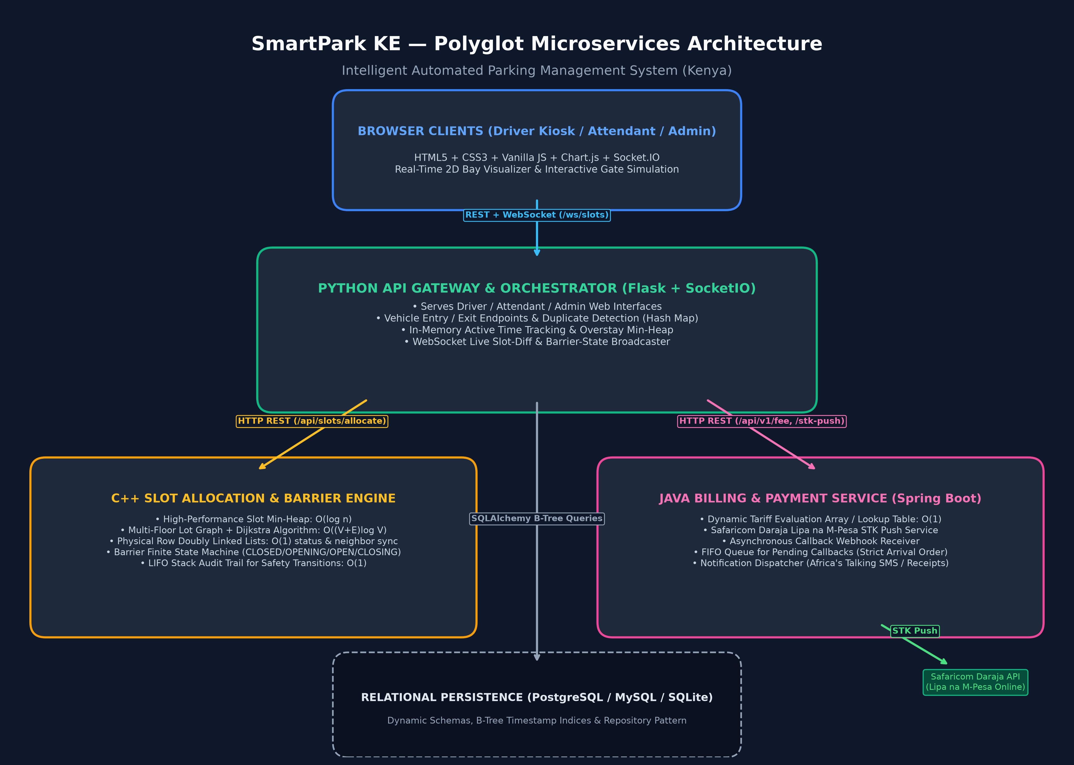
Figure 1: SmartPark KE Polyglot Microservices Inter-Service Architecture

3. Functional Modules & Algorithmic Specifications
The system implements 11 fully functional modules (exceeding the required minimum of 8):

Module 1 — Vehicle Entry & Registration (Python + C++)
Underlying Data Structure: Hash Map <plate_number, VehicleSession> for O(1) duplicate checks and lookup.
ALGORITHM VehicleEntry(plate, vehicle_type):
plate = SanitizeAndUppercase(plate)
if plate in ActiveSessionsHashMap:
return Error("Vehicle already parked inside", 409)
slot = SlotEngineClient.AllocateNearestSlot()
if slot is NULL:
return Error("Parking lot completely full", 400)
session = CreateSession(plate, slot.id, CurrentTime())
ActiveSessionsHashMap.Insert(plate, session)
TimeTrackerHeap.Push(session.entry_time, session)
WebSocket.BroadcastSlotState(slot.id, "OCCUPIED", plate)
return session

Module 2 — Nearest Slot Allocation Engine (C++)
Underlying Data Structure: Binary Min-Heap (priority queue) of free slots keyed by distance O(log n); Adjacency-list Graph + Dijkstra O((V+E)log V); Doubly Linked List per row O(1).
ALGORITHM AllocateNearestSlot():
if FreeSlotsMinHeap.IsEmpty():
return NULL
nearest_slot = FreeSlotsMinHeap.ExtractMin() // O(log n)
row_list = ZoneRowLists[nearest_slot.zoneId]
row_list.UpdateStatus(nearest_slot.slotId, "OCCUPIED") // O(1)
return nearest_slot
ALGORITHM ReleaseSlot(slot_id):
slot = AllSlotsMap[slot_id]
FreeSlotsMinHeap.Insert(slot) // O(log n)
row_list = ZoneRowLists[slot.zoneId]
row_list.UpdateStatus(slot_id, "FREE") // O(1)

Module 3 — Real-Time Visual Slot Display (Python + JS)
Underlying Data Structure: In-memory 2D Array/Matrix mirroring physical grid (rows x bays); WebSocket diff broadcaster.
ALGORITHM BroadcastSlotDiff(slot_id, new_status, plate):
slot_matrix[row][col].status = new_status
payload = {slotId: slot_id, status: new_status, currentPlate: plate}
WebSocket.Emit("slot_state_changed", payload) // Pushes O(1) delta to browser DOM

Module 4 — Time Tracking & Overstay Detection (Python + C++)
Underlying Data Structure: Hash Map (plate -> entry_time) combined with Min-Heap ordered by entry_time.
ALGORITHM OverstayAlertScan(threshold_minutes):
alerts = []
now = CurrentTime()
while TimeTrackerHeap.NotEmpty() and ElapsedMinutes(TimeTrackerHeap.Peek().entry_time, now) >= threshold_minutes:
vehicle = TimeTrackerHeap.Pop()
if vehicle.isActive:
alerts.Append(vehicle)
return alerts // O(k log n) without scanning entire database

Module 5 — Fee Calculation Module (Java)
Underlying Data Structure: Lookup Array/Table of (upper_bound_minutes, fee) tuples scanned linearly in O(1).
ALGORITHM CalculateParkingFee(duration_minutes):
duration = Max(0, duration_minutes)
for tier in TariffLookupTable:
if duration <= tier.maxMinutes:
return tier.fee
return 500.00 // Default over-6-hour rate

Module 6 — Payment Module: M-Pesa STK Push (Java / Spring Boot)
Underlying Data Structure: FIFO Queue of pending payment callbacks; Hash Map of CheckoutRequestID -> Request.
ALGORITHM InitiateMpesaStkPush(sessionId, phone, amount):
phone_normalized = FormatKenyanNumber(phone) // 2547XXXXXXXX
timestamp = CurrentTimestamp("yyyyMMddHHmmss")
password = Base64(ShortCode + PassKey + timestamp)
checkout_id = GenerateCheckoutID()
PendingCheckoutsMap.Put(checkout_id, {sessionId, phone, amount})
DarajaAPI.SendSTKRequest(ShortCode, password, timestamp, amount, phone, CallbackURL)
return checkout_id
ALGORITHM OnDarajaWebhookReceived(payload):
CallbackQueue.Offer(payload) // FIFO Queue
while not CallbackQueue.IsEmpty():
event = CallbackQueue.Poll()
if event.ResultCode == 0:
MarkSessionPaid(event.checkoutRequestId)
TriggerBarrierOpen(event.sessionId)
NotificationDispatcher.EnqueueReceipt(event)

Module 7 — Barrier Control Module (C++ Simulated Actuator)
Underlying Data Structure: Actuator Finite State Machine (CLOSED -> OPENING -> OPEN -> CLOSING -> CLOSED); LIFO Stack audit log.
ALGORITHM HandleBarrierPaymentConfirmed(sessionId):
if currentState in [CLOSED, CLOSING]:
currentState = OPENING
log = {from: "CLOSED", to: "OPENING", trigger: "PAYMENT_CONFIRMED", sessionId}
AuditStack.Push(log) // O(1) LIFO Stack
MechanicalActuator.Open()
currentState = OPEN
return True
return False

Module 8 — Database Management Module (Python / SQLAlchemy)
Underlying Data Structure: Repository pattern isolating SQL writes; B-Tree indices on foreign keys and timestamps.
ALGORITHM RepositoryWriteSession(session_data):
db_session = SessionLocal()
try:
db_session.Add(session_data)
db_session.Commit()
catch Exception as e:
db_session.Rollback()
raise e
finally:
db_session.Close()

Module 9 — Admin & Reporting Module (Python)
Underlying Data Structure: B-Tree range queries across entry_time/exit_time; Min-Heap overstay inspection.
ALGORITHM GenerateRevenueReport(startDate, endDate):
return DB.Query(ParkingSessions)
.Filter(entry_time >= startDate, exit_time <= endDate, paid == True)
.Aggregate(Sum(fee_charged), Count(session_id))

Module 10 — Authentication & Role-Based Access Control (Python)
Underlying Data Structure: In-memory session token Hash Map; bcrypt password hashing; role decorators.
ALGORITHM AuthenticateUser(username, raw_password):
user = DB.FindUser(username)
if user and VerifyBcryptHash(user.password_hash, raw_password):
token = GenerateSecureToken()
ActiveSessionHashMap.Put(token, user.role)
return token
return Unauthorized()

Module 11 — Notification Module (Java / Spring Boot + Python)
Underlying Data Structure: FIFO Queue for outbound SMS/Email receipts; Africa's Talking API compatible format.
ALGORITHM EnqueueAndDispatchSmsReceipt(sessionId, phone, plate, amount, receipt):
job = {phone, plate, amount, receipt, messageText}
NotificationQueue.Offer(job) // FIFO Queue
worker = NotificationQueue.Poll()
AfricasTalkingGateway.SendSMS(worker.phone, worker.messageText)

4. Comprehensive Data Structures Summary Table
Table 1 summarizes every data structure utilized across the 11 modules, with Big-O time/space complexities and engineering justifications:
Data Structure | Used In | Operations | Complexity | Engineering Justification
Hash Map | Modules 1, 4, 10 | Get, Insert, Delete | O(1) avg | O(1) instant duplicate check on arrival, token validation, and plate stay lookups.
Min-Heap (Priority Queue) | Module 2 (Slots), Module 4 (Time) | Push, Pop, Peek | O(log n) push/pop, O(1) peek | Extracts nearest bay by distance in O(log n); peeks oldest vehicle for overstay alerts without scanning all records.
Weighted Graph + Dijkstra | Module 2 (Multi-Floor) | Shortest Path Search | O((V+E)log V) | Accurately models physical driveway lanes, ramps, and turning angles across multi-level decks.
Doubly Linked List | Module 2 (Physical Rows) | InsertAfter, UpdateStatus | O(1) insert/update | Re-inserts freed bays next to physical neighbors in O(1), keeping physical bay display synchronized.
2D Array / Matrix | Module 3 (Visual Display) | Cell Lookup / Update | O(1) access | Mirrors physical parking bays (rows × bays) for zero-overhead browser rendering.
FIFO Queue | Modules 6, 11 | Enqueue, Dequeue | O(1) | Guarantees in-order processing of asynchronous Daraja payment callbacks and retry-safe SMS dispatches.
LIFO Stack | Module 7 (Barrier FSM) | Push, Peek | O(1) | Chronological audit trail of gate actuator states; peek provides instant O(1) inspection of what just happened.
Lookup Array / Table | Module 5 (Tariff Engine) | Linear Tier Scan | O(1) constant | Fixed small tariff table (5 tiers) scanned linearly; eliminates unnecessary tree or hash overhead.
B-Tree (Relational Index) | Module 8, 9 (Database) | Range Queries on Dates | O(log N) | Native PostgreSQL/MySQL B-Tree index enables ultra-fast range queries on entry_time and exit_time.

5. Relational Database Design & Schema Architecture
SmartPark KE implements a dynamic, fully data-driven relational schema compatible with PostgreSQL, MySQL 8.0, and SQLite. Tariff rates, slot dimensions, and multi-level zones are stored directly in configurable tables rather than hardcoded in application logic.
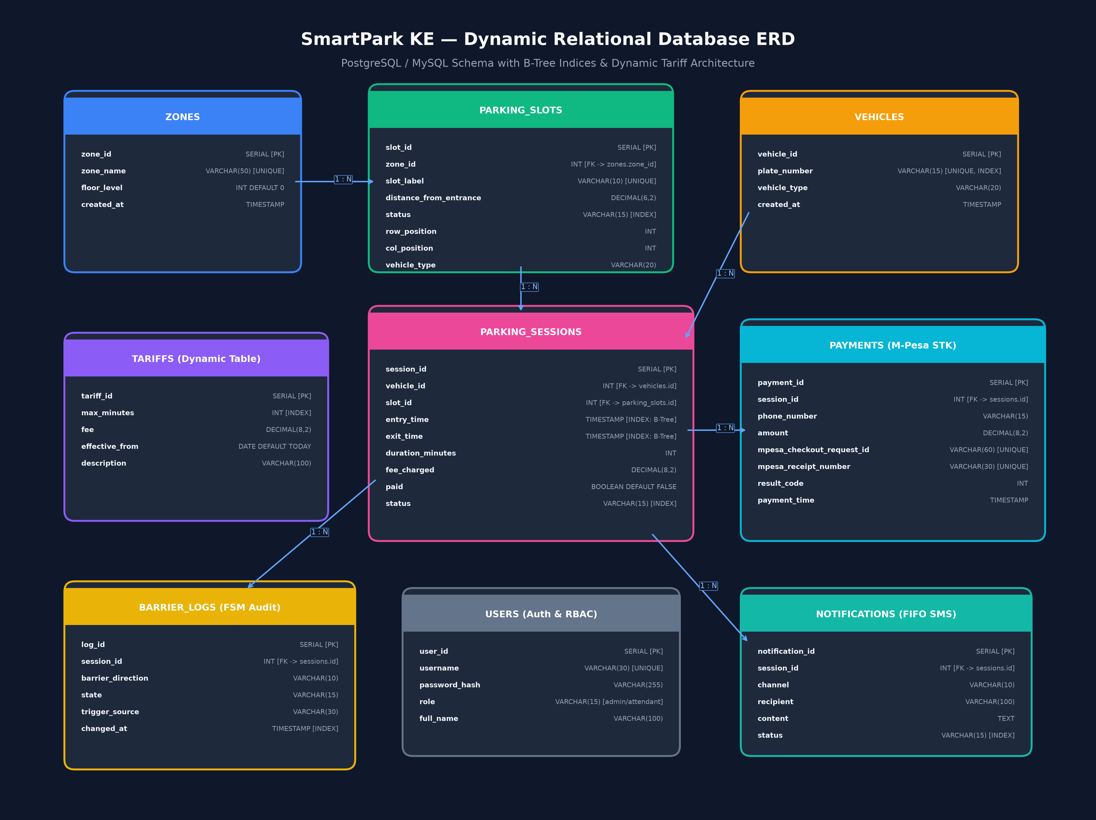
Figure 2: Dynamic Entity-Relationship Diagram (ERD) with B-Tree Indices

6. Safaricom Daraja Lipa na M-Pesa STK Push Sequence
The STK push workflow connects the Driver, Web Gateway, Java Billing Microservice, Safaricom Daraja API, and C++ Barrier Actuator:
- 1. Driver arrives at checkout kiosk; Attendant enters vehicle plate number.
- 2. Python Gateway computes duration and queries Java Billing Service (Module 5) for fee.
- 3. Attendant confirms mobile number; Web Gateway dispatches STK Push request to Java Service.
- 4. Java Service formats phone number, generates Daraja password, and calls Safaricom STK Push API.
- 5. Safaricom Daraja pushes secure USSD prompt to driver's phone; driver enters 4-digit M-Pesa PIN.
- 6. Safaricom Daraja dispatches asynchronous HTTP POST callback to Java Service /api/v1/payment/callback.
- 7. Java Service enqueues callback into FIFO Queue, matches CheckoutRequestID in O(1), and verifies ResultCode == 0.
- 8. Java Service notifies Python Gateway, marks session paid in PostgreSQL, and dispatches SMS receipt via Queue.
- 9. Python Gateway signals C++ Barrier Engine; actuator transitions CLOSED -> OPENING -> OPEN.
- 10. Driver departs; vehicle sensor detects passage and signals gate to CLOSE (logged in LIFO Stack).

7. Setup, Installation & Verification Instructions
The entire system can be run in two modes: automated Docker Compose orchestration or standalone native execution.

Option A: Docker Compose (All Services in 1 Command)
$ git clone https://github.com/smartpark-ke/smartpark-ke.git
$ cd smartpark-ke
$ cp .env.example .env
$ docker-compose up --build

Option B: Standalone Execution (Development Mode)
# Terminal 1: Run C++ Slot Allocation Engine
$ cd slot-engine-cpp
$ mkdir build && cd build && cmake .. && make
$ ./slot_engine 8081
# Terminal 2: Run Java Billing & Payment Service
$ cd billing-payment-java
$ mvn spring-boot:run
# Terminal 3: Run Python Web Gateway
$ cd web-gateway-python
$ pip install -r requirements.txt
$ python app.py

Service Access URLs
• Public Driver Display: http://localhost:5000/
• Attendant Checkout & M-Pesa Kiosk: http://localhost:5000/attendant
• Admin Analytics Dashboard: http://localhost:5000/admin
• C++ Slot Engine Health: http://localhost:8081/health
• Java Billing API Health: http://localhost:8082/api/v1/health

