Unit 5: Factor Markets

Introduction to Factor Markets:

* Households own the factors of production and earn income by selling them in the resource market
* The factor market graphs convey the same essential relationships as the product market graphs from units 1-4, the visual differences simply reflect the factor market perspective
* 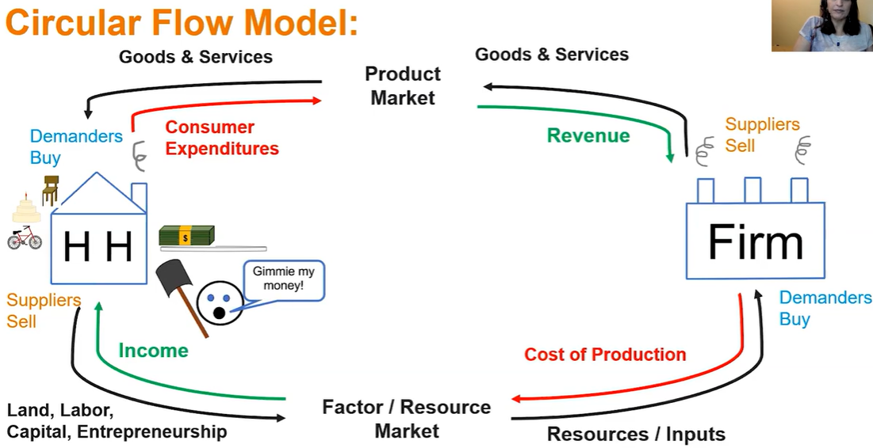
* 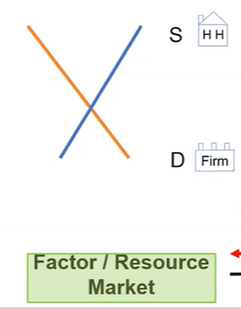
* Firms in the resource market purchase factors of production
* Households own the factors of production and earn income by selling them in the resource market
* Marginal revenue product refers to the extra revenue the firm gains when it hires an additional worker or other resource: MP x MR = MRP
* MP x MR = MRP is true whether market is perfectly or imperfectly competitive
* Marginal Factor (or Resource) cost (MFC or MRC) refers to the additional cost paid by the firm when it hires an additional worker or other resource
* Hiring inputs to the point where Marginal Revenue Product is equal to Marginal Factor Cost will produce the profit maximizing quantity of output where MR = MC (MRP = MFC)

Perfectly Competitive Product Market w/ a Perfectly Competitive Factor Market:

* Total Product indicates the amount produced with a given amount of workers
* Marginal Product is the change in total product that results from adding one more worker / resource
* When the product price is constant (P = MR) the product is produced in a perfectly competitive product market
* Since P = MR, MP x MR = MRP is exactly the same as MP x P = VMP (marginal product x product price = value marginal product)
* Value of Marginal Product (VMP) indicates perfectly competitive product & factor markets
* Table indicates increasing, diminishing (where profit maxim is), and negative returns
* Firm will hire worker / resource as long as the hire brings in as much or more than the cost to the firm: VMP = MFC
* Allocatively efficient

Imperfectly Competitive Product Market w/ a Perfectly Competitive Factor Market:

* Firm can only sell more product by lowering its price
* Total product indicates the amount produced with a given amount of workers
* When there is a downward sloping demand curve the firm must lower the price to sell additional units (imperfectly competitive)
* Total product is the quantity produced. Price x quantity = total revenue
* The change in total revenue with the addition of one more worker is marginal revenue product (MRP)
* Lesser output, higher price
* MRP applies to perfect & imperfectly competitive markets, but since P > MR, only MRP can be used when there are imperfect product markets
* MRP = change in TR / change in quant of labor
* Firm will hire worker / resource as long as the hire brings in as much or more than the cost to the firm: MRP = MFC
* Fewer workers / resources hired & less output
* MRP = MFC yields the MR = MC output
* Marginal revenue product of labor is the additional revenue a firm earns when it employs an additional unit of labor

Changes in Factor Demand and Factor Supply:

* Profit maximizing # of workers: MRP = MRC
* Derived demand: the demand for a resource is derived from product demand
* 2 reasons why the factor demand curve looks like it does: productivity, output price
* 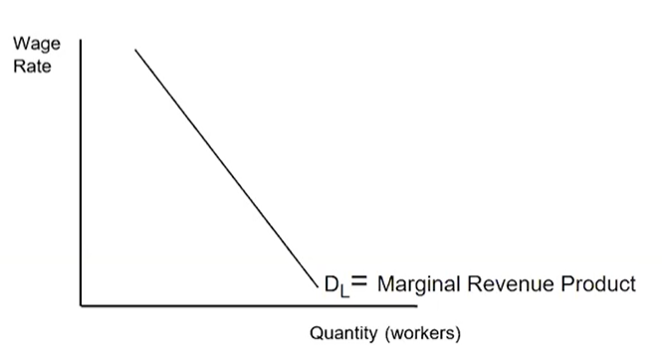
* Marginal physical product- the additional output produced by one more unit of a variable input, often labor
* 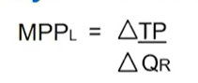
* 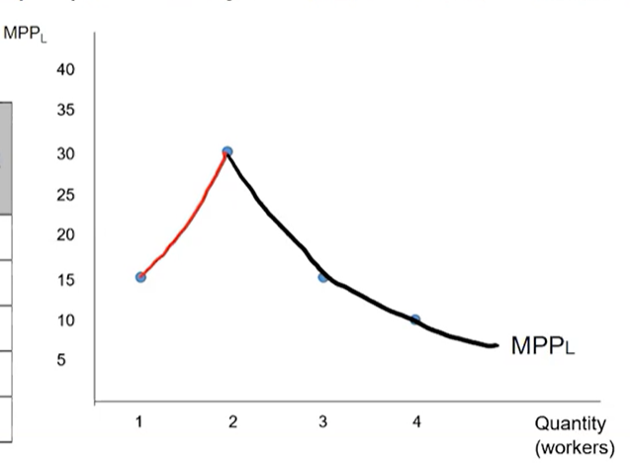
* Downward sloping of the Marginal Physical Product curve is caused by Diminishing Returns
* Diminishing returns: with all other resources held constant, with each additional input of a resource (worker), the output increases at a decreasing rate
* When MP is at its maximum, MC is at its minimum
* 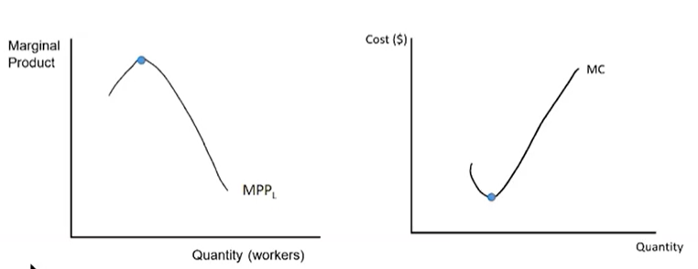
* MRP = change in TR / change in Q of revenue
* MRP = MPP x MR
* Perfect competition: all the price changes together across the firms
* 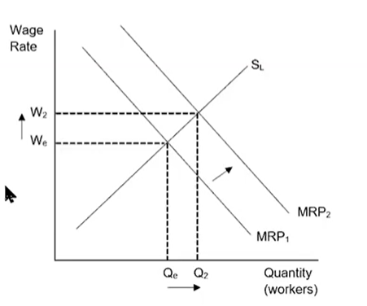
* As quantity of workers increases, MP decreases, MC increases
* Market resource demand curve is a horizontal summation of all the firms’ demand curves in the industry.
* The demand for resource is a derived demand
* 2 things affect derived demand: productivity, output price
* Marginal physical product causes the factor demand curve to be downward sloping because of diminishing returns
* As the number of workers increases, marginal physical product decreases
* Output price: changes in demand in the product market affect price and therefore MR
* Productivity: government regulations and improvements in education affect the productivity of workers
* MPP → productivity
* MR → output price
* Decrease in productivity, decrease demand for workers
* Increase in productivity, increase demand for workers
* Increase in demand: increase in quantity of workers, increase in wage rate
* When the factor supply curve shifts it impacts wage rate and employment
* Determinants of Labor Supply
  + Leisure: opportunity cost of work. When someone decides to increase their leisure time they will supply less of their labor
  + Number of Alternative Options: if workers decrease their supply of labor in one industry, they will increase their supply in another
  + Distribution of Age: as more old people retire there are less new workers entering the labor force
  + Education: as more years are spent at universities, there is a longer time before graduates enter the workforce. Their skill levels change also. Causes decrease in supply
  + Increase in immigration will provide more workers and decrease will supply less workers
* Supply curve left means less workers, supply curve right means more workers
* Decrease in supply causes decrease in quantity of workers and increase in the wage rate

Profit-Maximizing Behavior in Perfectly Competitive Factor Markets:

* Perfect Competition in the Labor Market
  + Many firms buying labor and many people selling their labor
  + Wage takers
  + Can be a perfect competitor in labor market even if it is an imperfect competitor in the product market
* Total Factor Cost = Number of Workers x Wage Rate
* MFC = Change in TFC / Change in Quantity produced
* 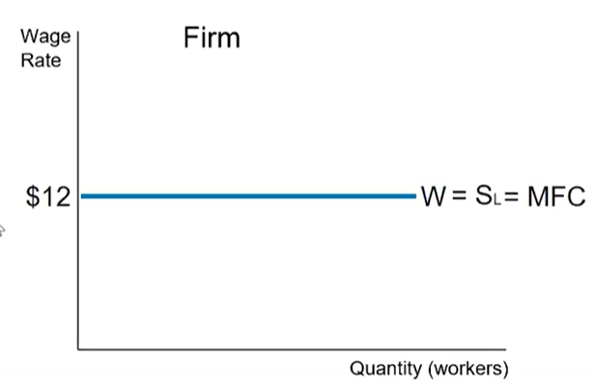(in perfectly competitive, supply perfectly elastic)
* Marginal Factor Cost (MFC) is also referred to as Marginal Resource Cost (MRC)
* MRP of a perfectly competitive firm > MRP of an imperfectly competitive firm
* Intersection of MRP and MFC is wage and quantity of workers for firm (profit maximizing)
* Least-Cost Rule: applies only in a perfectly competitive labor and perfectly competitive product market
* To minimize costs or maximize profits, a PC firm will employ:
  + Inputs (capital and labor): MPC / PC = MPL / PL
* For Utility Maximization (Unit 1): MUC / PC = MUD / PD (for 2 products)
* For a higher val, employ less. For a lower val, employ more
* Use for complements
* As the number of inputs increases, Marginal Physical Product decreases
* If the ratios are not equal, then remember that with diminishing returns, MPP decreases as the number of inputs increases
* When the both product and labor markets are competitive:
  + MRP = Value of Marginal Product
  + VMPL = MPL x P
* Making an optimal choice: MB = MC
* Firms produce the optimal amount: P = MC
* Firms decide how many workers to hire: MRP = MFC
* MRPL = MPL x MR
* VMPL = MPL x P
* In a PC output firm
  + MR = P → MRP = MPL x P → MRP = VMP
* In an imperfectly competitive output firm
  + MR < P, price has to keep decreasing to sell more units

Monopsonistic Markets:

* Monopsony: market where there is a monopsonist
* Monopsonist: a single buyer in the factor market (think firm)
* Monopsonistic Labor Market
  + Imperfectly competitive labor market
  + Only 1 firm hiring labor
  + Wage maker
* TFC = number of workers x wage rate
* For imperfectly competitive market, wage rate increases as quantity of workers increases
* MFC > supply (wage rate)
* MFC is the wage rate plus the wage rate from all previous workers hired at a lower wage rate
* 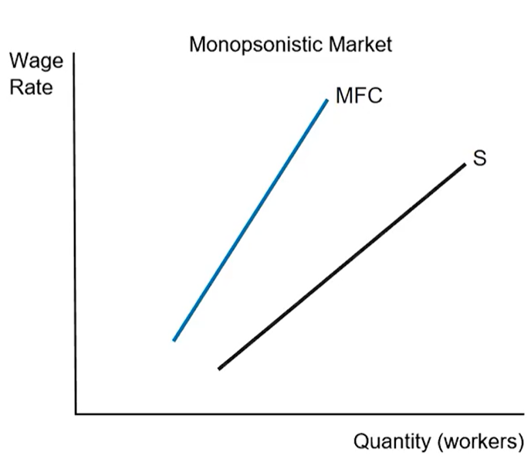
* A typical firm highers additional labor as long as the MRP >= MFC
* As long as total revenue is greater than total cost, firms are earning a profit
* Rational firms use marginal analysis to determine profit maximization
* MRP = MFC
* MRP = MFC is not wage rate, supply curve has wage rate
* 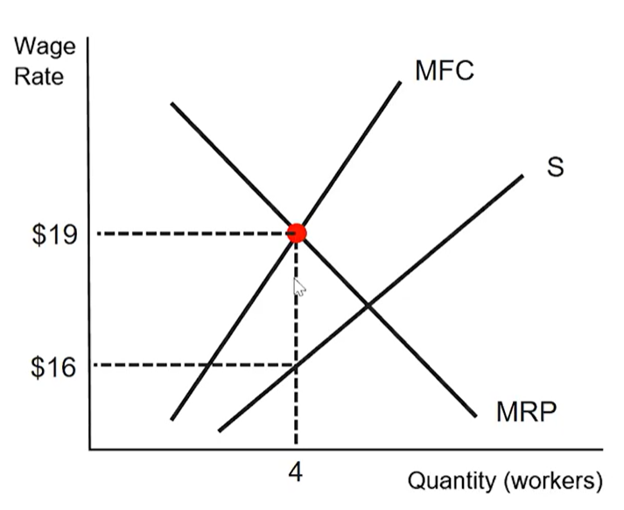
* A monopsonistic firm will always hire fewer workers than a Perfectly Competitive firm
* A monopsonistic firm will always pay a lower wage than a Perfectly Competitive firm
* 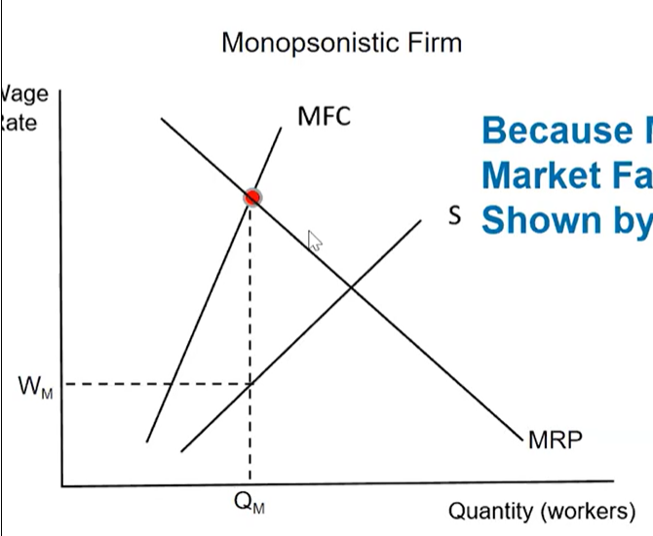
* 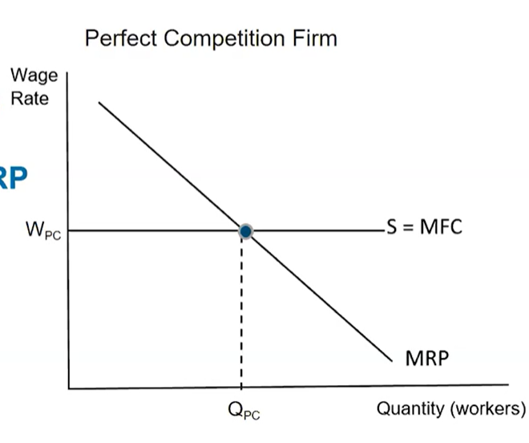
* Because MFC > S, Market Failure is shown by W < MRP
* Diminishing returns is when MP decreases