
PalaUnisannio, Università degli Studi Del Sannio
RESULTS
The reported expanded uncertainties (Ext. Uncertainty) are based on the standard uncertainty multiplied by a of confidence of approximately 95 %. | coverage factor k = 2

Via dei Mulini, 75, 82100 Benevento BN, Italy

CERTIFICATE OF CALIBRATION



No: C0001


Page 1 of 8

CALIBRATION OF

Description:
Manufacturer:
Series:
Sensing Range:
Gas Flow Meter
FS-1012-1100-NGRenesas Electronic Company
0 -10 L/m



Software version:
Calibration Operator:
LabVIEW 21
Aped

CUSTOMER

Measurement for Automation & Industrial Production
Prof. Sergio Rapuano
Prof. Ioan Tudosa

CALIBRATION CONDITIONS
Environment Temperature: | 25°C

SPECIFICATIONS
The Thermal Mass Flow Meter Renesas FS-1012-1100-NG has been calibrated in accordance with the requirements as specified
during the project presentation, using the Thermal Mass Flow Meter Renesas FS-2012-1100-NG as a reference instrument.

PROCEDURE
The measurements have been performed with the assistance of LabVIEW 21, which allowed the control of the acquisition devices remotely.

Client Signature
Calibration Technician

PalaUnisannio, Università degli Studi Del Sannio

Via dei Mulini, 75, 82100 Benevento BN, Italy

CERTIFICATE OF CALIBRATION

No: C001

Page 2 of 8

Table 1 INSTRUMENTATION
 | Instrument
Power Supply (GPIB Unit) | Agilent, Type e3634A
Power Supply (Manual Unit) | TTi QL355TP
Gas Used | Air
Flow Actuator | EAD NEO PP2
DAQ | NI USB-6008
Arduino Board | Arduino UNO R3

PalaUnisannio, Università degli Studi Del Sannio

Via dei Mulini, 75, 82100 Benevento BN, Italy

CERTIFICATE OF CALIBRATION

No: C001

Page 3 of 8

Measurements

The calibration procedure involved generating precise current ramps to control the air-pump, which in turn produced varying airflows. During these controlled airflow conditions, data was simultaneously acquired from both the analog Device Under Test (DUT) sensor and the digital reference sensor, capturing their respective responses across the flow range. While the nominal sensing input range of the sensor is 0 to 10 L/m, the calibration was performed exclusively within the range of 0 to 6 L/m. This reduced operational range was strictly adhered to during testing to prevent overheating of the air pump used in the calibration setup. In total, 2600 samples were acquired for each dataset (ascending and descending) for each sensor.

Table. 2 Results

DAQ board Sampling Frequency is set to 1000 Sa/s. Thus, the analog sensor output values captured are
the result of the average of 1000 measurements per second.

Input  Current  [mA] | Reference  Asc.  [mL/min] | Ext. Uncertainty  [mL/min] | Reference  Dec.  [mL/min] | Ext. Uncertainty  [mL/min] | DUT  Asc.  [mV] | Ext. Uncertainty  [mV] | DUT  Dec.  [mV] | Ext. Uncertainty  [mV]
250,00 | 1549,87 | 11,36 | 1984,14 | 10,67 | 333,69 | 0,81 | 396,93 | 0,30
275,00 | 1842,56 | 5,14 | 2290,00 | 7,05 | 378,48 | 0,46 | 435,88 | 0,36
300,00 | 2145,59 | 5,35 | 2608,57 | 5,48 | 421,29 | 0,56 | 470,42 | 0,44
325,00 | 2453,26 | 9,51 | 2938,03 | 9,85 | 458,04 | 0,64 | 500,77 | 0,99
350,00 | 2770,51 | 8,73 | 3458,73 | 8,79 | 492,20 | 0,55 | 528,62 | 0,94
375,00 | 3338,66 | 14,83 | 3726,61 | 5,29 | 523,00 | 0,65 | 554,77 | 0,89
400,00 | 3648,24 | 11,56 | 3963,66 | 4,95 | 549,57 | 0,63 | 575,57 | 0,85
425,00 | 3904,72 | 10,44 | 4178,72 | 5,46 | 574,12 | 0,61 | 594,25 | 0,98
450,00 | 4185,68 | 4,64 | 4367,50 | 5,35 | 598,97 | 1,43 | 613,62 | 0,81
475,00 | 4420,12 | 6,72 | 4557,52 | 8,44 | 619,42 | 0,51 | 633,09 | 0,54
500,00 | 4641,90 | 9,58 | 4741,12 | 4,96 | 637,54 | 0,58 | 648,72 | 0,59
525,00 | 4851,77 | 8,55 | 4937,52 | 6,02 | 656,04 | 0,59 | 662,22 | 0,59
550,00 | 5071,49 | 8,18 | 5092,10 | 6,05 | 672,08 | 0,54 | 675,50 | 0,66

The sensor output is affected by Hysteresis: YES NO

PalaUnisannio, Università degli Studi Del Sannio

Via dei Mulini, 75, 82100 Benevento BN, Italy

CERTIFICATE OF CALIBRATION

No: C001

Page 4 of 8

Table 3. Uncertainty Budget Table (Ascending Phase)

This table will list all identified sources of uncertainty (Type A and Type B), quantify them as standard uncertainties in a common unit, and then combine them. The table is specific for the ascending phase acquisitions. For this scenario, the conversion equation, which converts the raw voltage output (V) into a flow rate measurement (F) is: F = 10,89 *V - 2343,63

The table is given below:

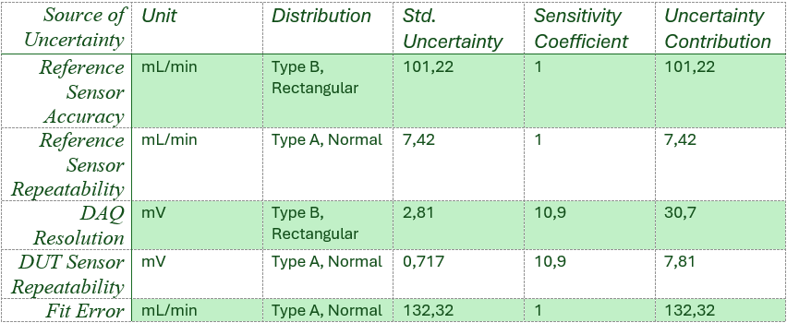

Measuring System Combined Standard Uncertainty: 169,66 mL/min
Extended Uncertainty (k=2): 339,33 mL/min

Table 4. Uncertainty Budget Table (Descending Phase)

This table will list all identified sources of uncertainty (Type A and Type B), quantify them as standard uncertainties in a common unit, and then combine them. The table is specific for the descending phase acquisitions. For this scenario, the conversion equation, which converts the raw voltage output (V) into aflow rate measurement (F) is: F = 11,51 *V - 2698,78

The table is given below:

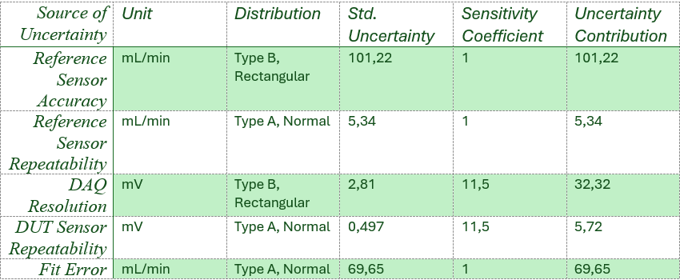

Measuring System Combined Standard Uncertainty: 127.3 mL/min
Extended Uncertainty (k=2): 254,57 mL/min

PalaUnisannio, Università degli Studi Del Sannio

Via dei Mulini, 75, 82100 Benevento BN, Italy

CERTIFICATE OF CALIBRATION

No: C001

Page 5 of 8

Graphs

