

„Stefan cel Mare” University of Suceava
FACULTY OF ELECTRICAL ENGINEERING AND COMPUTER SCIENCE
DUAL COMPUTER SYSTEMS PROGRAM

T H E
I N V E N T O R Y
Inventory Management Microservice.

Project developed by:
Strugariu Filip-Daniel
FIESC Group: 3111Da Year 1

Suceava 2026

Table of contents

2 Application description 2
3 API 3
4 Technologies / Tools 4
5 App structure 5
5.1 Database schema 5
5.2 Backend app structure (Module) 6
5.3 Frontend app structure 6
5.4 Git repo structure 6

6 App configuration & run 7
6.1 Local run (Development): 7
6.2 Production run 8

7 Conclusions / Lessons learned 8

Application description

The Inventory is a Full-Stack digital solution designed to optimize logistics workflows in medium-sized warehouses. The application allows real-time stock monitoring, supplier relationship management, and automated freight transfers between different physical locations.
Inspired by the standards of the ASSIST Learning platform, the project focuses on an intuitive user interface (Dashboard) and a high-performance backend capable of handling complex CRUD operations and rigorous data validations.

API
Automated documentation: the backend uses the OpenAPI (Swagger) specification for generating the testing interface.
Main routes:
/products: Product catalog management.
/warehouses: Storage capacity administration.
/inventory: Stock transfer and adjustment logic.
/suppliers: Commercial partners database.
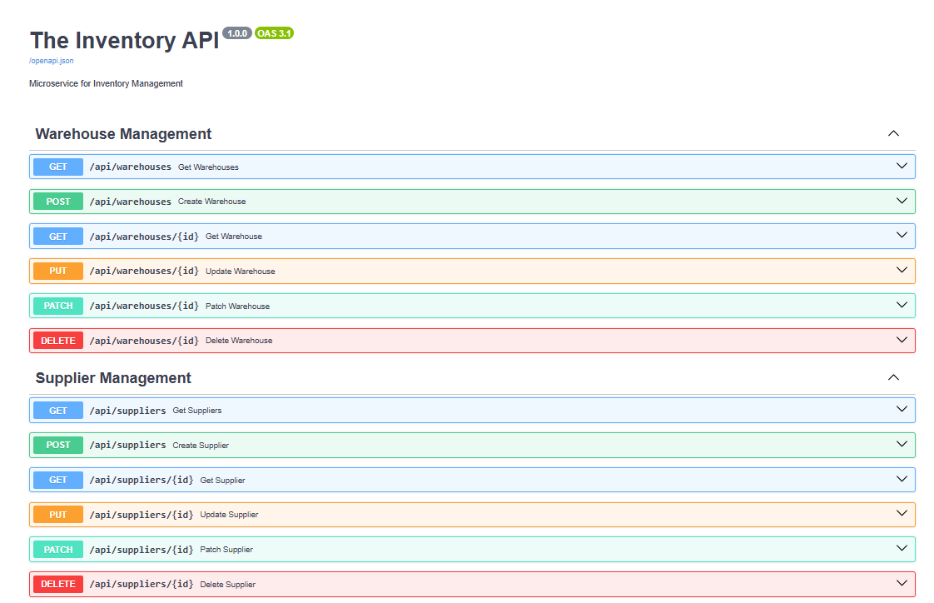

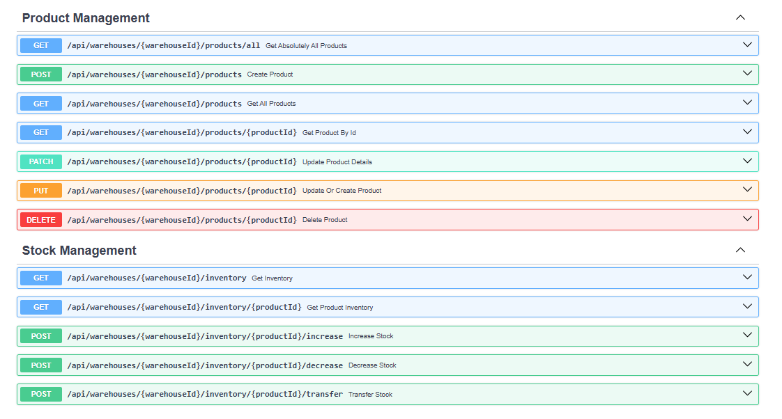

Technologies / Tools

Python & FastAPI - Development of the backend microservice and business logic.
React.js & Vite - Building the frontend user interface and managing application state.
PostgreSQL (Supabase) - Persistent data storage in a cloud-based relational database.
SQLAlchemy - ORM used for mapping Python objects to database tables.
Tailwind CSS - Fast and responsive styling of frontend components.
Render - Live hosting for the backend API.
Hostinger - Production deployment of the frontend.
Visual Studio Code - Main Integrated Development Environment (IDE).
Swagger (OpenAPI) - Automated generation of interactive documentation for real-time API endpoint testing.
Pydantic - Defining data structures (schemas) and automated input validation to ensure database integrity.

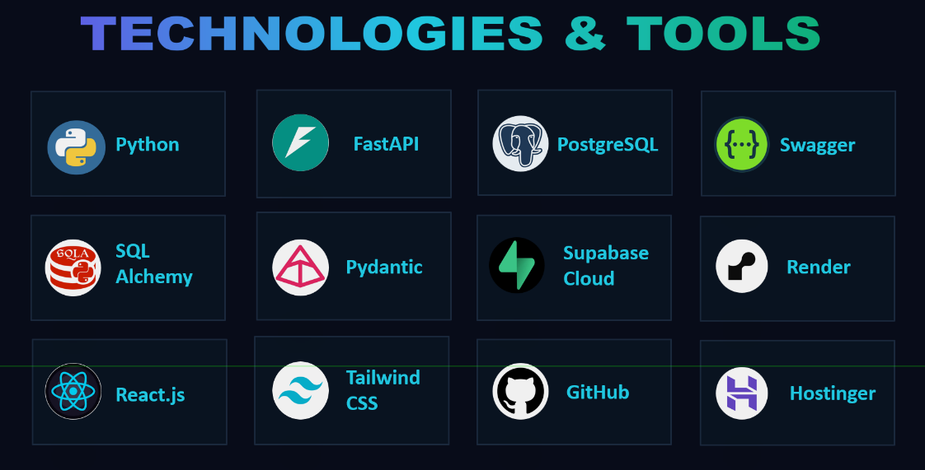

App structure

Database schema

The system is built on a relational architecture:

- Products: Stores details about SKU, price, and name.
- Warehouses: Monitors location and maximum capacity.
- Suppliers: Manages the database of partners supplying the products, including contact details.

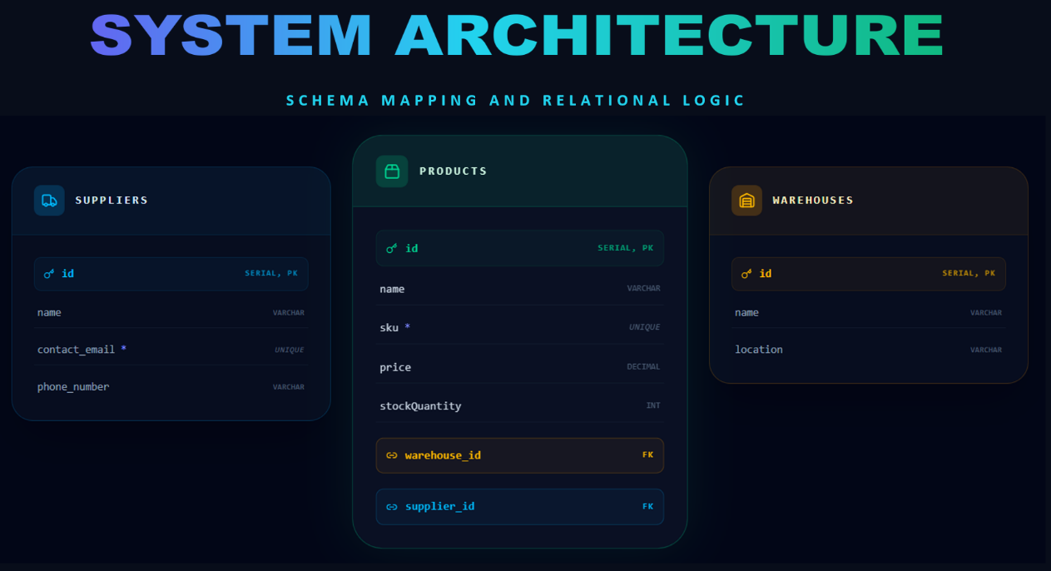

Backend app structure (Module)

- main.py: Entry point and CORS configuration. database.py: Managing the connection to the Supabase instance.
- models.py: Defining the structure of PostgreSQL tables.
- schemas.py: Input/output data validation using Pydantic.

Frontend app structure

The interface is built in React.js, organized into reusable components:
- UI components: Dashboard, Inventory tables, Editing forms.
- State management: Managing data received from the Render API via React hooks (useEffect, useState).
- Design: Implemented with Tailwind CSS for a modern and responsive look.

Git repo structure

- /backend: Contains Python code, the requirements.txt file, and API logic.
- /frontend: Contains the React project, Tailwind configuration, and component folders.
- .gitignore: File extensions ignored by Git.
- README.md: The main documentation of the repository.
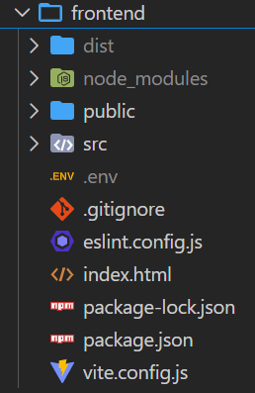
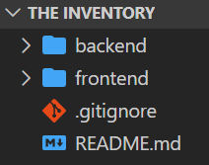

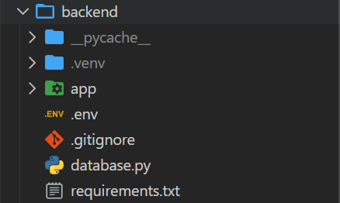

App configuration & run

Local run (Development):

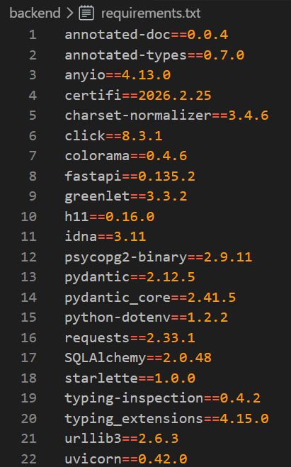
- Backend: Creating a virtual environment, installing dependencies (pip install -r requirements.txt), and starting the server with:
.\.venv\Scripts\activate
uvicorn app.main:app --reload.
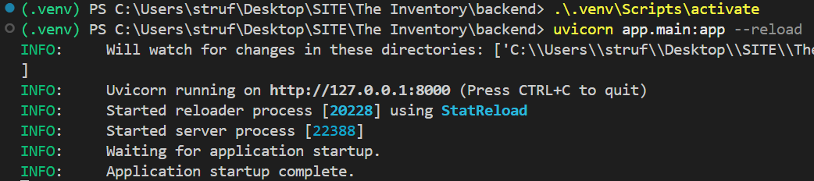

- Frontend: Installing Node modules (npm install) and starting the development server (npm run dev)
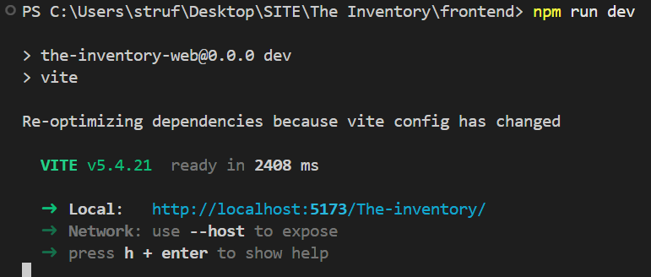

Production run

- Backend: Automatically connected to GitHub via Render for continuous deployment..
- Frontend: Compiled (npm run build) and uploaded to Hostinger.
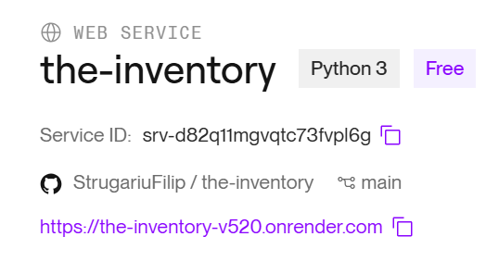

Conclusions / Lessons learned

By developing this project, I managed to deepen my understanding of data management mechanisms, learn how to create a scalable API-based infrastructure, and develop Full-Stack applications. Key knowledge acquired:
- Data modeling: I implemented a relational structure in PostgreSQL that ensures data consistency across products, warehouses, and suppliers, logically managing stocks without overloading the database with redundant tables.

- Microservices development: I used FastAPI to build an asynchronous API, focusing on data validation via Pydantic and securing stock transfer routes.

- Cloud resource management: I coordinated a distributed environment, learning to interconnect a secure cloud database (Supabase) with an API hosting service (Render).

