
MINISTRY OF EDUCATION AND RESEARCH
OF THE REPUBLIC OF MOLDOVA
Technical University of Moldova
Faculty of Computers, Informatics and Microelectronics
Department of Software Engineering and Automation

Teodor Strulea FAF-242

Report
Laboratory nr. 1
Cryptography and Security
Caesar Cipher over the Romanian Alphabet

Checked by:
[Instructor name], [title]

Chișinău – 2026
CONTENTS
Introduction 3
1 Theoretical Background
1.1 The Caesar Cipher 4
1.2 Key Space and Brute-Force Attack 4
1.3 The Caesar Cipher with a Permutation 4
2 Implementation
2.1 Project Structure 5
2.2 Letter Encoding of the Romanian Alphabet 5
2.3 Input Validation and Normalisation 5
2.4 Building the Permuted Alphabet 6
2.5 Encryption and Decryption 7
2.6 Console Program 8
2.7 Automated Tests 8
3 Results
3.1 Task 1.1 – Encryption and Decryption 9
3.2 Task 1.1 – Invalid Input 9
3.3 Task 1.2 – Encryption and Decryption 10
3.4 Task 1.2 – Invalid Input 11
Conclusions 12
Source Code 13
References 13

INTRODUCTION
This laboratory work studies the Caesar cipher, one of the oldest substitution ciphers, and a strengthened variant in which the alphabet is first permuted with a keyword. Both ciphers are implemented for the Romanian alphabet of n = 31 letters (A, Ă, Â, B, …, S, Ș, T, Ț, …, Z), using only the letter encoding prescribed in the handout (A = 0, Ă = 1, …, Z = 30).
The objectives of the work are: to understand how the Caesar cipher works and why its very small key space makes it insecure; to strengthen it with a keyword-based permutation of the alphabet; and to implement both versions, with complete validation of the user input (numeric key, keyword and text).
The solution was written in Python 3 and is organised as a small library (caesar.py), an interactive console program (main.py) and a set of unit tests (test_caesar.py). The report presents the theory behind the two ciphers, the most important fragments of the implementation, screenshots of the running program for valid and invalid input, and conclusions about the security of the two ciphers. The full source code is available in the GitHub repository given in the Source Code section.

1 THEORETICAL BACKGROUND

1.1 The Caesar Cipher
The Caesar cipher is a monoalphabetic substitution cipher: every letter of the plaintext is replaced by the letter located a fixed number of positions further along the alphabet, wrapping around from the last letter to the first. The secret key k is this shift value and is shared by the sender and the receiver. Because a shift of 0 leaves the text unchanged, the key is restricted to k ∈ {1, 2, …, n − 1}, where n is the size of the alphabet.
If x is the numeric code (position in the alphabet, counted from 0) of a plaintext letter and y the code of a ciphertext letter, encryption and decryption are defined by:
c = eₖ(x) = (x + k) mod n,
m = dₖ(y) = (y − k) mod n.
The operation a mod b is the remainder of the integer division of a by b. During decryption y − k can be negative and must be brought back into the range 0 … n − 1 by adding n; some languages return a negative remainder, so this case has to be handled explicitly. Python’s % already returns a non-negative result for a positive modulus, e.g. (1 − 3) % 31 = 29.
For the Romanian alphabet n = 31 and the letters are encoded as in Table 1.1. With k = 3 the plaintext “cifrul cezar” becomes, after conversion to upper case and removal of spaces, CIFRULCEZAR, and encrypts to FKITXOFHÂBT: C (4) → F (7), I (10) → K (13), …, Z (30) → (33 mod 31 = 2) → Â.
Letter | A | Ă | Â | B | C | D | E | F | G | H | I | Î | J | K | L | M
Code | 0 | 1 | 2 | 3 | 4 | 5 | 6 | 7 | 8 | 9 | 10 | 11 | 12 | 13 | 14 | 15
Letter | N | O | P | Q | R | S | Ș | T | Ț | U | V | W | X | Y | Z
Code | 16 | 17 | 18 | 19 | 20 | 21 | 22 | 23 | 24 | 25 | 26 | 27 | 28 | 29 | 30
Table 1.1: Letter encoding of the Romanian alphabet (n = 31) used in both tasks

1.2 Key Space and Brute-Force Attack
The key space of a cipher is the set of all possible keys. For the Caesar cipher it contains only n − 1 keys: 25 for the Latin alphabet and 30 for the Romanian one. Such a tiny key space makes an exhaustive search (brute-force attack) trivial: the cryptanalyst decrypts the intercepted ciphertext with every key in turn, and exactly one candidate is readable text in the language of the message. For instance, SILKVWFITVRKKRTB (BRUTE FORCE ATTACK encrypted with k = 17 over the English alphabet) is recovered after at most 25 attempts, since only k = 17 yields meaningful English.

1.3 The Caesar Cipher with a Permutation
To enlarge the key space, the alphabet can be reordered before the shift is applied. A second key k₂, called the keyword, is used for this purpose: the distinct letters of the keyword are written first (keeping only the first occurrence of every repeated letter), followed by the remaining letters of the alphabet in their natural order. For the English alphabet and k₂ = cryptography, the permuted alphabet is CRYPTOGAHBDEFIJKLMNQSUVWXZ.
The Caesar shift k₁ is then applied with respect to the permuted alphabet, i.e. the numeric code of a letter is its position in the new order, and the formulas stay the same: c = (pos(x) + k₁) mod n and m = (pos(y) − k₁) mod n, where pos(·) is the position of a letter in the permuted alphabet. With k₁ = 3 and k₂ = cryptography the plaintext CIFRULCEZAR becomes PLKTXQPJYDT, whereas the plain Caesar cipher produced FLIUXOFHCDU.
Since the alphabet can be ordered in n! ways and there are n − 1 shifts, the key space has (n − 1) · n! pairs (k₁, k₂): 25 · 26! ≈ 1.0 · 10²⁸ for the Latin alphabet and 30 · 31! ≈ 2.5 · 10³⁵ for the Romanian one, which rules out exhaustive search. The cipher is still monoalphabetic, however: each plaintext letter is always replaced by the same ciphertext letter, so the letter frequencies of the language remain visible and the cipher can be broken by frequency analysis.

2 IMPLEMENTATION

2.1 Project Structure
The solution is written in Python 3 without external dependencies and is stored on the Lab-1 branch of the course repository, in the Lab1/ folder:
- caesar.py – the library: the letter encoding of Table 1.1, the validation of keys, keywords and texts, the construction of the permuted alphabet and the encrypt/decrypt functions;
- main.py – the interactive console program that asks the user for the task, the operation, the key(s) and the text and prints the result;
- test_caesar.py – unit tests (python -m unittest -v) covering the encoding, the validation rules, round-trip encryption/decryption for all 30 keys and the permuted alphabet.
Both tasks share the same code: the plain Caesar cipher (Task 1.1) uses the natural alphabet, while the cipher with two keys (Task 1.2) passes the keyword-permuted alphabet to the same encrypt and decrypt functions.

2.2 Letter Encoding of the Romanian Alphabet
The handout requires that only the encoding of Table 1.1 be used and that built-in character codes (Unicode code points) must not take part in the shift. Therefore the alphabet is stored as a string in the prescribed order and two dictionaries map letters to codes and codes to letters. Even the conversion to upper case is done through an explicit table, so that at no point does the program rely on ord()/chr() or on the language’s case mapping.
Listing from caesar.py:
# The 31 letters of the Romanian alphabet, in the order of Table 2.
ALPHABET = "AĂÂBCDEFGHIÎJKLMNOPQRSȘTȚUVWXYZ"
N = len(ALPHABET) # n = 31

# Encoding tables: letter -> code and code -> letter.
LETTER_TO_CODE = {letter: code for code, letter in enumerate(ALPHABET)}
CODE_TO_LETTER = {code: letter for code, letter in enumerate(ALPHABET)}

# Upper-casing table, built explicitly from the lower-case alphabet.
_LOWERCASE = "aăâbcdefghiîjklmnopqrsștțuvwxyz"
_TO_UPPER = {lower: upper for lower, upper in zip(_LOWERCASE, ALPHABET)}
_TO_UPPER.update({upper: upper for upper in ALPHABET})

# Cedilla variants are treated as the same letters.
_CEDILLA_VARIANTS = {"Ş": "Ș", "ş": "Ș", "Ţ": "Ț", "ţ": "Ț"}

MIN_KEY, MAX_KEY = 1, N - 1 # key k in {1, 2, ..., 30}
MIN_KEYWORD_LENGTH = 7
The position of a letter in ALPHABET is its code: LETTER_TO_CODE["Ș"] is 22 and CODE_TO_LETTER[11] is "Î". The _CEDILLA_VARIANTS table implements the recommendation of the handout: Ş and Ţ typed with a cedilla are accepted and treated as Ș and Ț with comma below.

2.3 Input Validation and Normalisation
Invalid input is signalled with three dedicated exception classes (InvalidKeyError, InvalidCharacterError, InvalidKeywordError), whose messages state the allowed values. The console program catches them, prints the message and asks for the value again.
Listing from caesar.py:
def validate_key(value) -> int:
try:
key = int(str(value).strip())
except ValueError:
raise InvalidKeyError(
f"the key must be an integer between {MIN_KEY} and {MAX_KEY} "
f"inclusive (got {value!r})") from None
if not MIN_KEY <= key <= MAX_KEY:
raise InvalidKeyError(
f"the key must be an integer between {MIN_KEY} and {MAX_KEY} "
f"inclusive (got {key})")
return key
validate_key converts the string typed by the user to an integer and accepts it only if it lies between 1 and 30; anything else (0, 31, a negative number, letters, an empty string) is rejected with a message that names the allowed range and echoes the rejected value.
Listing from caesar.py:
def normalize_text(text: str) -> str:
result = []
for position, char in enumerate(text, start=1):
if char == " ": # spaces are allowed and removed
continue
char = _CEDILLA_VARIANTS.get(char, char)
upper = _TO_UPPER.get(char) # None if not a Romanian letter
if upper is None:
raise InvalidCharacterError(char, position)
result.append(upper)
return "".join(result)

def validate_keyword(keyword: str) -> str:
normalized = normalize_text(keyword) # may raise InvalidCharacterError
if len(normalized) < MIN_KEYWORD_LENGTH:
raise InvalidKeywordError(
f"the keyword must contain at least {MIN_KEYWORD_LENGTH} letters "
f"of the Romanian alphabet (got {len(normalized)})")
return normalized
normalize_text walks through the text character by character: spaces are dropped, cedilla variants are mapped to the comma-below letters, and every other character is looked up in the upper-casing table. A character that is not a Romanian letter raises InvalidCharacterError, which records the character and its position so the message can tell the user exactly what was rejected. The returned text is in upper case with the spaces removed, as required before encryption. validate_keyword reuses the same function and additionally checks the minimum length of 7 letters.

2.4 Building the Permuted Alphabet
Listing from caesar.py:
def build_permuted_alphabet(keyword: str) -> str:
keyword = validate_keyword(keyword)
permuted = []
for letter in keyword + ALPHABET:
if letter not in permuted: # keep only the first occurrence
permuted.append(letter)
return "".join(permuted)
The permuted alphabet is obtained by iterating over the keyword followed by the natural alphabet and appending each letter the first time it is met. The result always contains all 31 letters exactly once. For k₂ = criptografie the function returns CRIPTOGAFEĂÂBDHÎJKLMNQSȘȚUVWXYZ, which the console program prints together with the new codes so the result can be checked by hand.

2.5 Encryption and Decryption
Listing from caesar.py:
def encrypt(plaintext: str, key, alphabet: str = ALPHABET) -> str:
key = validate_key(key)
text = normalize_text(plaintext)
letter_to_code, code_to_letter = _encoding_tables(alphabet)
ciphertext = []
for letter in text:
x = letter_to_code[letter]
c = (x + key) % N # c = (x + k) mod n
ciphertext.append(code_to_letter[c])
return "".join(ciphertext)

def decrypt(ciphertext: str, key, alphabet: str = ALPHABET) -> str:
key = validate_key(key)
text = normalize_text(ciphertext)
letter_to_code, code_to_letter = _encoding_tables(alphabet)
plaintext = []
for letter in text:
y = letter_to_code[letter]
m = (y - key) % N # m = (y - k) mod n, never negative
plaintext.append(code_to_letter[m])
return "".join(plaintext)

def encrypt_with_keyword(plaintext, key, keyword): # Task 1.2
return encrypt(plaintext, key, build_permuted_alphabet(keyword))

def decrypt_with_keyword(ciphertext, key, keyword): # Task 1.2
return decrypt(ciphertext, key, build_permuted_alphabet(keyword))
Both functions receive the alphabet that defines the codes (the natural one by default), validate the key, normalise the text and then apply the formulas c = (x + k) mod n and m = (y − k) mod n letter by letter. Because Python’s % returns a non-negative remainder for a positive modulus, a negative y − k is automatically wrapped into 0 … 30, so decryption needs no special case. The two wrappers encrypt_with_keyword and decrypt_with_keyword implement Task 1.2 by building the permuted alphabet from the keyword and passing it to the same functions.

2.6 Console Program
Listing from main.py:
def ask_key() -> int:
while True:
try:
return caesar.validate_key(
ask(f"Enter key 1 (integer {caesar.MIN_KEY}-{caesar.MAX_KEY}): "))
except InvalidKeyError as error:
warn(f"Invalid key: {error}.") # message, then ask again

def main() -> None:
task = ask_task() # 1 = Caesar, 2 = Caesar with permutation
operation = ask_operation() # E = encrypt, D = decrypt
key = ask_key()
alphabet = caesar.ALPHABET
if task == "2":
keyword = ask_keyword()
alphabet = caesar.build_permuted_alphabet(keyword)
print(f" Permuted alphabet: {alphabet}")
print(caesar.encoding_table(alphabet))
if operation == "E":
text = ask_text("message (plaintext)")
print(f" Ciphertext: {caesar.encrypt(text, key, alphabet)}")
else:
text = ask_text("ciphertext")
print(f" Decrypted message: {caesar.decrypt(text, key, alphabet)}")
Each ask_* function loops until it obtains a valid value: the exception raised by the library is caught, its message is printed with the allowed range and the question is repeated. main then selects the alphabet (natural or permuted, printing the latter), reads the message or ciphertext and prints the result.

2.7 Automated Tests
Listing from test_caesar.py:
def test_round_trip_all_keys(self):
message = "ȘTIINȚA CRIPTOGRAFIEI ÎN ROMÂNĂ"
for key in range(1, 31):
self.assertEqual(decrypt(encrypt(message, key), key),
normalize_text(message))

def test_build_permuted_alphabet(self):
self.assertEqual(build_permuted_alphabet("criptografie"),
"CRIPTOGAFEĂÂBDHÎJKLMNQSȘȚUVWXYZ")
The unit tests check the Table 1.1 codes, the normalisation rules (upper-casing, space removal, cedilla variants, position of the rejected character), the key range, the wrap-around at the end of the alphabet, the permuted alphabet from the handout’s example, and that decryption inverts encryption for every key from 1 to 30 and for the two-key variant. All 16 tests pass.

3 RESULTS
The screenshots below show the console program running in a terminal. At start-up the program prints the encoding of Table 1.1, so that every result can be verified by hand.

3.1 Task 1.1 – Encryption and Decryption
Figure 3.1 shows the encryption of the message “cifrul cezar” with k = 3. The text is converted to upper case, the spaces are removed and the ciphertext FKITXOFHÂBT is obtained; the last letters wrap around (Z → Â). Figure 3.2 shows that decrypting this ciphertext with the same key returns CIFRULCEZAR.
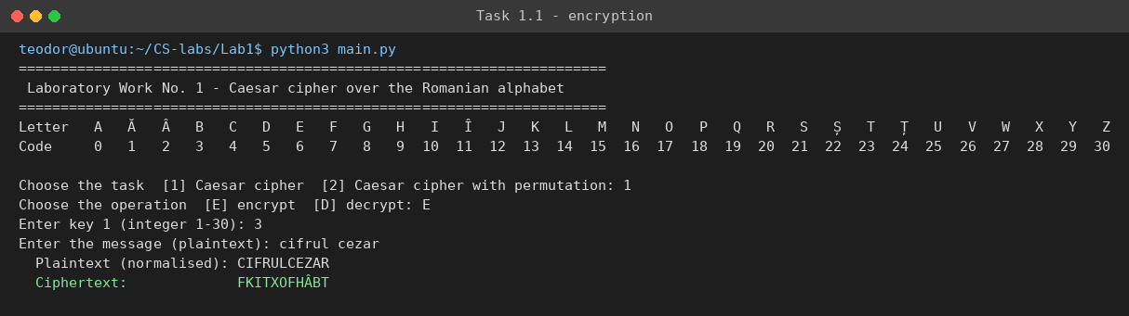
Figure 3.1: Task 1.1 – encryption of “cifrul cezar” with k = 3
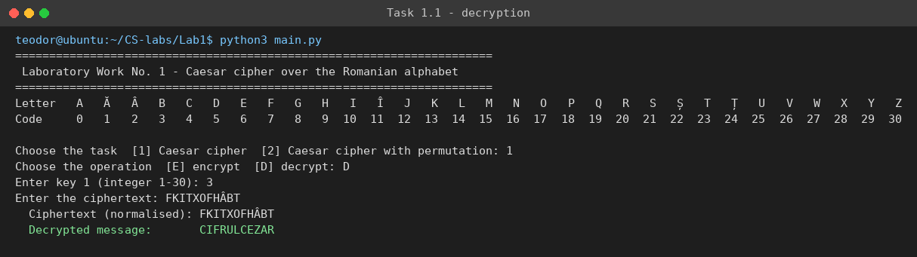
Figure 3.2: Task 1.1 – decryption of FKITXOFHÂBT with k = 3

3.2 Task 1.1 – Invalid Input
Figure 3.3 shows the reaction to invalid keys: 0, 31 and the string “abc” are all rejected with a message that states the allowed range 1–30 and echoes the rejected value, after which the key is requested again; the key 7 is then accepted and a message with Romanian diacritics is encrypted. In Figure 3.4 the texts “Hello, world!” and “parola 123” are rejected because of the comma and the digit, and the message names the offending character and its position. The text “Şi Ţara”, typed with cedillas, is accepted and normalised to ȘIȚARA.
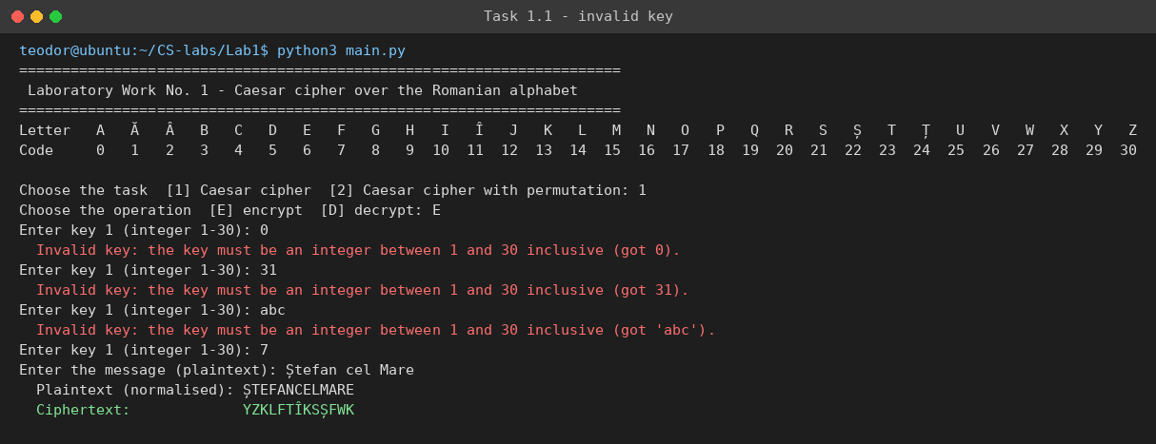
Figure 3.3: Task 1.1 – messages for invalid keys (0, 31, “abc”)
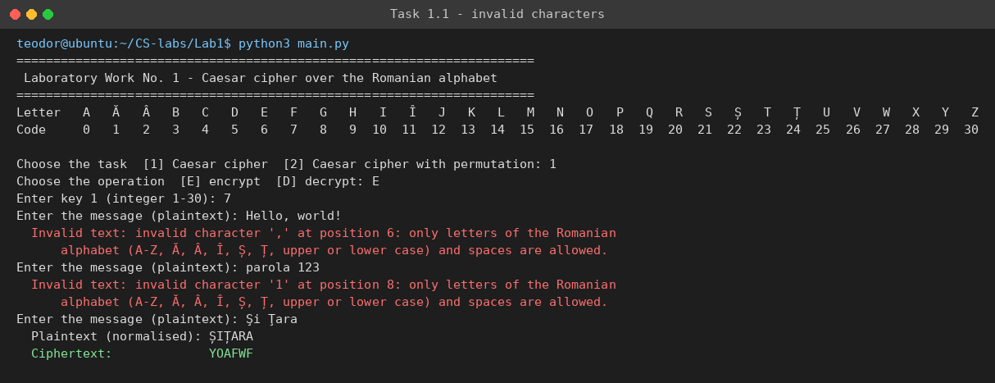
Figure 3.4: Task 1.1 – messages for invalid characters and acceptance of cedilla variants

3.3 Task 1.2 – Encryption and Decryption
Figure 3.5 shows Task 1.2 with k₁ = 3 and k₂ = criptografie. The program displays the keyword in upper case, the permuted alphabet CRIPTOGAFEĂÂBDHÎJKLMNQSȘȚUVWXYZ and the new codes, then encrypts “cifrul cezar” to POÂTXQPBIĂT – a different result from the plain Caesar cipher with the same shift (FKITXOFHÂBT). Figure 3.6 confirms that decryption with the same two keys recovers CIFRULCEZAR.
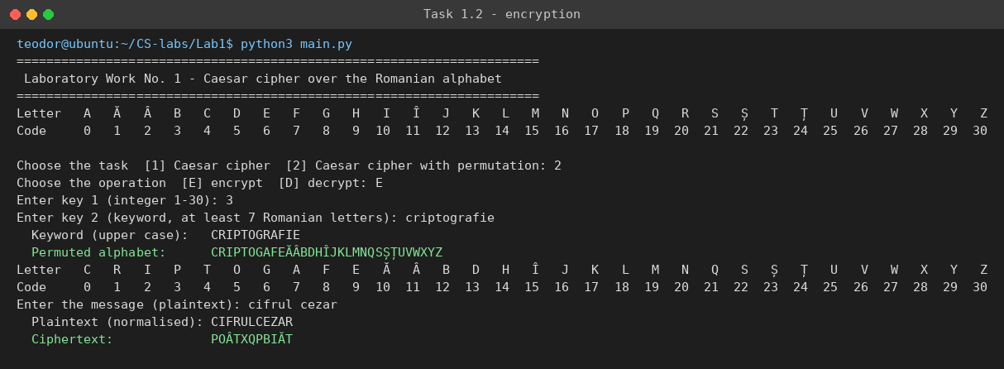
Figure 3.5: Task 1.2 – permuted alphabet and encryption with k₁ = 3, k₂ = criptografie
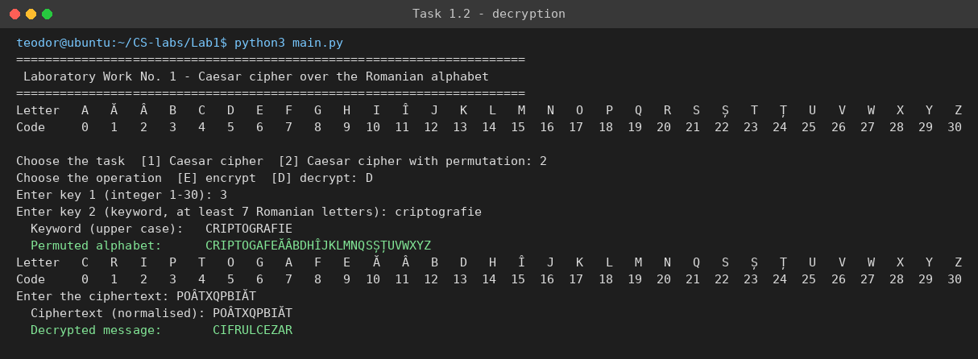
Figure 3.6: Task 1.2 – decryption of POÂTXQPBIĂT with k₁ = 3, k₂ = criptografie

3.4 Task 1.2 – Invalid Input
Figure 3.7 shows the validation of the keyword: “cheie” (5 letters) and “Ștefan” (6 letters) are too short, and “parola1” contains a digit; each attempt produces a message with the allowed values and the keyword is requested again. The keyword “securitate” is accepted, the permuted alphabet is displayed and the message “atac prin forța brută” is encrypted with k₁ = 17.
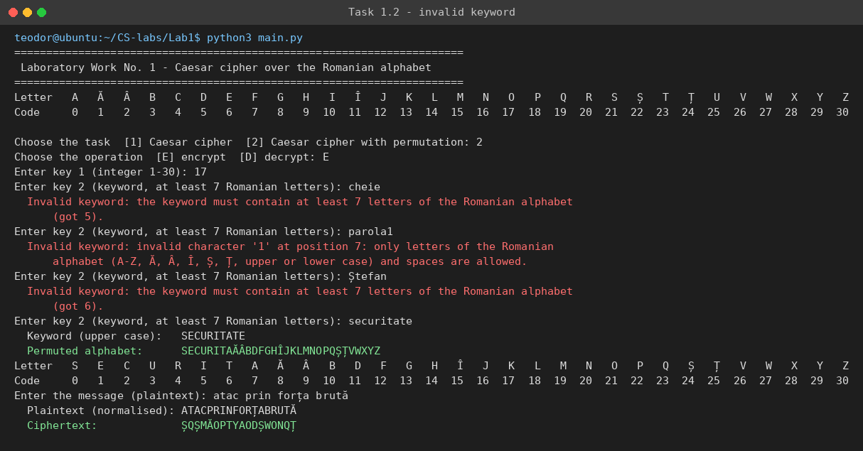
Figure 3.7: Task 1.2 – messages for a keyword that is too short or contains invalid characters

CONCLUSIONS
In this laboratory work the Caesar cipher and its keyword-permuted variant were implemented in Python for the Romanian alphabet of 31 letters, using exclusively the prescribed letter encoding, and both were tested with valid and invalid input.
The plain Caesar cipher offers essentially no security: with only 30 possible keys, a brute-force attack recovers the plaintext after at most 30 decryptions, which can be done by hand. Permuting the alphabet with a keyword increases the key space to 30 · 31! ≈ 2.5 · 10³⁵ pairs and makes exhaustive search impractical, but the cipher remains monoalphabetic – each plaintext letter always maps to the same ciphertext letter – so the letter frequencies of the language leak into the ciphertext and frequency analysis breaks it easily, especially for longer texts. A large key space is therefore necessary but not sufficient for security.
From the implementation point of view, the work showed the importance of a clean separation between the cipher itself (pure functions over codes) and the user interface, of handling the modulo operation carefully for negative values, and of validating every input with messages that tell the user exactly what is wrong and what is allowed. Working with the Romanian alphabet also highlighted practical issues such as the different Unicode forms of Ș and Ț, which the program accepts transparently.

SOURCE CODE
The complete source code of the laboratory work, together with the unit tests, is available in the GitHub repository of the course:
- Repository: https://github.com/Strulea-Teodor/CS-labs
- Laboratory Work No. 1 (branch Lab-1): https://github.com/Strulea-Teodor/CS-labs/tree/Lab-1/Lab1

REFERENCES
[1] Cryptography and Security, Laboratory Work No. 1 – Caesar Cipher (handout). FCIM / FAF, Technical University of Moldova, 2026.
[2] W. Stallings, Cryptography and Network Security: Principles and Practice, 8th ed., Pearson, 2020 – Chapter 3, Classical Encryption Techniques.
[3] Python Software Foundation, The Python Standard Library – unittest, textwrap, https://docs.python.org/3/library/, accessed October 2026.

